|  |
| --- |
| University of Colorado |
| How-to Website Guide |

|  |
| --- |
|  |

# 

Contents

Introduction 4

Purpose 4

Audience 4

This Edition 4

Things to Know 4

Best Practices 4

Check Work 4

Linking 4

Numbered Lists 4

Clickable Items 4

Terms 4

What is Editable? 4

Manager Functions 5

Creating a New User Account for Live Site 5

Creating a New User Account for Sandbox 5

Getting Started 6

Live Site Log on 6

Sandbox Log On 6

Changing a Password 7

Bookmarking a Page 7

Internet Explorer 7

Google Chrome 8

Firefox 8

Navigation 9

Site Navigation 9

Opening CKEditor Program 9

Editing Controls 0

Text Format 0

Analytics 0

From Google.com 0

With Page Analytics App in Google Chrome 0

Website Aspects 12

Accordions 12

How to Build an Accordion (in WYSIWYG) 12

How to Nestle Toggles and Accordions 12

Anchors 13

Linking to an Anchor 13

Buttons 14

Clone Content 14

Colors 15

ELD Colors 15

Commenting Out 16

Deep-linking to Skillsoft 17

Root URL 17

Finding the Library ID 17

Creating the Link 18

Deep-linking to Lynda.com 19

Images 20

From File not uploaded 20

From URL 20

Uploaded Image 21

Editing an Image 22

Image Map 23

EXAMPLE 23

View on Editor: 24

New Window- Opening Links in a New Window 26

Menus 27

Reorder Menus 27

Side Menus 28

Moving Documents from Sandbox to the Live Site 29

Unpublished Pages 29

Things that need to be checked 29

PDFs 30

Document pages 30

Uploading a PDF 30

Link to an Uploaded PDF 30

Logging an Uploaded PDF 32

Redirects 33

Tabs 34

Inserting a Tab 34

Inserting another Tab 34

Titling a Tab 34

Toggles 35

How to Nest Toggles 35

URL Path Settings 37

Videos 37

Website Banner Menu 38

# Introduction

## Purpose

This resource is to help editors of the live University of Colorado System’s website maintain a clean, clear, consistent and updated website. This guide will cover the tasks necessary to both develop and maintain different website aspects.

## Audience

The audience of this guide is website editors of the live website [www.cu.edu](http://www.cu.edu). This guide is intended to be used by website editors of any experience level.

## This Edition

This document is the third edition of a how-to guide for the University of Colorado website found at [www.cu.edu](http://www.cu.edu). It is applicable to the website as of April 2024.

# Things to Know

## Best Practices

When editing the website keep these best practices in mind. By following them the website is kept clean, precise and consistent.

### Check Work

Work should be checked every time an edit is made to ensure accuracy of information available for users of the University of Colorado website. This includes reviewing for spelling, grammar and broken links.

### Linking

In most instances, when you link a page, you should use the node ID, not the page URL. This ensures that links do not break as easily. (Ex.: If you edit the name of a page, this can change its URL and break all links to it.)

### Numbered Lists

Numbered lists should be used for procedures that are performed in order.

### Clickable Items

When giving directions be sure to copy the language of clickable items (i.e. buttons) exactly as they appear and bold them. Selected items should not have quotes around them. For example, when accessing Skillsoft users should click **Skillsoft** in the portal.

### Terms

The term “log on” should be used instead of “log in.”

## What is Editable?

What you can and cannot edit is dependent on your permission level. For the most part, you should be able to edit the content of a page. This included the text, images, and links on the pages for your department. You may not be able to edit navigation menus. If you are unsure about your permission level contact ES Communications ([ES.Communications@cu.edu](mailto:ES.Communications@cu.edu)).

# Manager Functions

This section covers setting up accounts for new users. It is meant for managers who have hired someone who needs access to edit the website.

## Creating a New User Account for Live Site

When hiring a new employee who will be editing the website, the following steps should be taken.*

1. Go to: <http://www.cu.edu/university-relations/cu-cms-help-and-requests>
2. Complete the **Request a New User** form
3. Enter “Employee Services”into the **Department/Group user needs access to** field
4. Click **Submit**

## Creating a New User Account for Sandbox

There is a test site (Sandbox) that mirrors the live site ([www.cu.edu](http://www.cu.edu)). Access is recommended for all users, especially ones getting used to editing the website. It will also be necessary for employees who will be developing new parts of the website. You **must** have permission within Sandbox to be able to create new users (may need to email [jon.arnold@cu.edu](mailto:jon.arnold@cu.edu)).

1. Log on to Sandbox at <http://es-sandbox-cu.gotpanteon.com/user>
2. Select **People** in the top menu
3. Click **Add user** at the top, right-hand corner of the dialog box
4. Complete all fields
   1. **Note**: Use the same username as for the live site ([www.cu.edu](http://www.cu.edu))
5. Check all boxes within the Roles section of the page to give the user control.
6. Check the **Notify user of new account** box beneath the Roles section.
   1. This generates an email with instructions for the new user on how to get started and allows them to change their password.
7. Click **Create new account**

# Getting Started

This section will explain how to get onto the website editor and how to bookmark the log on page for future use.

## Live Site Log on

1. Open preferred browser* and go to [www.cu.edu/user](http://www.cu.edu/user)   
   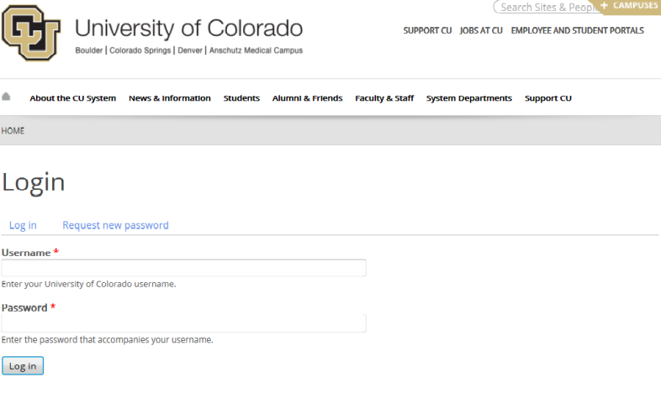
2. Input Username and Password
3. Select *CU Staff Login* >> then login via SSO (select the correct campus and use your university credentials)

* Chrome and Firefox work well with the website editor.

## Sandbox Log On

Sandbox is the test site of [www.cu.edu](http://www.cu.edu). It can be found at <http://es-sandbox-cu.gotpantheon.com/>. Sandbox is used to test and develop new web designs and for new website editors to practice.

1. Open browser and navigate to <http://es-sandbox-cu.gotpantheon.com/user>. The screen will look identical to [www.cu.edu/user](http://www.cu.edu/user). Before any edits are made make sure the correct site is accessed by **checking the URL**. All Sandbox URLs will have <https://es-sandbox-cu.gotpanteon.com> as a root.   
   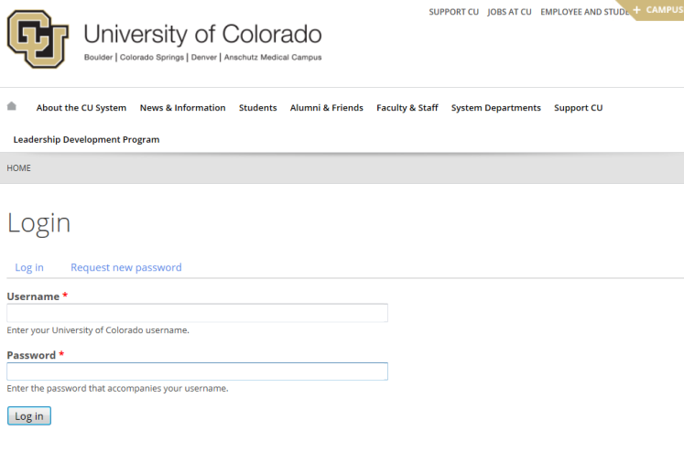
2. Input log on information
3. Select **Log in**

**Note:** If log on information is unknown, please contact your manager.

## Bookmarking a Page

To make finding the log on page easier and faster create a bookmark.

### Internet Explorer

1. Navigate to the log on page
2. Select the star to the right of the URL
3. 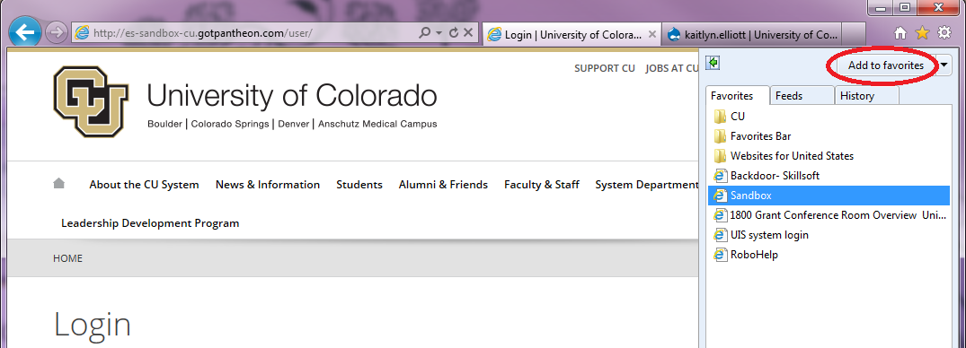Select **Add to favorites**
4. Name the site (e.g. Sandbox)
5. Select **Add**

### Google Chrome

1. Navigate to the log on page
2. Select the star to the right of the URL

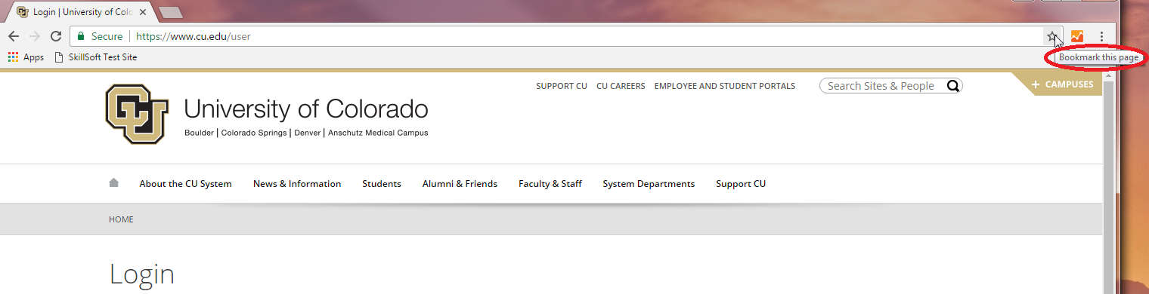

1. Name the link and select a folder to save it  
   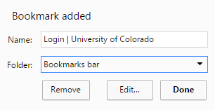
2. Click **Done**

### Firefox

1. Navigate to the page
2. Select the window with a star in the upper, right-hand corner
3. Select **Bookmark This Page**

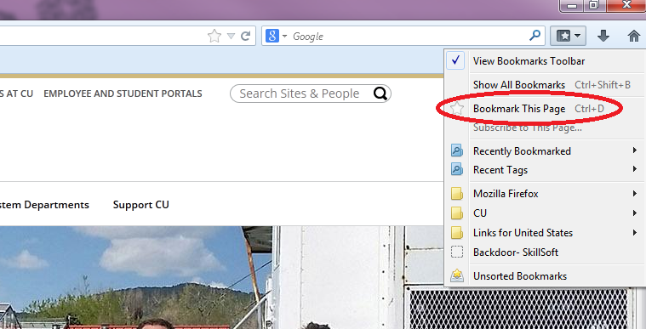

1. Input a name for the site (e.g. Sandbox)
2. Select **Done**

# Navigation

This section covers the basic navigation of the editor.

## Site Navigation

Log on to the website and then go to the page to be edited.

Once you are logged on, all new tabs you open will also be logged in.

## Opening CKEditor Program

The website will look similar whether or not you are logged on, it is important to look for subtle differences including:

* A blue bar just under the URL of the window
* A blue option bar under the page title

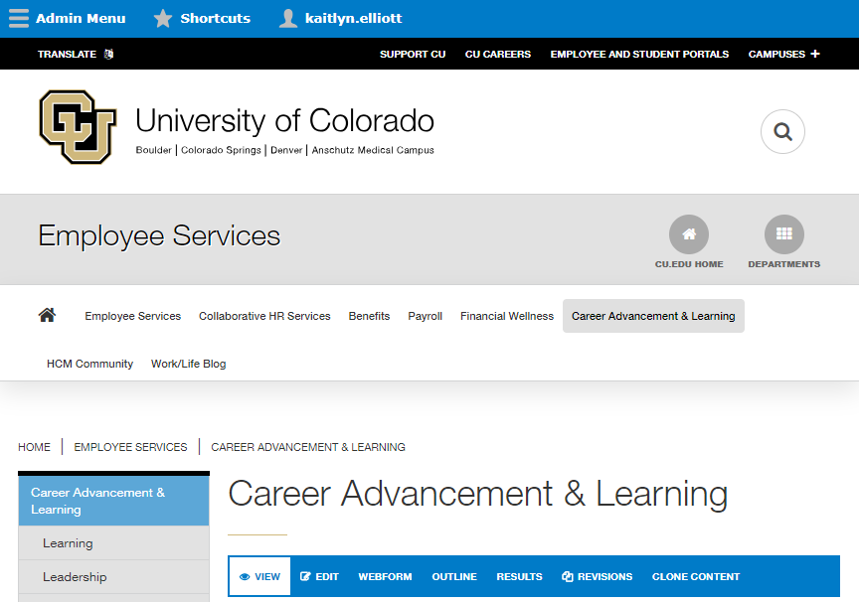

To edit a page:

1. Navigate to page
2. Select **Edit** in the blue option bar (circled above)
3. Edit
4. Select **Save**

## Editing Controls

Basic tools in the program mimic those found in many word processing programs. Some tools that are frequently used are circled below.

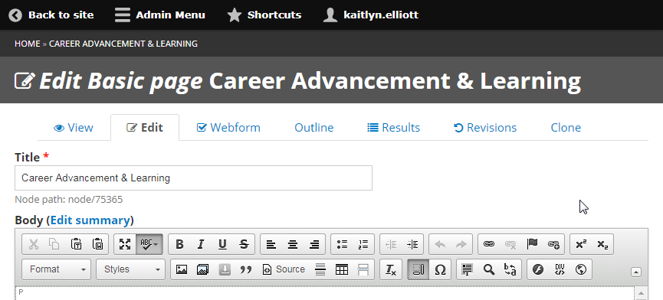

Linking options

Text options

Image

Insert Table

## Text Format

Text format refers to the computer language that is being used to edit the page. The default language for the site editing program is WYSIWYG CKEditor. The other commonly used language is Full HTML.

**Important**: When done editing any page the code must be in WYSIWYG CKEditor before being saved.

To switch computer languages:

1. Open **Edit** page
2. Scroll down to **Text format**
3. Select the language of choice

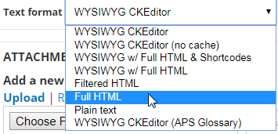

1. Edit the page
2. Rest the **Text format** to WYSIWYG CKEditor before saving
3. Select **Save**

Full HTML can also be accessed by the **Source** button.

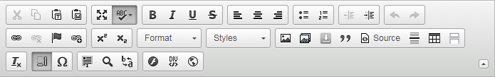

# Website Aspects

This section covers different types of edits on the website.

## Accordions

Accordions are used in conjunction with toggles to condense information on a page.

### How to Build an Accordion (in WYSIWYG aka What You See Is What You Get)

1. Open page
2. Select **Edit** in the toolbar
3. Start accordion with [accordion][accordion-item title= “Title”]
4. Write in information
5. End accordion with [/accordion-item][/accordion]
6. Select **Save**

### How to Nest Toggles and Accordions

1. Open page
2. Select **Edit** in the toolbar
3. Start accordion with [accordion][accordion-item title= “Title”]
4. Start a toggle with [toggle][toggle-item title= “Title”]
   1. The toggle will be a folder underneath the accordion
5. Press enter for a new paragraph box and add text
   1. This will appear under the toggle
6. Close the toggle with [/toggle-item][/toggle]
7. Close accordion with [/accordion-item][/accordion]
8. Select **Save**

## 

## Anchors

Anchors can be used in a web page to organize content and then link to that content. If a single page has a large amount of information on it, it can be helpful to provide a table of page contents and link to the different sections of the page using anchors (i.e. course catalog pages.

1. Open page
2. Select **Edit** in the toolbar
3. Switch to **Full HTML** under **Text Format** or from toolbar
4. Start anchor with <a name=”anchor name”>
5. End anchor with </a>
6. Check that **Text Format** is **WYSIWYG CKEditor**
7. Select **Save**

### Linking to an Anchor

1. Open page
2. Select **Edit** in the Toolbar
3. Switch to **Full HTML** under **Text Format**
4. Start link with <a href=”#anchor name”>
5. Add text that will be linked
6. End link with </a>
7. Check that **Text Format** is **WYSIWYG CKEditor**
8. Select **Save**

## 

## Buttons

Buttons are used to link to another page or external website. Buttons can be linked and deep linked. (Deep links connect users to Skillsoft resources. Creating deep links is explained later in this guide.)

1. Open page
2. Select **Edit**
3. Write in button with [button URL=”www.website.com” color=”color” target=”_blank”]Content[/button]
   1. URL will be the link to where you want the button to go
   2. color will be the color that the button will be
   3. target=”_blank” tells the button to open the link in a new window
4. Select **Save** at the bottom of the page

In the CKEditor this code looks like this:

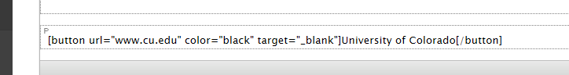

On the webpage this code looks like this:



This button would take the user to the home page of the University of Colorado ([www.cu.edu](http://www.cu.edu)) when they select it.

## 

## Clone Content

When developing a new item this is similar to existing content (ex. learning guide, microlearning, catalog or document page), you can copy another page to keep formatting consistent.

1. Log on to website
2. Go to a page to copy, for example:
   1. Learning Guide: <https://www.cu.edu/employee-services/career-advancement-learning/learning/learning-guides/meeting-management-learning>
   2. Microlearning: <https://www.cu.edu/employee-services/career-advancement-learning/learning/learning-guides/feedback-microlearning>
   3. Catalog: <https://www.cu.edu/node/75372>
   4. Document page: <https://www.cu.edu/docs/cu-training-matrix>
3. Click **CLONE CONTENT**
4. Change **Title**
5. 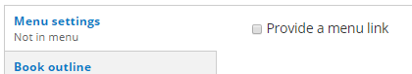Change applicable content in the **Body**
6. Click check box to add a menu link if applicable
   1. Parent item:
      1. Learning guides: Learning Guides
      2. Microlearning: Learning Guides
      3. Catalog: no link provided
      4. Document page: no link provided
7. Click **Save**

## Colors

Several web aspects have the ability to be colored. When coding for a color there are two options.

The first option is to use one of the 16 predefined (or basic) colors. These are colors that are recognized by the word for it. The 16 basic colors are:

* Silver
* Gray
* White
* Black
* Maroon
* Red
* Green
* Lime
* Navy
* Blue
* Purple
* Magenta
* Olive
* Yellow
* Teal
* Cyan

The second option is to use HEX colors. This option is used to get colors and hues not covered under the 16 basic colors. To use a HEX color, find the six digit number below. Then insert the number after a pound sign (#) into color=””.

### CU and ES Approved Colors

### CU Colors

* CU Gold: #cfb87c
* Black: #000000
* CU Dark Grey: #565a5c
* CU Light Gray: #a2a4a3
* CU Blue: 4b92db

### ES General

* Light orange: #ffb718
* Dark orange: #f38a00
* Light brown: #caa976 (secondary or accent color)

Benefits & Wellness

* Light blue: 00a6ce
* Dark blue: 005c82
* Yellow: #f3cd00 (secondary or accent color)

Collaborative HR Services

* Light purple: #873299
* Dark purple: #520975
* Orange: #f38a00

Payroll

* Light green: #b6bdoo
* Dark green: #648b1a

Career Advancement & Learning

* Dark red: #a32a29
* Light red: #e94f3d
* Purple: #72246c

## Commenting Out

HTML allows developers to add comments to the code for a page. Comments allow the next person to understand what was done already or to hide parts of a webpage.

1. Open the page in editor
2. Switch to **Full HTML** under **Text format** or from the toolbar

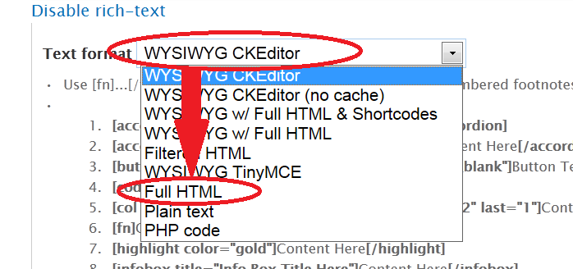

1. Find the section to comment out
2. Add <! - - to the beginning of the section
3. Add - -> to the end of the section
4. Check that the **Text format** is **WYSIWYG CKEditor**
5. Click **Save**

Before making edits on a page, make sure to check for comments. The code you are adding, might already be there.

## Deep-linking to Skillsoft

Deep linkingallows for the ability to directly link to a learning resources in Skillsoft from a website. This can be used to ease navigation for users. When a link to a course is clicked, the user will be directed to login to the employee portal and then taken directly to the Skillsoft course launch page. The user will then launch the resource. This eliminates many of the tedious steps previously needed to navigate to a specific resource within the Skillsoft catalog.

This linking technique is used throughout the ELD section of the website. Although it can work in emails, University Information Systems (UIS) asks that deep links be kept out of emails for security reasons.

Deep-links can be created for any learning resource that has a Library ID. Creating the link can be thought of as two parts: the root URL and the Library ID.

### Root URL

The root URL for Skillsoft 8i is <https://universityofcolorado.skillport.com/skillportfe/custom/login/saml/login.action?courseaction=launch&assetid=Library_ID>

### Finding the Library ID

The Library ID is used in deep linking to identify the specific resource being linked to within Skillsoft. It is used to complete the URL necessary to successfully deep link. The Library ID must be found in Skillsoft.

#### From Search

To find the Library ID from the search screen:

1. Click the down arrow
2. Select **Share**
3. Copy the Library ID from the end of the URL   
   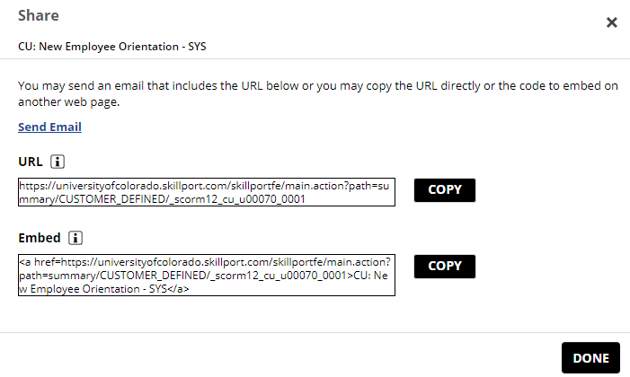

**Note**: Do not use either of these links to try and share resources in Skillsoft. Users will not be able to login and will not be able to access the resource.

#### From Resource Screen

To find the Library ID from the resource screen:

1. Click **About** tab
2. Scroll to bottom

### 

### Creating the Link

#### WYSIWYG CKEditor Version

1. Navigate to the page where the link will exist
2. Select **Edit**
3. Highlight the section of text that will be linked
4. Click the first link symbol  
    
5. Insert the URL

<http://universityofcolorado.skillport.com/skillportfe/custom/login/saml/login.action?courseaction=launch&assetid=Library_ID>   
  
**Note:** ITEMID will be unique to the course or item being linked. For books and videos add _ss_book: or _ss_video: right before the ITEMID.

1. Select **Save**

#### With a Button

Deep linking with a button is used by ELD on the Catalog.

1. Log on to website user account at [www.cu.edu/user](http://www.cu.edu/user)
2. Navigate to the page where the button will exist
3. Select **Edit**
4. Insert a button [button URL=”www.website.com” color=”color” target=”_blank”]Start SkillSoft[/button]
   1. “Start SkillSoft” is the wording for 2014 catalog upgrade
5. Insert course URL into URL=“www.website.com”

* Course URL: <http://universityofcolorado.skillport.com/skillportfe/custom/login/saml/login.action?courseaction=launch&assetid=Library_ID>   
    
  **Note:** ITEMID will be unique to the course or item being linked. For books and videos add _ss_book: or _ss_video: right before the ITEMID.

1. Select **Save**

**NOTE:** Buttons are finicky. Be careful that there are no unnecessary spaces or the button will not work.

## Deep-linking to Lynda.com

Deep links to lynda.com can be created, but are not used on the ELD website. Deep links to lynda.com are campus specific.

1. Go to resource page
2. Click Share arrow   
   
3. Click **Copy  
   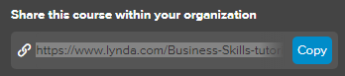**
4. Paste link   
   Example: <https://www.lynda.com/Business-Skills-tutorials/Happiness-Tips/426767-2.html?org=colorado.edu>

This default link will work for the Boulder campus. To change the link for other campuses, the end of the link needs to be edited. For UCD|AMC the ending should be ucdenver.edu. For UCCS or CU System the ending should be cu.edu.

## Images

When using images on a web page follow all copyright laws. Refer to ImageSearchProcess.docx (S:\Employee Services\ELD\eld_toolkit\tutorials\internal_guides\) for more information on image quality standards and usage rights at the university.

### From File not uploaded

If an image is not used elsewhere on the website then this process will help you upload it from your computer in fewer steps.

1. Log on to website user account at [www.cu.edu/user](http://www.cu.edu/user)
2. Navigate to the page where the picture will be
3. Select **Edit**
4. Move cursor to where the picture will be
5. Select the **add media icon**   
   
6. Select **Browse**
7. Navigate to the image
8. Select **Upload**
9. Select **Next**
10. Select **Next** on the Destination page
11. Add any Titles or Alternate Text needed
12. Select **Save**
13. Select **Submit**
14. Select **Save** for the page

### From URL

This process is for images that already exist on the web. It can be used for images used on [www.cu.edu](http://www.cu.edu) or any other website. Be sure when using an image from the web that copyright laws are not broken.

1. Find image
2. Copy URL
3. Log on to website user account at [www.cu.edu/user](http://www.cu.edu/user)
4. Navigate to the page where the picture will be
5. Select **Edit**
6. Select the **image icon**   
   
7. Paste in URL
8. Adjust size
9. Select **OK**
10. Select **Save**
11. Select **Save** again

### Uploaded Image

This process is very similar to that described in “From File not uploaded” above. Rather than loading the image onto the website on the page, the image is added first to the website editor’s database and then is added onto the page. If there are a lot of images to upload to the site this process may be easier.

1. Log on to website user account at [www.cu.edu/user](http://www.cu.edu/user)
2. Go to Content> Files
3. Select **Add File**
4. Browse for and select the PNG or JPG file of the image
5. Select **Upload**
6. Right click on the uploaded file and click **Copy shortcut** 
   1. May want to paste this address some where until you are ready to use it. You will not be able to insert the picture later without it.
7. Select **Next**
8. Select **Next** on the Destination page. This setting should not change.
9. Add any Alt Text or Title Text necessary and click **Save**.
10. Select **Save**
11. Go to the page where you want the picture
12. Select the **add picture icon**



1. Paste in the link location (This is the copied shortcut)
2. Check size
3. Select **Save**
4. Select **Save** again

### Editing an Image

Once an image is successfully added to a page the height, weight, border, surrounding space, and alignment can still be edited.

1. Navigate to the page where the picture is
2. Select **Edit**
3. Right click on the picture
4. Select **Image Properties**
5. Change settings
   1. Width
   2. Height
   3. Border
   4. HSpace – adds padding (white space) to left and right of image
   5. VSpace – adds padding (white space) to top and bottom of image
   6. Alignment
6. Select **OK**
7. Select **Save**

## Image Map

Image maps are not used on the ELD website currently. There are concerns about accessibility and responsiveness (for mobile platforms). Images are kept here as an example.

Image maps are used when more than one link is being tied to a picture. An image map will divide the image into sections so each can be linked to different sections. HTML must be used to put in an image map.

The general code structure for an image map looks like this:

<map name=””>  
<area href=”” coords=”__,__,__,__” target=””>  
<area href=”” cords=”__,__,__,__” target=””>  
</map>  
<img style=”width: px;height: px;” src=”” useMap=”#map name”>

The coordinates (coords) in an image map are variables. Rather than finding the coordinates by solving a complex set of equations use an online editor to help find them. I recommend the editor at: <http://www.maschek.hu/imagemap>

**Note**: the picture used in the online editor to find the coordinates must be the same size as the picture that will exist on the page. If they are not the same size then the coordinates will not line up and the link will exist in the wrong part of the image. It is recommended that the picture be sized on the web page first.

### EXAMPLE

#### Picture:

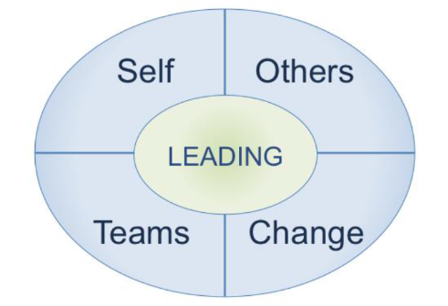

View on Editor:In the editor either click browse and upload a picture or copy and paste the URL where the image can be found. For the following screenshot, the picture was uploaded. Once the picture appears, click to start a mapping area. Then click where the area should end. The program will tell you the coordinates you need for the image map.

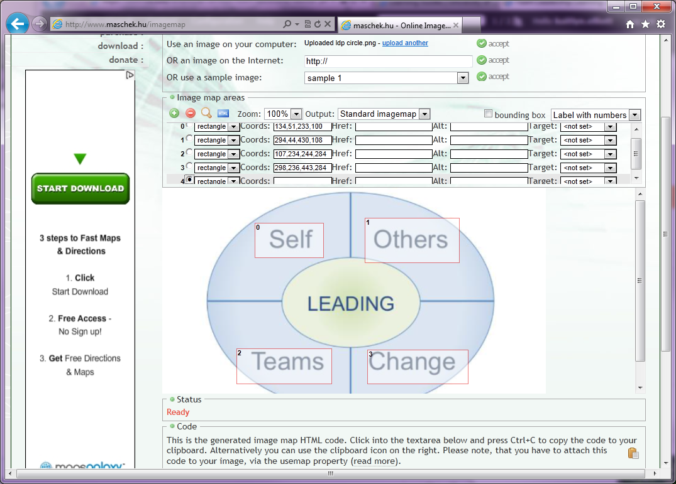

Although the editor will give the code for the image map, it is recommended that the code be written out separately. More information is given in the editor’s code than is necessary. To simplify the code to understand later on it is important to include only the tags and descriptions necessary.

#### Code:

HTML

<map name="leading">  
<area href="http://es-sandbox-cu.gotpantheon.com/employee-services/leading-self-toolbox" target="_blank" coords="97,42,199,99">  
<area href="http://es-sandbox-cu.gotpantheon.com/employee-services/leading-teams-toolkit" target="_blank" coords="86,226,206,283">  
<area href="http://es-sandbox-cu.gotpantheon.com/employee-services/leading-others-toolkit#" target="_blank" coords="269,48,396,98">   
<area href="http://es-sandbox-cu.gotpantheon.com/employee-services/leading-change-toolkit" target="_blank" coords="247,229,381,273">  
</map><img style="width: 450px; height: 333px;" src="http://es-sandbox-cu.gotpantheon.com/sites/default/files/media_crop/1048/public/ldp%20circle.png" useMap="#leading">

#### View in WSYIWYG CKEditor:

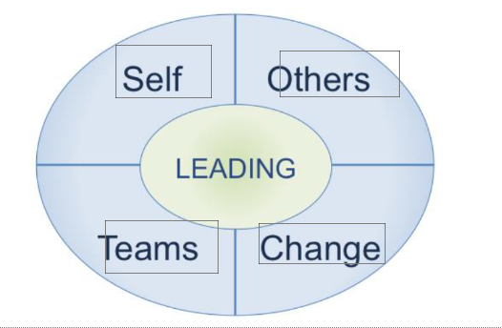

#### Page:



Each of the four types of leading are now linked to their respective toolkit home page. When scrolled over it becomes possible for the link to be selected.

## New Window- Opening Links in a New Window

When linking to either a PDF or hyperlink it can be opened on the same window, a pop up window, or a new window.

**ES Practice:** link to a new window.

1. Navigate to page and click **Edit**
2. Highlight the words to link
3. Select the **Link** icon  
    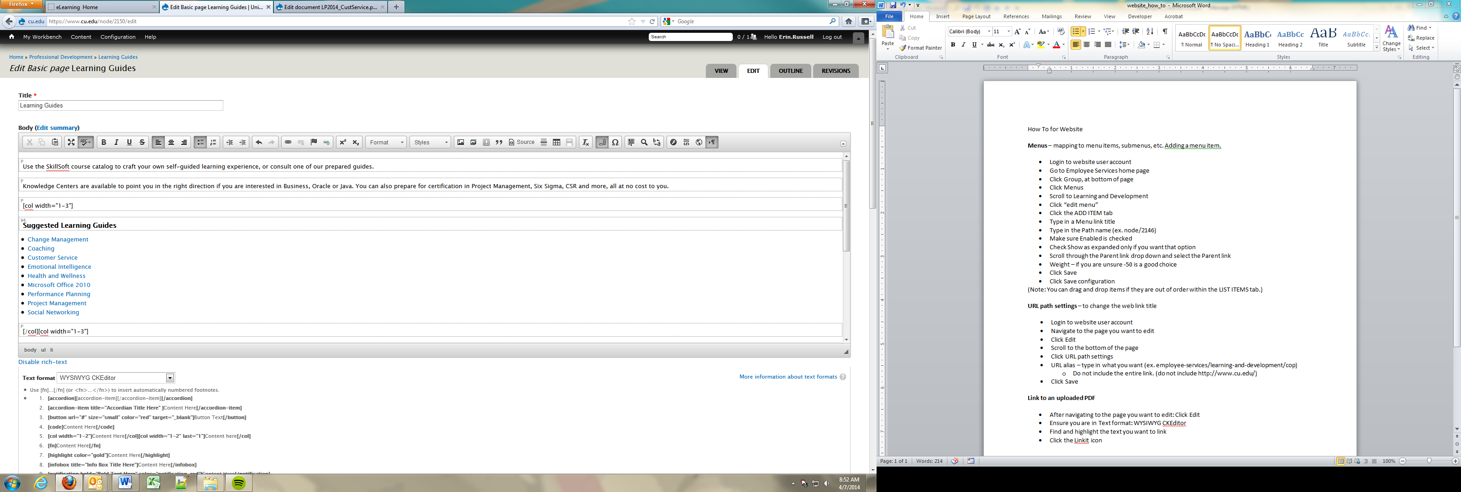
4. Select the **Target** tab
5. Use the drop down menu to choose the **New Window (_blank)** option
6. Select **OK**
7. Select **Save**

## Menus

Note: Most users will not have permission to add items to menus. For assistance, contact your support. When you add an item to the menu, the content inventory must be updated.

**Menus** – mapping to menu items, submenus, etc. Adding a menu item.

1. Go to the Admin menu
2. Select **Structure**
3. Select **Organic Groups Menus**
4. Find the menu you would like to alter. In this example, we will add a menu item.
5. Select the **ADD ITEM** tab
6. Type in a Menu link title
7. Type in the Path name (ex. node/2146)
8. Make sure **Enabled** is checked
9. Check **Show as expanded** only if you want that option
10. Scroll through the **Parent link** drop down and select the Parent link
11. Weight – if you are unsure -50 is a good choice
12. Select **Save**
13. Select **Save configuration**

(**Note:** You can drag and drop items if they are out of order within the **LIST ITEMS** tab.)

### 

### Reorder Menus

If all menu items already exist, and only need to be reordered use these directions.

1. Navigate to Employee Services home page
2. Select **Group**
3. Select **Menus**
4. Find Menu of Interest
5. Select **list links** next to menu
6. Click on **Menu Link** the item you would like and click **Edit**
7. Scroll through the **Parent link** drop down and select the Parent link
8. Weight – adjusting numbers will allow you to adjust the position of items within a submenu
9. Select **Save** once menu is in new order

### Side Menus

Side menus are used to navigate through a specific section of the website by the user.

1. Navigate to the Employee Services home page
2. Select **Group**
3. Select **Menus**
4. Select **list links**
5. Select **add item**
6. Input node number into Path
7. Select Parent link from drop down menu
8. Set Weight (If unknown set to -50)
9. Select **Save**

## Moving Documents from Sandbox to the Live Site

When doing a big project, it may be beneficial to build the page in Sandbox first to test and work through development without having the page live for anyone to see. Once the page is done, it must be transferred to the live site for users to be able to access it.

1. Select **Content**
2. Select Add Content> **Basic Page**
3. Input title of page
4. Copy HTML code from Sandbox page
5. Click **source** in toolbar on live site
6. Paste HTML code into Live Site page
7. Select **Publishing options**
8. Click published checkbox
9. Select **Save** (do NOT change back to WSYWIG)

### Unpublished Pages

When a page is under major changes it can be beneficial to unpublish the page so users cannot see it until the changes are done.

1. Select **Publishing options**
2. Uncheck Published
3. Select **Save**

### Things that need to be checked

* URLs from old code
* Pictures

## PDFs

### Document pages

Many documents on the website are kept in document pages. This makes updating documents easier. Once example is the CU Training Matrix (<https://www.cu.edu/docs/cu-training-matrix>).

To create a new document page:

1. Go to a current document page
2. Click **CLONE CONTENT**
3. Change Document Admin Name
4. Change Document Display Name
5. Change Document Description
6. Click **Remove** to remove current document
7. Click **Choose File**
8. Find and select new document
9. Click **Upload**
10. Change Document tags (suggest max 5)
11. Change Search Keywords
12. Click **Save**

### Uploading a PDF

To add a PDF file to a database:

1. Scroll over **Content** in the top, black bar
2. Select **Files**
3. Select **+ Add File**
4. Select **Browse…** and find file to upload
5. Select **Open**
6. Select **Upload**
7. Select **Next**
8. Select **Next** again
9. Select **Save**

### Link to an Uploaded PDF

1. Navigate to where the PDF will be linked
2. Select **Edit**
3. Ensure you are in Text format: **WYSIWYG CKEditor**
4. Find and highlight the text you want to link
5. Select the **Linkit** icon  
    
   * Note there are three icons and this one is the third one.
6. Begin typing the title of the PDF in the **Search content** bar.
   * Use the drop down menu to select the PDF you want.
   * The **Target path** bar will be populated.
7. Select **Insert link**
8. Highlight the new link
9. Select the **Link** icon   
   
10. Select the **Target** tab
11. Set the target to **New Window (_blank)**
12. Select **OK**
13. Select **Save**

### Logging an Uploaded PDF

It is important that all information is kept up to date. In order to track the age and location of the information on the website, uploaded files are logged.

1. Find the node number
   1. Found under **Edit** of that file on the website
   2. Launch **Edit** from the **Contents** page

If the file was updated and the old file was deleted…

1. Change the node number (if applicable)
2. Update the upload date
3. Save file

If a new file was added or the old file was not deleted…

1. Input all data
   1. File name
   2. File format
   3. Upload Date
   4. Link location
   5. Link name
2. Save file

If the old file is no longer being used on the website, locate it on the **Current Forms tab** then **Cut** and **Paste** it to the **Retired Forms tab.** In the notes column, please leave a details reason for its removal, as well as your name, for future reference.

**ELD-specific instructions:** If the old file is no longer being used on the website, delete it from the spreadsheet and website, and archive the file in the website folder.

## Redirects

Redirects are used if a new webpage has been created (with a new URL) that is replacing a retired page. When the old page is accessed it will forward the user to the new URL.

1. Open the new published webpage
2. Select **Edit**
3. Select **URL redirects**
4. Select **add URL redirect to this content**
5. Copy and paste old site link or node ID into From box
6. Select **Save**

## 

## Tabs

Tabs allow the user to see and switch between different categories of information easily.

### Inserting a Tab

1. Open page
2. Select **Edit**
3. Go to where you want to insert the tab
4. **Start tab with [tabs]**[tab-item]
5. Add text to the body
6. End tab with [/tab-item**][/tabs]**
7. **Select Save**

### Inserting another Tab

1. **Open page**
2. **Select Edit**
3. **Go to where the last tab ended with [/tab-item]**
4. **Start second tab with [tab-item]**
5. **Add what you want the tab to say**
6. **End tab with [/tab-item]**
7. **Close the tabs with [/tabs]**
8. **Select Save**

### Titling a Tab

1. Open page
2. Select **Edit**
3. Go to where the tab starts
4. After the tab is started add [tab-item title=”______”]
5. Be sure the tab is closed with [/tab-item][/tab]
6. Select **Save**

## Toggles

To create a toggle:

1. Open page where the toggle will be
2. Select **Edit**
3. Start toggle with [toggle][toggle-item title=””]
4. Add text
5. Close toggle with [/toggle-item][/toggle]
6. Select **Save**

### How to Nest Toggles

Each item in a toggle is the step under the main heading of the accordion. Nesting toggles are toggles underneath an initial toggle. They can be used to further break down information.

1. In line with the text for the first toggle add [toggle][toggle-item title= “Title”]
2. Add text to the toggle in paragraph box underneath
3. Close nestled toggle with [/toggle-item][/toggle]

The original toggle is open and both need to be closed for the nestled toggles to work. The structure will be similar to this:

[accordion][accordion-item title=”Example”]

[toggle][toggle-item title= “1st layer”]

[toggle][toggle-item title= “2nd layer”]

[/toggle-item][/toggle]

[/toggle-item][/toggle]

[/accordion-item][/accordion]

There are two lines of [/toggle-item][/toggle] because there are two toggles to close. “2nd layer” is nestled under “1st layer”.

In the CKEditor the code for nestled toggles looks like this:

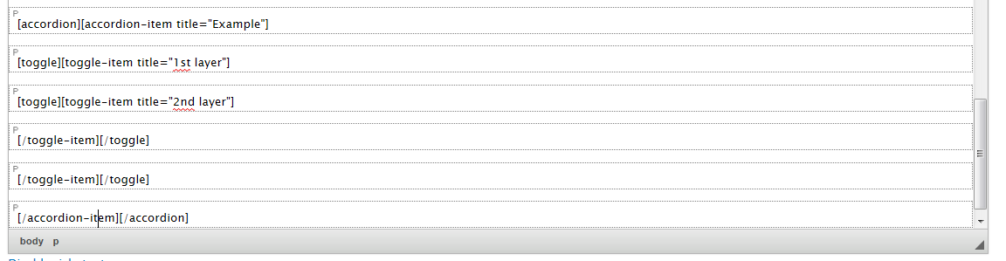

On the webpage this code looks like this:

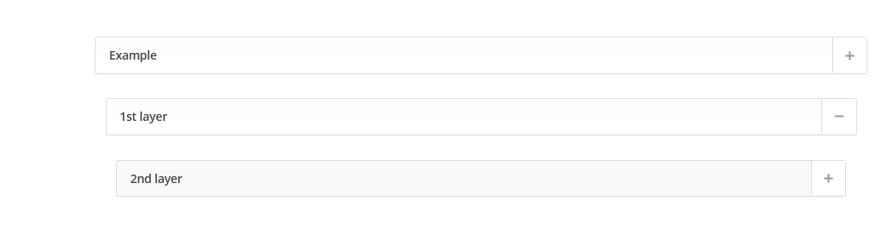

Accordion

1st Toggle

2nd Toggle

## 

## URL Path Settings

Although it is possible to do URL Path Settings it is **not** allowed. If the URL Path needs to be changed please contact Jon Arnold ([jon.arnold@cu.edu](mailto:jon.arnold@cu.edu)) for assistance.

URL Path Settings are used to generate a URL alias by which the page can be found. The URL alias is automatically set when the page is created. If it is necessary to change the automatic alias created please contact Jon Arnold.

## Videos

Many videos on the website are hosted on an external server. To have them saved on the server, contact Jon Arnold ([jon.arnold@cu.edu](mailto:jon.arnold@cu.edu)). Large videos will not be able to be attached to an email. To share these files with Jon, first upload them to Google Drive.

1. Go to drive.google.com
2. Log on   
   Email: [cu.eldstudent@gmail.com](mailto:cu.eldstudent@gmail.com)   
   Password: ELDWelcome
3. Right click on folder or file
4. Click **Get shareable link**   
   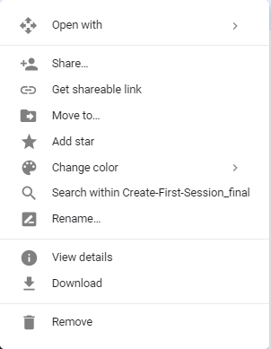
5. Include this in the email to Jon

## Website Banner Menu

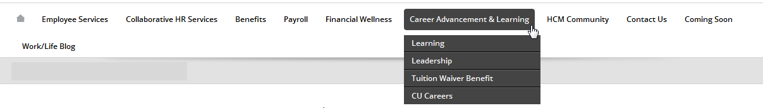

The website banner menu is the ribbon menu at the top of the university web page. Erika Floyd ([Erika.floyd@cu.edu](mailto:Erika.floyd@cu.edu)) and RyAnne Scott ([ryanne.scott@cu.edu](mailto:ryanne.scott@cu.edu)) have permission to edit this banner. If changes need to be made to this menu, contact them personally or Communications ([ES.Communications@cu.edu](mailto:ES.Communications@cu.edu)).