Search within Grainger Punch-out by entering keywords into the search field e.g. screw:

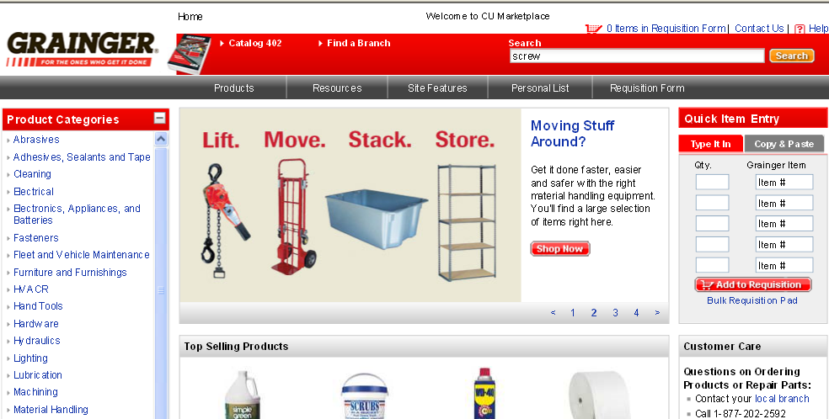

Select an item by clicking on the below icon or link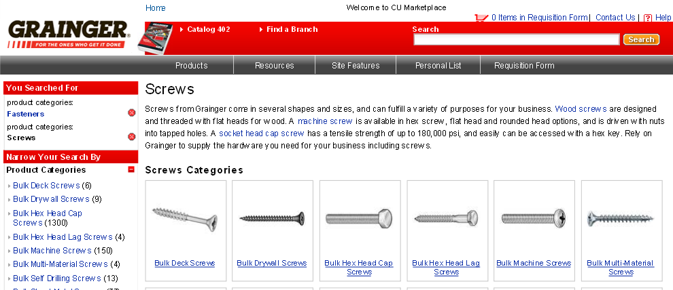

You can add the item to your cart by clicking

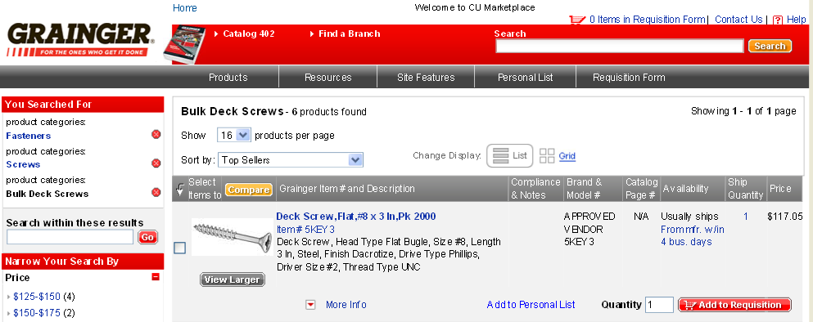

Now you can review your cart by clicking

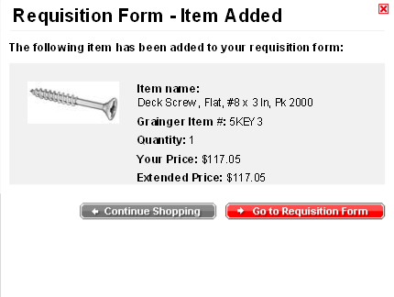

After you review the contents of your cart you can click

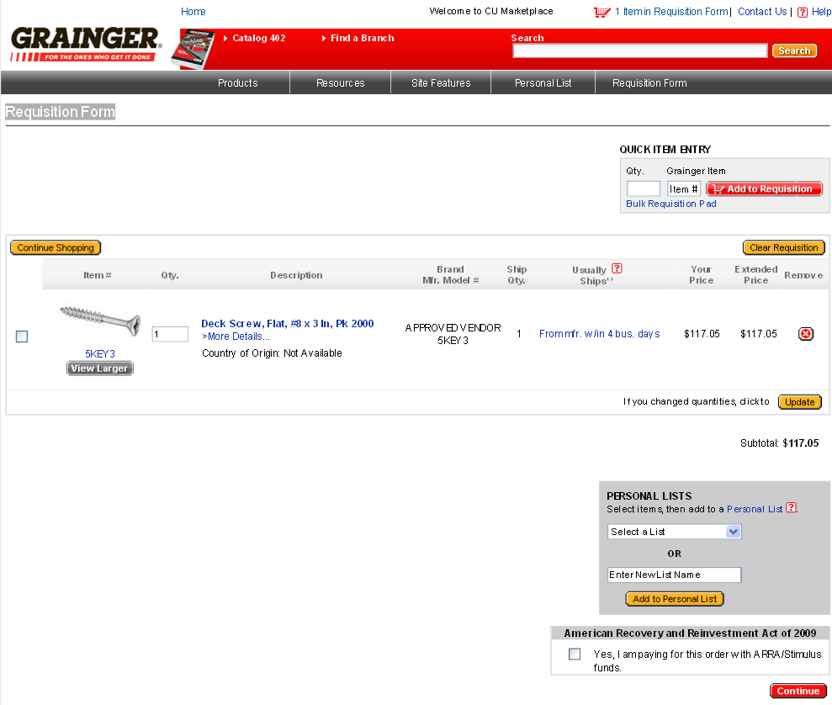

The final step is to click and the cart will be sent back to CU Marketplace

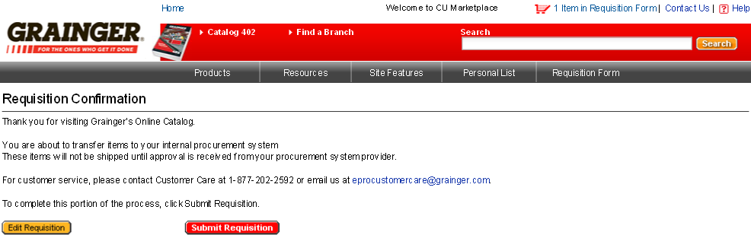

Success! Now your Grainger cart is back in CU Marketplace and you can submit your cart or assign it accordingly!

Don’t forget to “name your cart”!

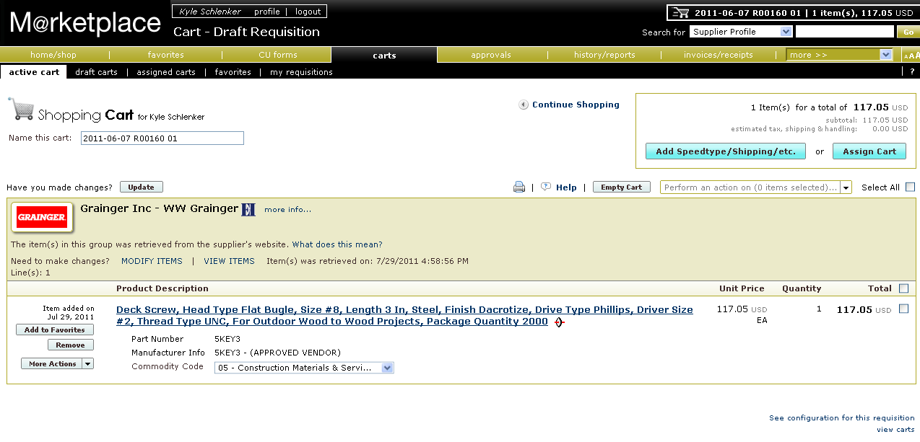
To modify item quantities or add additional products to this order click the link. You will be transmitted back to the Punch-out where you can add or delete items and then go through the same check-out process outlined in this user-guide.

Ordering Grainger Quotes Electronically:
If a Grainger Sales representative has provided you with a quote for goods you can retrieve and order that quote using the Grainger Punch-Out Catalog located on the CU M@rketplace shopping homepage.

If you’ve been provided with a quote from the Grainger Sales team they will send you an email notification that includes the quote number. This quote number will be used to purchase the order electronically from the Grainger Punch-Out.

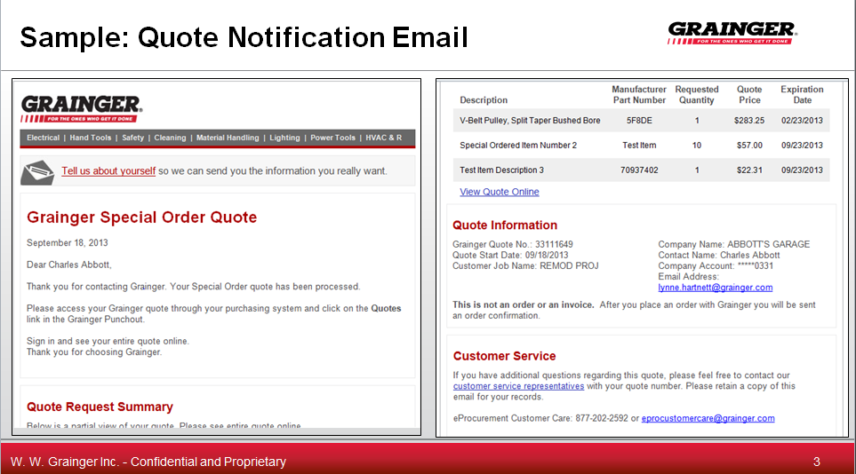

Once you’ve received your quote notification email navigate to the Grainger Punch-Out Catalog.

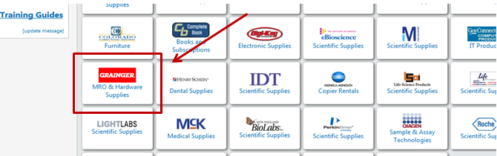
After entering the catalog look for the “Quote” label located on the dark gray ribbon at the top of the page and click on “Catalog Products” or “Special Order” depending on your type of quote.

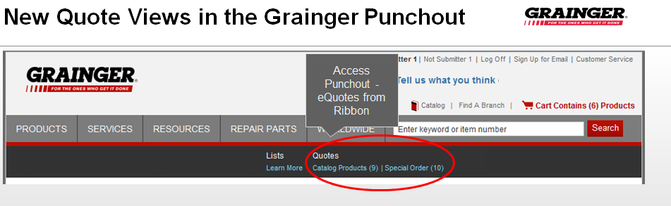

Next select “Quotation Number” from the drop down menu on the left hand side of the screen if it is not already selected then type the quote number in the text field to the right of the drop down menu, and click search:

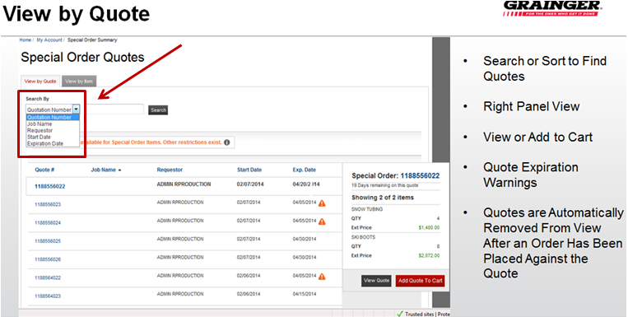

Make sure to take note of the expiration date listed for your quote to ensure there’s enough time for you requisition to be approved if such approval is required.
Once you’ve found your quote click on the actual quote number highlighted in blue on the left hand side of the screen. The next page that populates will be a detailed breakdown of the quote.

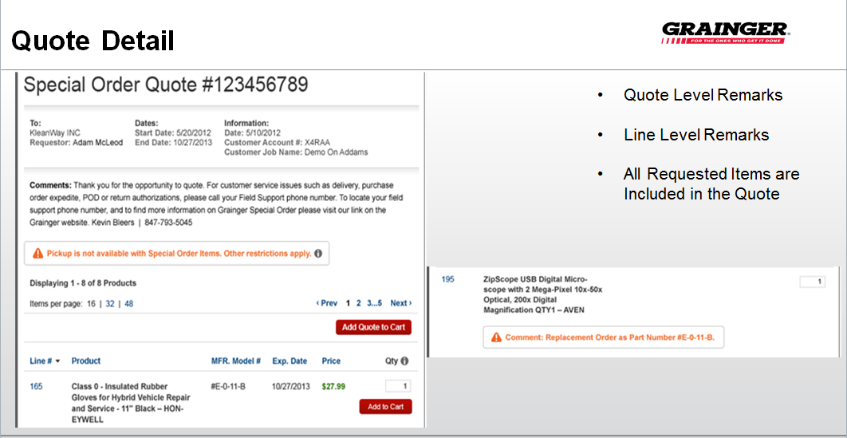

From here you can add the entire quote to your cart by clicking on “Add Quote to Cart” or you can add individual items by finding the item and clicking the “Add to Cart” button located under the quantity field.

Once you’ve selected an “Add to Cart” button you will be directed to your Grainger shopping cart. You will have the opportunity to change quantity in both the quote detail field and in the shopping cart; however, you won’t be able to reduce the quantity quoted, you can only increase it.
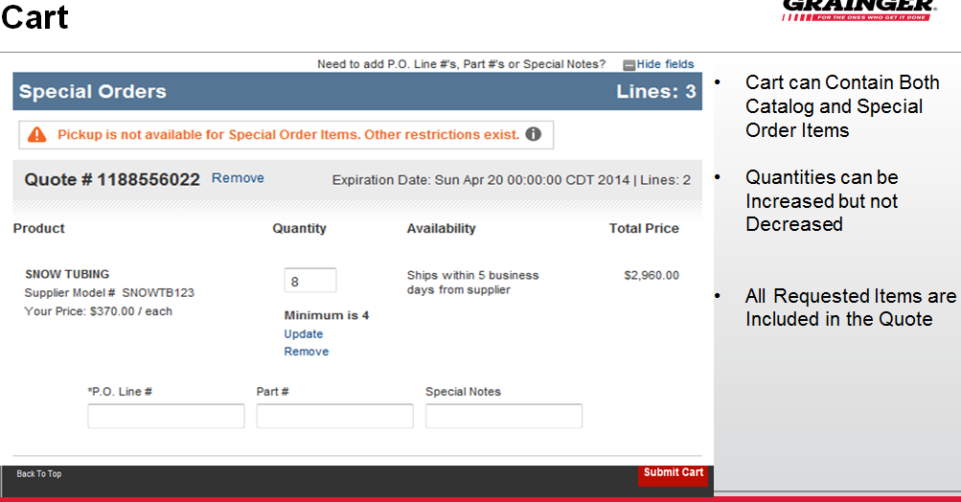

Once you’ve made any needed adjustments and you’re ready to checkout within Marketplace click on the “Submit Cart” button. From here you can enter your speedtype(s), shipping address, and submit or assign the cart for approval.

