Cvent Attendee Management

Cvent, Inc.
1765 Greensboro Station Place
McLean, VA 22102
www.cvent.com
customercare@cvent.com

U.S. and Canada (toll-free) – 866.318.4357
UK (toll-free) – 0808.234.4543
Australia (toll-free) – 1800.502.472
All others and local – 703.226.3535
International Numbers available here

Table of Contents
CVENT SUPPORT RESOURCES 2
Online Resources 2
Customer Care 2
EVENT DETAILS 2
Event Templates 2
Express Event Template 2
Standard Event Template 2
Creating an Event 3
From Template 3
From Scratch 5
Salesforce integration 6
Creating agenda items + fees 6
WEBSITE AND REGISTRATION 9
Event Website 9
Pages 9
Layout 10
Theme 10
Registration 12
Registration Settings 12
Registration Pages 12
Registration Questions 13
Badges 15
PROMOTION AND COMMUNICATION 15
Weblinks 15
Editing Automated Emails 16
EVENT LAUNCH 16
Event Approval 16
Launching the Event 17
INVITEE MANAGEMENT 17
Managing Registrants 17
Registration Modification 17
Planner-Side Registration for VIPs 18
Registration Cancellation 19
Marking Participants 20
Importing Participants 20
REPORTING 21
Standard Reports 21
Adding Reports to a Parked Group 22
TESTING 23
Moving to Test Mode 23
Testing the Event Yourself 24
Sending Scenarios to Others 24

CVENT SUPPORT RESOURCES

Online Resources
Cvent has excellent customer support and online help articles. You can access the community by clicking the Community link at the top of any page in Cvent.

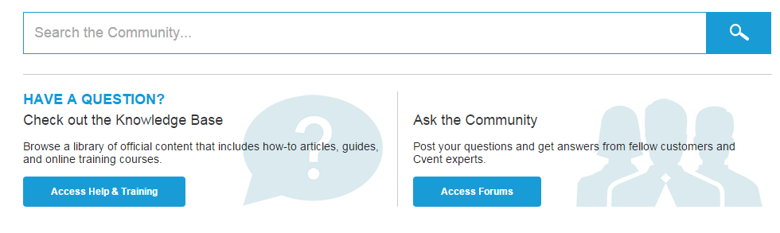

Customer Care
Customer Care is available 24/7 to answer your questions. You can reach them by chat or by phone at any time by clicking the blue Get Help Now button at the bottom of the Community page.
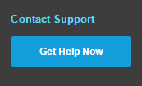

EVENT DETAILS

Event Templates
There are event templates available for your use that have already been configured with basic functionality and CU branding. If you are not sure which template to use, consult with your eComm specialist.

Express Event Template
The Express Event template is a streamlined registration process where all participants will have the same experience. This template does not offer sessions, registration paths or fees.

Standard Event Template
Use this template for more complex events, such as multi-day events, events with multiple sessions, complex fee structures, and/or different attendee types.

Creating an Event

From Template
- After you login to your account, select Events from the Solutions drop down on the top.
- Click on Create Event on the right of the page. This gets you into the Event Creation Wizard.
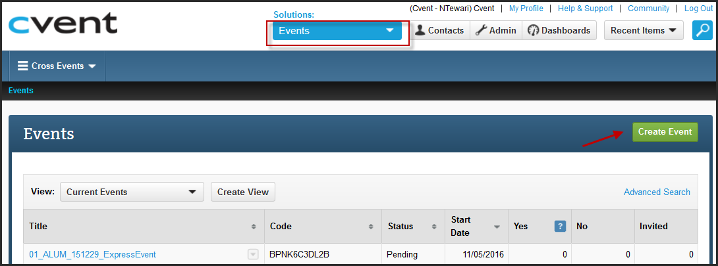
- Choose the Creation method. To use the template, select the second radio button and choose from the templates saved in your account by clicking on the ellipsis.
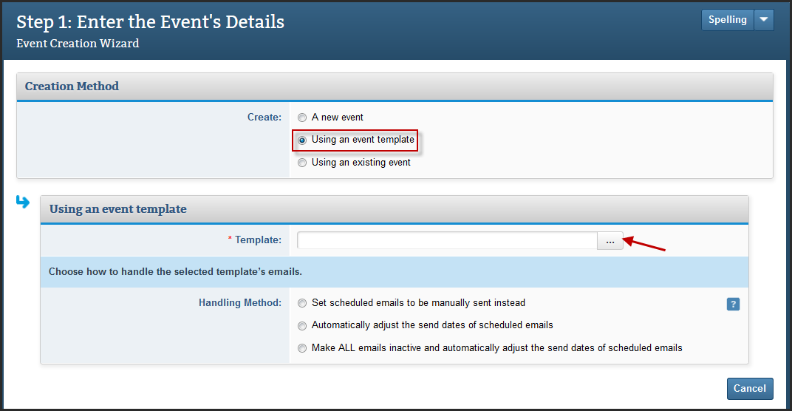
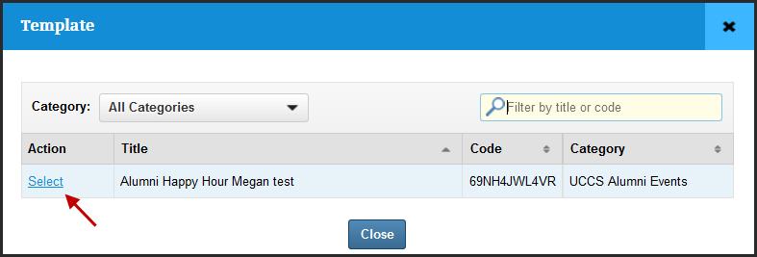
- Complete the required fields: The title tops almost every page on the website and throughout the registration process. Select a category. The description, location, and date display by default on your event's summary page.
- Set the time zone to match the venue. Select the dates and times in the When section. The Registration Deadline is the last day invitees will be able to register.
- In the Event Planner section, enter the planner's first and last name. This will appear by default in the From Name field of event emails by way of data tags.
- Step 2: To turn on features related to event details, check the boxes to the left. Don't overlook the sub-settings in the ones that require more information.
- If you are not sure what the feature is, hover over the to the right of its name. Go through each section. Once you're done, click Next.
- Do the same for Website and Registration, then Promotion & Communication.
- Click on Finish once you have selected all the features you want in your event. You can come back and add/remove the features later in the lifecycle by accessing Event Configuration under Event Details.
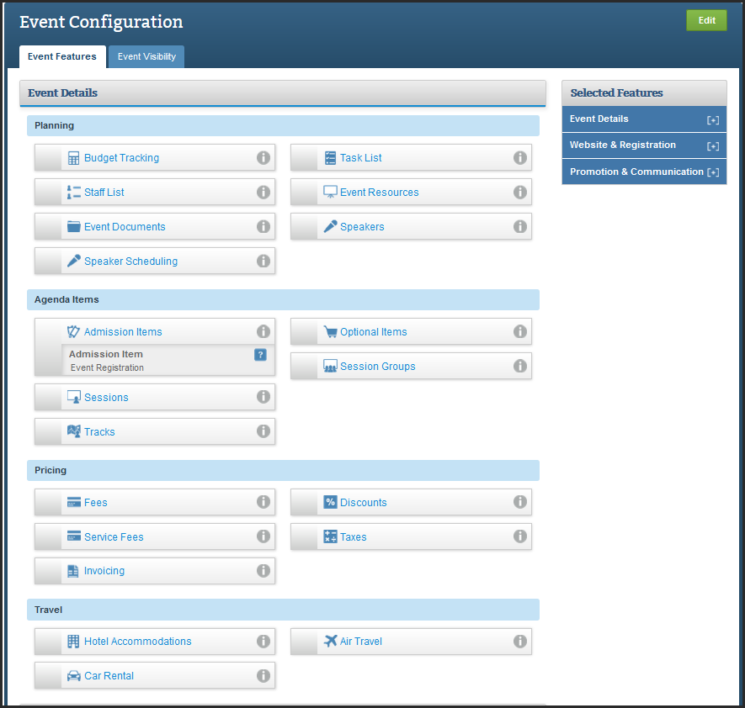
- You will see a progress bar like the one below and once it is 100% complete, you will land on the Overview page of your event.
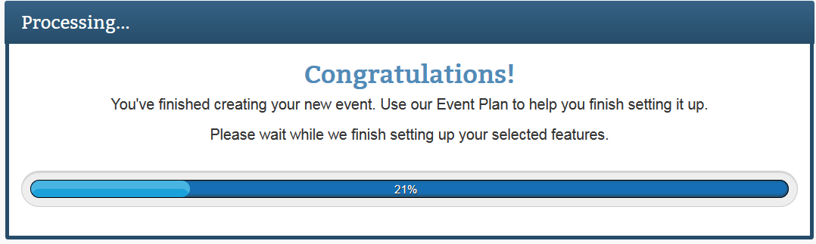

From Scratch
- Select Events from the Solutions drop down on the top of your account screen.
- Click on Create Event on the right of the page and then select your event type. This gets you into the Event Creation Wizard.
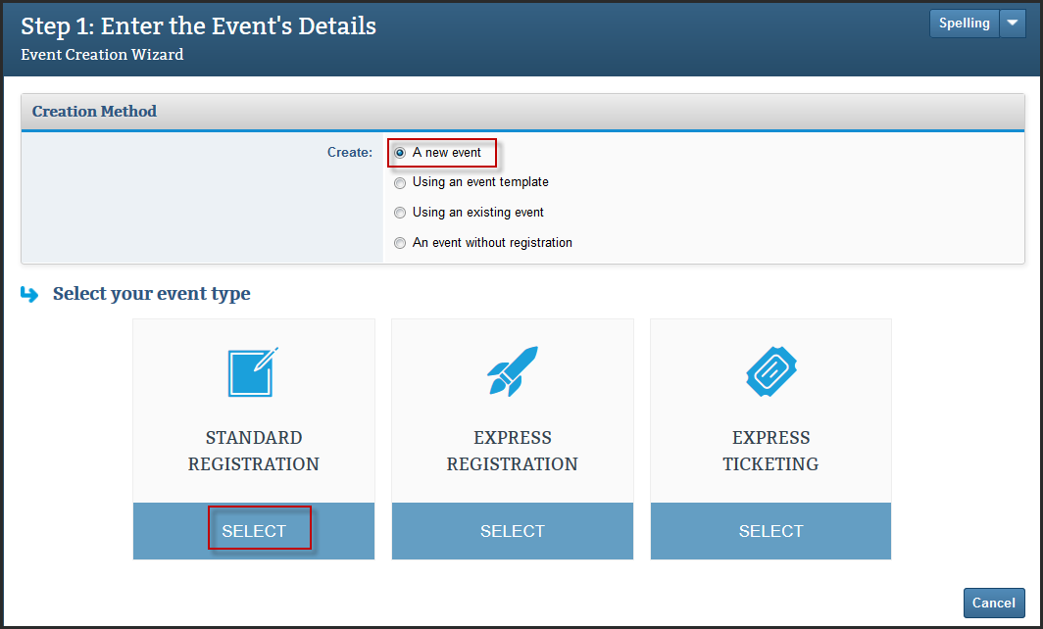
(Standard Registration: These are events for all types of attendees using features like sessions, registration types, waitlists and more.
Express Registration: Simple one click registration forms for attendees to register through.
Express Ticketing: Create tickets and offer attendees a streamlines way to purchase them.)
- Enter the event details like the Basic Information, When, Where, Event Planner and Custom Event Fields (if any).
- Complete the required fields: The title tops almost every page on the website and throughout the registration process. Select a category. The description, location, and date display by default on your event's summary page.
- Set the time zone to match the venue. Select the dates and times in the When section. The Registration Deadline is the last day invitees will be able to register.
- In the Event Planner section, enter the planner's first and last name. This will appear by default in the From Name field of event emails by way of data tags (You can change this when editing the emails).
- Step 2: To turn on features related to event details, check the boxes to the left. Don't overlook the sub-settings in the ones that require more information.
- If you are not sure what the feature is, hover over the to the right of its name. Go through each section. Once you're done, click Next.
- Do the same for Website and Registration, then Promotion & Communication.
- Click on Finish once you have selected all the features you want in your event. You can come back and add/remove the features later in the lifecycle by accessing Event Configuration under Event Details.
- You will see a progress bar like the one below and once it is 100% complete, you will land on the Overview page of your event.

Salesforce integration
When you send your event for approval, your campus eComm specialist will set up the Salesforce integration for the event.

Creating agenda items + fees
- You can build you agenda by creating multiple sessions. To create Sessions, go to Event Details and then under Agenda Items, you will see Sessions.
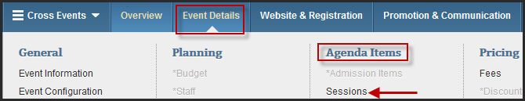
- Click on the green button that reads Create Session at the top right of the page.
- Enter the Session’s Details – Fill in the details like the Session Name, Start and End Date and Time and Description (if needed). Also select the Availability – Included or Optional.
  - (Included Session – it is a part of a registrant’s agenda by default once he completes his registration and cannot be charged for.
  - Optional Session – the registrant can choose if he wants to attend that session and planner can change for optional sessions.)
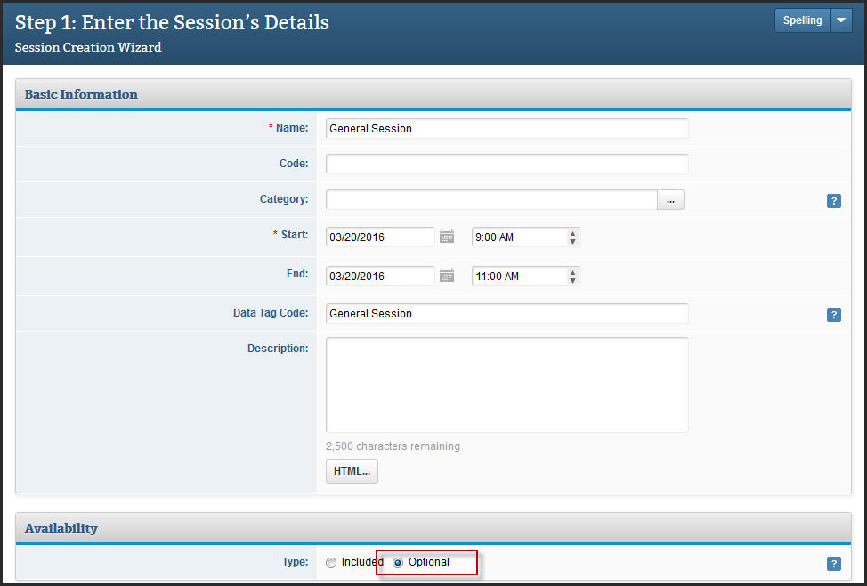

- You can also put a Capacity on the session or an Auto Close Date (after which the session is not available for registration).
- There is also an option to enable a Waitlist so registrants can show they are interested in a session after it has reached its capacity by adding themselves to the waitlist.
- Select if you want to display this session on the Agenda page on the event website along with the session times.
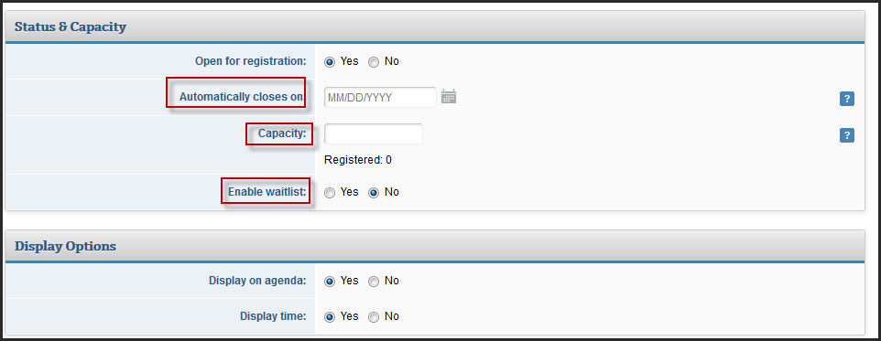

- You can also set up a fee for the session, it can either be a simple fee or an advanced fee with refunds and discounts.
Simple Fee
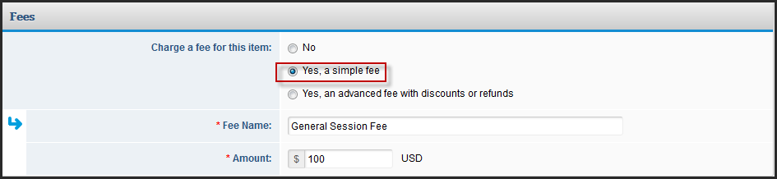
Advanced Fee
Early Bird Pricing: It is a discounted price that invitees can pay for registering if they register before a set date.
Refund Policy: The amount an invitee is eligible to get back in cases of cancellation until a set date)
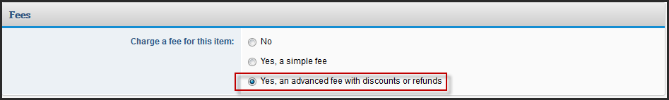
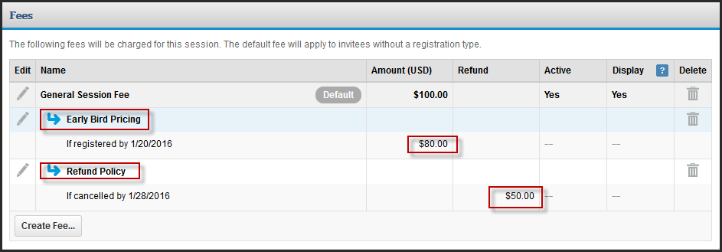
- Click on Finish & New to create more sessions and Finish when you do not want to add any more sessions.
- If you have a lot of sessions in an excel file, adding them one by one can be a task. They can be added in bulk using Import under Actions. Just follow the import wizard and you will be able to add them in one go.
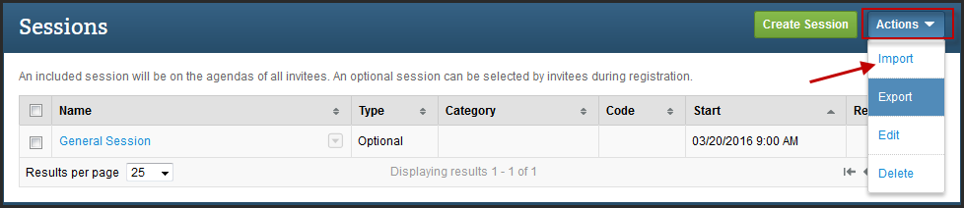

WEBSITE AND REGISTRATION

Event Website
- Go to Website & Registration on the top blue navigation bar and under Website, click on Event Website.
- It is divided into three tabs – Pages, Layout and Theme.

Pages
- It has a list of website pages that will be displayed on the event website. You can Preview them by clicking on the little eye icon next to the display slide bar.
- You can choose to make a page inactive and not display it on the website by simply clicking on the display slider. The ones that have a green check are the ones that will show up on the website.
- You can also create your own Custom Pages by clicking on Create Page on the right side on the page.
- Click on any of the standard pages to customize the content. All the pages are enabled with HTML Editor. Click on Save on each page after making your changes.

Layout
- You can select the layout at the top and also choose between the different navigation styles.
- You can customize the Header and Footer on this page that goes well with your branding guidelines. The header width is either 790px or 950px depending on the layout you choose.
- Also there is an option to customize the text for the Register button as well as the placement.

Theme
The event templates are already configured with the CU colors. If you need to make adjustments to the website theme, please refer to the CU branding guidelines.
- You can choose from the various themes available by simply clicking on Change Theme. The Button Format can also be changed and you can even choose not to display the Progress Bar.
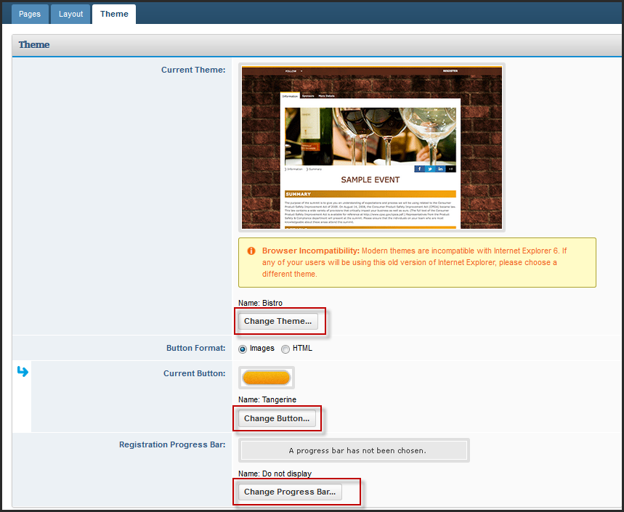
- Under the Display Options, you can change the Date & Time Format and even the Text Font and Size.
- Under the Website Design, you can update the hex values for the different section in the website to suit your branding or if you have someone that can support CSS, you can go for Advanced Mode and fully customize the website experience.
- Click on Save after making your changes.
- Click on Preview to assess your changes and walk through the event website pages.

Registration

Registration Settings
- Go to Website & Registration and under Registration, click on Registration Settings.
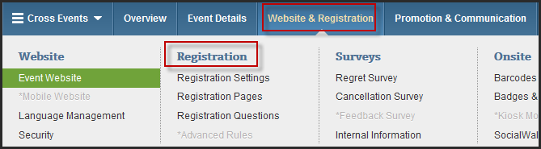
- It is divided into different sections that control various aspect of registration experience.
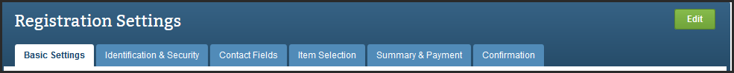
(Basic Settings: Allows you to enable or disable registration modifications and cancellations along with date and time format during the registration. It also helps you place any Terms & Conditions that registrants have to agree to before they can register.
Identification & Security: This section helps you decide if they want everyone or a pre identified list of people to register for the event. Also it helps you choose a key identifier to be used for registration like an email address.
Contact Fields: This is what the registrants will see and fill up during their registration and this information gets stored in your address book. You can choose between standard and custom contact fields to be displayed here.
Item Selection: It helps you choose what aspects of agenda items (code, descriptions and capacity etc.) should be displayed to the registrants.
Summary & Payment: You can set up the payment options available to the invitees (if the event has a fee enabled).
Confirmation: This is where you choose the Actions available to the registrant after he has completed the registration as well as his registration related information.)
- If you want to have a different experience for different registration types (different payment options, information on registration pages or different contact fields etc.), you can create multiple registration paths. Simply click on Create Registration Path on the top right of the Registration Settings page.

Registration Pages
- Go to Website & Registration and under Registration, click on Registration Pages.
- Here is the list of registration pages that the registrant will see during the course of his registration process.
- You can customize the content of these pages by clicking on the page and using the HTML Editor available when you click on Edit Section.
- You can also edit the Basic Settings like changing the name of the page, the way it appears on the website.
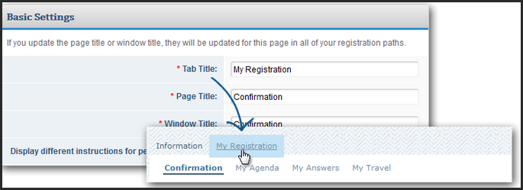

- Click on Save after making your changes.
- The number of pages that you see here may vary depending on the features enabled for your event.

Registration Questions
- Go to Website & Registration and under Registration, click on Registration Questions.
- Chose the correct question tab. You can create questions to gather information from your attendees in this section.
(General Questions: are for everyone that registers for this event. Where the questions appear during registration is determined on another page.
Admission Item Questions: will only appear for invitees that select that particular admission item after the Item Selection page.
Session Questions: appear when invitees select a session with questions associated to it. The questions will appear after an invitee selects their sessions, and clicks Next, unless admission item questions are set up and apply to the invitee. In that case, the session questions will appear after that.
Travel Questions: pertain to hotels and transportation, and will appear on the same page as the travel accommodations invitees are making. Determine if your invitees will see a request question that appears when they submit their accommodation or an alternate question when they decline travel.)
- You can either add questions on a one by one basis or pull a list of pre saved questions from your account library.
- Simply drag a question type from the left section to the middle of the page and then type your question and the answer options.
- You can choose from the different question types available. This information that you gather stays with the invitee at the event level and does not get stored in your address book.
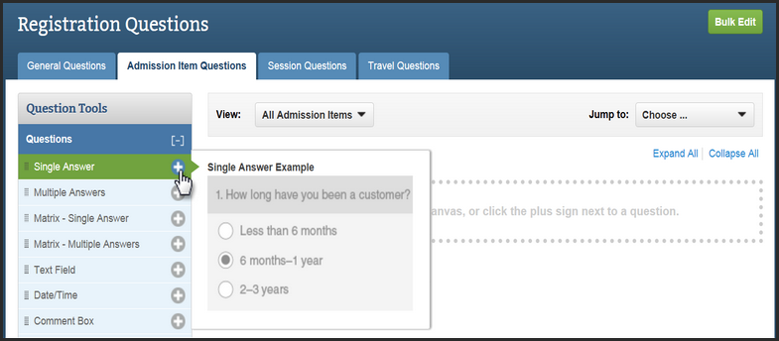
- When the pop-up appears, enter the question details. Options will vary depending on the selected question type.
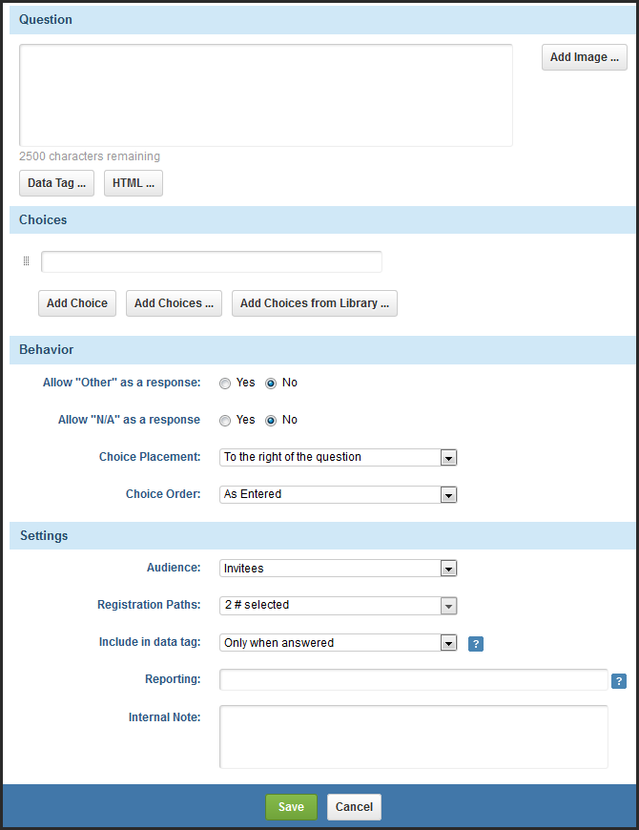

Badges
- Click on Badges & Certificates under Website & Registration > Onsite.
- Click on Create New on the right side of the page.
- Step 1: Enter the basic details like the Name, Type and Stock.
- Step 2: Design your badge choosing from Components and Data Tags from the section on the left.
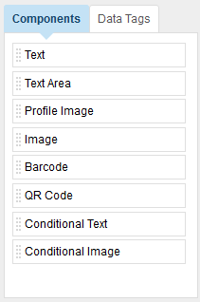

PROMOTION AND COMMUNICATION
As you are not using Cvent for email campaigns, you will be working on automated emails like Cancellation Confirmation, Modification Confirmation, Registration Confirmation.

Weblinks
- Go to Promotion & Communication in the blue navigation bar at the top and under Web, click on Weblinks.
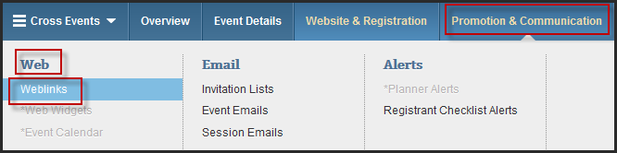
- You can also create custom links by clicking on Create Link at the top right of the page.
- The links that you see on the page can be sent to the invitees to direct them to a specific page (the links are only active once the event is launched).
- You can also track the origin of registration by adding a Reference ID at the end of the URL as this can be tracked with the help of an event level report.

Editing Automated Emails
- You will find Event Emails under Promotion & Communication > Email.
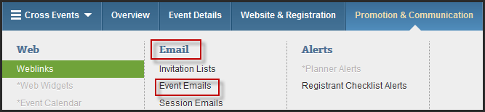
- You can also make the automated email (e.g., Registration Confirmation) inactive and it will not send.
- To edit an email, click on the email name and under Details, you can edit details like the Subject, From Name or From Email Address.
- To design the email, go to Content and click Edit.
- It is HTML enabled so you can completely customize the content. You can also inset hyperlinks, images and data tags (to personalize the emails for each invitee). The recommended width for email headers and footers is 600px.
- Click on Save to retain your changes.
- Preview will help you get a quick look on how the email looks like or you could do a test/manual send to receive the email.

EVENT LAUNCH

Event Approval
You will be required to send your event for approval before it can be launched. To send an event for approval:
- Go to Event DetailsEvent StatusClick the green Send for Approval button
- Select your approver, enter a message in the body field and send.
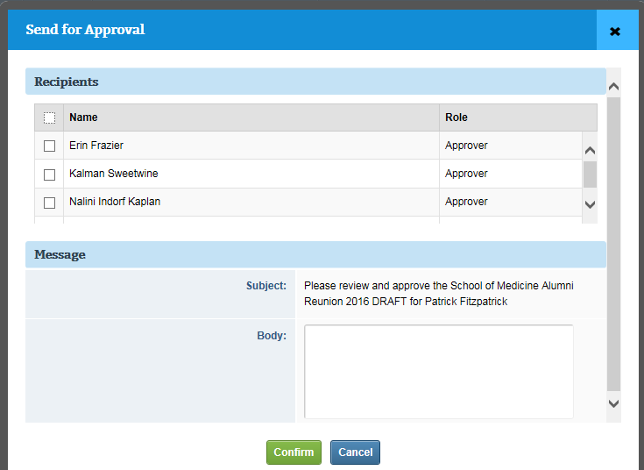

Launching the Event
Upon clicking Launch Event, the event will be moved to Active status, all test registrations will be removed and each accepted registration from here on will incur a fee per your agreement with Cvent.
You can now process online payments. Admission items, sessions, optional items, tracks, and any associated fees can no longer be deleted. However, you can prevent them from appearing during registration by deactivating them.
- Access the Event Status page. Begin by selecting your event. Hover over Event Details and, under General, click Event Status.
- Activate your event. Click Launch Event.
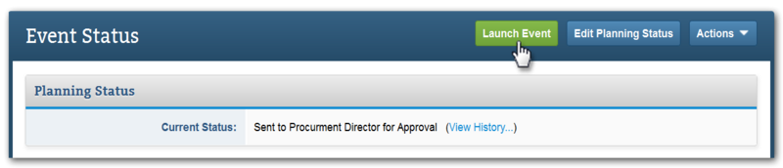
Select whether to keep or remove all email data used during Test Mode, then click Confirm.

INVITEE MANAGEMENT

Managing Registrants

Registration Modification
- Go to Invitee Management and under Manage, click Invitees & Registrants. Search for the registrant and click on the appropriate action for the registrant.
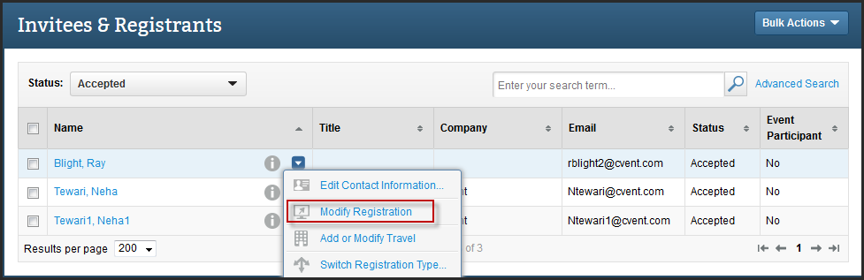
- You can modify the registration related details or the contact level information.
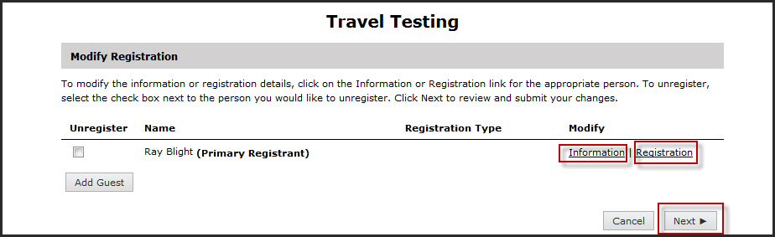
- You can also adjust the amount for your registrants to show a lesser amount due to or to record an offline payment.
- Click on Finish to confirm the modification.

Planner-Side Registration for VIPs
Some VIP attendees will be registered by the planner and they will not incur fees for attending the event. To remove fees while registering someone from the back end, follow these steps.
- Access the Register Invitee page. Begin by selecting your event. Hover over Invitee Management and, under Quick Action, click Register Invitee.
- Enter their basic information. Type in the invitee's first and last name, then click Submit.
- Register the invitee. Be careful with planner-side registration. Fields that are required for invitees are not required for you. For example, you can skip filling in an email address, but, if you do, the invitee won't receive any event-related correspondence. Click Next to continue through registration.
- Adjust the amount due, if applicable. If you want to charge this registrant less, or nothing at all, click the Edit Amounts link on the Submit Payment page (marked below). Enter a new amount in the Price field and click Save.
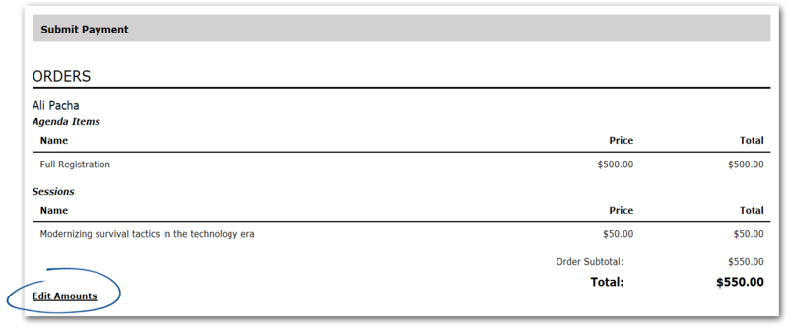
Select a payment method. Your choices include:
- No Payment finalizes registration without processing a payment or refund.
- Offline Payment records an offline payment immediately upon clicking Finish.
- Online Payment processes a credit card transaction immediately upon clicking Finish.
Check the box near the bottom to send a confirmation. To complete registration, click Finish.

Registration Cancellation
- Go to Invitee Management and under Manage, click Invitees & Registrants. Search for the registrant and click on the appropriate action for the registrant.
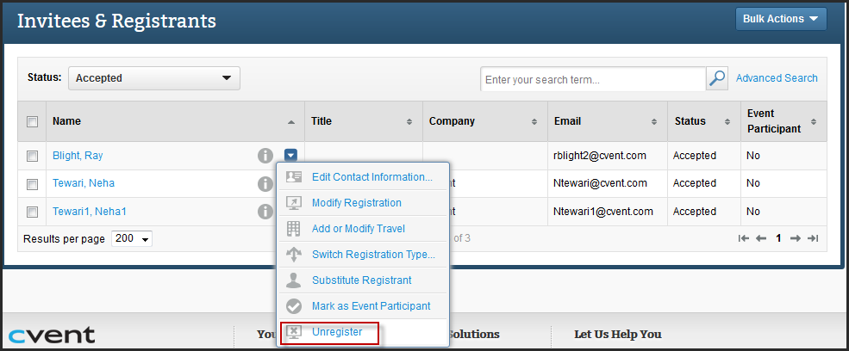
- You can choose not to send a cancellation confirmation to the registrant (even if the cancellation confirmation is inactive under email, the email will be fired off if the box is checked).
- Click on Finish.

Marking Participants
- Go to Invitee Management and under Assign, click Participation.
- Select the appropriate registrants by checking the box to the left of their name and click on Update Participation.
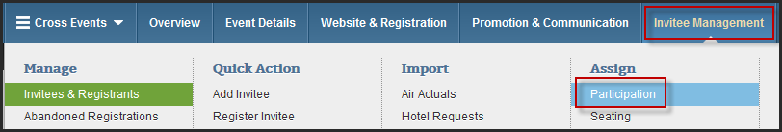
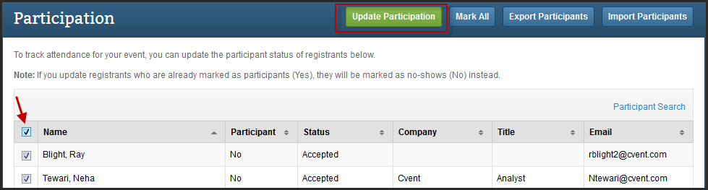
- The No will be changed to Yes and the Yes will be changed to No.

Importing Participants
- Click on Export Participants on the Participation Screen.
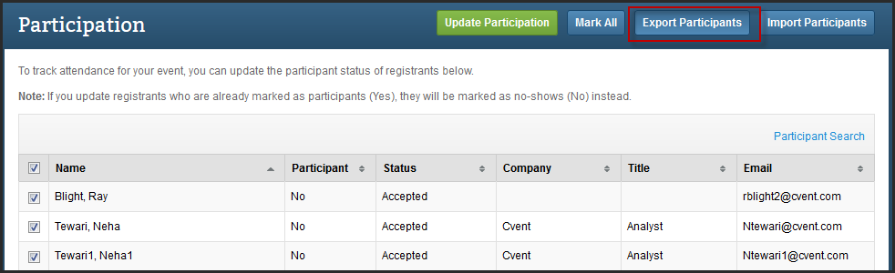
- You will get an excel file where you can make the updates to the Participant Status of the registrants. Once the changes are saved, click on Import Participants.
- Go through the Participant Import Wizard to upload your file and then map your columns to Cvent columns.
- Click on Finish to import the file.
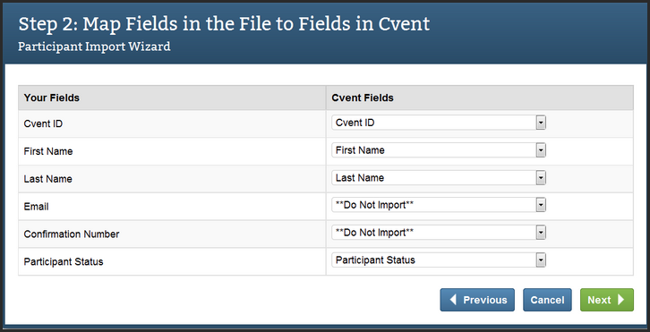

REPORTING

Standard Reports
- You can access them under Reporting> Reports> Standard Reports.
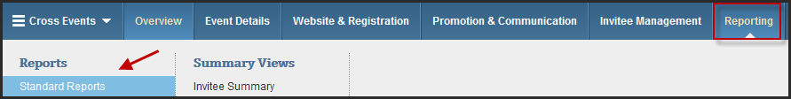
- Cvent provides with a list of Standard Reports categorized into headers such as Registrant Status, Registration, General Event, Email Reports etc.
- Apart from these standard reports, you can also create custom reports to customize the data you can get in a report.
- To know what data would a report return, click on the “+” icon to the left of the report and it would give you a description for that report.
- To run a report, click on the name of the report. You can define a date range for which you want to run the report along with the fields (columns) you would want to see. To narrow down your results, apply Advanced Filters at the bottom of the report.
- Click on Run Report. The report will be generated which you can further export into various formats like PDF, Excel etc.
- You can also save the report for later use.
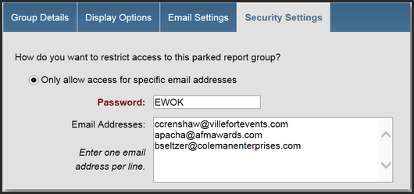
- When you save a report, make sure you have the end date in the future so that the report data is updated every time you run it.
- Also saved reports can be parked and added to a Parked Report Group that could be accessed by non-login users.

Adding Reports to a Parked Group
- Create a parked report group.
- Click on Admin in the top right, then click Reports in the blue navigation bar. Under Section Links on the left, click Parked Report Groups. Click Add in the middle of the page.
- Name the group for your reference. Enter the date your parked reports page will expire in the Auto Close Date field. No one will be able to access these reports once this date passes.
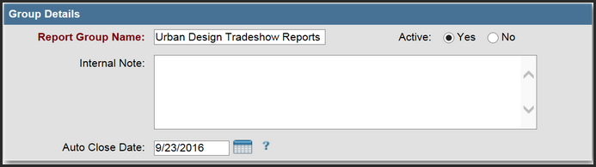
- Click Edit, then Add Report. When the pop-up appears, click Select to the left of the reports you want to include.
- You can also filter for reports by entering criteria in the Report, Source, or Report Type fields and clicking Search.
- Once you're done, click Save. Each report now appears as a link on the parked reports page.
- To upload a header image and add content to the parked reports pages, click the neighboring tab, Display Options.
- Click the neighboring tab, Email Settings. You can create an email with a link to the parked reports page and schedule it to remind recipients to check in for the latest data.
- Use the dropdown to select a From Email Address and enter a From Name in the appropriate box. Select the date, time, and frequency of when the email will go out.
- Include a subject line and consider adding a message in the appropriate textboxes. If you are requiring a password, include that information here as well. Click HTML to stylize the text or add images.
- Click Save.
- You can protect your reports page with a password and restrict access to specific email addresses or users by selecting the rightmost tab, Security Settings.
- Click Edit.
- To limit access to specific email addresses, select the first radio button option. Create a password and list the email addresses, one per line, in the appropriate textbox.
- Remember to include the password in the email message created in the Email Settings tab.
- If you've created any Report Users, select Only allow access for selected users and user groups. Then, choose Report Users from the dropdown and click the ellipsis (...) in the User or User Group text box when it appears.
- Click Select to the left of an existing user's name in the pop-up. Use the remaining dropdowns to add more users. Click New Line to add more dropdowns.
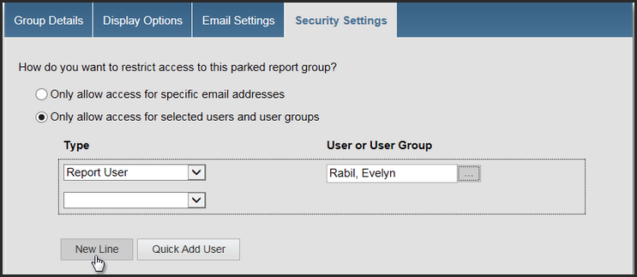
- Further limit access by specifying which IP addresses (codes that identify a computer network) can log in to the parked reports page. Select "Yes, also restrict by the specified IP addresses" and list the IP addresses, separated by commas, in the following format: 123.4.5.6.
- In the last textbox, you can edit the text that appears when people have been denied access to the parked reports.
- Click Save.

TESTING

Moving to Test Mode
Moving an event to Test Mode allows you to accept up to 100 test registrations and send up to 100 emails. Take full advantage of this to guarantee everything is customized to your needs before opening your site to invitees. Once an event is launched, all registrations, including those that were denied approval or cancelled, will count towards your contract number.
- Access the Overview page. Begin by selecting your event.
- Move your event to Test Mode. Click Move to Test Mode.
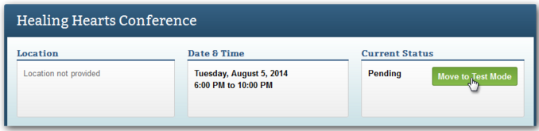
- A confirmation screen will appear. Click Confirm.
After moving your event to Test Mode, you can create unique testing scenarios to quickly evaluate different aspects of your event. Check the invitation that exhibitors receive, view your website through the eyes of a speaker, or experience registration as someone not in your Address Book. Best of all, you don't have to assess all that hard work yourself. You can get someone else to do it for you.

Testing the Event Yourself
- Customize your test profile, if necessary. Click My Profile in the top right. The User Information tab will open. Click the rightmost tab, Test Profile, then Edit.
A test profile is used exclusively for mock data during test scenarios. Once you initiate the test, the contact information entered here will be automatically pulled into the appropriate fields.
- Access the Overview page. Under Solutions at the top of the page, select Events, then open your event by clicking its name. Click Perform Test.
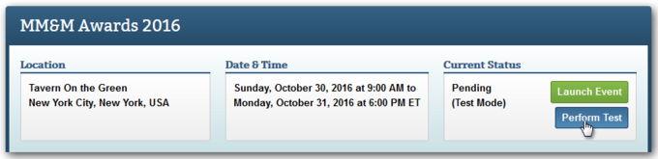
- Set the parameters. Choose what area of the event you want to test. Your choices include:
  - Email - Do not use this parameter. You will send your invitation through Marketing Cloud.
  - Website – Choose the generic weblink option and select a starting page.
  - Registration Process - If arriving to registration from a path-specific weblink, simply select the registration path. When you initiate the test, registration opens in a new window. Getting an error message? Weblinks won't allow you to register twice. Choose Cvent Email to get around this.
  - My Registration - Select a test registrant. You must have at least one to test the My Registration page.

Sending Scenarios to Others
- Add test users, if necessary. Want to send these scenarios to individuals without access to Cvent? You'll first need to add them as Test Users. Begin by clicking Admin in the top right. In the blue navigation bar, click Users.
  - Click Add User. Select Test User from the User Type dropdown. Test Users are not able to log in to Cvent. Their only access will be through the scenarios you send them.
  - Enter a username, first name, last name, and email address. Click Save.
  - You'll be taken to the User Information tab. Click the neighboring tab, Test Profile.
  - Click Edit to add information, then Save.
- Access the Overview page. Under Solutions at the top of the page, select Events, then open your event by clicking its name. Click Perform Test.
- Specify the recipients and set up the test email. Select “Email test scenarios to other people.” Choose the From Email Address. Then, click Add Recipient.
Choose Account User or Test User from the Type dropdown, check the box next to the appropriate user, and click Save.
- In the Scenarios section, choose what area of the event you want them to test. Just click Add Scenario... and your choices include:
  - Email - Do not use this parameter. You will send your invitation through Marketing Cloud.
  - Website - Choose the generic weblink option and select a starting page.
  - Registration Process - If arriving to registration from a path-specific weblink, simply select the registration path.
Explain the scenario to those testing in the Description textbox. Click Save.
