Event Registration:
View & Manage Registrations

Table of Contents
Introduction 3
View Registrations 4
Registration Views 5
View Summary Registration 6
View Full Registration 7
Modify Registrations 8
Cancel Registrations 10
Change Status 13
Process Credits & Refunds Requested thru Online Community 14
Apply a Credit Via CyberSource 16

Introduction

Event Registration is an online registration system that enables an admin to populate the Events Calendar with upcoming events as well as create an associated online application for each event to handle registration and/or item purchases, when applicable.

In this Event Registration: View and Manage Registrations training manual, you will find how to:
- View summary and full registrations
- Modify and cancel registrations
- Process Credits/Refunds
- Change Status of Pending and Processed Orders
- Use Cybersource to Apply Credits for orders older than 60 days

View Registrations

View Registrations
How to view registrations:

The Event list allows administrators to get a quick view of total orders/registrations, total amount of revenue, total credit requests, and open credit requests. The list of events can be filtered by all events (the default filter), ownership, payment processing status, activation status, archive status and calendar status. See figure 1.

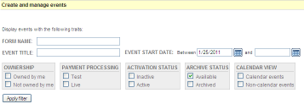
Figure 1

 | - Log into the Administration Center.  - In the top navigation mouse over Forms Management > Events and click on Create/Manage Events. The Event Registration application will appear. Locate appropriate form. | - Click the ACTIONS > Manage: Orders. The View & Manage Orders tab will appear. See Figure 3.  OR  In the ORDER TOTALS column click the number of orders placed.  - The View & Manage Orders tab will appear. See figure 3.
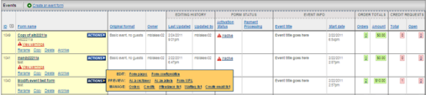
Figure 2

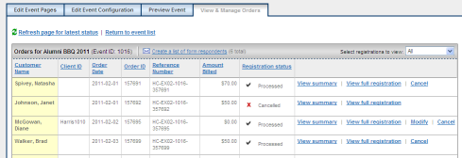
 |  | Figure 3

Registration Views
Registrations can be viewed in Summary version or in Full Registration version. See figure 4.

Registration View | Information Displayed
View Summary is a snapshot of the registration. | - Event Title, Order ID, Reference Number, Order Date  - Registration status, Payment Method  - Customer Name, Email Address, Class Year (if available), Client ID (if available)  - Description and Quantity of Event items ordered, Grand total dollars
View Full Registration displays the entire registration. | - All fields above, plus  - Personal Information, Billing Address, Home Address (if available)  - Event Details, Attendance list flag  - Payment Information
Figure 4
View Summary Registration
How to view Summary Registration:
- Log into the Administration Center.  - In the top navigation mouse over Forms Management > Events and click on Create/Manage Events. The Event Registration application will appear. Locate appropriate form.  - Click the ACTIONS > Manage: Orders. The View & Manage Orders tab will appear.  - Click on View Summary link for a specific registration.  - The Registration Summary page displays. See figure 5. | 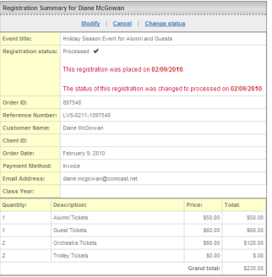  Figure 5
Note: Active links for Modify, Cancel and Change Status are displayed at the top of the Summary Registration page as well as in the registration list only when applicable to the status of the registration.

View Full Registration
How to view Full Registration:
- Log into the Administration Center.  - In the top navigation mouse over Forms Management > Events and click on Create/Manage Events. The Event Registration application will appear. Locate appropriate form.  - Click the ACTIONS > Manage: Orders. The View & Manage Orders tab will appear.  - Click on View Full Registration link for individual registration.  - The Full Registration page displays. See figure 6. | 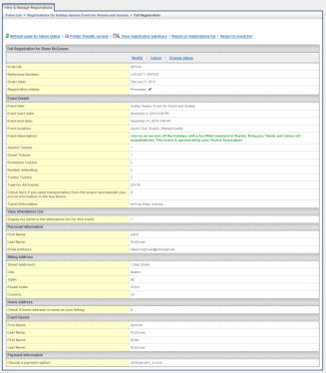  Figure 6
Note: Active links for Modify, Cancel and Change Status are displayed at the top of the Full Registration page as well as in the registration list only when applicable to the status of the registration.

Modify Registrations
Modify is used to update an existing order by increasing/decreasing the number of tickets purchased, removing/adding a sub-event, or changing guest names, etc.

IMPORTANT!
Administrators using CyberSource as their payment gateway can apply immediate credit processing for modifications to orders placed within 60 days. See page 15 for instructions to make modification to orders older than 60 days. Clients using other payment gateways will need to manually apply credits via the payment gateway site. Additional gateways will be configured to handle immediate credit processing in the future.

Modify Registration
How to modify a registration:
 |  | - Log into the Administration Center.  - In the top navigation mouse over Forms Management > Events and click on Create/Manage Events. The Event Registration application will appear. Locate appropriate form.  - Click the ACTIONS > Manage: Orders. The View & Manage Orders tab will appear. | - Click either View Summary or View Full Registration link for the registration to be modified.  - Click on Modify link at top of the returned page. See figure 7.  Note: the Modify link will not display if the order has been successfully cancelled or the current date is more than 60 days since the order date.
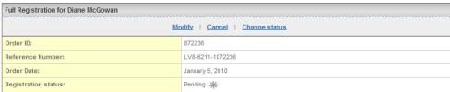
Figure 7

 |  | - The Modify pop up panel offers three actions. Choose the appropriate link. See figure 8.  - Clicking either Yes link results in the original event registration form displaying in a new browser window with all original values pre-populated.  - Make the appropriate changes to the registration form. Credit card number may be required to submit the modified registration. Click to Submit the registration. When the Confirmation page appears close the browser window. | 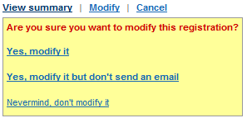  Figure 8
- Click "Refresh page for latest status" link at top of page to see revised and new orders in the list.
- The original order will have displayed in the Registration Status column, and the Amount Billed will become a negative amount. Only the View summary link appears next to the order. The new order is displayed as a new entry in the list of registrations.
- If using Offline Payment Processing, the new order will display with in the Registration Status column. The administrator will need to Change the status of the order once the transaction has been successfully credited manually. See figure 9.

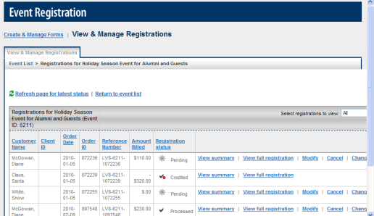
Figure 9
.
Cancel Registrations

IMPORTANT!

This section applies to these payment gateways and processors only:

CyberSource | CyberSource HOP | Cashnet
PayPal Express Checkout | InfiNet | TouchNet T-Lin
Clients using other payment gateways and processors will need to MANUALLY apply credits via their payment gateway site. Additional gateways will be configured to handle immediate credit processing in the future.
Administrators using CyberSource as their payment gateway can apply real time, immediate credit processing when canceling orders placed within 60 days. The administrator can choose to send an email notification to the registrant, make the inventory available again, and/or credit (refund) the registrant. See page 16 for instructions to make changes to orders older than 60 days.
Administrators using CyberSource HOP, Cashnet, PayPal Express Checkout, InfiNet or TouchNet T-Link can reconcile manually canceled orders between their payment processor and the Harris Connect Event Registration application, which allows them to email registrants about pending refunds, make inventory available again, and subtract canceled orders from event revenue. Administrators cannot apply real time credit processing and must still manually apply credits through the payment processor.

Cancel a Registration using CyberSource Gateway Only
How to cancel a registration:
 | - Log into the Administration Center.  - In the top navigation mouse over Forms Management > Events and click on Create/Manage Events. The Event Registration application will appear. Locate appropriate form. |  | - Click the ACTIONS > Manage: Orders. The View & Manage Orders tab will appear.  - Click the Cancel link beside the registration to be cancelled. See Figure 10.
Figure 10

- The Cancel panel will appear. Choose the appropriate action. See figure 11.  Note: If you do not wish to:  - Make the inventory available again,  - Send the registrant an email notification or  - Credit (refund) the registrant,  be sure to uncheck the appropriate checkboxes prior to processing the cancellation. |  | 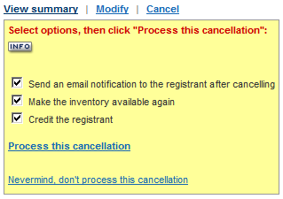  Figure 11
- Click the Process this cancellation link or Nevermind, don’t process this cancellation link to abort. See Figure 10.

- Click "Refresh page for latest status” link at top of page to see revised and new orders in the list.
- The cancelled order will have displayed in the Registration Status column, and the Amount Billed will become a negative amount. Only the View summary or View full registration link appears next to the order.

For Offline Payment Processing
The new order will display with in the Registration Status column. The administrator will need to Change the status of the order once the transaction has been successfully credited manually via the payment processor.

IMPORTANT!
The make inventory available again option does not display if the event is NOT using Inventory Control.

Cancel a Registration for CyberSource HOP, CashNet, PayPal Express Checkout, InfiNet or TouchNet T-Link Payment Processors ONLY
How to cancel a registration for CyberSource HOP, CashNet, PayPal Express Checkout, InfiNet or TouchNet T-Link payment processors:
- Log into the Administration Center.  - In the top navigation mouse over Forms Management > Events and click on Create/Manage Events. The Event Registration application will appear. Locate appropriate form. | - Click the ACTIONS > Manage: Orders. The View & Manage Orders tab will appear.  - Click the Cancel link beside the registration to be cancelled. See Figure 12.
 | .
Figure 12

- The Cancel panel will appear. Choose the appropriate action. See figure 13.  Note: If you do not wish to:  - Make the inventory available again or  - Send the registrant an email notification or  be sure to uncheck the appropriate checkboxes prior to processing the cancellation. | 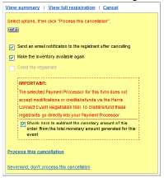  Figure 13
- Click the Process this cancellation link or Nevermind, don’t process this cancellation link to abort. See Figure 13.

- Click "Refresh page for latest status" to see revised and new orders in the list.
- The cancelled order will have displayed in the Registration Status column. Only the View summary or View full registration link appears next to the order.

Important:
Actual refunds MUST still be manually processed via the payment processor.

Change Status
The Change Status feature is used for both online and offline payment processing. It allows administrators to change pending orders to processed.
Online Processing
Registrations paid by checks, money orders, invoices, or pay at the door are defaulted to Pending registration status, and can be changed from Pending to Processed once the funds have been secured.

Note: Credit card payments are automatically processed via the payment processor. The default registration status is Processed. The status for these transactions cannot be changed.

Offline Processing
Pending is the default registration status for all payment options (credit, checks, money orders, invoices, and pay at the door). The administrator must change the status once the transaction has been successfully processed manually via the payment processor.

How to change a pending order to processed:
- Log into the Administration Center.  - In the top navigation mouse over Forms Management > Events and click on Create/Manage Events. The Event Registration application will appear. Locate appropriate form.  - Click the ACTIONS > Manage: Orders. The View & Manage Orders tab will appear.  - Click the Change status link next to the appropriate registration. See figure 14. | 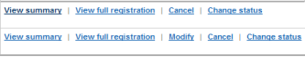  Figure 14  - The Change status panel will display. Click the Yes, change the status to “Order processed” link, or Nevermind, don’t change it link to abort. See figure 15.  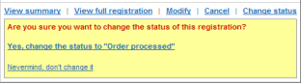 Figure 15

How to change a processed order to pending:
- Log into the Administration Center.  - In the top navigation mouse over Forms Management > Events and click on Create/Manage Events. The Event Registration application will appear. Locate appropriate form.  - Click the ACTIONS > Manage: Orders. The View & Manage Orders tab will appear. | - Click the Change status link next to the appropriate registration.  - The Change status panel will display. Click the Yes, change the status to “Order pending” link, or Nevermind, don’t change it link to abort.

Process Credits & Refunds Requested thru Online Community

Administrators have the ability to enable registrants to modify or cancel their registration via the Online Community.

IMPORTANT!
This process is available only for organizations using CyberSource as their payment gateway to apply immediate credit processing for orders placed within 60 days. See page 16 for instructions to make changes to orders older than 60 days. Clients using other payment gateways will need to manually apply credits via the payment gateway site. Additional gateways will be configured to handle immediate credit processing in the future.
An Event Registration/Order History link on the Member Services page will appear within the Online Community once an order or registration has been submitted provided the registrant has used the “auto fill” option and has logged into the Online Community with a username and password. See figure 15.  Orders modified or cancelled via the Online Community are flagged as in the Registration Status column of the Event Registration application of the Administration Tool.  Process a Credit | 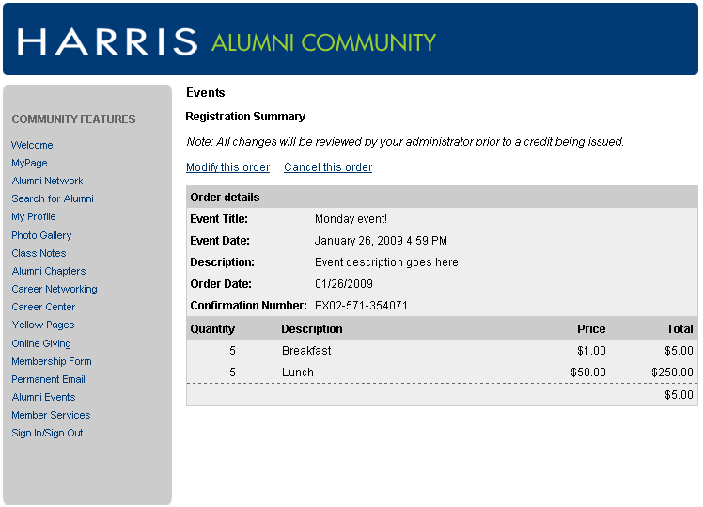  Figure 16
How to process a credit (refund):
- Log into the Administration Center.
- In the top navigation mouse over Forms Management > Events and click on Create/Manage Events. The Event Registration application will appear. Locate appropriate form.
- Click the ACTIONS > Manage: Credits. The View & Manage Orders tab will appear.

- Click the Process credit link next to the appropriate registration. See figure 17.

Figure 17

- The Credit panel will display. See figure 18. Click the Process this credit link, or click Nevermind, don’t process it link to abort.  The credited order will have displayed in the Registration Status column, and the Amount Billed will become a negative amount. Only the View summary or View Full Registration link appears next to the order. | 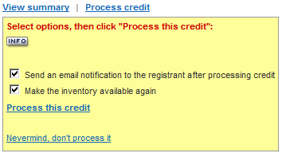  Figure 18

Note: If you do not wish to make the inventory available again or send the registrant an email notification, be sure to uncheck the appropriate checkboxes prior to processing the credit.

Apply a Credit Via CyberSource
Use this feature to apply credits to orders greater than 60 days old, or to make partial refunds. Additional details for each step are found in the Cybersource Business Center manual available for download in the Client Online Community Training Center.

How to apply a credit via Cybersource:
- Go to CyberSource Business Center: https://ebc.cybersource.com/  The login page will display. See figure 19.  - Enter your Merchant ID, User Name, and Password.  3. Click Login.  Note: Your Merchant ID may be pre-populated. For most users Merchant ID and User Name are the same. |  | Figure 19
- Click Transaction Search in the left navigation of returned page.

- Search for the transaction.

- Click the Request ID link.  The Transaction Search Details page will display. See figure 20. | 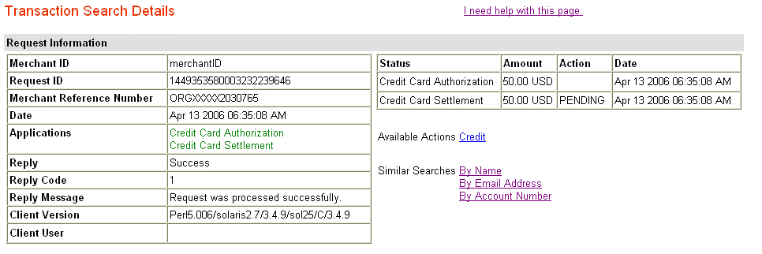  Figure 20
- Click the Credit link. See figure 20.
- The Credit Card Credit page will display. See figure 21.  - Enter the amount that you wish to credit in the Credit Amount box.  - Click the Credit button.  A warning message appears asking you to confirm the amount you would like to credit. | Figure 21
- Click OK to credit for the amount that you entered; otherwise, click Cancel. The Transaction Search Details page reappears with a success message.

