Event Registration: Reporting

Table of Contents

Accessing Event Registration Reports 4
Summary Reports 5
Detailed Reports 6
Transaction Reports 6
Name Tag Reports 7
Event Item Summary and Detailed Reports 10
Downloading Detail Report Results 11
Using Queries 13
Customized Field Names for Reports 16
Matching Registrants with Client ID 17
Recurring Payments in Reports 21

Introduction

In this Event Registration: Reporting reference manual, you will find how to create:
- Summary Reports
- Detailed Reports
Transaction reports
Nametag reports
Customized Detail reports
- Event Item summary reports
- Event item detailed reports

Accessing Event Registration Reports

How to access Event Registration Reports
- Log into the Administration Center.
- Mouse over Reporting > Form Reports on the top navigation. Click the Event Registration Reports. The Event Registration Reports form listing page will display. See Figure 1.
- The form list may be sorted by clicking the appropriate column heading.
- The form list may be filtered according to event start date, ownership, activation status, archive status, and/or calendar view.
- A link is available to create a printer friendly version of the page if hardcopy is required.

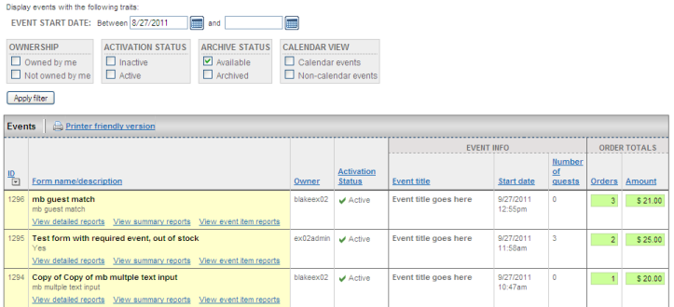
Figure 1

Note: Detailed, Summary and Event Item reports are also accessible from the form application Actions Menu (Mouse over Forms > Event Registration > Create & Manage Events). See Figure 2.

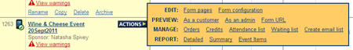
Figure 2

Summary Reports
Based on a Date Range, Summary Reports enable the administrator to quickly capture the Total Guests, Total Orders and Total Amount received for an individual event form. Clicking the View summary reports link under the form name on the Event Reports form listing page will display the Summary Reports tab for the selected event form. See Figure 3.

Links on the Summary Report page allow an admin to jump to the actual form for editing and/or preview purposes.

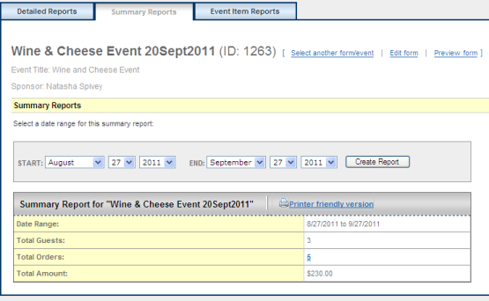
Figure 3

How to create a summary report
- Log into the Administration Center.
- Mouse over Reporting > Form Reports on the top navigation. Click on Event Registration Reports. The Event Reports form listing page will display.
- Click the View summary reports link below the appropriate form name. The Summary Report tab will display
- Modify the Start and End dates to reflect the date range for the event registrations to be included.
- Click the Create Report button. The page will refresh, and the report results will display.

Note: The default report displays the Total Number of Events from one month ago to the current date.

Detailed Reports
Detailed Reports enables an administrator to capture detailed information for all the active event registrations that have occurred within a specific date range. There are two default queries available to provide detail reports:
- Transaction Report: to view all transactions for a specific form, including total guest count when applicable (NOTE: The Matching Guest section in the event form must be enabled for guest count to appear.)
- Name Tag Report: to create a file to send to name-tag software

In addition, unlimited custom detail reports can be created and saved as needed. Detailed report results can be customized to include any field from the event form as well as a number of other values specific to the transaction. The administrator also has the ability to select the field to sort the report results on as well as other report display options.

Transaction Reports

How to create a Transaction Report
- Log into the Administration Center.
- Mouse over Reporting > Form Reports on the top navigation. Click on Event Registration Reports. The Event Reports form listing page will display. Click the View detailed reports link under the appropriate form name. The Detail Report tab will display.
- Modify the Start and End dates to reflect the date range of the event registrations to include in the search results.
- Select Transaction Report in the dropdown choices for Select A Saved Query or Pre-Defined Report.
- Click Display Report tab.
- A full listing of transactions for the event will appear. See Figure 4.
- Clicking on the Order ID link will drill down to the order summary page.
- Total guest count is displayed in the lower left of page.
- The Match option in the Client ID column will allow the admin to match the transaction to a constituent’s client ID. (See Match Option section below.)

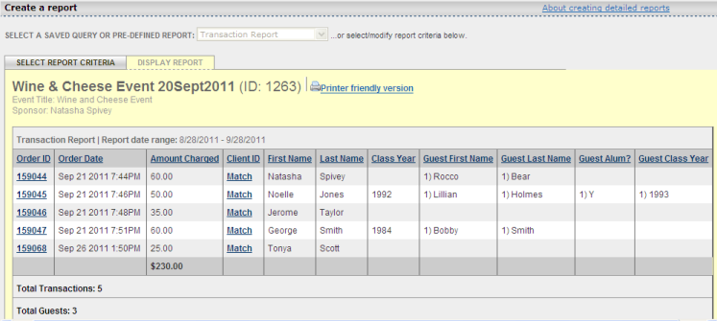Figure 4

Name Tag Reports
The Name Tag report is meant to allow an admin to generate name tags for event attendees by downloading data and using mail merge functionality to create labels. A standard Name Tag report is generated automatically for each event form, but an admin may modify it or create other name tag reports as needed.

How to create a name tag report
- Log into the Administration Center.
- Mouse over Reporting > Form Reports on the top navigation. Click on Event Registration Reports. The Event Reports form listing page will display. Click the View detailed reports link under the appropriate form name. The Detailed Reports tab will display.
- Modify the Start and End dates to reflect the date range of the event registrations to include in the search results.
- Select the Name Tag Report query from the Retrieve A Saved Query dropdown. The selection criteria will refresh to reflect the default criteria saved with that query.
- By default, the Name Tag Report query includes the following fields:
  - Form ID
  - Order ID
  - Order Date
  - Client ID - displays the Client ID of the registrant who submitted the form, provided they were logged in when the form was filled out. NOTE: this field will display the same value regardless of whether the current report row reflects a registrant or a guest - it ALWAYS pertains to the registrant.
  - Name Tag Event Item - displays the event item ordered for the displayed attendee
  - Name Tag First Name - displays the First name of the attendee
  - Name Tag Last Name - displays the Last name of the attendee
  - Name Tag Guest ID - displays the sequential ID of the event attendee ("0" indicates a registrant; any number greater than 0 indicates a guest)
  - Name Tag Guest Flag - displays "Guest" for a guest and a blank for a registrant
  - Name Tag Class Year - displays the registrant's Class Year for registrants and the guest's Class Year for guests.
- The fields, sorting, and reporting options in the standard Name Tag Report query may be modified as needed by following the steps outlined in the How to modify a saved Query section
- Locate the Report Display Options section on the page.
- By default, the “Set the Display results in "Name Tag report" format (one row for each registrant or guest)?” option will be set to "Yes".

Note: The intent of the fields in the Event Guests section is to display guest information for ALL guests registered with the registrant. That means that for each row in a report, each Event Guests field will reflect the values for all guests included in the event form submission. As a result, it is generally not appropriate to include these fields in a name tag report because there are potentially multiple rows for each event form submission – if included, the same information will be displayed for EACH attendee row associated with the same transaction. Generally, the fields in the “Name Tag Information” section will suffice.

IMPORTANT!
The Display results in "name tag report" format (one row for each registrant or guest)? Report Display option MUST be set to Yes for a Name Tag report – otherwise, only one row will display for each event form submission.

How to create custom detailed reports
- Log into the Administration Center.
- Mouse over Reporting > Form Reports on the top navigation. Click on Event Registration Reports. The Event Reports form listing page will display. Click the View detailed reports link under the appropriate form name. The Detail Report tab will display.
- Modify the Start and End dates to reflect the date range of the event registrations to include in the search results.
- Select the information to include in the report results by checking the checkboxes next to the appropriate fields. Note that a checkbox exists for each field that appears on the form (including “admin only” fields like those in the “Order Discount” section). Additional checkboxes are available for other information specific to the transaction (e.g., “Order Date”, “Order ID”, “Order Submitted By”, etc.) See Figure 5.
- Select the appropriate display options in the Report Display Options section. By default, all options are set to No.
  - Include failed credit card attempts? – by default, only successful transactions are included in the report results, but selecting the Yes radio button will additionally include credit card transactions that failed.
  - Show totals for numeric columns? – by selecting Yes, the report results will display the total number of transactions as well as a total under each column that reflects a numeric field.
  - If applicable, display guests matched to event names? – selecting Yes for this option will include an additional column for each event item such that it will reflect all the attendees registered for that particular event item. In order to use this option, at least one event item field must be selected for inclusion in the report results.
  - Display results in “name tag report” format (one row for each registrant or guest) –Selecting Yes for this option will display one row for each event attendee and event item they've been matched with – see the Name Tag Report section for more information on Nametag Reports.
  - If applicable, include “TBD” guests in report? – By default, guest attendees for whom names were not provided in the event registration submission are not listed in the report results. By selecting this option, “TBD” will appear in the report for any unnamed guest.
- Select the appropriate field from the Sorting Options section to control the sort of the report results.
- Click the Display Report tab. The page will refresh, and the report results will display. To modify the report selection criteria, simply click the Select Report Criteria tab.

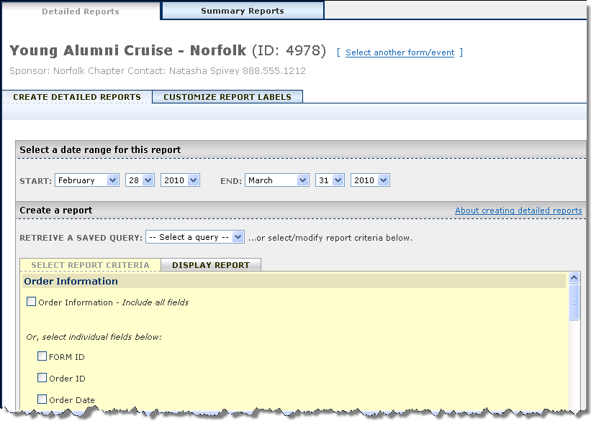
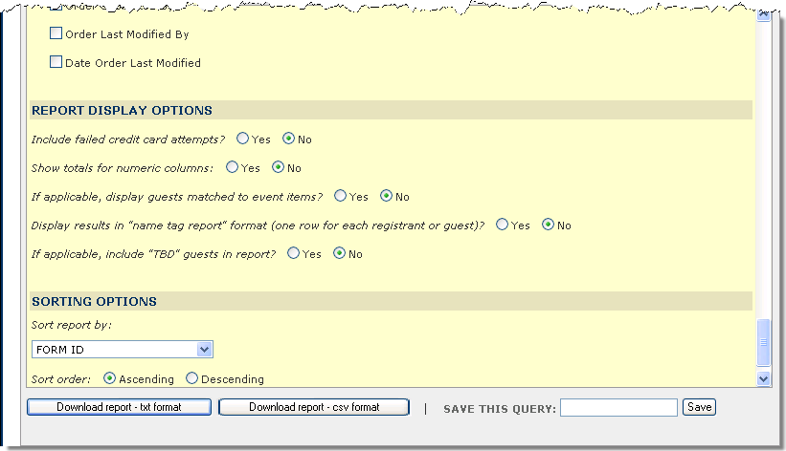
Figure 5

Event Item Summary and Detailed Reports
Event Item reports show the number of event items allocated (total units), sold (quantity), and remaining (currently available) for each event that includes event items, plus the revenue generated by the event items sales. The event items names are hyperlinks to the Event Item Detailed Report.

How to create Event Item Summary and Detailed Reports
- Log into the Administration Center.
- Mouse over Reporting > Form Reports on the top navigation. Click on Event Registration Reports. The Event Reports form listing page will display. Click the View event item reports link under the appropriate form name. The Event Item Reports tab will display. See Figure 6.
- The Event Item names are hyperlinks to the Event Item Detailed Report.

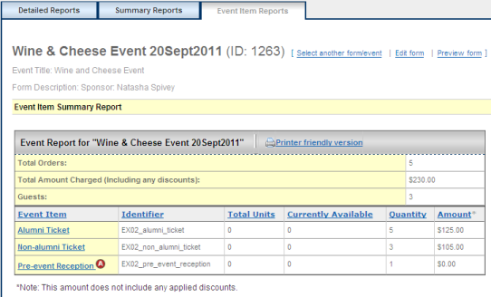
Figure 6

The Event Item Detailed Report provides a list of all the orders captured for a specific event item. See Figure 7. The report includes order details such as order ID, order date, quantity purchased and order total (amount) along with registrant’s name, class year and client ID. The orders IDs are hyperlinks to the Order Summary Page.
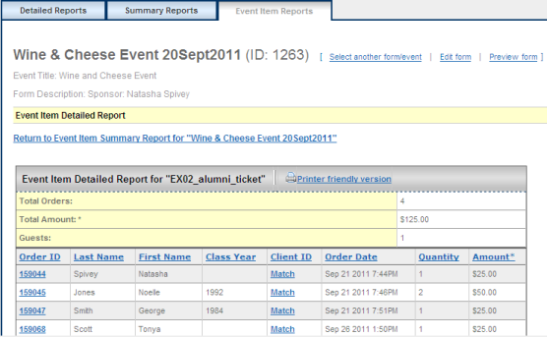

Figure 7

Downloading Detail Report Results
Event Registration Report results may be downloaded in one of two formats:
- .txt – Text format
- .csv – Comma separated value format

How to download and save custom detailed report results

- Log into the Administration Center.  - Mouse over Reporting > Form Reports on the top navigation. Click on Event Registration Reports. The Event Reports form listing page will display. Click the View detailed reports link under the appropriate form name. The Detail Report tab will display.  - Modify the Start and End dates to reflect the date range of the event registrations to include in the search results.  - Select the saved query or if creating a new query, choose appropriate dates, fields, display options, and sorting options.  - Click the Download report – txt format or Download report – csv format button based on the format you’d like to download the report results in. The File Download popup will display. Click Save to save the report. The Save As popup will display. See Figure 8.  - Locate the folder where you’d like to save the report results and enter a Filename. Click the Save button to save the results to a file. See Figure 9.  - A Download Complete popup window will display when the file has been saved. See Figure 10. | 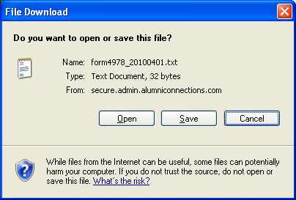  Figure 8  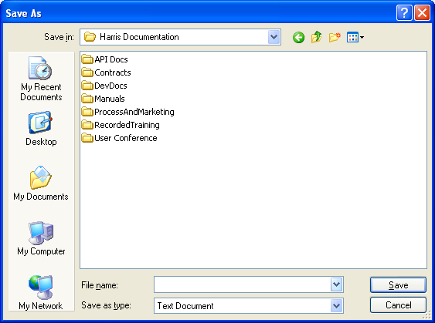  Figure 9  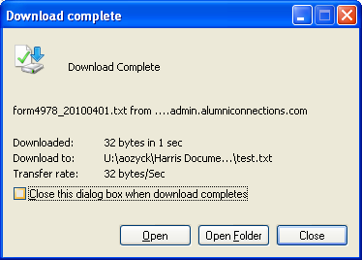  Figure 10
  Note: Clicking Open will display the report using the application that your system is set up to use for the file format chosen. For example, txt files are commonly opened in Notepad while .csv files are most frequently opened in Microsoft Excel

Using Queries
For reports that are used repeatedly, an admin may save report selection criteria as a Query instead of having to recreate the same report each time it is needed. So for example, if an administrator needs to review the names and ticket counts for all the event items on a weekly basis, a Query containing the name and event item fields could be created and saved so it may be retrieved weekly.

How to create a saved Query
- Log into the Administration Center.
- Mouse over Reporting > Form Reports on the top navigation. Click on Event Registration Reports. The Event Reports form listing page will display. Click the View detailed reports link under the appropriate form name. The Detail Report tab will display.
- Modify the Start and End dates to reflect the date range of the event registrations to include in the search results.
- Select the appropriate dates, fields, display options, and sorting options.
Note: The selected date range will NOT part of the saved query. Dates must be reselected even when using saved queries unless the default date range is appropriate
- Enter a name for the query in the Save This Query box at the bottom of the page. See Figure 11.
- Click the Save button to save the query. Going forward, that query will be available from the Retrieve A Saved Query dropdown.

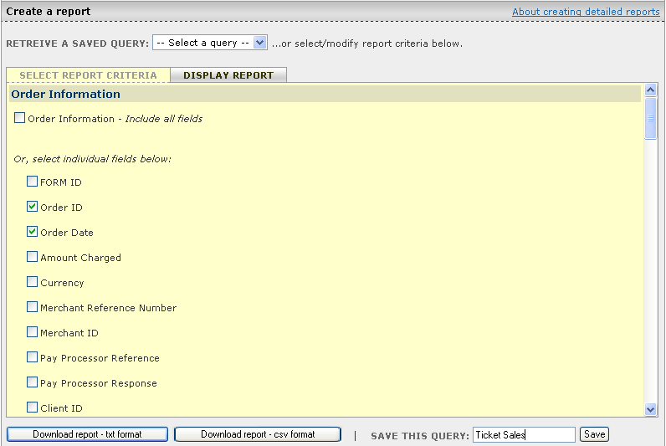
Figure 11

How to retrieve a saved Query
- Log into the Administration Center.
- Mouse over Reporting > Form Reports on the top navigation. Click on Event Registration Reports. The Event Reports form listing page will display. Click the View detailed reports link under the appropriate form name. The Detail Report tab will display.
- Modify the Start and End dates to reflect the date range of the event registrations to include in the search results.
- Select the appropriate saved query from the Retrieve A Saved Query dropdown at top of page. See Figure 12. The report selection criteria will refresh to reflect the criteria saved with that query.

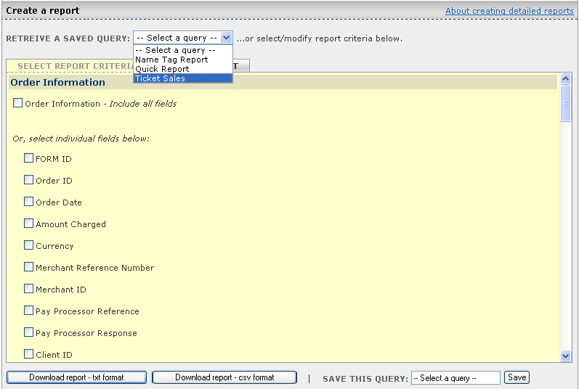
Figure 12

How to modify a saved Query
- Log into the Administration Center.
- Mouse over Reporting > Form Reports on the top navigation. Click on Event Registration Reports. The Event Reports form listing page will display. Click the View detailed reports link under the appropriate form name. The Detail Report tab will display.
- Modify the Start and End dates to reflect the date range of the event registrations to include in the search results.
- Select the query to be modified from the Retrieve A Saved Query dropdown.
- Make necessary modifications to the selected report criteria (fields, report display options, and/or sorting option).
- The name of the saved query selected from the Retrieve A Saved Query dropdown will appear in the Save This Query box. To save over the existing query, leave that value as is; or enter a new name in the Save This Query box to create a new query.
- Click the Save button.

Customized Field Names for Reports
Administrators can customize the field names used in the column heading of their reports for the form.

How to customize detail report fields
- Log into the Administration Center.
- Mouse over Reporting > Form Reports on the top navigation. Click on Event Registration Reports. The Event Reports form listing page will display. Click the View detailed reports link under the appropriate form name. The Detail Report tab will display.
- Click the Customize Field Labels. See Figure 13.
- Enter the new field name in the associated input box.
- Click Update Field Names button.
- Going forward, the new custom field names will display on the Detail Reports Select Report Criteria tab as well as in the report results on the Display Report tab.

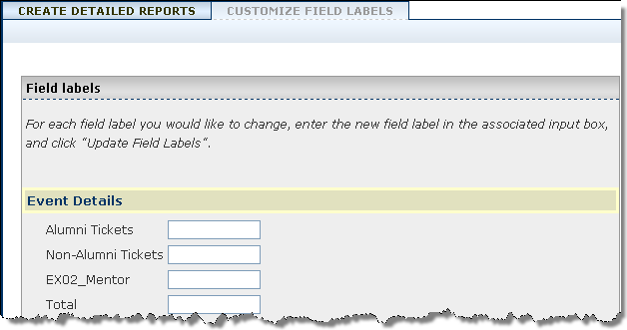
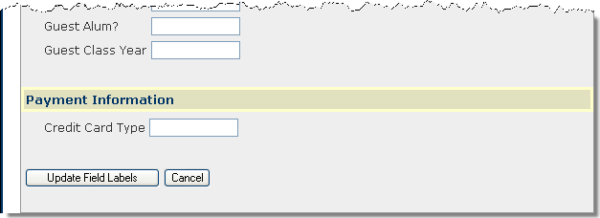
Figure 13

Matching Registrants with Client ID
If a community user is logged in at the time an event registration is submitted, the resulting transaction will be linked to their community record. As a result, information related to that transaction will be available through the Data on Demand tool for reports involving that individual. For transactions that were submitted by non-authenticated users that ARE in fact part of the community, Administrators can match registrations to the corresponding community user, subsequently linking their transaction and community record as if they had been authenticated at the time the registration was submitted.

How to use matching registrants feature
- Log into the Administration Center.
- Mouse over Reporting > Form Reports on the top navigation. Click on Event Registration Reports. The Event Reports form listing page will display.
- Click the View detailed reports link under the appropriate form name. The Detail Report tab will display.
- Modify the Start and End dates to reflect the date range of the event registrations to include in the search results.
- Select the appropriate dates, fields, display options, and sorting options as described in the Detailed Reports section.

IMPORTANT!
The Client ID field MUST be selected in order to use the Matching Registrants feature.

- Click the Display Report tab. The Detailed Reports result page will display. For registrations that were submitted by non-authenticated users, the Client ID value will display as a Match link. See Figure 14.

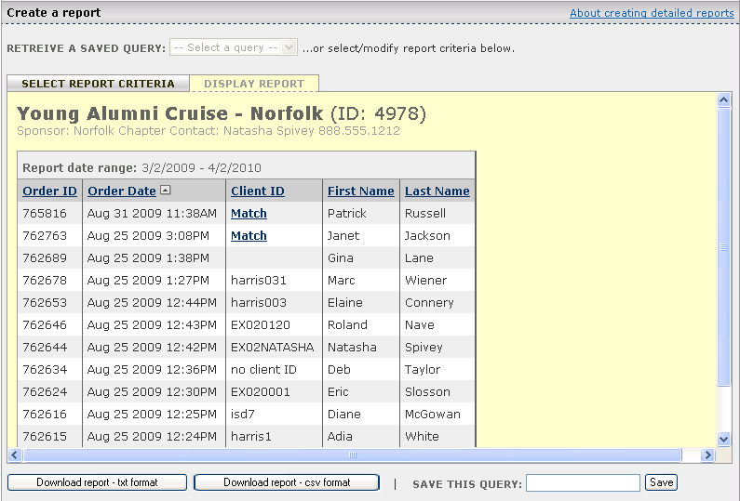
Figure 14

- Click the Match link next to the appropriate registrant’s name. The Admin Search popup will display. By default, the search criteria will be pre-populated based on the First Name, Last Name, Primary Email, City and State entered during the event form submission (provided those fields are captured on the event form). The admin may modify the search criteria as needed by clicking the appropriate search category and adding or removing criteria. See Figure 15.

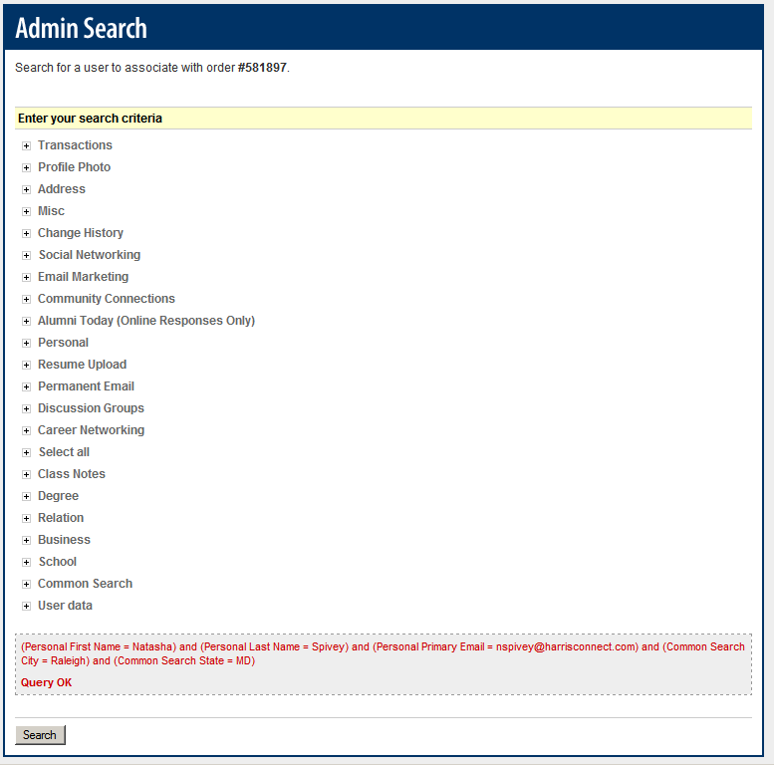
Figure 15

- Click Search button at the bottom of the page. The User Order Entry Search Results page will display with the members who match the specified search criteria. See Figure 16.

Note: If no users are found, the page will refresh, and a “Your search returned no results” message will display

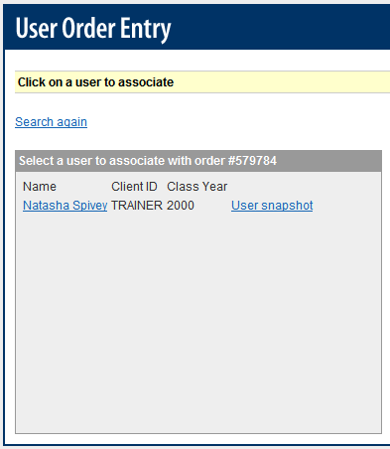
Figure 16

- Click the appropriate member’s name to associate the order to his/her profile.

Suggestion: Click the User Snap Shot to verify the member’s identity

- A confirmation message will appear indicating that the order is now associated with the selected individual. See Figure 17.

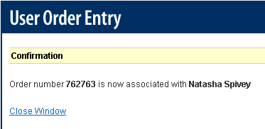
Figure 17

Recurring Payments in Reports
If a form is set up to accept Recurring Payments, several related fields will be available via Detailed Reporting:
- Recurring Payment Flag
- Recurring Amount
- Recurring Frequency
- Recurring Number of Payments
- Recurring Start Date
- Recurring Automatic Renew
See Figure 18.

An asterisk will appear as the total for recurring payment orders. In addition, a message will display at the bottom of the report which advises the administrator to refer to the CyberSource Payment Batch Detail Report for their Merchant ID for reconciliation of recurring payments. See Figure 19.

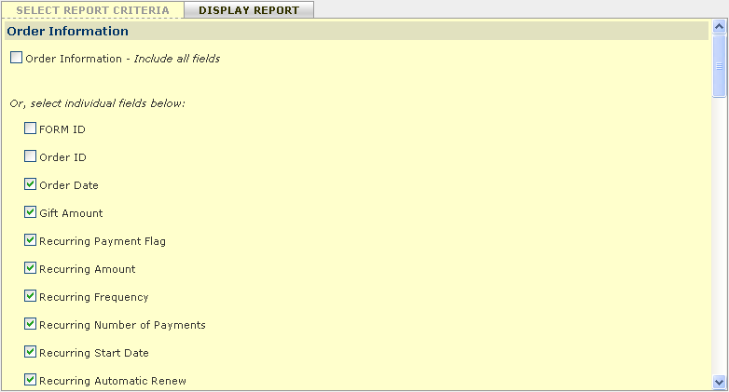
Figure 18
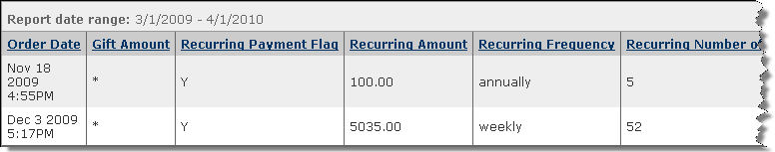
Figure 19

