Groups 2.0

Table of Contents
Introduction 4
Getting Started 5
Initial Setup 5
Manage Categories 6
Modify Category Name or Description 6
Create a Sub-category 6
Move a Sub-Category 6
Remove a Sub-Category 7
Group Requests 8
Create A New Group 8
Review Group Requests 10
Approve/Deny Group Request 10
Manage existing groups 11
View My Groups 11
View All Groups 11
Browse Groups by Category 11
View Group Homepage 12
Send A Message To Group Owners 12
Change “About Group Owners” Text 13
View Group Details 14
View My Subscription Settings 15
Modify My Default Subscription Settings 16
Refer This Group To A Friend 16
Add Group Photo 17
Group Features 18
Group Details 18
Message Posts 19
Member Directory 20
Group Messages 23
Subscriptions 24
Usage Analysis 25
Report Types 25
Calendar 26
Links 30
Post A Message 32
Attachments 32
Discussion Group Reporting 33
Groups Summary Report 33
Discussion Groups Org Admins Report 34

Introduction
Groups 2.0 is a web application that allows administrators to create an institution/association network for members to hold discussions and post user generated content. The Category level may be divided into sub- categories such as Clubs, Affinities, or Career Groups. Sub- categories can be further divided. For example, the Athletics category may be divided into sport specific categories.

The terms "group" refers to a specific sub-forum dealing with a distinct topic. For example, in the Careers sub-category there may be an Education discussion group.

Groups 2.0 includes the following upgrades:

- Re-designed Navigation – Members have the option to view only groups that they manage or subscribe to (View my groups), all active public groups (View all groups) or to browse all active public groups (Browse groups by category).

- Group Home Page – The group homepage has a significant new look.

- Group Photo – Customize your group with a group photo.

- About Group Owner – Learn more about a group's owner.

- Recent Posts – Recent posts display on the group homepage with the subject link, posted by, and date/time stamp of the post.

- Refer-A-Friend– Users can refer a group to a friend from the group homepage.

- Group Calendar – Group owners can share events with the group.

- Groups are created on the FLY! – Users can create a group of their own so they can get in touch and keep in touch with other members. Please note - this feature must be configured. All groups must be approved by the super administrator in the default setting.

- Global Searches – Groups are included in Global Searches.

- Attachments – Up to three files can be attached to each post.

Groups 2.0 provides easy-to-use functionality that will drive your alumni and members to return frequently to your Online Community.

Getting Started
- Go to the Online Category.  - Click the Discussion Groups link in the main navigation.  - Log in as the Super-Administrator. The Discussion Groups landing page will load with the Administration Tool dropdown menu displayed in the top right-hand corner. See figure 1. | 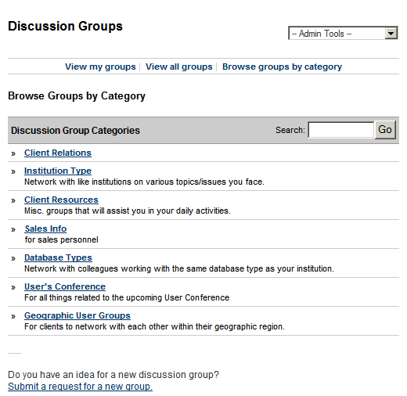  Figure 1

Initial Setup
When setting up Discussion Groups for the first time, the first category should be the school/association name. It is the foundation in which all other sub-categories will be built upon.

Manage Categories

Modify Category Name or Description
- Select Manage Categories in the Admin Tool drop down menu.  - Change the Category Name or Description. See figure 2.  - Click the Modify Category button. A “Category modified successfully” confirmation message will display at the top of the screen. | 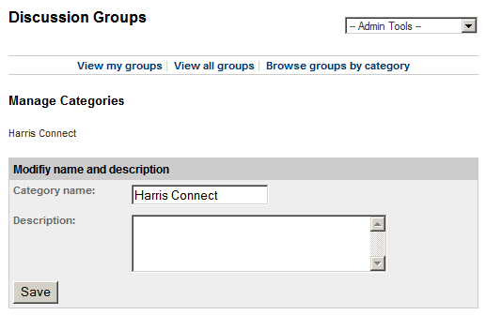  Figure 2

Create a Sub-category
- Select Manage Categories in the Admin Tool drop down menu.  - Scroll down to the Create a Sub-category section at the bottom of the page. See figure 3.  - Enter the Category Name and Description.  - Click the Add New Sub-Category button. A “Sub-category added successfully” confirmation will display at the top of the screen.  The newly added sub-category will display in the Manage Sub-categories section. | 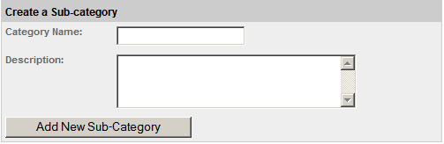  Figure 3

Move a Sub-Category
- Select Manage Categories in the Admin Tool drop down menu.  - Scroll down to the Manage Sub-categories section.  - Select the checkbox next to the appropriate sub-category name(s). See figure 4.  - Select the Parent Category.  - Click the Move Selected Categories button. A “Sub-Categories moved successfully” confirmation message will display at the top of the screen. | 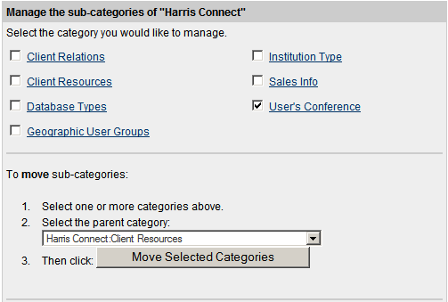  Figure 4

Remove a Sub-Category
- Select Manage Categories in the Admin Tool drop down menu.  - Scroll down to the Manage Sub-category section.  - Select the checkbox next to the appropriate sub-category name(s).  - Click the Remove Selected Categories button. See figure 5. A “Sub-Categories removed successfully” confirmation message will display at the top of the screen.  IMPORTANT!  All groups associated with the sub-category you wish to remove must be assigned to a different category prior to removal. | 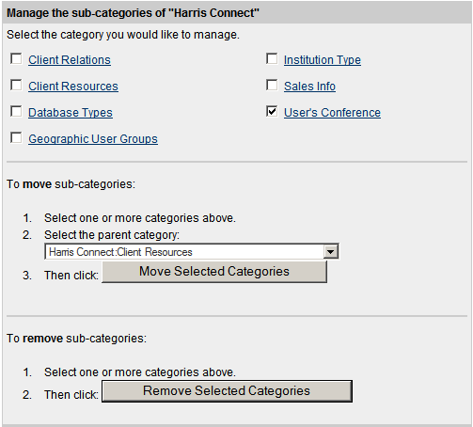  Figure 5

Group Requests

Create A New Group
- Go to the Online Community.  - Click the Discussion Groups link.  - Login to the Discussion Groups page.  - Click the Submit a request for a new group link at the bottom of the page. See figure 6. The Create New Group page will display. See figure 6.  - Enter the appropriate group information.  - Click the Next button.  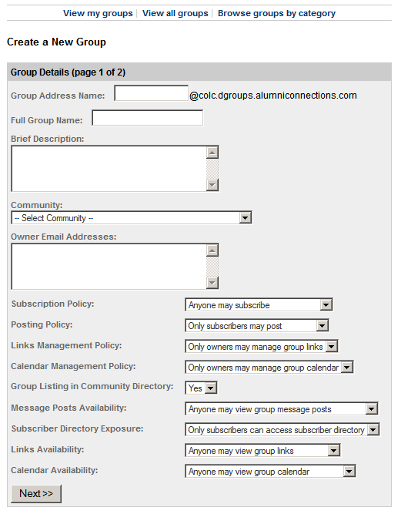  Figure 7 | 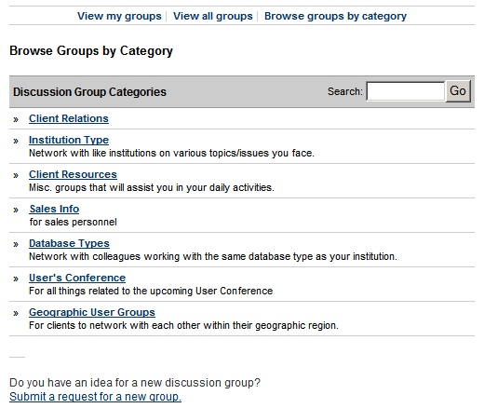  Figure 6  Group Address Name – The email address used for the group. Use only numbers, letters, dashes (-), and underscores (_). No spaces allowed.  IMPORTANT!  The Group Address Name cannot be modified. Confirm the name prior to hitting the Next button.  Full Group Name – The full name of the group.  Brief Description – A brief description about the purpose of the group.  Category – Select the category the group should be assigned to.  Owner Email Addresses – Enter the owners’ email addresses. Enter one email address per line.
Group Settings
Subscription Policy  - Anyone may subscribe (default)  - All subscriptions are to be approved | Calendar Management  - Subscribers may manage group calendar  - Only owners may manage group calendar (default)
Posting Policy  - Only subscribers may post (default)  - Subscriber postings are moderated  - Only owners may post | Calendar Availability  - Anyone may view group calendar (default)  - Only subscribers may view group calendar
Links Management Policy  - Subscribers may manage group links  - Only owners may manage group links (default) | Group Listing in Community Directory  - Yes (default)  - No
Links Availability  - Anyone may view group links (default)  - Only subscribers may view group links | Message Posts Availability  - Anyone may view group message posts (default)  - Only subscribers may view group message posts
Subscriber Directory Exposure
- Anyone can access subscriber directory
- Only subscribers can access subscriber directory (default)
- Only owners can access subscriber directory

Review Group Requests
- Select Review Group Requests in the Admin Tool drop down menu. A list of group requests pending approval will display. See figure 8.  - Click the Group Name hyperlink. The Group Details page will display. See figure 9.  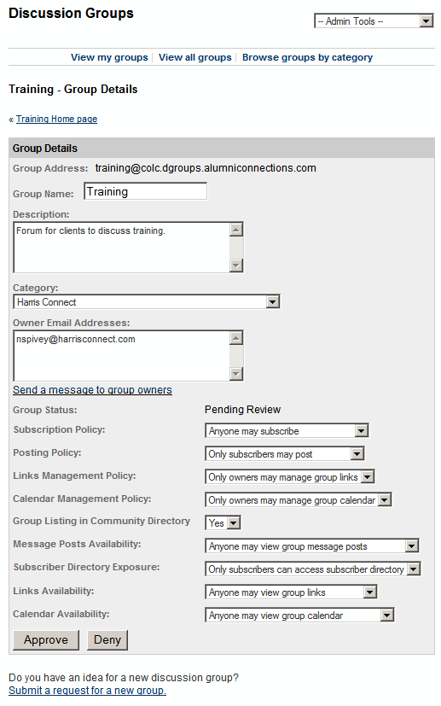  Figure 9 | 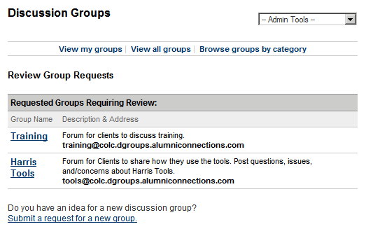  Figure 8  - Make modifications, if necessary.  Approve/Deny Group Request  - Click Approve. A “Group information successfully modified” confirmation will display at top of the screen.  OR  Click Deny. You will be returned to the list of pending group request. The denied group will be removed from the list.  Note: Members will receive an automatic email notification informing them that their group request has been approved or denied.

Manage existing groups

View My Groups
View my groups allows the user to view the groups they manage/own and are subscribed to.

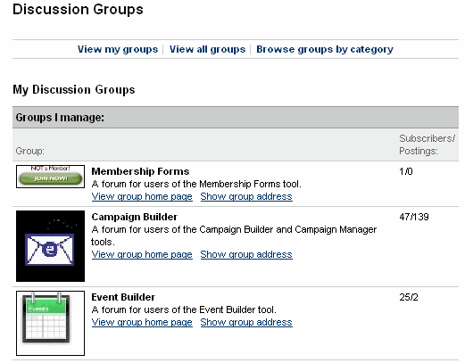

View All Groups
View all groups allows the user to view all groups. Groups managed/owned are indicated by (You manage this group.). Groups the user is subscribed to are indicated by (You subscribe to this group.)

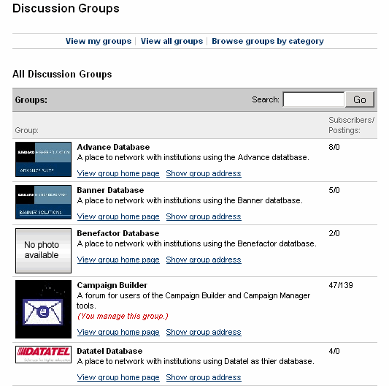

Browse Groups by Category
Browse groups by category, the default setting, allows the user to view groups by category.

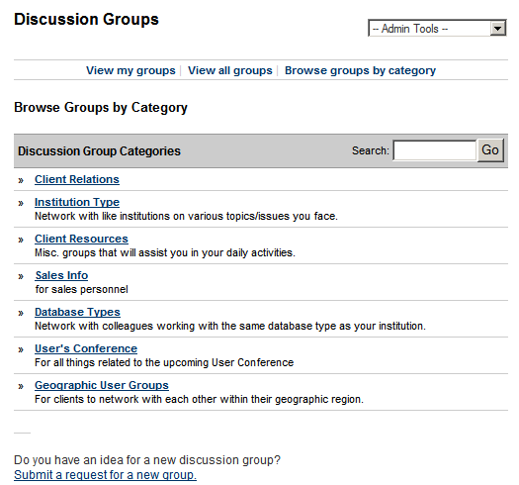

View Group Homepage
- Click Browse groups by category in the top navigation.  - Click the Category Name. A list of current groups will display.  - Click the View group homepage. The Group Homepage will display. See figure 11.  Send A Message To Group Owners  - Click Browse groups by category in the top navigation.  - Click the Category Name. A list of current groups will display.  - Click the View group homepage. The Group Homepage will display.  - Click the Send a message to group owners link. The Post A Message will display. See figure 12.  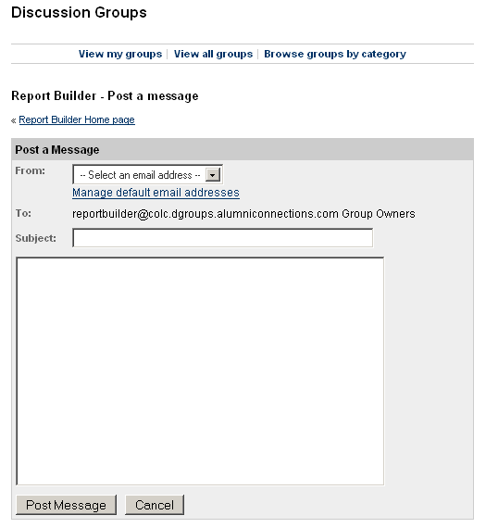  Figure 12 | 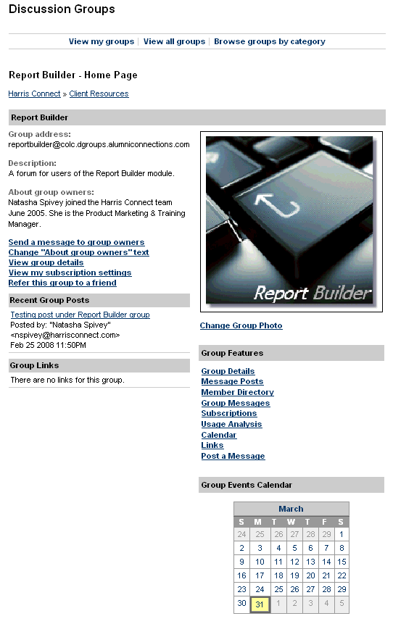  Figure 11

Change “About Group Owners” Text
- Click Browse groups by category in the top navigation.  - Click the Category Name. A list of current groups will display.  - Click the View group homepage. The Group Homepage will display.  - Click the Change “About group owners” text link. The Group Homepage will refresh with the About group owners text area open for content. See figure 13.  - Enter the appropriate content.  - Click the Update Owner Profile button, or Cancel to abort. The Group Homepage will refresh with the following onscreen confirmation: Group owners' profile successfully modified | 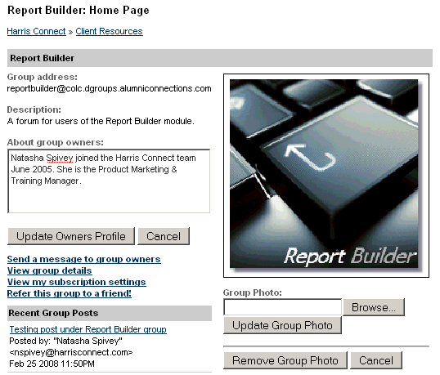  Figure 13

Note: Only super administrators and owners have access to edit the About Group Owner Text

View Group Details
- Click Browse groups by category in the top navigation.  - Click the Category Name. A list of current groups will display.  - Click the View group homepage. The Group Homepage will display.  - Click the View group details link. The Group Homepage will refresh. See figure 14.  - Click the Hide link to hide the View Group Details section. | 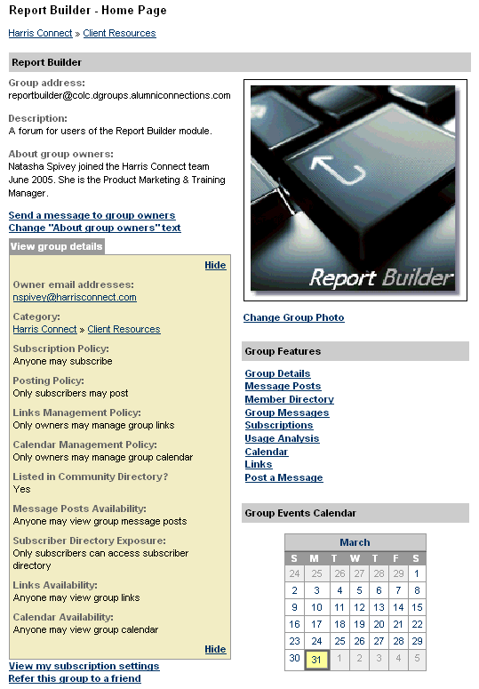  Figure 14

View My Subscription Settings
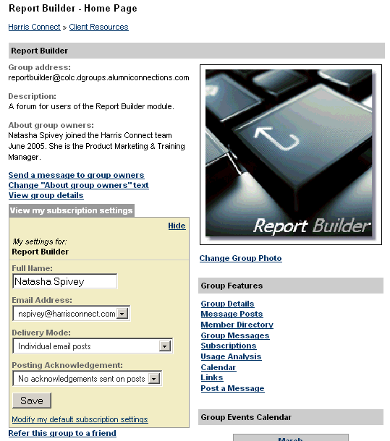  Figure 15  Delivery Modes  Web access only The subscriber will access all message postings via the Discussion Groups homepage.  Individual email posts The subscriber will receive each individual post via the email address set under the subscription settings for that particular discussion group.  A summary digest once a day (also known as plain text digest) A plain text digest that displays message postings one after the other into one large text message.  One daily email with all postings attached (also known as MIME digest) MIME (Multipurpose Internet Mail Extensions) digest has each posting as an attachment inside the email message. Note: Not all mail readers support MIME.  Figure 16 | - Click Browse groups by category in the top navigation.  - Click the Category Name. A list of current groups will display.  - Click the View group homepage. The Group Homepage will display.  - Click the View my subscription settings link. The Group Homepage will refresh. See figure 15.  - Modify appropriate fields (Full Name, Email Address, Delivery Mode, or Posting Acknowledgement). Four Delivery Modes are available. See figure 16.  - Click the Save the button.
Modify My Default Subscription Settings  - Click Browse groups by category in the top navigation.  - Click the Category Name. A list of current groups will display.  - Click the View group homepage. The Group Homepage will display.  - Click the View my subscription settings link. The Group Homepage will refresh. See figure 17.  - Click the Modify default subscription settings the link. The Modify default subscription settings page will display.  - Update appropriate settings. | 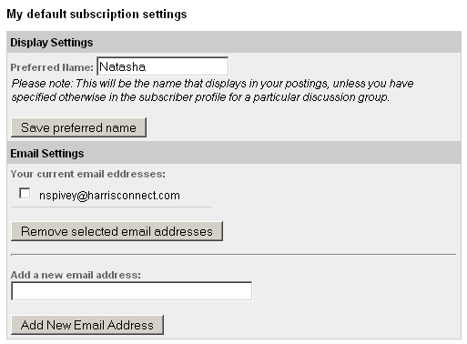  Figure 17

Refer This Group To A Friend
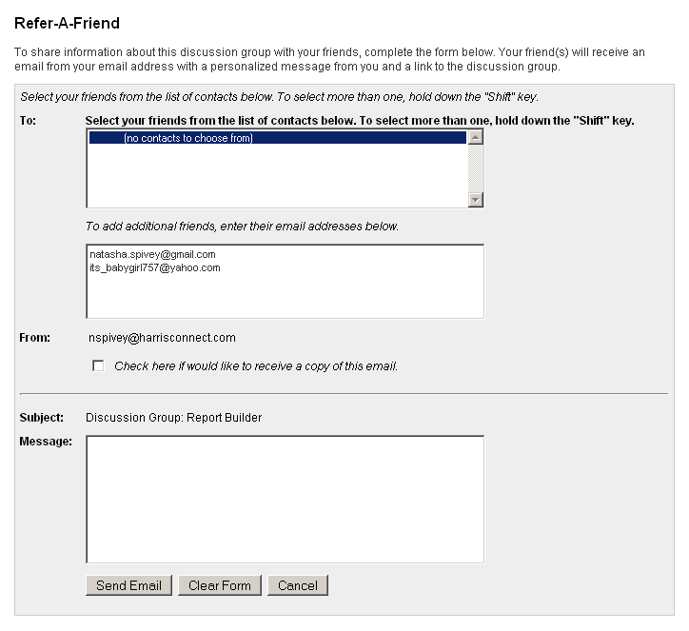  Figure 18 | - Click Browse groups by category in the top navigation.  - Click the Category Name. A list of current groups will display.  - Click the View group homepage. The Group Homepage will display.  - Click the Refer this group to a friend link. The Refer-A-Friend page will display. See figure 18.  - Select your friends from the list of contacts below. To select more than one, hold down the "Shift" key.  OR  Enter e-mail addresses (one per line) in the additional friends field.  - If you would like to receive a copy of this email click the checkbox.  - Enter your message.  - Click the Send Email button, Clear Form to try again, or Cancel to abort.

Add Group Photo
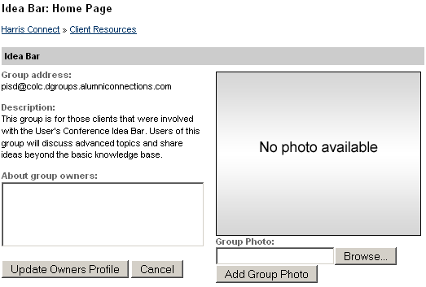  Figure 19 | - Click Browse groups by category in the top navigation.  - Click the Category Name. A list of current groups will display.  - Click the View group homepage. The Group Homepage will display.  - Click the Add Group Photo link. The Group Homepage will display. See figure 19.  - Click the Browse button.  - Select the photo from your local computer.  - Click the Add Group Photo button.
Change/Remove Group Photo

- Click Browse groups by category in the top navigation.  - Click the Category Name. A list of current groups will display.  - Click the View group homepage. The Group Homepage will display.  - Click the Change Group Photo link. The Group Homepage will display. See figure 20.  - Click the Browse button.  - Select the photo from your local computer, and click the Update Group Photo button.  Or  Click the Remove Group Photo button, or Cancel to abort. | 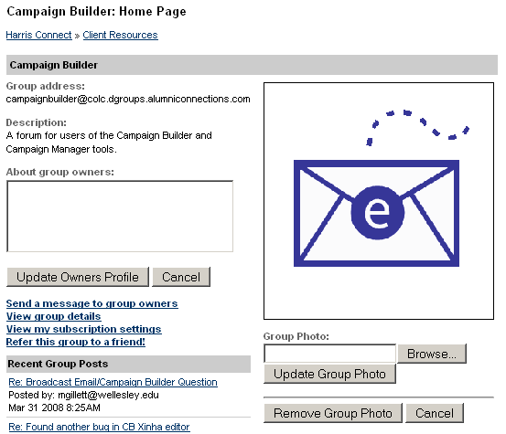  Figure 20

Group Features

Group Details
Group details allow super administrators and owners to modify the group details. Subscriber will not see the Group Details link.
How to modify Group Details:
- Click Browse groups by category in the top navigation.  - Click the Category Name. A list of current groups will display.  - Click the View group homepage. The Group Homepage will display.  - Click the Group Details link under Group Features.  - Modify the necessary settings.  - Click the Modify Details button. See figure 21. | 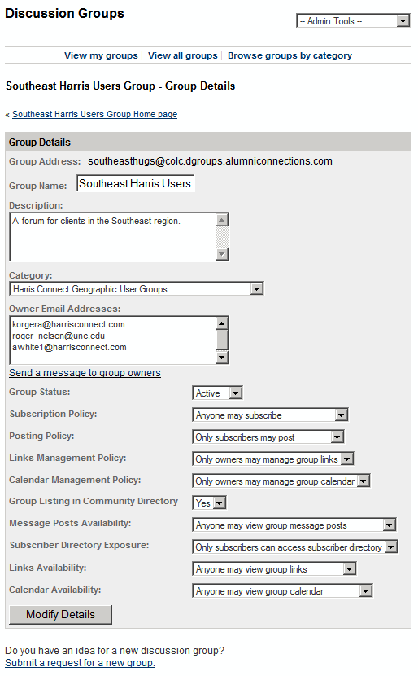  Figure 21

Message Posts
Message Posts allow super administrators, owners, and subscribers to post a message to the group.
Search Message Posts  - Click Browse groups by category in the top navigation.  - Click the Category Name. A list of current groups will display.  - Click the View group homepage. The Group Homepage will display.  - Click the Message Posts link under Group Features. The Message Posts page will display.  - Click the Subject, Sender, or Post Date headers to resort the list of messages.  - OR  - Enter keywords into the Search Archives text field, and click Go. See figure 22.  - The page will refresh with only the messages that match your keyword search. See figure 23. | 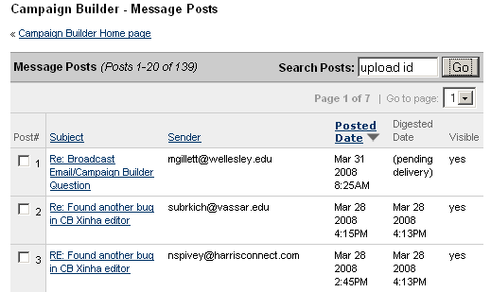  Figure 22  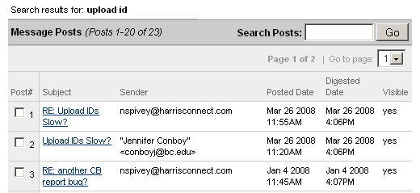  Figure 23

Activate/Inactivate A Post
- Click Browse groups by category in the top navigation.
- Click the Category Name. A list of current groups will display.
- Click the View group homepage. The Group Homepage will display.
- Click the Message Posts link under Group Features. The Message Posts page will display.
- Check the message(s) you wish to activate or inactivate.
- Click Activate or Inactivate.

Member Directory
Administrators can view pending subscriptions for a particular group and view current group subscribers.
View Pending Subscriptions  - Click Browse groups by category in the top navigation.  - Click the Category Name. A list of current groups will display.  - Click the View group homepage. The Group Homepage will display.  - Click the Member Directory link under Group Features. The Member Directory page will display with Pending Subscriptions at the top of the page. See figure 24. The page will refresh with a Pending subscription approved or Pending subscription denied message | Figure 24

Search Member Directory  - Click Browse groups by category in the top navigation.  - Click the Category Name. A list of current groups will display.  - Click the View group homepage. The Group Homepage will display.  - Click the Member Directory link under Group Features. The Member Directory page will display.  - Scroll through the list to search for the member.  - Members are listed by email address in alphabetical order.  - Resort list by clicking the Name, Owner, or # of Post headings.  OR  Enter the member’s name or email address in the Search Member text field, and click Go. | 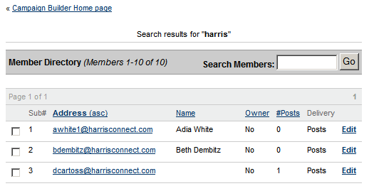  In this example, I entered “harris” as the keyword.
Unsubscribe a member  - Click Browse groups by category in the top navigation.  - Click the Category Name. A list of current groups will display.  - Click the View group homepage. The Group Homepage will display.  - Click the Member Directory link under Group Features. The Member Directory page will display.  - Search for the member.  - Check the checkbox next to the name of the subscriber(s) you wish to unsubscribe. See figure 25.  - Uncheck the Send Farewell Message checkbox, if you choose to not send the Farewell Message.  - Click Unsubscribe These Members button |  | 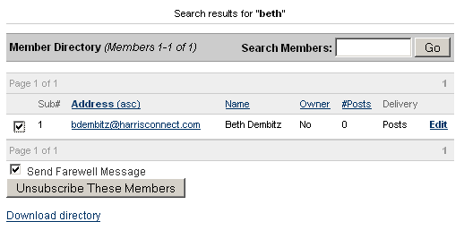  Figure 25

Contact a specific member
- Click Browse groups by category in the top navigation.
- Click the Category Name. A list of current groups will display.
- Click the View group homepage. The Group Homepage will display.
- Click the Member Directory link under Group Features. The Member Directory page will display.
- Search for the member.
- Click on their emails address. See figure 25. Your email client will open in compose message.
- Enter your message, and send the email.

Edit member information  - Click Browse groups by category in the top navigation.  - Click the Category Name. A list of current groups will display.  - Click the View group homepage. The Group Homepage will display.  - Click the Member Directory link under Group Features. The Member Directory page will display.  - Search for the member.  - Click the Edit link next to their name. The Edit Member Information page will display. See figure 26.  - Make the necessary modifications.  - Click Modify or Cancel to abort. | Figure 26  Note: Subscriber can modify their own Subscription Settings when they view the group details.

How a subscriber can unsubscribe themselves  - Go to the Online Community.  - Click the Discussion Group link in the main navigation.  - Log into the Online Community.  - Click Browse groups by category in the top navigation.  - Click the Category Name. A list of current groups will display.  - Click the View group homepage. The Group Homepage will display.  - Scroll down to the View my subscription settings section. See Figure 27.  - Click the Unsubscribe button. | 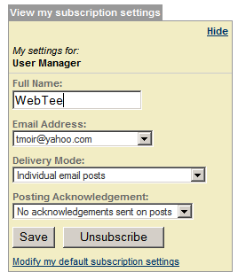  Figure 27

Download member directory  - Click Browse groups by category in the top navigation.  - Click the Category Name. A list of current groups will display.  - Click the View group homepage. The Group Homepage will display.  - Click the Member Directory link under Group Features. The Member Directory page will display.  - Click the Download directory link at the bottom of page. See figure 28. The entire directory will download into a Microsoft Excel spreadsheet. | Figure 28  Note: Only super administrators and owners can download the member directory

Group Messages
Group messages allow users to view archived group messages.
Modify group message
- Click the View all groups link in the top navigation. See figure 29.  - Click the View group homepage hyperlink. The Group Homepage will display.  - Click the Group Messages link in the top navigation. See figure 30. The Group Messages page will display. See figure 31.  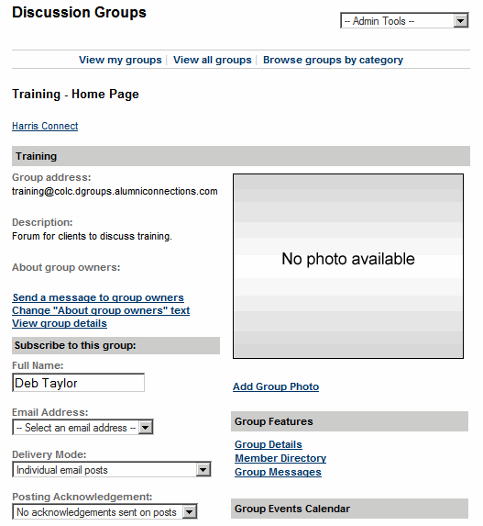  Figure 30  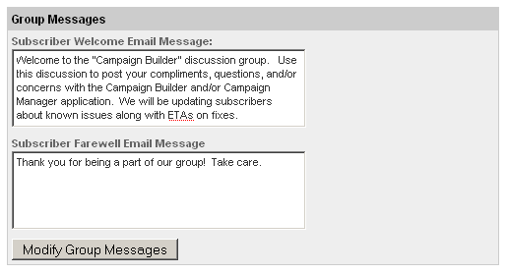  Figure 31 | 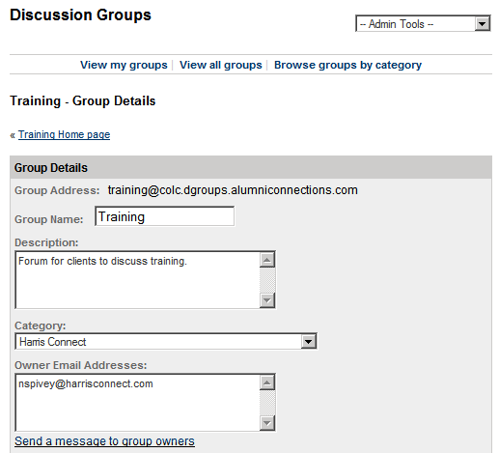  Figure 29  - Modify the Welcome or Farewell Email Messages for group subscribers.  - Click the Modify Group Members button. The Group Message page will refresh, and a “Group messages successfully modified” message will display at the top of the page.

Subscriptions
Send an invitation to a member to join a specific discussion group, or enroll members into a specific discussion group.

Send Invitations  - Click Browse groups by category in the top navigation.  - Click the Category Name. A list of current groups will display.  - Click the View group homepage. The Group Homepage will display.  - Click the Subscription link under Group Features. The Subscription page will display. See figure 32.  - Select whom the invitation should come from.  - Enter the potential subscriber’s email address. If inviting more than one, enter one email address per line.  - Click the Send Invitations button. The page will refresh, and an Invitation sent successfully confirmation will display at the top of the page. | 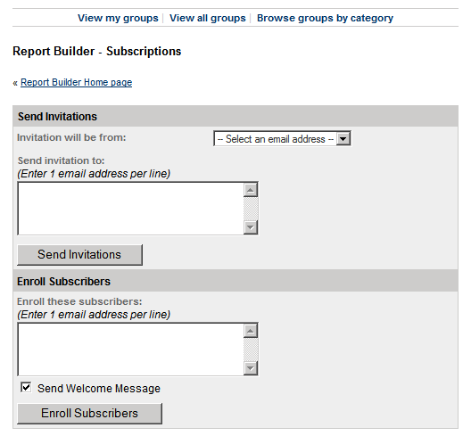  Figure 32

Usage Analysis
User analysis allows the administrator and owner the ability to capture the number of users by month, year, or school/year.

Report Types
Usage By Month - | Displays the Date (YYYY/MM) and the # of posts.
Usage By Member - | Displays the member's email address, preferred name, # of posts.
Usage By School/Year - | Displays school, class year, and # of posts.

How to create a Usage Analysis report:
- Click Browse groups by category in the top navigation.  - Click the Category Name. A list of current groups will display.  - Click the View group homepage. The Group Homepage will display.  - Click the Usage Analysis link under Group Features. The Usage Analysis page will display. See figure 33.  - Select the Report Type.  - Select the Date Range.  - Click Generate Usage Report. The page will refresh with the usage report displayed at the bottom of the page. See figure 34.  In the example used in Figures 34, the user wanted to capture the usage for Jan. 2008 - April 2008 by month. | 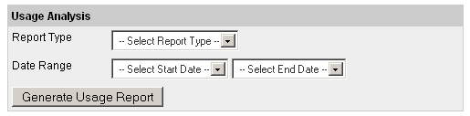  Figure 33  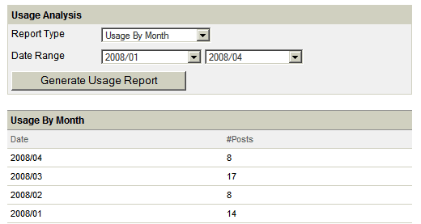  Figure 34

Calendar
Calendar allows administrators and owners to add, modify, and delete group events.
How to access the Group Calendar:
- Click Browse groups by category in the top navigation.  - Click the Category Name. A list of current groups will display.  - Click the View group homepage. The Group Homepage will display. The Group Events Calendar will display. See figure 35.  Note: Dates in bold have events listed, the current date is highlighted in yellow.  - Click the Month to view the view the larger version of the calendar or click the Calendar link under Group Features. See figure 36. Click the date to view that specific day’s events. See figure 37. | 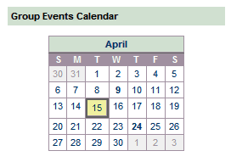  Figure 35
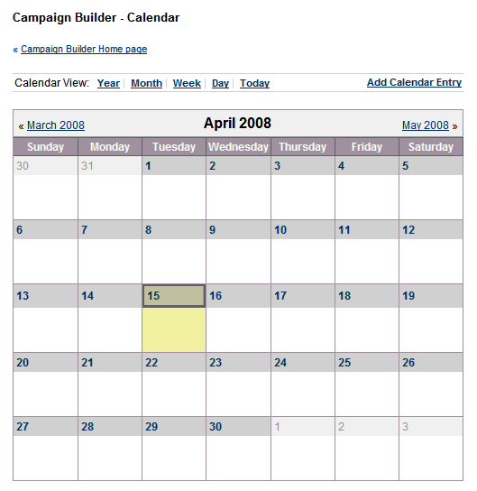  Figure 36 | 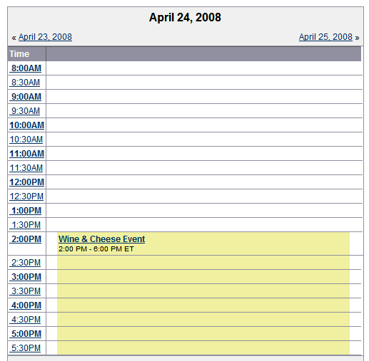  Figure 37
View additional calendar views such as Year, Week, & Today.

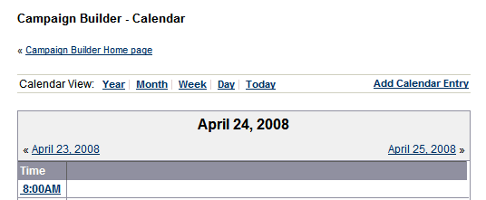

How to add an event to the Group Calendar:
- Click Browse groups by category in the top navigation.  - Click the Category Name. A list of current groups will display.  - Click the View group homepage. The Group Homepage will display.  - Click the Calendar link under Group Features. The Calendar page will display.  - Click the Add Calendar Entry link. The Add Group Calendar Entry page will display. See figure 38.  - Enter the event name as the Item Name, Start Date, Time, Duration, Time Zone Code, Description, and Location.  If the event recurs, select the frequency (Daily, Weekly, Monthly, Quarterly, or Yearly and select the end date or No End Date.  - Click Add Calendar Entry, or Cancel to abort. A Group calendar entry successfully added confirmation message will display at the top of the page. | 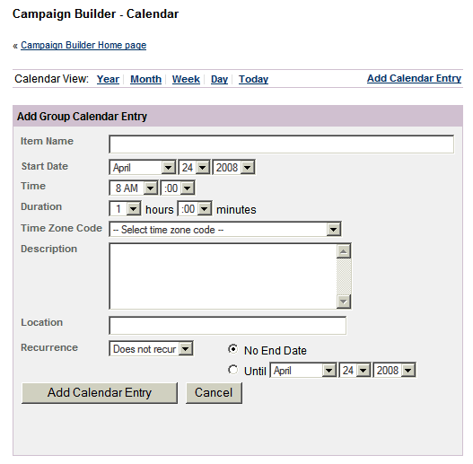  Figure 38

How to modify an event on the Group Calendar:
- Click Browse groups by category in the top navigation.  - Click the Category Name. A list of current groups will display.  - Click the View group homepage. The Group Homepage will display.  - Click the Calendar link under Group Features. The Calendar page will display.  - Access the appropriate date of the event you wish to modify. The Modify Group Calendar Entry will display. See figure 39.  - Make the necessary modifications.  - Click Modify Calendar Entry, or Cancel to abort. A Group calendar entry successfully modified confirmation message will display at the top of the page. | 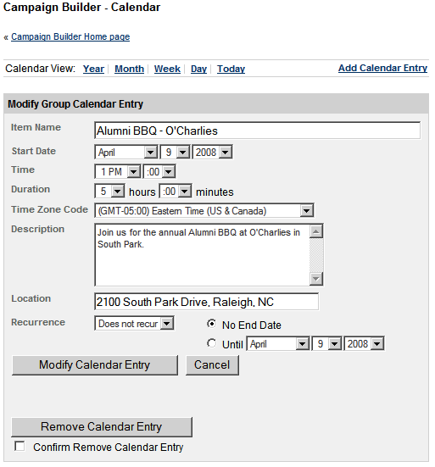  Figure 39
How to remove an event from the Group Calendar:
- Click Browse groups by category in the top navigation.
- Click the Category Name. A list of current groups will display.
- Click the View group homepage. The Group Homepage will display.
- Click the Calendar link under Group Features. The Calendar page will display.
- Access the appropriate date of the event you wish to modify. The Modify Group Calendar Entry will display. See figure 39.
- Check the Confirm Remove Calendar Enter checkbox.
- Click the Remove Calendar Entry button.

Links
Links allow administrators and owners to add group links.

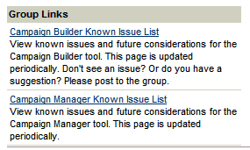
Figure 40

Add a group link  - Click Browse groups by category in the top navigation.  - Click the Category Name. A list of current groups will display.  - Click the View group homepage. The Group Homepage will display. Group Links display on the homepage under the Recent Group Posts. See figure 40.  - Click the Links link under Group Features. The Links page will display. See figure 41.  - Enter the Link URL.  - Enter the Name or Title of the site.  - Enter the Description.  - Click the Add Group Link. The page will refresh, and a “Group Link added” confirmation screen will display at the top of the page. | 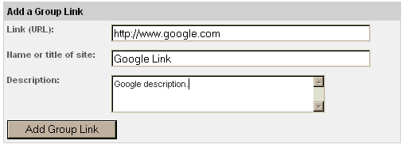  Figure 41

Modify/remove a group link  - Click Browse groups by category in the top navigation.  - Click the Category Name. A list of current groups will display.  - Click the View group homepage. The Group Homepage will display. Group Links display on the homepage under the Recent Group Posts.  - Click the Links link under Group Features. The Links page will display. See figure 42.  - Make the necessary modifications.  - Click the Modify Group Link or click the Remove Group Link to delete the link completely. | 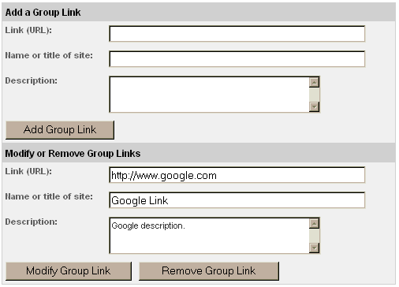  Figure 42

Group links accessed by subscribers.  - Click Browse groups by category in the top navigation.  - Click the Category Name. A list of current groups will display.  - Click the View group homepage. The Group Homepage will display. Group Links display on the homepage under the Recent Group Posts.  - Click the site name go to the site. | Figure 43

Post A Message
Post a message allows subscribers to post messages to the group.

How to post a message via the Groups 2.0 module:
- Click Browse groups by category in the top navigation.  - Click the Category Name. A list of current groups will display.  - Click the View group homepage. The Group Homepage will display.  - Click the Post A Message link under Group Features. The Post a Message page will display. See figure 44.  - Enter the Subject line, and your message in the space provided.  - If attachment(s) will be added click on Attach File link. See figure 44. Use the Internet browser’s capability to select and open the attachment(s).  - Once selected the attachments will display by name and size. See figure 45.  - Click Post this Message.  Attachments | 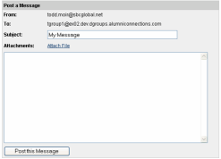  Figure 44  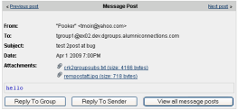  Figure 45
Important Information about Attachments

- Attachments must have one of the following file extensions:
  - Microsoft Word (file extensions: doc, dot)
  - Microsoft Excel (file extensions: xla, xlc, xlm, xls, xlt, xlw)
  - Microsoft Power Point (file extensions: pot, pps, ppt)
  - Adobe PDF (file extensions: pdf)
  - HTML (file extensions: htm, html, stm)
  - Text (all)
  - Image (all)
- Attachments are limited to three per post.
- Attachments can be added to the original message and/or replies to the group.
- Attachments cannot be added to a reply to sender only.
Note: If your organization does not wish to allow attachments or requires any changes to the default set-up please contact your CRM.

How to delete an attachment to a message:
- To delete prior to posting click the delete icon (“x”) that will appear next to the filename.
- To delete after posting only the super admin or owner can deactivate the posting. The message, without the attachment, can then be re-posted by the user, super admin or owner.

How to post a message by replying to a received message:
- Log into your email client
- Find a message you received from the group with the appropriate subject line.
- Click to Reply to the message.
- Enter your message.
- Click Send.

Note: If you are setup to receive individual email posts, you will receive a copy of your post.

Discussion Group Reporting
Discussion Group Reporting allows administrators to create downloadable Group Summary and Discussion Groups Organization Administrators reports in the Admin Tool.

How to access Discussion Group Reporting:
- Login to the Administration Center.
- Mouse over Reporting > Pre-Defined Reports in the top navigation. Click on Discussion Group Reports. The Group Summary report will load.
- Click the appropriate tab for the Report Type to view.

Groups Summary Report
The Groups Summary report displays the group name, group email address, parent category, status, owners, number of subscriptions, and the number of posts for each group.

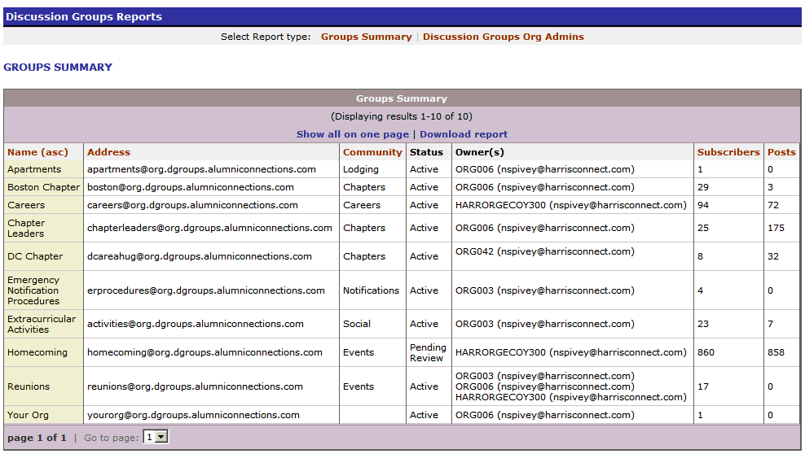
Discussion Groups Org Admins Report
The Discussion Groups Org Admins report displays each Discussion Group administrator's client ID, name, and email addresses. This report is downloadable. Click the Download Report link.

