How to Use Conditional Tags to Personalize Email Marketing

Administrators have the ability to create conditional content that will only display for targeted recipients within the recipient list. For example, for the Reunion Weekend announcement email blast we could say, “Welcome to your 1st Reunion Weekend!” to the class of 2008, but we could say “Join us for Reunion Weekend 2008!” to all other class years.

These instructions have been excerpted from the Email Marketing manual available in the Client Online Community Training Center. Please consult the manual for additional information.

Follow these steps:
- Log into your Administration Center.  - Mouse over Email Marketing in the top navigation.  - Click on Create & Manage Email Content.  - Click on Create content button.  - Anchor your cursor where you want to place the conditional statement.  - Click the Create a conditional tag button at the top of the page. The Create a conditional tag popup will display. See figure 1.  - Select the field you wish to target from the dropdown choices.  - Select equals or contains.  - Enter the text you wish to display for this targeted group.  - Check the Check here to include an “else” clause, if applicable. The window will refresh and the “or else” content area will display. See figure 2.  - Enter the Else clause.  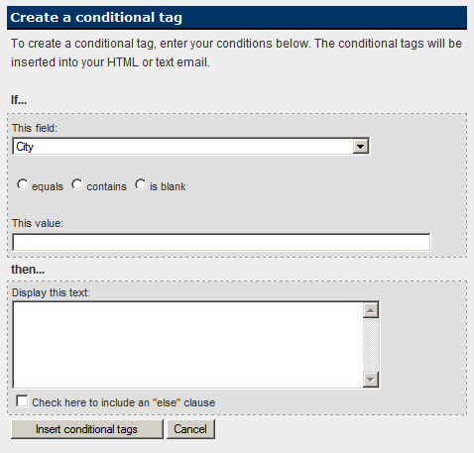.  Figure 1 | - Click Insert Conditional tags, or Cancel to abort.  - The conditional statement will appear in the content window. See figure 3.  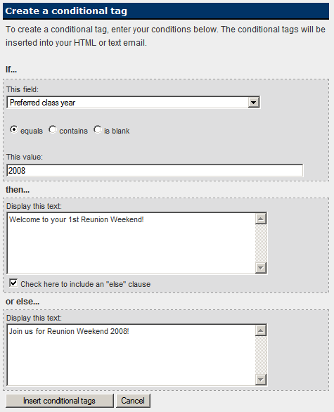  Figure 2  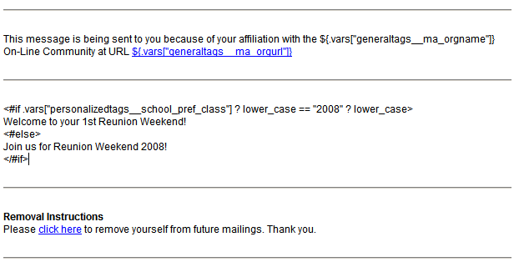  Figure 3

