Category Reports

Table of Contents

Introduction 3
Category Reports 3
How to access Category Reports 3
Category List Page 4
How to Customize the Category List Page 5
How to print the Category List Page 5
How to download the Category List Page 6
Category Summary Report 9
How to access the Category Summary Report 9
How to print the Category Summary Report 10
Category Transaction Report 11
How to access the Category Transaction Report 11
How to print the Category Transaction Report 12

Introduction
Category Reports provide consolidated form activity information across form applications (Event Registration, Donations, Memberships and Surveys). Administrators can analyze category-specific form activity data, track the success of forms based on form categories, print report results and report on other valuable information.

Available Category Reports include Category List, Category Summary and Category Transaction Reports. Reports can be customized by form ownership, activation status, archive status, or type. (Calendar view filtering is also available for Events.)

Printer friendly versions are available for each report.

Category Reports
How to access Category Reports:
- Log into the Admin Center. Select Reporting > Form Reports > Category Reports. See figure 1. The Category List page will display. | 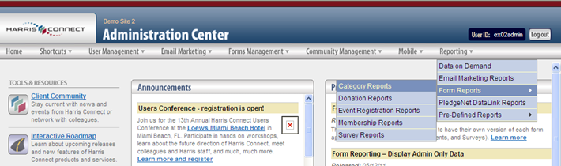  Figure 1

Category List Page
The Category List page is the Category Reports landing page that displays all active form categories all along with the total number of available forms assigned to each category, total orders placed through all forms, and the total amount captured for all forms. The Total number of forms count will direct administrators to the new Category Summary Report, and the Total orders for all forms count will direct administrators to the new Category Transaction Report. See Figure 2.
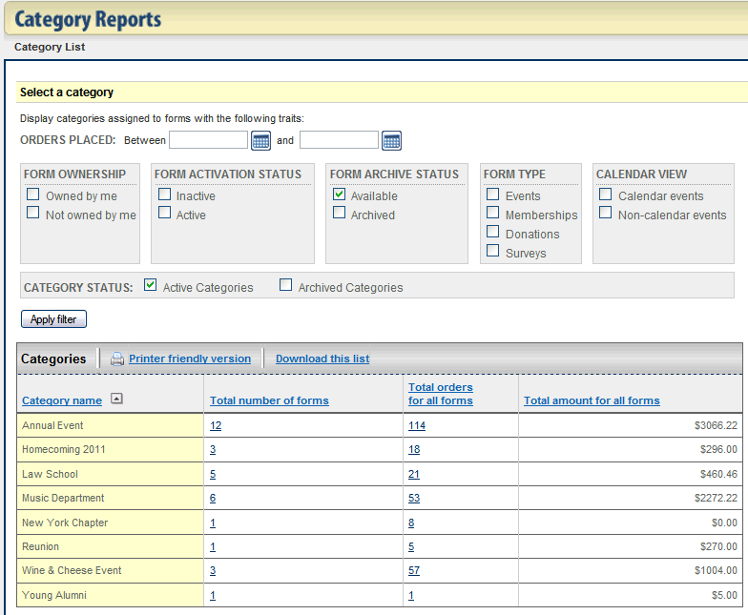
Figure 2

How to Customize the Category List Page:
- Login to the Admin Center.
- Select Reporting > Form Reports > Category Reports. The Category Reports page will display.
- Enter the appropriate filter settings. See Figure 3.
- Click Apply filter. The Category List page will refresh.

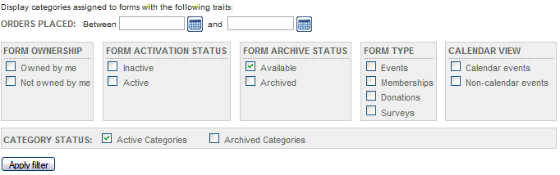
Figure 3

How to print the Category List Page:
- Login to the Admin Center.
- Select Reporting > Form Reports > Category Reports. The Category Reports page will display.
- Click the Printer friendly version link. See Figure 4. The printer friendly version will open with the Print window.

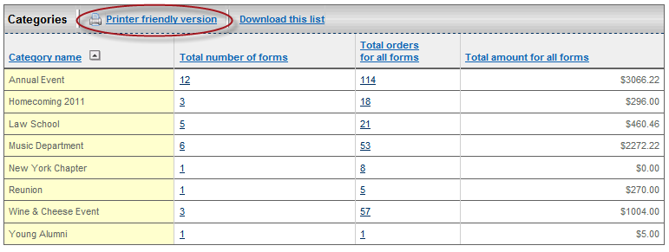
Figure 4

- Click the Print button. See Figure 5.

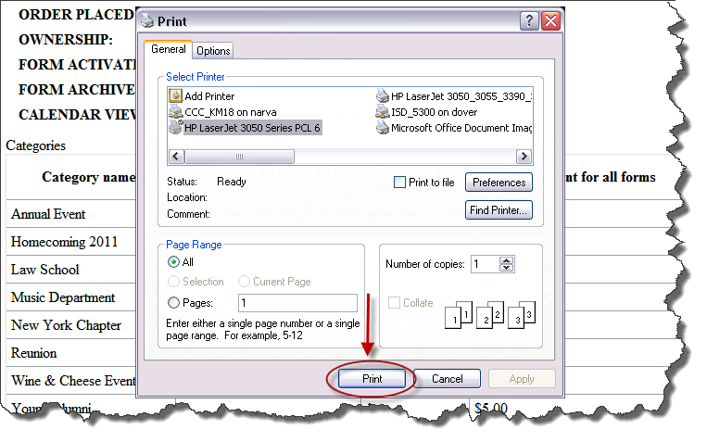
Figure 5

How to download the Category List Page:
- Login to the Admin Center.
- Select Reporting > Form Reports > Category Reports. The Category Reports page will display.
- Click the Download this list link. See Figure 6. The File Download window will display. See Figure 7.

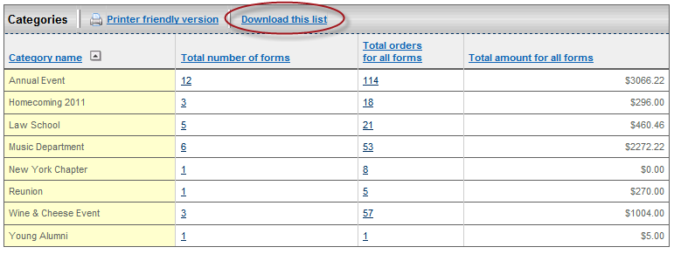
Figure 6

- Click Save to save the comma separated file to your local computer. The Save as window will display. See Figure 8.

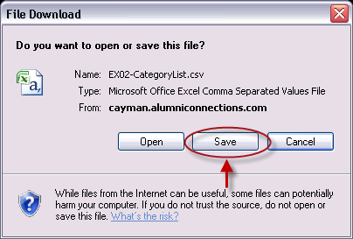
Figure 7

- Find the appropriate location to save the folder. Notice the name of the file (Form Category Report M_DD_YYYY.csv).
- Click Save button. See Figure 8.

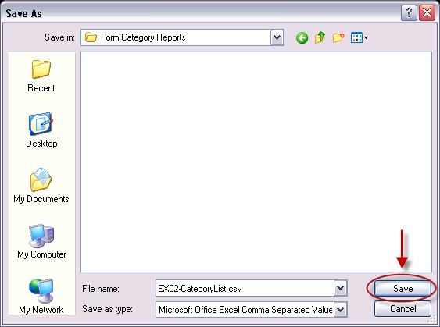
Figure 8

The saved report can be opened using Microsoft Excel. See Figure 9. Note: The column widths may need to be manually adjusted.

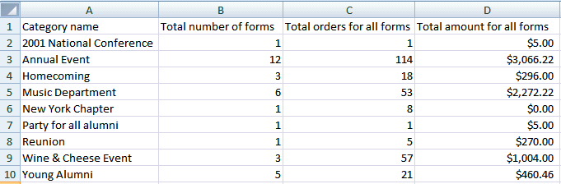
Figure 9
Category Summary Report
The Category Summary Report provides a summary for all forms assigned to the selected category. See Figure 10. Cumulative totals appear at the top while form application specific totals are broken out below. The Form IDs are hyperlinks to the Summary Report within the Form Report application. A quick link to the corresponding Category Transaction Report is available via the Total orders in all forms count.

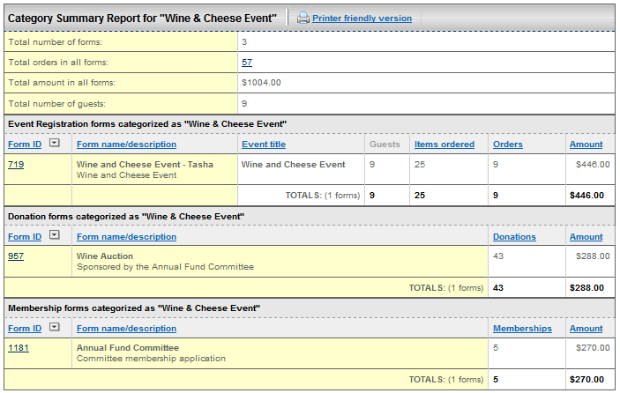
Figure 10

How to access the Category Summary Report:
- Login to the Admin Center.
- Select Reporting > Form Reports > Category Reports. The Category Reports page will display.
- Click the form count link in the Total number of forms column. See Figure 11. The Category Summary Report will display.

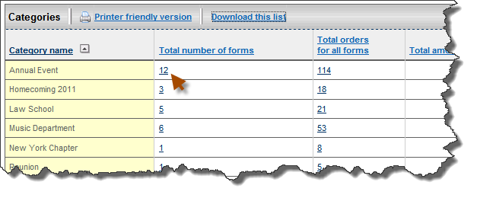
Figure 11

How to print the Category Summary Report::
- Login to the Admin Center.
- Select Reporting > Form Reports > Category Reports. The Category Reports page will display.
- Click the form count link in the Total number of forms column. The Category Summary Report will display.
- Click the Printer friendly version link. See Figure 12. The printer friendly version will open with the Print window.
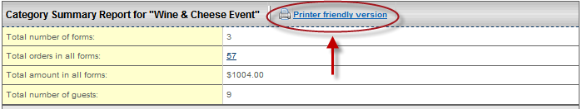
Figure 12

- Click Print. See Figure 13.

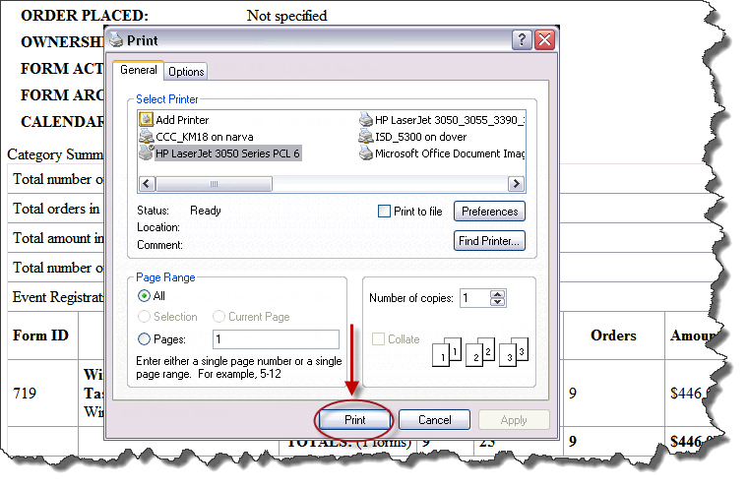
Figure 13
Category Transaction Report
The Category Transaction Report provides list of all the transactions/orders captured for the selected category. See Figure 14. Cumulative totals appear at the top while form application specific totals are broken out below. The Order IDs are hyperlinks to the Order Summary Page within the Event Registration Report application.
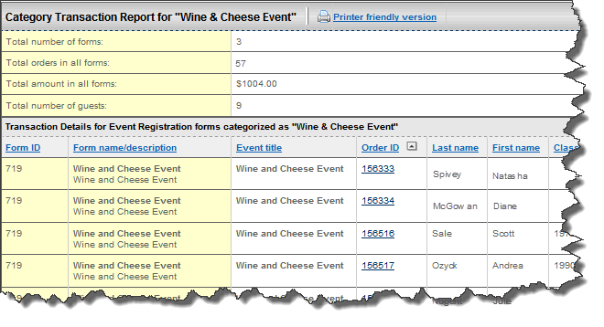
Figure 14

How to access the Category Transaction Report:
- Login to the Admin Center.
- Select Reporting > Form Reports > Category Reports. The Category Reports page will display. See Figure 15.
- Click the order count link in the Total orders for all forms column. See Figure 15. The Category Transaction Report will display.

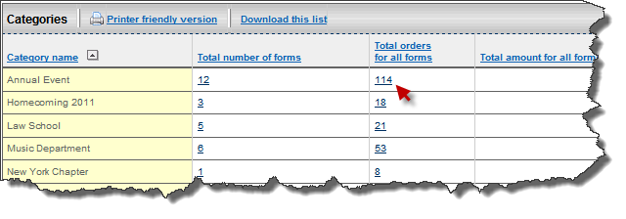
Figure 15

How to print the Category Transaction Report:
- Login to the Admin Center.
- Select Reporting > Form Reports > Category Reports. The Category Reports page will display.
- Click the order count link in the Total orders for all forms column. The Category Transaction Report will display.
- Click the Printer friendly version link. See Error: Reference source not found. The printer friendly version will open with the Print window.
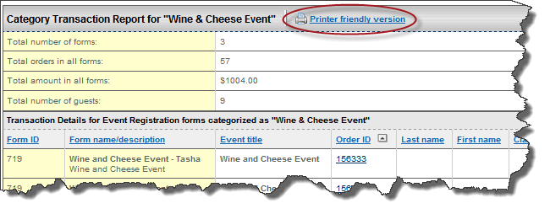
Figure 16

- Click Print. See Figure 17.

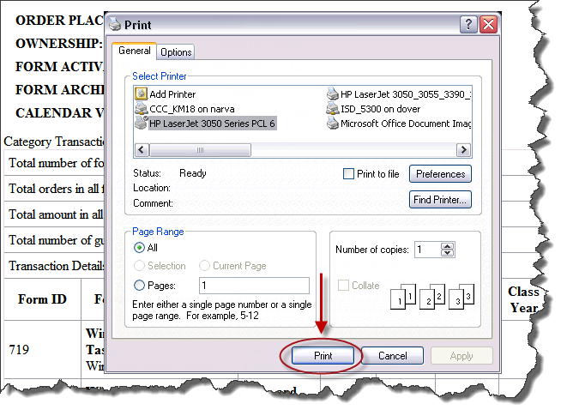
Figure 17

