User Order Entry

Register User for An Event
Submit a Donation Form for User
Submit a Membership Form for User
Submit a Survey Form for User

Table of Contents
Introduction 3
Submit Form on Behalf of a Community User 4
Form Selection 4
Identify Community User 4
Submit Form 6
Submit Form on Behalf of Anonymous Registrant 6
Form Selection 6
Submit Form 7

Introduction

User Order Entry allows administrators to submit forms (event registrations, donations, membership forms, survey forms) for online community users as well as for the general public. Any field, section or payment option that has been designated as "admin only" will be available to administrators when submitting a form via User Order Entry.

When submitting on behalf of a community user, administrators can easily search for and identify that user within the database, select the form, and enter the order for the user. A pop-up user profile snapshot also provides administrators the ability to view other profile information to ensure that they are selecting the correct user for which they are entering a donation or other form. The user’s client ID is attached to the form during the auto-fill stage, and can be reported out in reports or feeds.

All forms are located in one area, giving administrators easy access to move from form to form when entering information on behalf of a community user and/or the general public. This process enables a deeper profile of a community user’s activities.

Submit Form on Behalf of a Community User

Use this function to submit an Event Registration Form or Membership Form or Online Giving Form or Survey Form on behalf of a member of your community who has a record in your database. During the auto-fill stage, the member’s client ID will be attached to the form for reporting purposes.

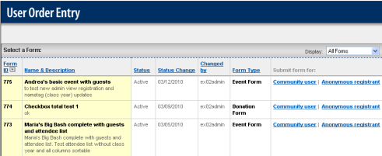
Figure 1

Form Selection
How to select a form:
- Log into the Administration Center.
- Mouse over Forms Management in the top navigation.
  - For Events choose Events > Register User for an Event.
  - For Donations choose Donations > Submit a Donation Form For User
  - For Memberships choose Memberships > Submit a Membership Form For User
  - For Surveys choose Surveys & Polls > Submit a Survey Form For User.
- The User Order Entry page will display. See figure 1.
- Identify the form from the list of active forms. If the form you wish to use is not listed verify the form has been activated within the Event Registration or Donation/Membership Forms applications.

Note: The forms may be sorted by any clickable column heading.

Identify Community User
How to identify the correct community user:
- Click on Community User link in column labeled “Submit form for:” See figure 1.
- The confirmation email selection window will display.
- Select whether to send a confirmation email.
- Click Continue.
- The page entitled “Search for a Community User” will be returned.
- To search for the community user by name, enter the user’s First and Last Name values in the Common Search or Personal table.
- To view all available search fields click the expand icon () to view each table. Use the collapse icon () to hide the fields.
- Click Search button at bottom of page. See figure 2.

Note: The sections and fields that display on the search criteria page will differ for each institution/association. | 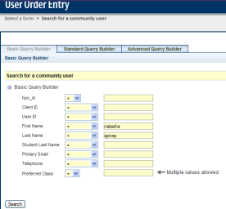
Figure 2

- The Search Results page will be returned to the screen. See figure 3.

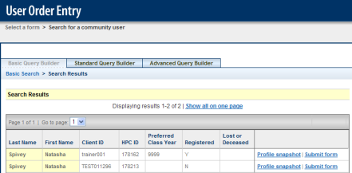
Figure 3

- To identify the correct community user, click the View profile snapshot link to view a snapshot of the user’s profile. See figure 4.  - If multiple records are displayed, click Previous or Next to move between records. Click Close window when viewing is completed. | - When the correct community user is identified click on Submit form link beside the name. This will return the correct form for collection of additional information. See figure 5.

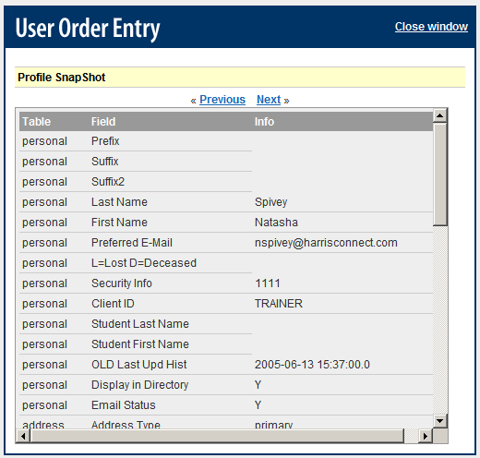 | 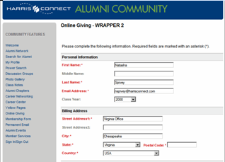  Figure 5
Figure 4

Submit Form
How to submit a form for a community user
- The form will be pre-populated with the community user’s data from the database. See figure 5.
- Complete the additional required and appropriate information.
- Click Submit button.

Submit Form on Behalf of Anonymous Registrant

Use this function to submit an Event Registration Form or Membership Form or Online Giving Form on behalf of an anonymous registrant who does not have a record in your database. No auto-fill will be available; no client ID will be attached to the form.

Form Selection
How to select a form:
- Log into the Administration Center.
- Mouse over Forms Management in the top navigation.
  - For Events choose Events > Register User for an Event.
  - For Donations choose Donations > Submit a Donation Form For User
  - For Memberships choose Memberships > Submit a Membership Form For User
  - For Surveys choose Surveys & Polls > Submit a Survey Form For User.
- The User Order Entry page will display. See figure 1.
- Identify the form from the list of active forms. If the form you wish to use is not listed verify the form has been activated within the Event Registration or Donation/Membership Forms applications.

Note: The forms may be sorted by any clickable column heading.

Submit Form
How to submit a form for anonymous registrant:
- Click on Anonymous Registrant link in column labeled “Submit form for:” See figure 1.
- The confirmation email selection window will display.
- Select whether to send a confirmation email.
- Click Continue.
- The form will display with no pre-filled information. Complete all required and appropriate fields. See figure 6.
- Click Submit button.

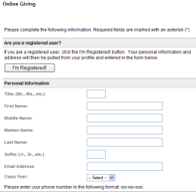
Figure 6

