User Manager

Table of Contents

Introduction 3
Modify User 4
Basic Query Builder 4
Standard Query Builder 6
Advanced Query Builder 6
Edit user info 8
Change History 9
Alumni Photo (Profile Photo) 11
Resume Upload 17
Privacy Settings 23
User Registration 25
Broadcast Preferences 29
Add/Edit Class Notes 31
View User Snapshot 33
Send User ID/Password 36
Add New User 37

Introduction

From one view of a user, administrators can easily manage the user profile data, modify or enter a Class Notes for a user, view their photo galleries, manage their resume, change their privacy and broadcast email preferences and more. Institutional administrators can enable administrative status from this view as well. This new tool will streamline the management of users for administrators, combining several existing administrative tool functions into one easy-to-use interface.

Modify User
Use this option to view and/or update an individual's record in the database. You can also use this feature to determine whether or not the individual is registered.

Basic Query Builder
Basic Query Builder automatically displays common search fields to allow administrators to quickly search for users with ease.

How to search for a user:
- Log into the Administration Center.  - Mouse over User Management > View/Modify/Register User. The Modify User tab will display with the Basic Query Builder selected by default.  - Enter the values for the appropriate fields to successfully search for the user.  - Click Search. The Search Results page will display. See figure 2. | 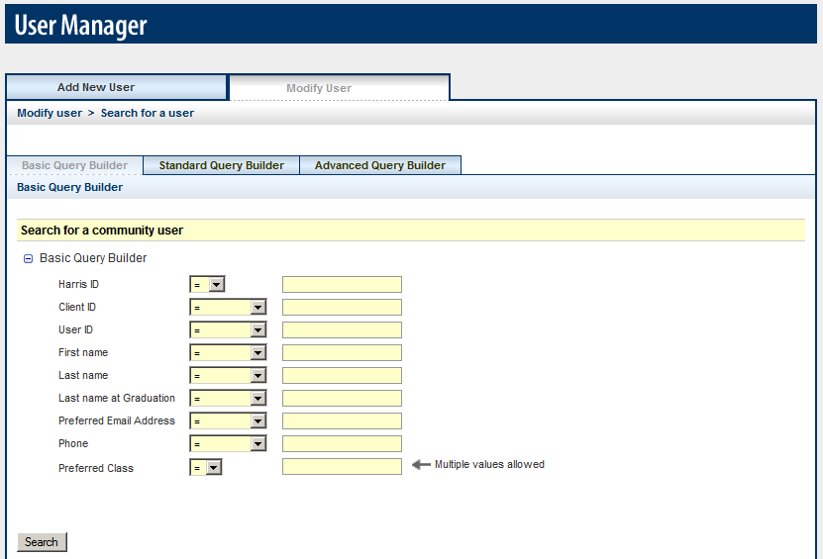  Figure 1
  Operators
  = | Equal To
  != | Not Equal To

Search Results Page
The Search Results Page allows administrators to capture additional information about all users who matched the search query such as Client ID, Name, Preferred Class Year, and Email Address.

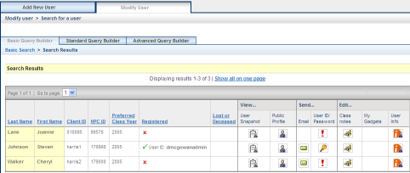
Figure 2

Registered
Y indicates the user is registered and displays the User ID; N indicates the user is not registered.

Lost/Deceased
L indicates the user is lost, and D indicates the user is deceased if the value is available for the record.

View… User Snapshot
Click the icon to access the various snapshot reports for the user.

View… Public Profile
Click the icon to view how the public sees the user’s profile.

Send… Email
Hover over the icon to see the user’s email address; click the icon to quickly send an email message.

Send… User ID/Password
Click the key icon to quickly send an email to the user containing their login information. If the exclamation point icon appears, it means that the login information cannot be sent – click the exclamation point icon to find out why.

Edit… Class Notes
Click the icon to add/edit Class Notes on the user’s behalf.

Edit… My Gadgets
Click the icon to edit the user’s gadgets if configured.

Edit… User Info
Click the icon to edit the user’s profile information.

Standard Query Builder
Standard Query Builder is used to expand your search capabilities.

How to search for a user:
- Log into the Administration Center.  - Mouse over User Management > View/Modify/Register User. The Modify User tab will display by default.  - Click the Standard Query Builder tab.  - Click the expand icon (), to view the available fields in the appropriate table.  Use the collapse icon () to hide the fields.  - To search by name, expand the Personal section and enter the appropriate First and Last Name values.  - Click Search. | 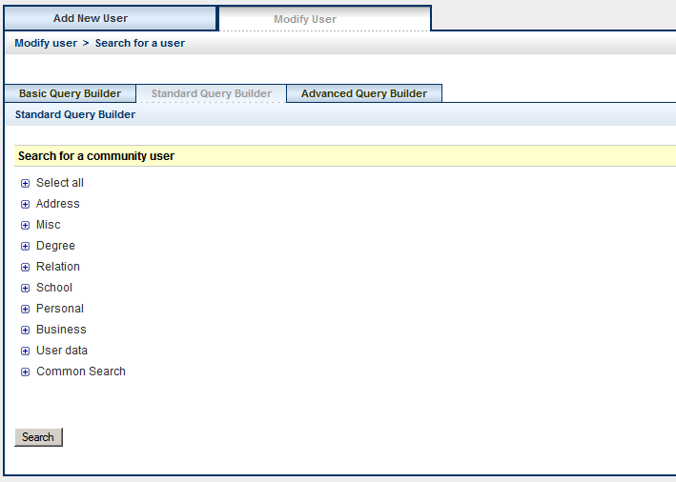  Figure 3

Advanced Query Builder
Standard Query Builder is used to expand your search capabilities.

How to search for a user:
- Log into the Administration Center.  - Mouse over User Management > View/Modify/Register User. The Modify User tab will display by default.  - Select Advanced Query Builder tab.  - Select the appropriate table, field, and logical operator (equal to/not equal to).  - Enter the appropriate value(s)  - Select the appropriate Boolean operator (and/or). Query OK message displays when the query is valid. | 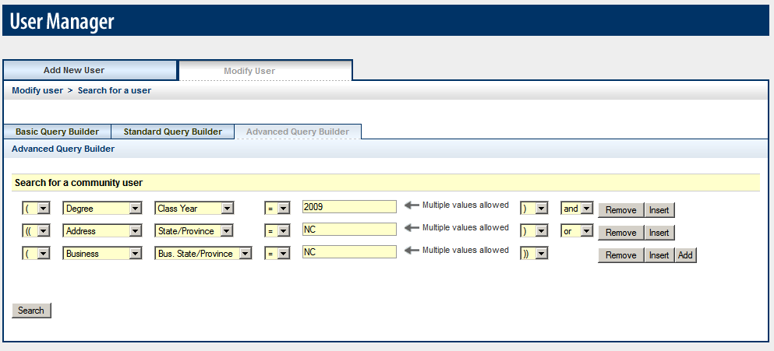  Figure 4
Use the parenthesis to group statements together. For example: If I’m searching for a member who has a class year equal to 2009 and lives or works in North Carolina, them my query should be:

(Degree Class Year = 2009) and ((Address State = NC) or (Business State = NC))

Edit user info
The Edit user info link allows the administrator to access the user’s profile.

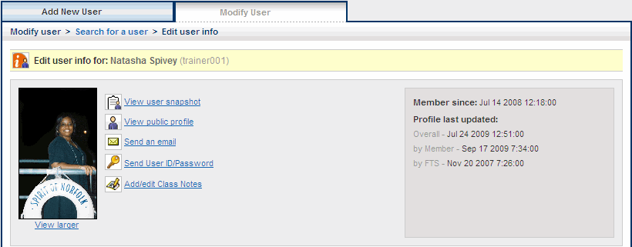

Search for a user | Click to return to the search results page.
Member since | Indicates how long the user has been a member.
Profile last updated | Indicates date & time stamp of when the user’s profile was last updated.
View user snapshot | Click to access the various snapshot reports for the user.
View public profile | Click to view how the public sees the user’s profile.
Send an email | Click to quickly send an email message.
Send User ID/Password | Click to quickly send an email to the user containing their login information.
Add/edit Class Notes | Click to add/edit Class Notes on the user’s behalf.
View larger | Click to view larger photo.

How to modify a user’s profile:
- Log into the Administration Center.  - Mouse over User Management > View/Modify/Register User. The Modify User tab will display with the Basic Query Builder selected by default.  - Enter search criteria.  - Click Search. The Search Results page will display.  - Click the Edit user info icon for the appropriate user. The Edit user info page will display with the Profile Details tab selected by default. See figure 6.  - Click the expand icon (), to view the available fields in the appropriate table.  Use the collapse icon () to hide the fields.  - Make the necessary modifications.  - Click Save Profile Details, or Cancel to abort. | 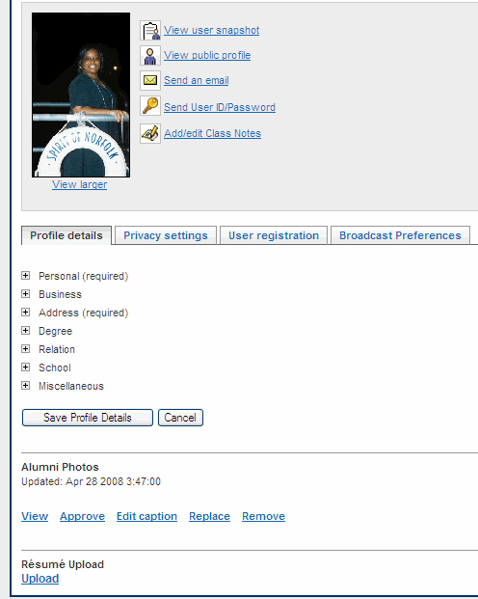  Figure 6

Change History
Administrators have the ability to capture change history for Profile data.
How to access change history:
- Log into the Administration Center.  - Mouse over User Management > View/Modify/Register User. The Modify User tab will display with the Basic Query Builder selected by default.  - Enter search criteria.  - Click Search. The Search Results page will display.  - Click the Edit user info icon for the appropriate user. The Edit user info page will display with the Profile Details tab selected by default. See figure 6.  - Click the expand icon (), to view the available fields in the appropriate table.  Use the collapse icon () to hide the fields.  - Click the data field name, which is a hyperlink (underlined). See figure 7.  - The Field History popup window will display. See figure 8. | 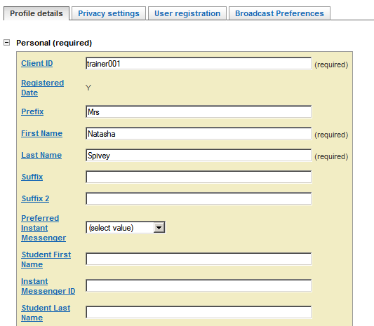  Figure 7  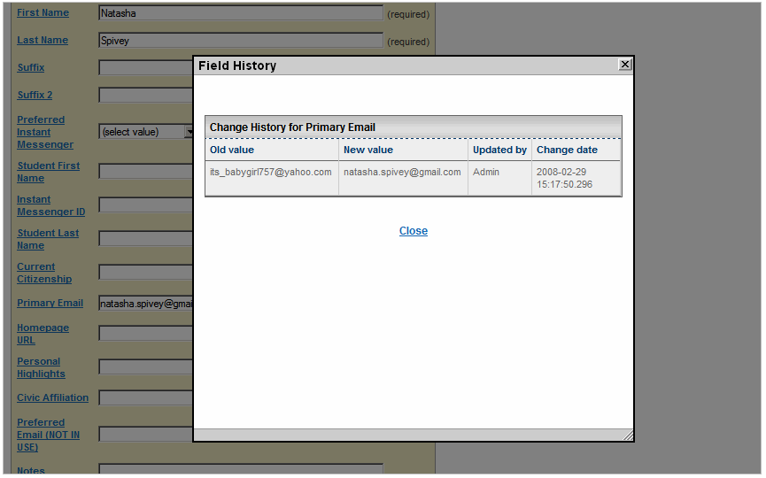  Figure 8

Alumni Photo (Profile Photo)
Use this option if the Online Directory Photo Upload feature is activated in your online directory. Administrators have the ability to upload, replace, or remove a photo on a user’s behalf, approve/reject a photo, and edit the photo’s caption.

IMPORTANT!
* The photo image must not exceed the maximum size (150000 bytes).
* Photo file format must be GIF, JPEG or PNG image type.

How to upload a photo:
- Log into the Administration Center.  - Mouse over User Management > View/Modify/Register User. The Modify User tab will display with the Basic Query Builder selected by default.  - Click the expand icon (), to view the available fields in the appropriate table.  Use the collapse icon () to hide the fields.  - Enter search criteria.  - Click Search. The Search Results page will display.  - Click the Edit user info icon for the appropriate user. The Edit user info page will display with the Profile Details tab selected by default.  - Click the Upload link under Photos section. See figure 9. The page will refresh with the Select a photo to upload field displayed. See figure 10.  - Click the Browse button to search for the appropriate photo.  - Click Upload photo, or Cancel to abort. “User Directory Photo Modified” will display at the top of the Edit user info page. | 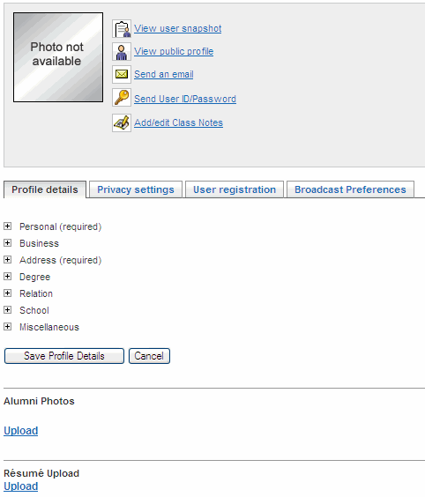  Figure 9  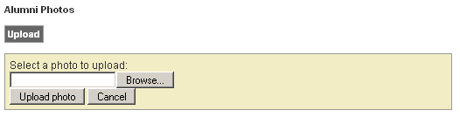  Figure 10

How to remove a photo:
- Log into the Administration Center.  - Mouse over User Management > View/Modify/Register User. The Modify User tab will display with the Basic Query Builder selected by default.  - Click the expand icon (), to view the available fields in the appropriate table.  Use the collapse icon () to hide the fields.  - Enter search criteria.  - Click Search. The Search Results page will display.  - Click the Edit user info icon for the appropriate user. The Edit user info page will display with the Profile Details tab selected by default.  - Click the Remove link under Alumni Photo. An “Are you sure…?” section will appear. See figure 11.  - Click Remove photo, or Cancel to abort. “User Directory Photo Modified” will display at the top of the Edit user info page. | 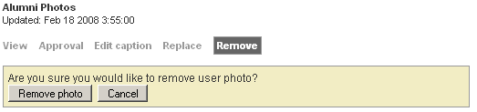  Figure 11
How to replace a photo:
- Log into the Administration Center.  - Mouse over User Management > View/Modify/Register User. The Modify User tab will display with the Basic Query Builder selected by default.  - Click the expand icon (), to view the available fields in the appropriate table.  Use the collapse icon () to hide the fields.  - Enter search criteria.  - Click Search. The Search Results page will display.  - Click the Edit user info icon for the appropriate user. The Edit user info page will display with the Profile Details tab selected by default.  - Click the Replace link under Alumni Photo. A “Select a photo to upload:” field will appear. See figure 12.  - Click Upload photo, or Cancel to abort. “User Directory Photo Modified” will display at the top of the Edit user info page. | 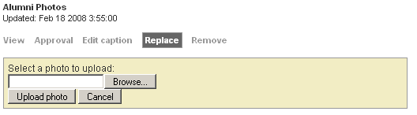  Figure 12

How to edit the photo caption:
- Log into the Administration Center.  - Mouse over User Management > View/Modify/Register User. The Modify User tab will display with the Basic Query Builder selected by default.  - Click the expand icon (), to view the available fields in the appropriate table.  Use the collapse icon () to hide the fields.  - Enter search criteria.  - Click Search. The Search Results page will display.  - Click the Edit user info icon for the appropriate user. The Edit user info page will display with the Profile Details tab selected by default.  - Click the Edit caption link under Alumni Photo. An “Enter a photo caption” field will appear. See figure 13.  - Click Save caption, or Cancel to abort. “User Directory Photo Modified” will display at the top of the Edit user info page. | 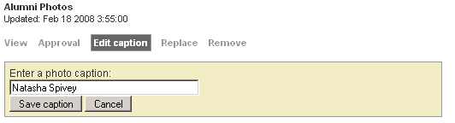  Figure 13

How to approve a user’s photo:
- Log into the Administration Center.  - Mouse over User Management > View/Modify/Register User. The Modify User tab will display with the Basic Query Builder selected by default.  - Click the expand icon (), to view the available fields in the appropriate table.  Use the collapse icon () to hide the fields.  - Enter search criteria.  - Click Search. The Search Results page will display.  - Click the Edit user info icon for the appropriate user. The Edit user info page will display with the Profile Details tab selected by default.  - Click the Approve link under Alumni Photo. An “Approval status” shaded area will appear. See figure 14.  - Select the appropriate Approval status.  - Click Update approval, or Cancel to abort. “User Directory Photo Modified” will display at the top of the Edit user info page. | 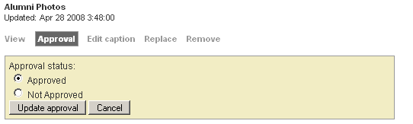  Figure 14
How to view the full view of a user’s photo:
- Log into the Administration Center.  - Mouse over User Management > View/Modify/Register User. The Modify User tab will display with the Basic Query Builder selected by default.  - Click the expand icon (), to view the available fields in the appropriate table.  Use the collapse icon () to hide the fields.  - Enter search criteria.  - Click Search. The Search Results page will display.  - Click the Edit user info icon for the appropriate user. The Edit user info page will display with the Profile Details tab selected by default.  - Click the View link under Alumni Photo. A new window will appear with the full view of the user’s photo. See figure 15.  - Click close window link to return to the Edit user info page. | 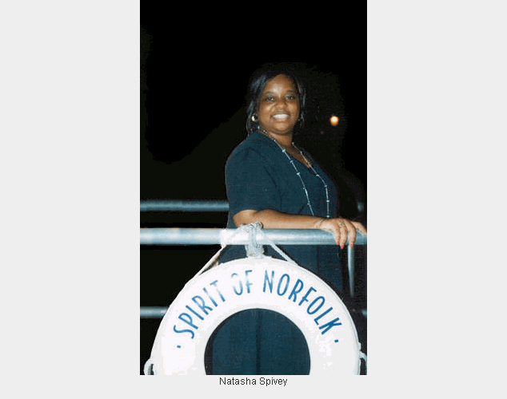  Figure 15

Resume Upload
Use this option if the Resume Upload feature has been activated for your online directory. Administrators have the ability to upload a Resume on a user’s behalf. The Resume Upload application may be referred by a different name in the Online Directory such as Resume Bank or Resume Depot.
How to upload a resume:
- Log into the Administration Center.  - Mouse over User Management > View/Modify/Register User. The Modify User tab will display with the Basic Query Builder selected by default.  - Click the expand icon (), to view the available fields in the appropriate table.  Use the collapse icon () to hide the fields.  - Enter search criteria.  - Click Search. The Search Results page will display.  - Click the Edit user info icon for the appropriate user. The Edit user info page will display with the Profile Details tab selected by default.  - Click the Upload link under Resume Upload. A “Select a resume to upload” field will appear. See figure 16.  - Click Browse and search for the appropriate resume file.  - Click Update resume, or Cancel to abort. “User Resume Modified” will display at the top of the Edit user info page. | 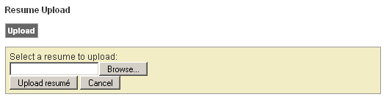  Figure 16
How to remove a resume:
- Log into the Administration Center.  - Mouse over User Management > View/Modify/Register User. The Modify User tab will display with the Basic Query Builder selected by default.  - Click the expand icon (), to view the available fields in the appropriate table.  Use the collapse icon () to hide the fields.  - Enter search criteria.  - Click Search. The Search Results page will display.  - Click the Edit user info icon for the appropriate user. The Edit user info page will display with the Profile Details tab selected by default.  - Click the Remove link under Resume Upload. An “Are you sure…?” shaded area will appear. See figure 17.  - Click Remove resume, or Cancel to abort. “User Resume Modified” will display at the top of the Edit user info page. | 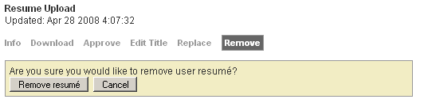  Figure 17

How to replace a Resume:
- Log into the Administration Center.  - Mouse over User Management > View/Modify/Register User. The Modify User tab will display with the Basic Query Builder selected by default.  - Click the expand icon (), to view the available fields in the appropriate table.  Use the collapse icon () to hide the fields.  - Enter search criteria.  - Click Search. The Search Results page will display.  - Click the Edit user info icon for the appropriate user. The Edit user info page will display with the Profile Details tab selected by default.  - Click the Replace link under Resume Upload. A “Select a resume to upload” field will appear. See figure 18.  - Click Browse and select the appropriate resume file to upload.  - Click Update resume, or Cancel to abort. “User Resume Modified” will display at the top of the Edit user info page. |  | 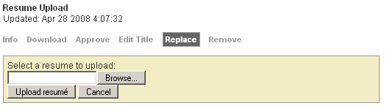  Figure 18
How to edit a Resume title:
- Log into the Administration Center.  - Mouse over User Management > View/Modify/Register User. The Modify User tab will display with the Basic Query Builder selected by default.  - Click the expand icon (), to view the available fields in the appropriate table.  Use the collapse icon () to hide the fields.  - Enter search criteria.  - Click Search. The Search Results page will display.  - Click the Edit user info icon for the appropriate user. The Edit user info page will display with the Profile Details tab selected by default.  - Click the Edit Title link under Resume Upload. A Resume title field will appear. See figure 19.  - Enter the appropriate Resume title.  - Click Save title, or Cancel to abort. “User Resume Modified” will display at the top of the Edit user info page. | 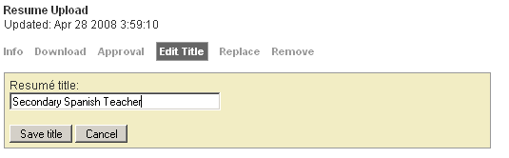  Figure 19

How to approve/reject a Resume:
- Log into the Administration Center.  - Mouse over User Management > View/Modify/Register User. The Modify User tab will display with the Basic Query Builder selected by default.  - Click the expand icon (), to view the available fields in the appropriate table.  Use the collapse icon () to hide the fields.  - Enter search criteria.  - Click Search. The Search Results page will display.  - Click the Edit user info icon for the appropriate user. The Edit user info page will display with the Profile Details tab selected by default.  - Click the Approval link under Resume Upload. An “Approval status” shaded area will appear. See figure 20.  - Select the appropriate Approval status.  - Click Update approval, or Cancel to abort. “User Resume Modified” will display at the top of the Edit user info page. |  | 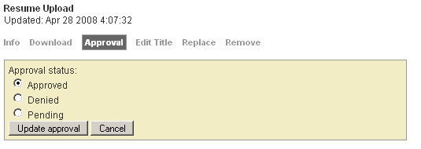  Figure 20
How to download a Resume:
- Log into the Administration Center.  - Mouse over User Management > View/Modify/Register User. The Modify User tab will display with the Basic Query Builder selected by default.  - Click the expand icon (), to view the available fields in the appropriate table.  Use the collapse icon () to hide the fields.  - Enter search criteria.  - Click Search. The Search Results page will display.  - Click the Edit user info icon for the appropriate user. The Edit user info page will display with the Profile Details tab selected by default.  - Click the Download link under Resume Upload. A File Download window will appear. See figure 21.  - Click Save to save the download resume to your local computer. A Save As window will display. See figure 22.  - Click Save. A Download Complete window will display.  - Click Open to access the resume. | 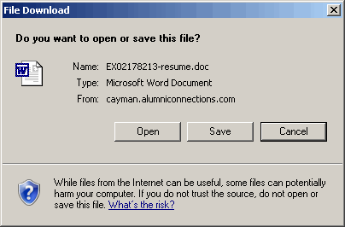  Figure 21  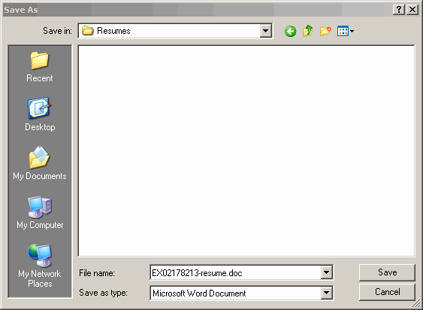  Figure 22

How to view resume info:
- Log into the Administration Center.  - Mouse over User Management > View/Modify/Register User. The Modify User tab will display with the Basic Query Builder selected by default.  - Enter search criteria.  - Click Search. The Search Results page will display.  - Click the Edit user info icon for the appropriate user. The Edit user info page will display with the Profile Details tab selected by default.  - Click the Info link under Resume Upload. The info will display in a shaded area. See figure 23.  - Click Close to hide the info section. | 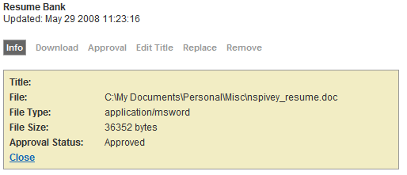  Figure 23

Privacy Settings
Administrators can completely hide/unhide a user’s personal profile or specific data fields on a user’s behalf.

How to hide/unhide a user’s entire profile:
- Log into the Administration Center.  - Mouse over User Management > View/Modify/Register User. The Modify User tab will display with the Basic Query Builder selected by default.  - Enter search criteria.  - Click Search. The Search Results page will display.  - Click the Edit user info icon for the appropriate user. The Edit user info page will display with the Profile Details tab selected by default.  - Click the Privacy settings tab. The Privacy settings page will display. See figure 24.  - Check the Hide my entire personal profile from public view checkbox.  - Click Modify Privacy Settings, or Cancel to abort. “User Privacy Modified” will display at the top of the Privacy settings page. | 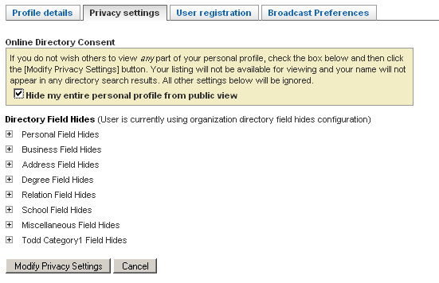  Figure 24
How to hide/unhide specific data fields:
- Log into the Administration Center.  - Mouse over User Management > View/Modify/Register User. The Modify User tab will display with the Basic Query Builder selected by default.  - Click the expand icon (), to view the available fields in the appropriate table.  Use the collapse icon () to hide the fields.  - Enter search criteria.  - Click Search. The Search Results page will display.  - Click the Edit user info icon for the appropriate user. The Edit user info page will display with the Profile Details tab selected by default.  - Click the Privacy settings tab. The Privacy settings page will display.  - Click the expand icon (), to access the available fields in the appropriate table.  Use the collapse icon () to hide the fields.  - Check the Hide checkbox next to the appropriate data field. See figure 25.  - Click Modify Privacy Settings, or Cancel to abort. “User Privacy Modified” will display at the top of the Privacy settings page. | 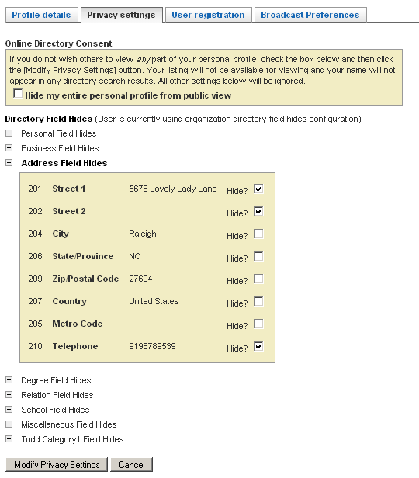  Figure 25

User Registration
User Registration allows administrators to view and/or reset a user’s password and security word, register on a user’s behalf, and activate a registered user as an administrator.
How to view a user’s password:
- Log into the Administration Center.  - Mouse over User Management > View/Modify/Register User. The Modify User tab will display with the Basic Query Builder selected by default.  - Click the expand icon (), to view the available fields in the appropriate table.  Use the collapse icon () to hide the fields.  - Enter search criteria.  - Click Search. The Search Results page will display.  - Click the Edit user info icon for the appropriate user. The Edit user info page will display with the Profile Details tab selected by default.  - Click the User registration tab. The User registration page will display. See figure 26.  How to reset the user’s password or Security Info  - Enter the new password or security info.  - Click Save User Registration, or Cancel to abort. “User Registration Modified” will display at the top of the User registration page. | 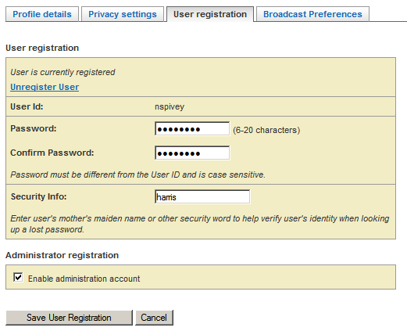  Figure 26  IMPORTANT!  To modify the member’s User ID forward the request to your Client Relations Manager. Include the member’s Client ID, First & Last Name, the current User ID, and the new User ID.

How to register a user:
- Log into the Administration Center.  - Mouse over User Management > View/Modify/Register User. The Modify User tab will display with the Basic Query Builder selected by default.  - Click the expand icon (), to view the available fields in the appropriate table.  Use the collapse icon () to hide the fields.  - Enter search criteria.  - Click Search. The Search Results page will display.  - Click the Edit user info icon for the appropriate user. The Edit user info page will display with the Profile Details tab selected by default.  - Click the User registration tab. The User registration page will display. See figure 27.  - Enter the member’s User ID.  - Enter the member’s Password.  - Enter the member’s Security Info.  - Enter the member’s Email Address.  - Under Confirmation Email, select the Email User ID & password option.  - Click Save User Registration, or Cancel to abort. “User Registration Modified” will display at the top of the User registration page. | 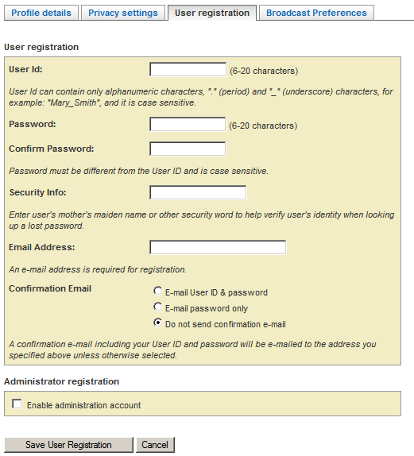  Figure 27  IMPORTANT!  A member must be registered before he/she can be made an administrator.

How to activate a registered user as an administrator:
- Log into the Administration Center.  - Mouse over User Management > View/Modify/Register User. The Modify User tab will display with the Basic Query Builder selected by default.  - Click the expand icon (), to view the available fields in the appropriate table.  Use the collapse icon () to hide the fields.  - Enter search criteria.  - Click Search. The Search Results page will display.  - Click the Edit user info icon for the appropriate user. The Edit user info page will display with the Profile Details tab selected by default.  - Click the User registration tab. The User registration page will display. See figure 28.  - Check the Enable administration account checkbox.  - Click Save User Registration, or Cancel to abort. “User Registration Modified” will display at the top of the User registration page. | 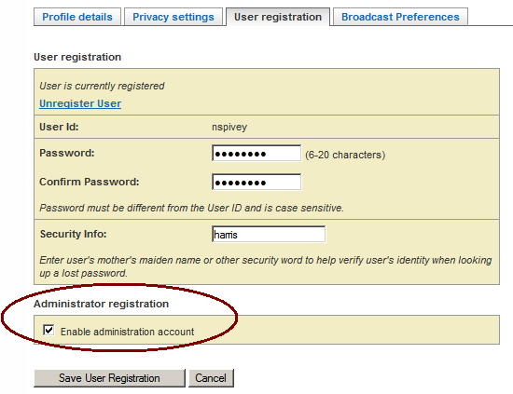  Figure 28

How to deactivate a registered user as an administrator:
- Log into the Administration Center.
- Mouse over User Management > View/Modify/Register User. The Modify User tab will display with the Basic Query Builder selected by default.
- Click Search. The Search Results page will display.
- Click the Edit user info icon for the appropriate user. The Edit user info page will display with the Profile Details tab selected by default.
- Click the User registration tab. The User registration page will display. See figure 28.
- Uncheck the Enable administration account checkbox.
- Click Save User Registration, or Cancel to abort. “User Registration Modified” will display at the top of the User registration page.

Broadcast Preferences
Broadcast preferences allow an administrator to modify a user’s email address, email status, and category preferences.

How to view a user’s broadcast preferences:
- Log into the Administration Center.  - Mouse over User Management > View/Modify/Register User. The Modify User tab will display with the Basic Query Builder selected by default.  - Click the expand icon (), to view the available fields in the appropriate table.  Use the collapse icon () to hide the fields.  - Enter search criteria.  - Click Search. The Search Results page will display.  - Click the Edit user info icon for the appropriate user. The Edit user info page will display with the Profile Details tab selected by default. | 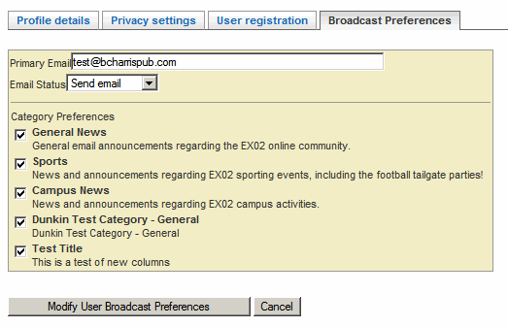  Figure 29
- Click the Broadcast preferences tab. The Broadcast preferences page will display. See figure 29.

How to modify a user’s primary email:
- Modify the user’s Primary Email.
- Click Save User Broadcast Preference, or Cancel. “User Broadcast Preferences Modified” will display at the top of the Broadcast preferences page.

How to modify a user’s email status: | How to modify a user’s category preferences:
- Log into the Administration Center.  - Mouse over User Management > View/Modify/Register User. The Modify User tab will display with the Basic Query Builder selected by default.  - Click the expand icon (), to view the available fields in the appropriate table.  Use the collapse icon () to hide the fields.  - Enter search criteria.  - Click Search. The Search Results page will display.  - Click the Edit user info icon for the appropriate user. The Edit user info page will display with the Profile Details tab selected by default.  - Click the Broadcast preferences tab. The Broadcast preference page will display. See figure 29.  - Modify the user’s Email status.  - Click Save User Broadcast Preferences, or Cancel. “User Broadcast Preferences Modified” will display at the top of the Broadcast preferences page. | - Log into the Administration Center.  - Mouse over User Management > View/Modify/Register User. The Modify User tab will display with the Basic Query Builder selected by default.  - Click the expand icon (), to view the available fields in the appropriate table.  Use the collapse icon () to hide the fields.  - Enter search criteria.  - Click Search. The Search Results page will display.  - Click the Edit user info icon for the appropriate user. The Edit user info page will display with the Profile Details tab selected by default.  - Click the Broadcast preferences tab. The Broadcast preference page will display. See figure 29.  - Modify the user’s Category Preferences. Check only the categories the member wishes to subscribe to, and uncheck the categories the member chooses to unsubscribe from.  - Click Save User Broadcast Preferences, or Cancel. “User Broadcast Preferences Modified” will display at the top of the Broadcast preferences page.

Add/Edit Class Notes
Administrators can add/edit a Class Note on a member’s behalf. The Edit Class Notes icon will only display if your organization has this feature activated.
How to add/edit a Class Note:
- Log into the Administration Center.  - Mouse over User Management > View/Modify/Register User. The Modify User tab will display with the Basic Query Builder selected by default.  - Click the expand icon (), to view the available fields in the appropriate table.  Use the collapse icon () to hide the fields.  - To search by name, expand the Personal section and enter the appropriate First and Last Name values.  - Click Search. The Search Results page will display. See figure 30.  - Click the Edit Class Notes icon. The Submit/Edit Class Notes page will display. See figure 31.  How to view, edit or delete a Class Note:  - Click the link for the class note you would like to edit listed under the View/Edit Submitted Class Notes section. The note will open in edit mode.  - Note: If there have not been any previously submitted notes, this will be indicated in the View/Edit Submitted Class Notes area. Otherwise, this area will include a list of the previously submitted notes as hyperlinks.  - Make the necessary edits.  - Click Update This Note or Delete This Note.  How to Add a Class Note:  - Click the class note category name link under the Submit Class Notes section. This will bring you to a data entry screen.  - Enter the appropriate information.  - Click the button to format your note.  - Click the button. This process is identical to the one the end user would see when submitting a note directly from Online Community. | 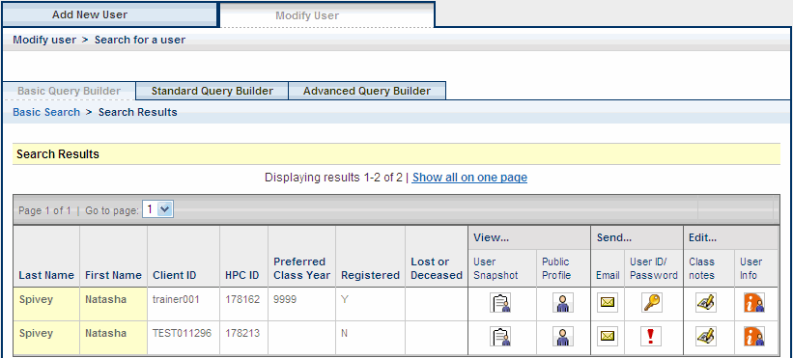  Figure 30  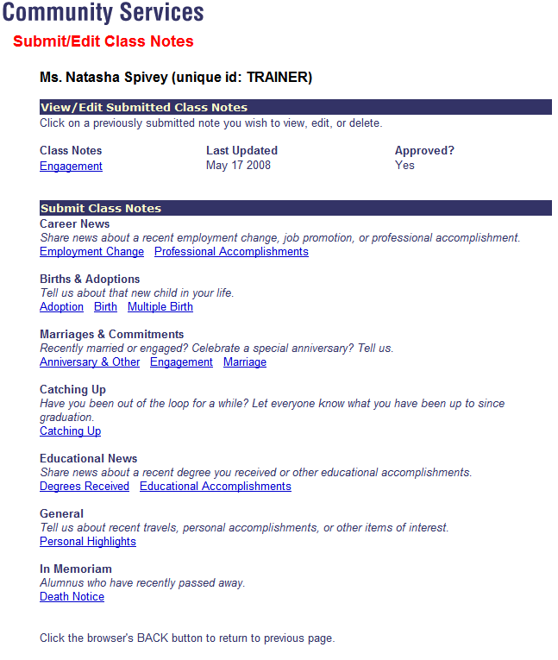  Figure 31

View User Snapshot
Administrators can capture user detail reports.

How to view user detail reports:
- Log into the Administration Center.  - Mouse over User Management > View/Modify/Register User. The Modify User tab will display with the Basic Query Builder selected by default.  - Click the expand icon (), to view the available fields in the appropriate table.  Use the collapse icon () to hide the fields.  - To search by name, expand the Personal section and enter the appropriate First and Last Name values.  - Click Search. The Search Results page will display. See figure 32.  - Click the View user snapshot icon. The User Snapshot page will display with the User Snapshot report. See figure 33.  - Select the appropriate report(s).  - Click Display Report. The User Snapshot page will refresh with the generated reports at the bottom of the page. | Figure 32  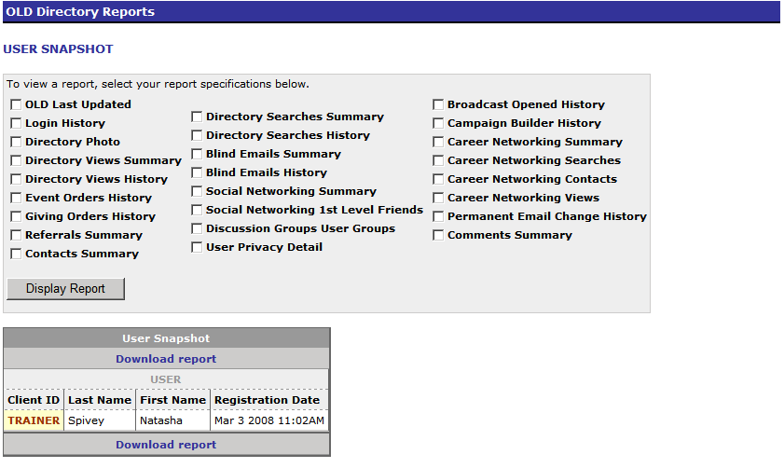  User Snapshot Report  Figure 33

User Detail Reports
OLD Last Updated – displays the date & time the user's profile was last updated by user, by FTS (File Transfer System), and by overall (Admin Tool). | Blind Emails History - displays the breakdown of sent and received blind emails by date and total sent and received.
Login History – displays the date & time stamp of the last 10 logins. | Social Networking Summary – displays total number of friends by level (1st, 2nd, and 3rd) and email privacy.
Directory Photo – displays the photo’s file name, caption, approval status, last updated. | Social Networking 1st Level Friends – displays the client ID, last name, first name preferred class, email privacy, total number of friends by level (1st, 2nd, and 3rd).
Directory Views Summary – displays the total unique views and total views. | Discussion Groups User Groups – displays group information (group name & email address) along with subscription information (user's email address, owner status (Y/N), delivery mode, last delivery date, number of posts sent, and last post date).
Directory Views History – displays view date, total views. | User Privacy Detail – displays Y or N for consent to Display Profile along with the table, column, label, change date for the hidden data fields.
Event Orders History – displays the order ID, order date, event ID, event title, event start, and order cost of the last events. | Broadcast Opened History – displays email subject, sent date, & opened date for opened emails sent via the Broadcast Email module.

Event Registration Orders History – displays the order ID, order date, event ID, event title, event start, and order cost of the last events. | Career Networking Summary – displays email address, start date, status, suspend until, last updated, status last updated, views, unique views, contacted, and last viewed.
Giving Orders History – displays the order ID, form ID, from name, gift date, gift amount, and recurring payment information (if applicable). The recurring payment information includes recurring status (Y/N), subscription ID, number of payments, start date (yyyymmdd) and auto renew status (Y/N). | Career Networking Searches – displays total career networking searches and results by date.
Membership Orders History – displays the order ID, form ID, form title, membership date, membership amount of the last membership forms submitted. | Career Networking Contacts – displays total career networking contacts by date.
Referrals Summary – displays total number of referrals and recipients by referral type. | Career Networking Views – displays total career networking views by date.
Contacts Summary – displays the total number of contacts. | Permanent Email Change History – displays change date, previous email address, and new email address.
Directory Searches Summary – displays total overall, total advanced, total simple, total custom. | Comments Summary - displays total comments posted by application.
Directory Searches History – displays the date and total searches for the last 10 searches.
Blind Emails Summary – displays the overall total of blind emails sent and received.
Campaign Builder History – displays email subject, sent date, & opened date for opened emails sent via the Campaign Builder module.

Send User ID/Password
Administrators can send an email reminder to a member containing their login information.
How to send a member their user id and password:
- Log into the Administration Center.  - Mouse over User Management > View/Modify/Register User. The Modify User tab will display with the Basic Query Builder selected by default.  - Click the expand icon (), to view the available fields in the appropriate table.  Use the collapse icon () to hide the fields.  - To search by name, expand the Personal section and enter the appropriate First and Last Name values.  - Click Search. The Search Results page will display. See figure 30.  - Click the Send User ID/Password icon. The page will refresh to display a yellow message box underneath the key icon in the Send User ID/Password column. See figure 31.  - Click the appropriate link to send the user id and password or the user id only. The yellow message box will refresh to indicate that the message was sent. | Figure 30  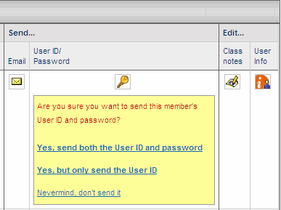  Figure 31

Add New User
Administrators can add a new user to the Harris Connect database. The Regular user option should be reserved for those individuals who by their nature should be included in the database and have full access to the site i.e. an alumnus/a for an educational institution or a member for an association. The Special user option is used to add staff members or faculty who are not alumni or members. This is especially important if you are including an Online Directory, since Regular users can control whether or not they are displayed in the directory, while Special users default to "not displayed" and this setting cannot be changed. In addition, records for Special users are not exchanged with us via the data update process.

How to add a new user:
- Log into the Administration Center.  - Mouse over User Management > Add New User. The Enter User Profile Details page will display. See figure 34.  - Select User Type.  - Click the expand icon (), to view the available fields in the appropriate table.  Use the collapse icon () to hide the fields.  - Enter appropriate data.  - Note: Personal and Address have required fields.  - Click Add Community User. The Edit user info page will display with “Community User Added” confirmation message at the top of the page. | 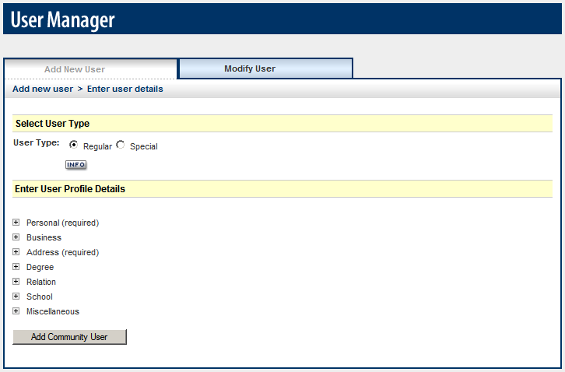  Figure 34

