Skillsoft: Quick Reference

Finding Report Update Time
Background  Before data will appear in a report it must first go through an ETL (extract, transform, and load) process. This is the refresh process for the Skillsoft database that updates reports to include all current data. In general, Skillsoft refreshes the database several four to six hours, though it may be as long as 24 hours between ETLs.  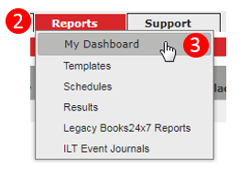  To find the latest ETL:  - Log on to Skillsoft  - Click Admin  - Click Reports  - Select My Dashboard  - Click on Content Completions chart  - Click Show Parameters | 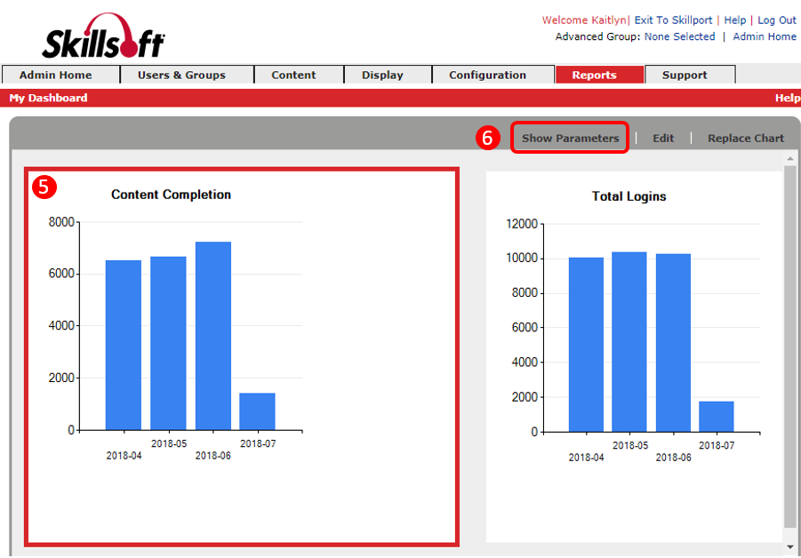
The Latest ETL will be listed last. It is in Coordinated Universal Time (UTC), six hours ahead of Mountain Standard Time (MST). All courses, including ILT courses, are included in Skillport. | 