33

PeopleSoft Query

Contents
Chapter 1 4
Creating and Running Simple Queries 4
Prerequisite 4
Common Elements in This Chapter 5
Creating a New Query 6
Pages Used to Create a Query 6
Selecting Records 7
Adding Fields to Query Content 9
Viewing Fields Selected for Output 11
Changing Column and Sort Order for Multiple Fields 12
Editing Field Properties 13
Viewing and Editing Query Properties 15
Viewing Underlying SQL Code 16
Running Query Results Prior to Saving 16
Saving a Query 17
Running a Query 18
Adding Queries to Portal Menu - My Favorites 19
Downloading the Query 19
Performing a Lookup 19
Printing Query Results 21
Using Query Viewer 21
Chapter 2 23
Defining Selection Criteria 23
Choosing Selection Criteria 23
Defining Criteria 24
Pages Used to Enter Selection Criteria 24
Entering Selection Criteria 25
Selecting Condition Types 27
Entering Comparison Values 28
Specifying Effective Date Criteria 33
Relating Multiple Criteria 34
Chapter 3 37
Modifying and Scheduling Queries 37
Modifying Queries 37
Opening an Existing Query 37
Renaming a Query 38
Deleting a Query 39
Updating an Existing Query 39
Scheduling Queries 40
Submitting a Process Request 40
Selecting a Process Request 41
Using Process Monitor 42
Viewing Output in Report Manager 43

v

Chapter 1

Creating and Running Simple Queries

This chapter lists prerequisites and common elements and discusses how to:

• Create a new query.

• Save a query.

• Run a query.

• Print query results.

• Download the query.

• Perform a lookup.

• Print query results.

• Use Query Viewer.

Prerequisite

Before you can create a new query, navigate to the Query Manager search page.
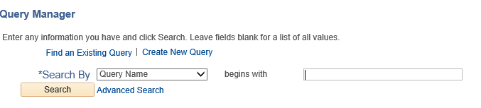

Query Manager search page

To begin defining a new query:

1. Select Reporting Tools, Query, Query Manager.

The Query Manager search page appears.

2. Click the Create New Query link to open to the Find an Existing Record search page.

The Find an Existing Record search page appears. This is the first in a series of pages you’ll use to define the parts of your query within Query Manager. Access each of the pages using the tabs. In this chapter, we discuss those tabs used to create a simple query: Records, Query, Fields, and Properties tabs.

The View SQL page enables you to view the Structured Query Language (SQL) code for the query. The Preview tab enables you to view the results before running your query. We discuss the Expressions, Prompts, Criteria, and Having tabs in “Defining Selection Criteria.”

See Also

“Defining Selection Criteria”

Common Elements in This Chapter

Add Record Click this link to access the Query page, where you can add fields to the query content or add additional records.

Col (column) Current column number for each field listed.

Query Name New Unsaved Query appears in this read-only field until you change it on the Properties page. This field appears on all of the Create New Query pages.

Record.Fieldname Record alias and name for each field listed.

Indicates key fields.

Click the Delete button to delete the associated record from the query.

A confirmation message appears. Click the Yes button to proceed with the deletion. Click the No button to cancel the deletion.

Click the Use as Criteria button to open the Criteria page, where you can add criteria for the selected field.

Click the Folder button to view the fields for the chosen record. Query Manager expands the record so that you can see the fields and make sure that this record has the content that you want.

Click the Folder button again to hide the fields for a record.

A key is displayed to the left of key fields.

Creating a New Query

The basic steps involved in creating a query are as follows:

1. Select the records upon which to base the new query.

2. Add fields to the query content.

3. Format the query output.

4. Specify selection criteria.

5. Run the query.

6. Save the query.

Pages Used to Create a Query

Page Name | Object Name | Navigation | Usage
Records | QRY_RECORDS | Reporting Tools, Query, Query Manager, Create New Query link, Find an Existing Record | Select the records upon which to base the new query.
Query | QRY_QUERY | Reporting Tools, Query, Query Manager, Create New Query, -Records, - Query | Add fields to the query content. You can also add additional records by doing joins.  When you first access this page, if you’ve selected the record for an effective-dated table, PeopleSoft  Query displays a dialog  box informing you that an effective date criteria has been  automatically added for this record. Click the OK button to close the dialog box.
Fields | QRY_FIELDS | Reporting Tools, Query, Query Manager, Create New Query, -Records, - Fields | View how fields are selected for output; view the properties of each field; and change headings, order-by numbers, and aggregate values.
Page Name | Object Name | Navigation | Usage
Edit Field Ordering | QUERY_FIELDS_OR DER | Reporting Tools, Query, Query Manager, Create New Query, -Records, - Fields, Edit Field Ordering | Use to change the column order and/or sort order for multiple fields.
Edit Field Properties | QRY_FIELDS_SEC | Reporting Tools, Query, Query Manager, Create New Query, -Records, - Fields, Edit Field Properties | Use to format the query output (for example, to change column headings, display translate table values in place of codes, or specify a sort order).
Query Properties | QRY_PROPERTIES | Reporting Tools, Query, Query Manager, Create New  Query, Properties Link | View and edit query data, such as the query name and description.  Also use to record information about your query so that you can use it again in the future.
View SQL | QRY_SQL | Reporting Tools, Query, Query Manager, Create New Query, View SQL | View the underlying SQL code that Query Manager generates based on your query definition.  You cannot modify  SQL on this page.
Preview | QUERY_VIEWER | Reporting Tools, Query, Query Manager, Create New Query, Preview | View the results of your query prior to saving in order to verify that your query provides you with the results you need. Continue to adjust and preview your query as necessary.

Selecting Records

Access the Records page.

Records page
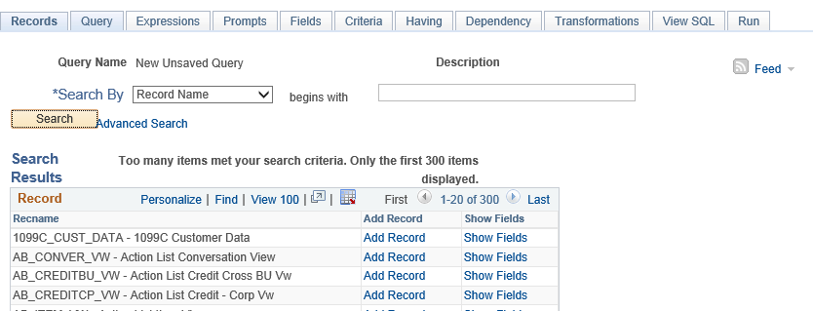

Note. In your PeopleSoft database, tables are represented as record definitions. In PeopleSoft Query, we refer to the record definitions as records.

To find a record:

1. If you know the name of the record you want, enter it in the Search For field on the Find Existing Record page, and click the Search button.

• If you want to search for a record, leave the field blank and click the Search button to display a list of up to 300 records.

By default, only the first 20 records appear on the page. To see more of the list, use the navigation buttons and links located on the header bar. To display all of the records, select the View All link, and use the scrollbar to go through the rest of the list.

• Perform a partial search by entering part of a record name or description in the Search For field.

Search records either by name or description, then further define your search by choosing either a begins with or a contains search type. Click the Search button to display a list of records that match your search criteria.

Selecting the View All link causes all of your records to appear on the page and requires you to scroll through what is often a long list to find your record. An easier way to find a specific record is to use the Search For field, which limits the number of records that appear. The Find link starts the Find utility, where you can enter a search string and locate the record that you need.

Note. Enter as much of the record name as possible to find the correct record.

3. Enter the name of the required record in the Search For box, and then click the Search button.

For example: JRNL_HEADER

Query Manager displays the record at the top of the page.

4. Click Add Record.

The Query page appears listing the fields associated with that record.

Note. In most cases, you will select only one base record from this page. If you navigate back and select a second base record, you are creating an “any join” for the two records.

See Also

“Advanced Query Options,” Creating Any Record Joins

Adding Fields to Query Content

Access the Query page.
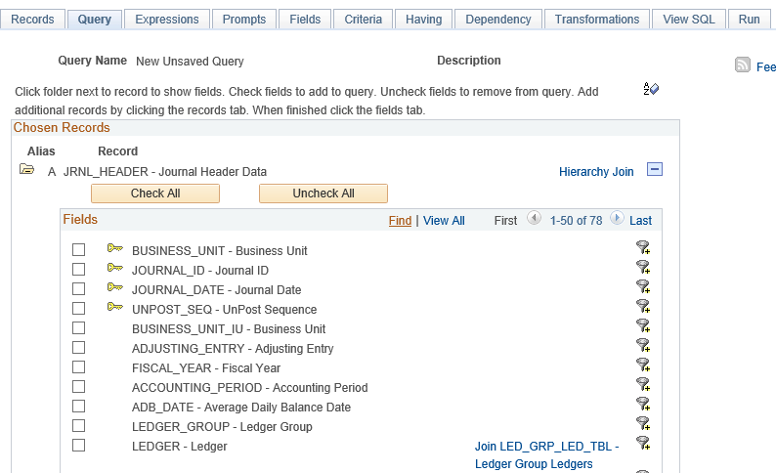

Query page

Click the Sort button once to list fields in alphabetical order. Click the button again to return to original sort.

Alias The alias name that the system automatically assigns to the chosen records.

Hierarchy Join Click this link to join a child table to its parent table.

Check All Fields Click this button to check all fields in the record. Once you select a field, the system automatically adds it to the query and you can view it on the Fields page.

This button does not appear when the field names are hidden.

Uncheck All Fields Click this button to clear all fields in the record.

Field Names Select the box located to the left of each field that you want to add to your query content.

Related Record Join Click this link to join two records based on a shared field.

For example, in the above screenshot, the JRNL_HEADER record is related to the JRNL_LN record by the JOURAL_ID field.

Expand All Records Click this button to view all fields in the records

This button appears only when there is more than one record listed.

Collapse All Records Click this button to hide all fields in the records.

This button appears only when there is more than one record listed.

See Also

“Defining Selection Criteria,” Specifying Effective Date Criteria

“Advanced Query Options,“ Joining Records

Viewing Fields Selected for Output

Access the Fields page.
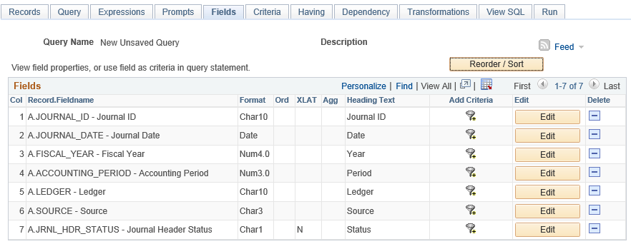

The Fields page

Format Field type and length for each field listed.

Ord (order) Shows one or more fields selected to sort your query output.

If the field is the first sort field, a 1 appears, and the system sorts rows based on this field first. The second sort field selected is numbered 2, and so on.

A descending sort order can also be specified. The letter D appears if sorting fields in descending order is selected.

XLAT (translate) Specifies which translate value you want to appear in the query results: N (none), S (short), or L (long).

The table you’re querying may include fields that use the Translate table. If so, the field itself contains a short code of some kind, for which the Translate table provides a set of corresponding values. For example, if the table includes an EFF_STATUS field, the value is A or I, which the Translate table translates into Active and Inactive. If a field has values on the Translate table, a letter appears in the XLAT column for that field.

In your query results, you might want to display the translated value rather than the code (for example, Active instead of A). To tell PeopleSoft Query to make this substitution specify L as the translate value.

Translate tables are effective-dated, so you must select which effective date to use for it. For most tables, PeopleSoft Query defaults to the current date, meaning that it uses the currently active list of Translate table values. However, if the table you’re querying is also effective-dated, PeopleSoft Query uses the value in the EFFDT field for a row. That is, for each row the query returns, PeopleSoft Query uses the Translate table values that were active as of that row’s effective date.

If neither of these effective date options are what you want, you have two more:

• If the table you’re querying includes another date field, you can use the value in that field as the effective date for Translate table values. Click the Edit button and then select the Field option, and then select the field name from the drop-down list box.

• Use an expression to set the effective date for the Translate table. For example, enter a fixed effective date or prompt the user for one.

Agg (aggregate) Aggregate function for each field listed.

Heading Text The heading assigned to appear at the top of the column for the query output for each field listed.

Edit Click this button to format the query output (for example, to change column headings, display translate table values in place of codes, or specify a sort order).

ReOrder/Sort Click this button to display the Edit Field Ordering page, which enables you change the column order and/or sort order for multiple fields.

Changing Column and Sort Order for Multiple Fields

Access the Edit Fields Ordering page by clicking the Reorder/Sort button on the Fields page.
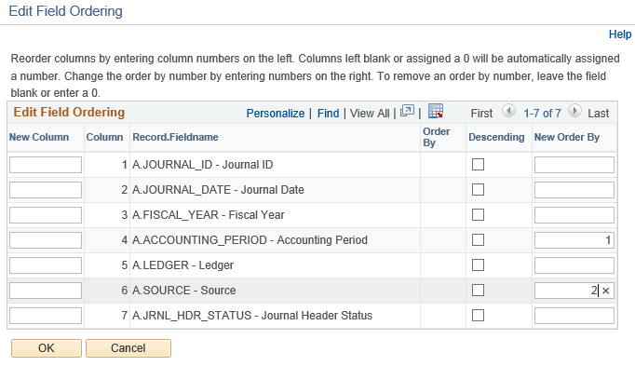

Edit Field Ordering page

New Column Enter new column number to reorder columns. Columns left blank are automatically assigned a number.

Order By Current sort order.

Descending Select this check box to sort fields in descending order.

New Order By Enter new sort order number to change the sort order.
Enter zero to remove a sort order.

Editing Field Properties

Access the Edit Field Properties page by clicking the Edit button on the Fields page.
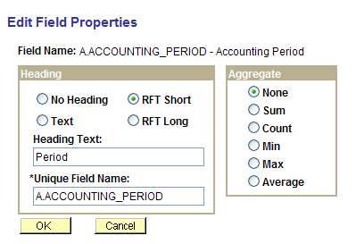

The Field Properties page

Field Name The name of the field for which you are editing properties.

Heading Choose a column heading from the following:

No Heading: The column does not have a heading.

Text: The column heading is the text you’ve entered in the text box.

RFT Short: The column heading is the short name from the record definition.

RFT Long: The column heading is the long name from the record definition.

Unique Field Name Used for translations. There is no need to change the default value, which is a single-letter alias for the record followed with the record field name (for example A.NAME or B.EMPLID).

Aggregate If you are using aggregate values, select the aggregate function value for this field.

An aggregate function is a special type of operator that returns a single value based on multiple rows of data. When your query includes one or more aggregate functions, PeopleSoft Query collects related rows and displays a single row that summarizes their contents.

None Will not use aggregate functions.

Sum Adds the values from each row and displays the total.

Count Counts the number of rows.

Min (minimum) Checks the value from each row and returns the lowest one.

Max (maximum) Checks the value from each row and returns the highest one.

Average Adds the values from each row and divides the result by the number of rows.

See Also

“Advanced Query Options,” Aggregate Functions

Viewing and Editing Query Properties

Access the Query Properties page.
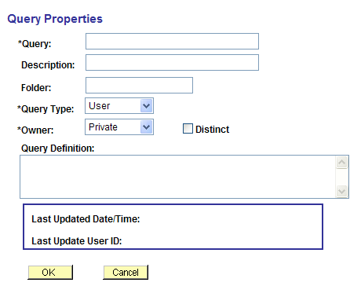

Query Properties page

Query Enter a name for the new query. This field appears on all the Create New Query pages.

Description Enter a description for the new query. This field appears on all the Create New Query pages.

Query Type Select User, Process, or Role. Workflow queries are either Process or Role.

Owner Select from the following:

Private: Only the user ID that created the query can open, run, modify, or delete the query.

Public: Any user with access to the records used by the query can run, modify, or delete the query (if they have access to public queries).

Distinct Select this check box to eliminate duplicate rows in a query result.

Some queries return the same row more than once because it satisfies the query in more than one case. For example, if you query the JOB record to return all JOBCODES, you’ll receive multiple rows that look identical because some employees have the same JOBCODE. If you select the Distinct check box, you’ll receive each JOBCODE only once.

This option isn’t visible for union selections because unions are automatically distinct.

Query Definition Free text area that you can use to further describe your query.

Save Click to save the page.

Viewing Underlying SQL Code

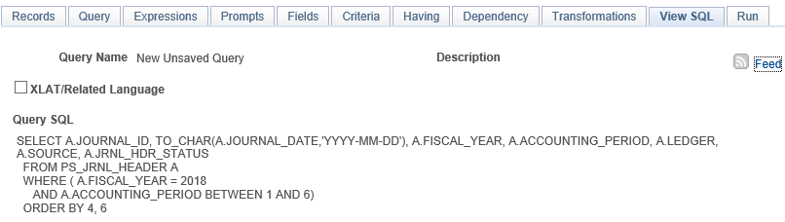
Access the View SQL page.

View SQL page

Query SQL Displays the underlying SQL code that Query Manager generates based on your query definition. To copy the SQL statement, highlight the text of the statement and copy it using your browser’s copy command. Paste it into another application, if desired.

Running Query Results Prior to Saving

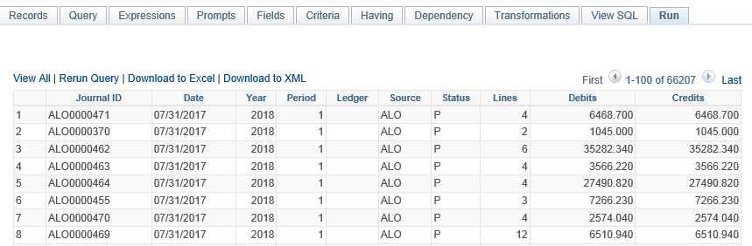
Access the Run page.

View All Click this link to view all rows and use scroll bar to navigate.

Rerun Query Click this link to rerun your query preview. If you have made changes to your query since the last preview, you must rerun the query to see the affect of your changes.

Download to Excel Click this link to output your results into Microsoft Office Excel

Saving a Query

You can save a query at any time after you have selected one record and at least one field for your query. Save queries from any Query Manager page (except for the Run page) by clicking either the Save button or the Save As link. You must enter some basic information about the query before the system allows you to save it for the first time.

Saving a query

To save a query:

1. After you make your changes in Query Manager, select Save.

2. In the Query field, enter a short name for the query; in the Description field, enter information that will help you to later identify the query.

3. Select a Query Type.

Standard queries are designated as User queries. Workflow queries are either Process or Role queries.

4. In the Owner field, select whether your query is Public (requires approval) or Private..

• Private means that only the user ID that created the query can open, run, modify, or delete the query.

• Public means that any user with access to the records used by the query can run, modify, or delete the query. Making a query public requires consultation with the Office of University Controller.

5. Enter the Query Definition.

Note. Using Save As creates another instance of the query that you can modify and save under a different name. When you select Save As, the Properties page appears, enabling you to change the name, description, and owner of the new query.

Running a Query

You can run a predefined query from your browser and view it online. When you use the Run option from the Query Manager search page, PeopleSoft Query displays the results in a new browser window. This Run option is useful if you want to run multiple queries or run the same query multiple times with different run time prompt values and compare the results of the queries.

To run a predefined query:

1. Select Reporting Tools, Query, Query Manager.

Query manager Search page appears.

2. If you know the name of the query you want to run, enter it in the Search For field, and click the Search button.

• If you want to search for a query, leave the Search For field blank, and click the Search button to display a list of up to 300 queries.

• Perform a partial search by entering part of a query name or description in the Search For field.

Use the drop-down list to search queries by either name or description, then further define your search by selecting either a begins with or contains search type. Click the Search button to display a list of queries that match your search criteria.

The Search Results page appears. The results list all the queries that match the search criteria. The following information appears:

• Query name.

• Query description.

• Ownership (public or private).

• Actions allowed (based on security access).

3. Scroll to the name of the query that you want to run.

By default, only the first 30 queries appear on the page. To see more of the list, click the navigation buttons and links located on the header bar.

To display all of the queries, select View All and use the scrollbar to view the rest of the list.

4. To run a query from the list of queries, click the Run link located on the same row as the required query name.

Adding Queries to Portal Menu - My Favorites

To add a query to the My Favorites on the portal menu:

1. Right-click the Run link on Query Manager or Query Viewer search page.

2. Select Add to Favorites from the drop-down menu.

3. Change the name to the name of your query.

4. Click OK.

Internet Explorer adds the query to your Favorites list.

Downloading the Query
You can download your query to an Excel spreadsheet or CSV text file. To download your query results, select one of the following:

• Excel spreadsheet: Excel 2010 or later is preferred.

You can configure your environment to open the Excel file in a separate window or save it as a file on your local hard drive by modifying the File Type Option settings for Excel Worksheets.

• CSV Text File link: The output has no formatting and does not support UTF-8 encoded data.

Performing a Lookup

Some queries are designed to prompt you for information when you select to run them. By doing this, the results of your query are narrowed to only the data matching the information you entered, instead of returning all the data from the records. To help you enter the correct information, you can perform a search using the Lookup button that appears on the screen.

For example, the GL_JOURNAL_HEADER_BY_SOURCE query prompts you for a specific journal source code. Using the Lookup button, you use the information that you do have to find the required information.

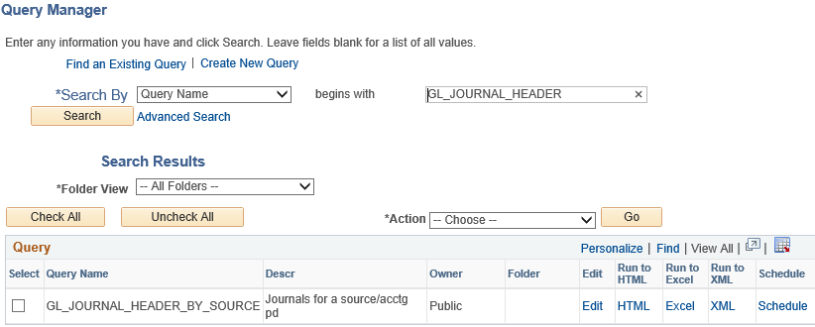
In this example, we perform a basic lookup using GL_JOURNAL_HEADER_BY_SOURCE.

To perform a basic lookup:

1. Click the Run to HTML link from the Query Manager Search page for the GL_JOURNAL_HEADER_BY_SOURCE query name from the query list.

2. If you know the Journal Source for the journals you are looking up, enter it in the Source field; if you need to search for the Journal Source, click the Lookup button.

3. On the Lookup page, to find all values for this field, leave the search field blank and click the Lookup button. You can also display all of the search fields at once by clicking the Advanced Lookup link.

4. Select the value to Search By, and then click the Lookup button.

Your lookup information appears on the page.
5. Select the link in the result field.

The Query page appears with the required value already complete.

6. Click the View Results button.

The query results appear on the page.

Printing Query Results

To print query results, you must first run the query and have the results appear in your browser. Click the Print button from your browser, or select File, Print from you browser menu. The query prints on your default printer.

If you choose to download the query in Excel, you can print the query using Excel’s print function.

Using Query Viewer

Query Viewer is a read-only version of Query Manager. It allows security administrators an easy way to limit some users to read-only access for all queries. The Security Administrator can easily provide read-only access to users who should only view or print queries.

Query Viewer enables you to:

• Search for a query:

To preview a query, click the name of the required query.

• Preview a query (which displays results in current browser window):

From the Preview page, view results of your query, rerun the query, and download the results to Excel.

• Run a query (which displays results in a new browser window):

Once you run your query, you can download the results to an Excel spreadsheet or a CSV Text file.

• Print a query:

- To print query results, you must first run the query and display the results in your browser.

Click the Print button from your browser, or select File, Print from you browser menu. The query prints on your default printer.

- If you choose to download the query in Excel or another tool, you can print the query using their print functions.

• Schedule a query:

- From the Search results page, click the Schedule link associated with the required query.

- Query Viewer interacts with PeopleSoft Process Scheduler to give users the ability to schedule queries.

You can submit requests to schedule a query, check the status of your request using Process Monitor, and view your output using Report Manager.

See Also

Previewing Query Results Prior to Saving

Running a Query

“Modifying and Scheduling Queries,“ Scheduling Queries

Chapter 2

Defining Selection Criteria

To selectively retrieve just the data you want, you define selection criteria. Selection criteria refines your query by specifying conditions that the retrieved data must meet. For example, you can specify that the system retrieve only those phone numbers with a certain area code instead of all phone numbers.

This chapter discusses how to:

• Choose selection criteria.

• Define criteria.

• Define having criteria.

• Define expressions.

• Define prompts.

Choosing Selection Criteria

Because your PeopleSoft database stores data in tables, you can identify every individual piece of data by saying what column (field) and row (record) it’s in. When you create a query, pick the data you want by specifying which columns and rows you want the system to retrieve.

If you run the query after selecting the fields, the system retrieves all the data in those columns; that is, it retrieves the data from every row in the table or tables. You select which rows of data you want by adding selection criteria to the query.

The selection criteria serves as a test that the system applies to each row of data in the tables you’re querying. If the row passes the test, the system retrieves it; if the row doesn’t pass, the system doesn’t retrieve it. For example, suppose you needed the depreciation journals for equipment assets. You’d start by creating a query that retrieves the journal id from the journal header table. You can then add a selection criterion that tells PeopleSoft Query to scan for rows where the journal id begins with DEPR.

In most cases, a selection criterion compares the value in one of a row’s fields to a reference value. In the example from the previous paragraph, you would compare the value in the journal ID field to the constant value DEPR% In other situations, you might compare the value to the value in another record field or to a value that the user enters when running the query.

Defining Criteria

This section discusses how to:

• Enter selection criteria.

• Select condition types.

• Enter comparison values.

• Specify effective date criteria.

• Relate multiple criteria.

Pages Used to Enter Selection Criteria

Page Name | Object Name | Navigation | Usage
Criteria | QRY_CRITERIA | Reporting Tools, Query, Query Manager, Create New Query, Criteria | Enter selection criteria for the query.
Query | QRY_QUERY | Reporting Tools, Query, Query Manager, Create New Query, Query | Click the Add Criteria icon associated with the required field.
Fields | QRY_FIELDS | Reporting Tools, Query, Query Manager, Create New Query, Fields | Click the Add Criteria icon associated with the required field.

Entering Selection Criteria

Access the Criteria page.

Criteria page
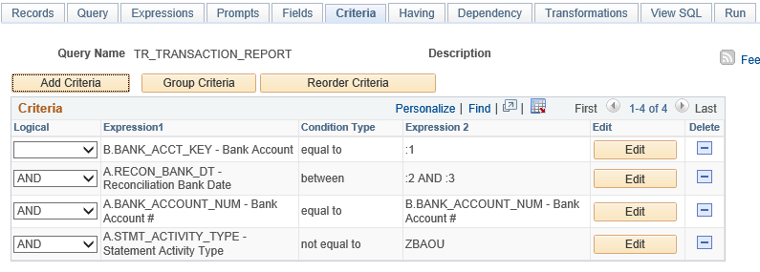

Any rows after the first row must include either an AND or OR logical value in the Logical column to specify whether you want the rows to meet this criterion in addition to other criteria you’ve defined or as an alternative criterion. The first criterion you define doesn’t have a value in this column. The default for subsequent criteria is AND.

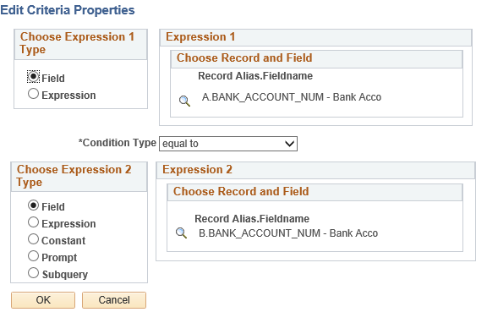

The Edit Criteria Properties page

Field Select if you want to base the selection criterion on another field’s value. Usually a field in another record component. To compare the values from fields in two records, you must join the record components.

When you select this option, you must go on to select a condition type. See Selecting Condition Types

Click the drop-down button in the Condition Type column and select the appropriate comparison operator from the pop-up menu.

Expression Select if you want PeopleSoft Query to evaluate an expression that you enter before comparing the result to the value in the selected field.

When you select this option, you must go on to select an expression type. If you are entering an aggregate value, select the Aggregate Expression check box. You can also enter parameters for length and decimal positions.

Also enter the expression in the text box. Query Manager inserts this expression into the Structured Query Language (SQL).

To create criteria based on a field:

1. Click the Add Criteria icon associated with the required field, on the Fields or Query page.

Query Manager opens the Edit Criteria Properties page with the selected field entered as
Expression 1.

2. Specify the criteria for that field, and then click OK to return to the Fields or Query page.

You can also use a field from a record as criteria even if you haven’t chosen that field for query output.

To create criteria that isn’t based on a field:

1. Click the Add Criteria button on the Criteria page.

The Edit Criteria Properties page appears, enabling you to edit Expression 1 and
Expression 2.

2. In the Choose Expression 1 Type group box, select Field or Expression.

3. Edit the second (right-hand) Expression column to enter comparison values.

4. Save your query.

See Also

Entering Comparison Values

Selecting Condition Types

The condition type determines how Query Manager compares the values of the first (left- hand) expression to the second (right-hand) expression.

The following table describes the available condition types. For each of the condition types, Query Manager offers a “not” option that reverses its effect. For example, not equal to returns all rows that equal to would not return.

Note. It’s always better to use the not version of an operator rather than the NOT operator on the entire criterion. When you use NOT, PeopleSoft Query can’t use SQL indexes to speed up the data search. When you use the “not” version of an operator, PeopleSoft Query can translate it into a SQL expression that enables it to use the indexes.

Condition Types | When It Returns a Row
between | The value in the selected record field falls between two comparison values. The range is inclusive.
equal to | The value in the selected record field exactly matches the comparison value.
exists | This operator is different from the others, in that it doesn’t compare a record field to the comparison value. The comparison value is a subquery. If the subquery returns any data, PeopleSoft Query returns the corresponding row.
greater than | The value in the record field is greater than the comparison value.
in list | The value in the selected record field matches one of the comparison values in a list.
in tree | The value in the selected record field appears as a node in a tree created with PeopleSoft Tree Manager. The comparison value for this operator is a tree or branch of a tree that you want PeopleSoft Query to search.
is null | The selected record field doesn’t have a value in it. You don’t specify a comparison value for this operator.  Key fields, required fields, character fields, and numeric fields do not allow null values.
less than | The value in the record field is less than the comparison value.
like | The value in the selected field matches a specified string pattern. The comparison value may be a string that contains wildcard characters. The wildcard characters that PeopleSoft Query recognizes are % and _.  % matches any string of zero or more characters. For example, C% matches any string starting with C, including C alone.  _ matches any single character. For example, _ones matches any five-character string ending with ones, such as Jones or Cones.  PeopleSoft Query also recognizes any wildcard characters that your database software supports. See your database management system documentation for details.  To use one of the wildcard characters as a literal character (for example, to include a % in your string), precede the character with a \ (for example, percent\%\).

Note. If you’ve selected the EFFDT field on an effective-dated table, PeopleSoft Query also offers special effective date operators.

See Also

Specifying Effective Date Criteria

Entering Comparison Values

The procedure for entering comparison values differs depending on what kind of value you’re entering. If you’re comparing one field to another, pick the second record field; if you’re comparing the rows to a constant value, enter the constant.

The following table describes all the available value types, the dialog boxes that appear based on each comparison type, and the fields you must complete in those dialog boxes.

Value Type | Action
Field | The value in the selected field is compared to the value in another field, usually a field in another record component.  When you’ve selected Field as the comparison value, the Select Field dialog box appears. The Record Alias field lists all the records that are part of the current query. Select the record and the field. The selected field name appears in the second Expression column of that field’s row.
Expression | The value in the selected field is compared to an expression you enter, which PeopleSoft Query evaluates once for each row before comparing the result to the value in the selected field.  When you’ve selected Expression as the comparison value, the Edit Expression dialog box appears. In the text box, enter a valid SQL expression.  To add a field or user prompt to the expression, click the Add Prompt link or the Add Field link. These links display the same dialog boxes that you see when adding a field or prompt as a comparison value: the Add Prompt displays the Run-time Prompt dialog box; the Add Field link displays the Select Field dialog box. The only difference is that PeopleSoft Query adds the field or prompt to your expression rather than using it directly as the comparison value.
Constant | The value in the selected field is compared to a single fixed value.  When you select Constant as the comparison value the Edit Constant Value dialog box appears. In the text box, enter the value you want to compare the first expression to.
Subquery | The value in the selected field is compared to the data returned by a subquery.  When you select Subquery as the comparison value, the Define Subquery dialog box appears. Click the Define/Edit Subquery link to move to the Records tab to start a new query.  See “Advanced Query Options,” Subqueries
Prompt | The value in the selected field is compared to a value that you enter when running the query.  When you select Prompt as the comparison value, the Define Prompt dialog box appears. Click the New Prompt link to move to the Edit Prompt Properties page.  See Defining Prompts
In List | The value in the selected field is compared to a list of values that you enter. This value type is available only when the selected operator is in list or not in list.  When you select In List as your comparison value, the Edit List dialog box appears.
Current Date | The value in the selected field is compared to the current date on the database server.
Tree Option | The value in the selected field is compared to a selected set of tree nodes. This value type is available only when the selected operator is in tree or not in tree.  When you select Tree Option as the comparison value, the Select Tree Node List dialog box appears. Use this dialog box to create a list of values for PeopleSoft Query to compare to the value from the first expression
Effective Seq  (effective sequence) | Used on some effective-dated records, the effective sequence is a sequencing number provided to further refine the effective date.

Note. Not all value types are available for all operators. For example, when you select the exists operator, Subquery is the only available value type. After you select an operator, PeopleSoft Query displays only the value types that are available for that operator.

This section discusses how to:

• Build a list of values.

• Add prompts to the expression list.

• Add a comparison value to the list.

Building a List of Values

When you select In List as your comparison value, the Edit List dialog box appears. Use this dialog box to build a list of values for PeopleSoft Query to compare to the value from the first expression. To add a comparison value to the list, click the Lookup button on the Edit List dialog box.
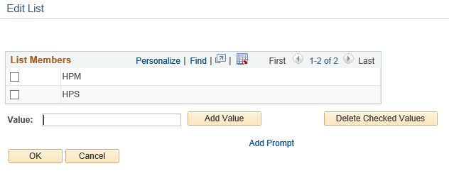

Example of adding values to the Edit List dialog box

To build a list of values:

1. On the Edit List page, click the Add Value link associated with the required field.

The List Member grid, containing the selected value, appears when a value is selected.

For each value you want to add, manually enter a value in the Value text box and click the Add Value button.

2. To delete a value, select the check box to the left of the appropriate List Members value and click the Delete Checked Values button.

You can also add one or more prompts to the list so that users can enter the comparison values when they run the query.

Adding Prompts to the Expression List

You can add one or more prompts to the expression list so that users can enter comparison values when they run a query.
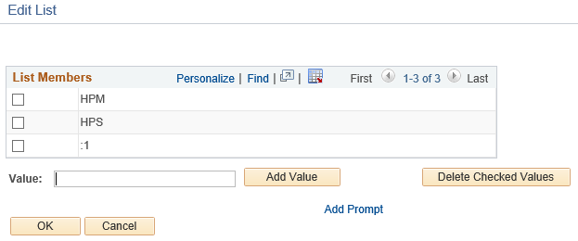

Example of adding prompt values to the Edit List page

To add prompts to the expression list:

1. Click the Add Prompt button to open the Select a Prompt page.

2. Click the required prompt.

The prompt appears on the Edit List page in the List Members list box.

If you selected the in list operator, you may want to add more than one prompt so that your users can enter more than one value to search for.

3. To add another prompt, click the Add Prompt button again and select a different prompt.

Because you already have a prompt in place, a different dialog box appears, showing the prompt you’ve already added.

4. To add the next prompt, click the New button and complete the Run-time Prompt dialog box.

The settings for this second prompt are the same as those used with the first prompt. If you want a different label for this prompt, enter that label in the Heading Text box.

When you click OK, the second prompt appears in the Available Prompts list.

5. Highlight the second prompt, and click the Select button to add it to the list of comparison values.

The prompt then appears in the Edit List dialog box.

6. Repeat this process for each prompt you want to add.

When you’re done, click OK to close the Edit List dialog box.

Adding a Comparison Value to the List

When you select Tree Option as the comparison value, the Select Tree Node List dialog box appears. Use this dialog box to create a list of values for PeopleSoft Query to compare to the value from the first expression. Click the New Node List link to display the Select Tree page.

If the Selected Nodes List has been previously populated, you can either:

• Change the tree by clicking the New Nodes List link.

• Open the previously selected tree, bypassing the Tree Selection page, by clicking the
Edit Node List link.

Only trees to which you have access are listed. Click the name of the desired tree to display the Display and Select TreeNodes page, which you can use to select which element of the tree PeopleSoft Query will check. If no nodes have been previously selected, the Selected Nodes List grid is collapsed.
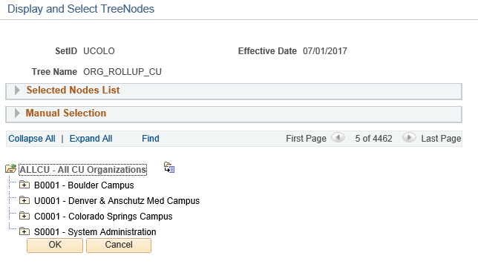

Selecting tree nodes on the Display and Select TreeNodes page

To select tree nodes:

1. Highlight the desired tree node, and click the Add Node icon.

2. If you know the name of the desired node, enter the name of the desired node in the
Manual Selection list box.

Alternatively, click the Lookup button to select the desired node from a list of available nodes. When you find the node you’re looking for, click the Add to List button to add it to the list. The nodes you enter or select from the list appear in the Selected Nodes list box.

3. Remove nodes from the list by clicking the corresponding icon.

4. Display the selected tree branch by clicking the corresponding icon.

5. Click OK.

The selected tree setID, tree name, effective date, and selected nodes appear in the Select
Tree dialog box.

Specifying Effective Date Criteria

Effective-dated tables have record definitions that include the Effective Date (EFFDT) field. This field, used throughout the PeopleSoft applications, provides a historical perspective, allowing you to see how the data has changed over time. Whenever users add a row of data to the table, they specify the date on which that data becomes effective; whenever users change a row of data, they specify a new effective date, and the system retains the previous version of the row as history.

When you’re using a PeopleSoft application for day-to-day processing, you usually want the system to give you the currently effective rows of data—the row where the effective date is less than or equal to today’s date. You don’t want to see the history rows, which are no longer accurate, nor do you want to see future-dated rows, which aren’t yet in effect.

When you’re querying an effective-dated table, though, you may well want to see some rows that aren’t currently in effect. You might want to see all the rows, regardless of their effective dates. Or you might want to see the rows that were effective as of some date in the past.

To specify effective date criteria:

1. When you choose the record that has EFFDT as a key field, Query Manager automatically creates default criteria and adds that criteria to the Criteria page.

This criteria is used to specify which row of data PeopleSoft Query retrieves for each item in the table. The default is the currently effective row. Defaults are as follows:

Expression 1 Record Alias.EFFDT

Condition Type EffDt <= Expression 2 Current Date Effective Sequence Last

2. If you choose one of the comparison options, choose to compare each row’s effective date against today’s date or a date other than today.

• Select Current Date to compare each row’s effective date against today’s date.

• Select Constant to display the Constant box so that you can enter a date.

Select this option when you want to see the rows that were effective as of a past date or that will be effective on some future date.

• Select Expression to display the Edit Expression box so that you can enter a SQL
expression that evaluates to a date.

Select this option if you want to prompt users for an effective date when they run the query. You can add a prompt to the expression you define in the Edit Expression box.

• Select Field to display the Select Field box so that you can select the record field that holds the date to which you want to compare effective dates.

Select this option when you want to see the rows that were effective at the same time as some other record. For example, if you’re reviewing the list of products on a customer order, you’ll want to see the products that were effective on the date of the order.

• Select First Effective Date to return the row with the oldest effective date, usually the first row entered for an item.

• Select Last Effective Date to return the row with the latest effective date, even if that date is still in the future.

• Select No Effective Date to return all rows, regardless of their effective dates.

Note. All options (except No Effective Date) return a single row for each item on the table. If you want a subset of the rows (say, all future-dated rows or all history rows), select No Effective Date, then enter a selection criterion on the Effective Date field. Use the standard comparison operators rather than the Effective Date comparison operators.

Keep in mind that the effective date operators work differently than the standard comparison operators: they always return a single effective-dated row. For example, Eff Date <= returns the one row whose EFFDT value is most recent, whereas not greater than would return the currently active row and all history rows.

Relating Multiple Criteria

Using PeopleSoft Query, you can relate multiple criteria in specific ways that you define using the AND, AND NOT, OR, and OR NOT operators. You can also group criteria using parentheses.

This section discusses how to:

• Use AND and OR logical operators.

• Group criteria with parentheses.

Using AND and OR Logical Operators

When you specify two or more selection criteria for a query, you must tell PeopleSoft Query how to coordinate the different criteria. For example, suppose you’re querying the list of your customers and you’ve defined two criteria. You may want PeopleSoft Query to return only those rows that meet both conditions, or you may want the rows that meet either one of the conditions.

When your query includes multiple criteria, link them using either AND, AND NOT, OR, or OR NOT. When you link two criteria with AND, a row must meet the first and second criterion in order for PeopleSoft Query to return it. When you link two criteria with OR, a row must meet the first or second criterion, not necessarily both.

By default, PeopleSoft Query assumes that you want those rows that meet all the criteria you specify. When you add a new criterion, PeopleSoft Query displays AND in the Logical column on the Criteria tab. To link the criterion using one of the other options instead, select the required option from the drop-down list.

Grouping Criteria with Parentheses

When your query includes multiple criteria, PeopleSoft Query checks the criteria according to the rules of logic: it evaluates criteria linked by ANDs before those linked by ORs. When all the criteria are linked by ANDs, this order always returns the correct results. When you mix in one or more ORs, however, this isn’t always what you want.

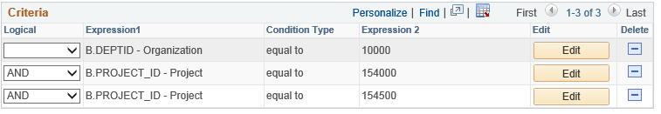

Example of criteria that returns an incorrect result

The set of criteria entered in the previous screen shot returns a list of journal lines in org 10000 and project id is 154000 or project id is 154500 for all orgs. This list results because PeopleSoft Query evaluates OR separately from AND.

On the Criteria tab, the opening parenthesis appears just before the field name and the close parenthesis appears just after the comparison value. The following is the set of criteria that returns the result you want:

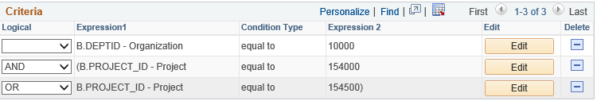

Adding parentheses around the last two criteria

To group criteria:

1. Click the Group Criteria button located on the Criteria tab.

The Edit Criteria Grouping page appears.

2. Use the edit boxes to enter parenthesis for each criteria.

A parenthesis appears at the beginning of the Expression1 column for the first row you selected and at the end of the Expression2 column for the last row you selected. In the previous example, see that the AND operator precedes the parentheses, while the OR operator is located within the parentheses.

You can add as many parentheses as needed.

Chapter 3

Modifying and Scheduling Queries

This chapter discusses how to:

• Modify queries

• Schedule queries.

Modifying Queries

This section discusses how to:

• Open an existing query.

• Rename a query.

• Delete a query.

• Update an existing query.

Opening an Existing Query
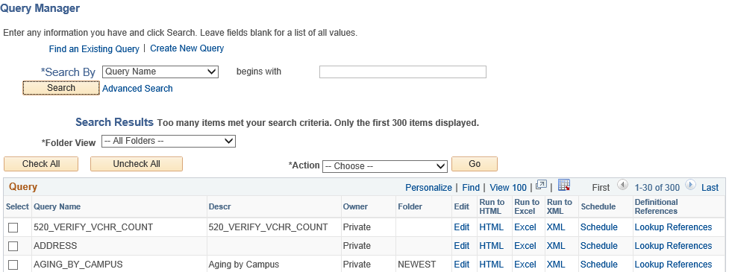
Use Query Manager to open and view queries.

Query Manager Search Results page

To open an existing query from your browser:

1. Select Reporting Tools, Query, Query Manager.

The Query Manager search page appears.

2. If you know the name of the query you want, enter it in the Search for field, and click the
Search button.

If you want to search for a query, leave the Search for field blank, select a query type from the adjacent drop-down list, and click the Search button to display a list of up to 300 queries.

Perform a partial search by entering part of a query name or description in the Search for field. Use the drop-down list to search queries by either name or description. Then further define your search by choosing either begins with or contains search type. Select the query type, and click the Search button to display a list of queries that match your search criteria.

The Search Results page appears. The results list all the queries that match the search criteria. The following information appears:

• Query name.

• Query description.

• Ownership (public or private).

• Actions allowed (based on security access).

Renaming a Query

If your security access allows, you can change the name of a query from the Query Search
Results page.
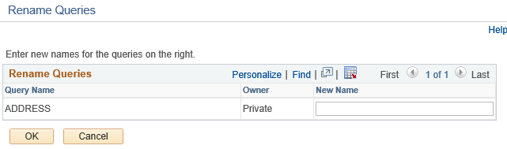

Query Rename page

To rename a query:

1. On the Query Manager Search Results page, find the query that you want to rename and click the Rename link next to the query name.

The Query Rename page appears. The current name and description appears at the top of the page.

2. Enter the new name for the selected query in the Query Name field.

3. Click OK to save your changes.

Deleting a Query

You can delete any public query that you have access to as well as any private query that you have created.

To delete a query:

1. On the Query Manager Search Results page, find the query that you want to delete and click the Delete link next to the query name.

The Query Delete Verification page appears.

2. Click Yes to confirm the deletion or No to avoid deletion.

Updating an Existing Query

There may be times when you’d like to update a query to reflect new conditions or copy an existing query and modify the new query for other uses. You can open a query, examine it to see if it’s suitable, and then use the Save As function to save it with a new name.

To update an existing query:

1. On the Query Manager Search Results page, find the query that you want to modify and click the Query Name link.

The Properties page appears.

2. Enter the new information for the query.

3. Click either the Save button to update the existing query, or click the Save As link to save a different instance of the query under a new name.

Scheduling Queries

Query Manager interacts with PeopleSoft Process Scheduler to give users the ability to schedule queries.

This section discusses how to:

• Submit requests to schedule a query.

• Check the status of your request using Process Monitor.

• View your output using Report Manager.

• Specify user’s language.

Submitting a Process Request

A process request enables you to submit a job or process to run. The Process Request page enables you to specify such variables as where to run the process and in what format to generate the output based on a run control ID.

Scheduled Query Run Control page
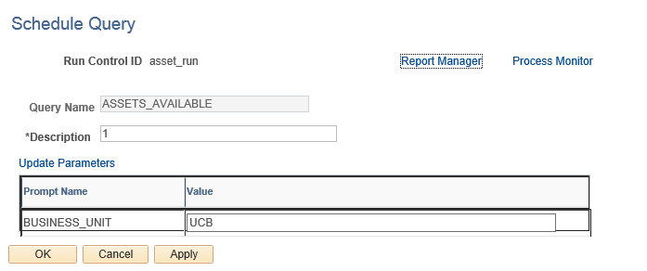

To submit a query process request:

1. Select Reporting Tools, Query, Schedule Query.

The Schedule Query Search page appears.

2. Select an existing Run Control ID, or click the Add New Value tab to enter a new ID.

The Query Process Request dialog box appears.

3. Select the query for which you want to schedule and update any prompt parameters.

Use the Update Parameters link to select or change the value required for each available prompt. When values have been selected, they appear in the Prompt Name and Value fields.

4. Click the Save button to save changes and remain on the Schedule Query page.

5. Click the Run button to display the Process Scheduler Request page.

When scheduling queries from Query Manager or Query Viewer, the Run button is replaced with an OK button.

6. Click the Process Monitor link to view the status of your request; click the Report
Manager link to view the output of your request.

Selecting a Process Request

The Process Scheduler Request page enables you to set the server, run date and time, how often the process runs (the recurrence of the process), output type, and format.

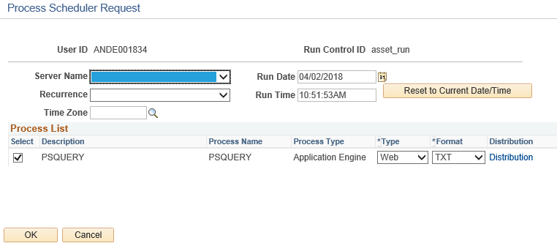

Process Scheduler Request page

To schedule a process request:

1. Open the Process Scheduler Request page.

2. Complete the fields on this page.

Type The destination type for this process:

Web: Sends the output of the process to the report repository, including log and trace files. The format of the report is the format selected on this page.

File: Enables you to write the output to a file that appears in the Output Destination.

When the output distribution type is Web, click the Distribution link to display the Distribution Detail page, where you can enter additional information.

3. Click OK to run the query.

The system displays the Query Process Request page. The Process Instance Number appears below the Schedule button.

4. Click the Process Monitor link to view the status of your request.

The Process List page appears. The Run Status field reveals the status of your scheduled or running process.

Using Process Monitor

Process Monitor consists of two pages: the Process List page and the Server List page.
• The Process List page lets you monitor the process requests you’ve submitted. You can select filtering options (for example, process type and run status) so that you
view only the process requests that meet the selected criteria. And you can view details associated with particular process requests.

• The Server List page lets you monitor the PeopleSoft Process Scheduler server agents within your system.

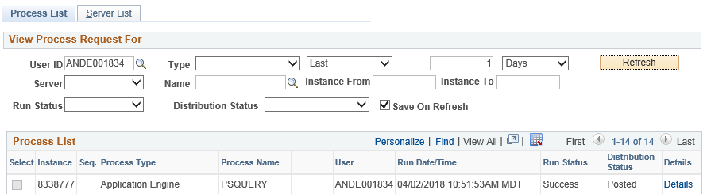

Process Monitor - Process List page

User View the processes submitted by a particular user ID.
Usually, you view by your own user ID.

Type View by a particular process type (for example,
Application Engine).

Last Specify an interval of time by which to limit the process requests that appear in the list. Enter a numerical value in the edit box preceding the drop-down list, and then select
a unit type from the drop-down list: Days, Hours, or
Minutes.

Server Select to view processes run on a particular server.

Run Status Select if you want to view processes by a specific status, such as Success or Error.

Instance Use the process instance number to identify a specific process.

Sequence This field is blank; it’s not used for query processes. User The ID of the user who submitted the process. Details Click to open the Process Details page.
Refresh Click to check the current status of a process. This button refreshes the list.

Go back to Schedule Query Clink to return to the Query Process Request page.

Report Manager Clink to view your query reports.

Viewing Output in Report Manager

Report Manager is like your own personal inbox of reports and process output. It provides a secure way to view report content, check the posting status of your output, and see content detail messages.

View all of your reports by opening your Report List in your browser.

Select Reporting Tools, Report Manager, or click the Report Manager link located on the Schedule Query page. Click on the Administration tab for best results.

