

LEAD WITH YOUR STRENGTHS

Learning and Development

Participant Guide

# Lead With Your Strengths

## Course Objectives

By the end of today’s session, participants will be able to:​

* Understand the Strengths-Based Theory Concept​
* Describe the Strengths Development Principles​
* Understand Your Strengths as a Leader​
* Describe the Strengths Team Model​
* Understand the Four Domains of Team Strengths​
* Understand How to Apply Your Themes in a Leadership Role to Achieve Team Success​

## Course Etiquette

* Listen actively and attentively.
* Ask for clarification if you are confused.
* Do not interrupt on another.
* Challenge one another but do so respectfully.
* Build on one another’s comments; work towards shared understanding.
* One person speaks at a time.
* Speak from you own experience, without generalizing.
* Consider anything that is said in class to be strictly confidential.

## Agenda

[Course Objectives 2](#_Toc79147209)

[Course Etiquette 2](#_Toc79147210)

[Agenda 2](#_Toc79147211)

[What is Strengths-Based Leadership Theory? 4](#_Toc79147212)

[4](#_Toc79147213)

[Strengths Development Principles 4](#_Toc79147214)

[Talent X Investment = Strength 5](#_Toc79147215)

[People Who Focus on Using Their Strengths 6](#_Toc79147216)

[“The Well-Rounded Myth” 7](#_Toc79147217)

[Your Leadership Strengths 7](#_Toc79147218)

[Breakout Room Exercise: Get to Know Your Breakout Room 8](#_Toc79147219)

[8](#_Toc79147220)

[Strengths-Based Team Model 9](#_Toc79147221)

[Four Domains of Team Strengths 10](#_Toc79147222)

[Breakout Room Exercise: Unique Contributions 11](#_Toc79147223)

[Cohort Team Grid 12](#_Toc79147224)

[Four Basic Needs of Followers 13](#_Toc79147225)

[Breakout Room Exercise: How to Apply as A Leader 14](#_Toc79147226)

[Accomplish Your Goals 15](#_Toc79147227)

[Closing Discussion 16](#_Toc79147228)

[Summary 16](#_Toc79147229)

[Additional Resources 17](#_Toc79147230)

## What is Strengths-Based Leadership Theory?

The [central premise of strengths-based leadership](https://high5test.com/strengths-based-leadership/) is that leveraging a company’s assets and human strengths will optimize performance. Strengths-based leadership shifts leaders’ focus from obstacles to possibilities, so that instead of trying to improve deficits, they try to capitalize on available resources, such as people, systems, and tools, to maximize organizational productivity.  Three essential principals to this theory:​

* Successful leaders invest in their employees' strengths​
* Successful leaders gather the right people to form teams that consist of people that complement each other​
* Successful leaders work to understand and respond to their employees’ needs​

Your Notes:

## 

## Poster_Graphics-03Strengths Development Principles

* Themes are neutral​
* Themes are not labels​
* Lead with *positive* intent​
* Differences are an **advantage**​
* People need one another​

Your Notes:

## Talent X Investment = Strength

Your Notes:

## People Who Focus on Using Their Strengths



**are three TIMES as likely to report having an excellent quality of life**



**Are six TIMES as likely to be engaged in their jobs**

Your Notes:

*“A leader needs to know his strengths as a carpenter knows his tools, or as a physician knows the instruments at her disposal. What great leaders have in common is that each truly knows his or her strengths – and can call on the right strengths at the right time. This explains why there is no definitive list of characteristics that describes all leaders.”*

*~Donald O. Clifton, Ph.D.*

*2003 Interview Quote*

## “The Well-Rounded Myth”

Your Notes:

## Your Leadership Strengths

Goal of this report:​

* Learn about your most powerful strengths​
* Understand what you do naturally as a leader​
* Discover practical ways to apply them​
* Use them to become a better leader​

Your Notes:

# 

### Breakout Room Exercise: Get to Know Your Breakout Room

In your breakout rooms, discuss the following:​

* Introduce yourself to your fellow team members​
* Tell your team members what your Top 5 Strengths are from your report and answer the following?​
  + What surprised you when reviewing your results?​
  + Which of your Top 5 do you connect with the most and why?​
* After each member has completed their introduction, discuss as a team if you saw any similarities in your team’s Top 5? If so, what? If not, what were the major differences?​
* Pick a spokesperson to provide a debrief of your team’s discussion.​

Your Notes:

## 

## Strengths-Based Team Model

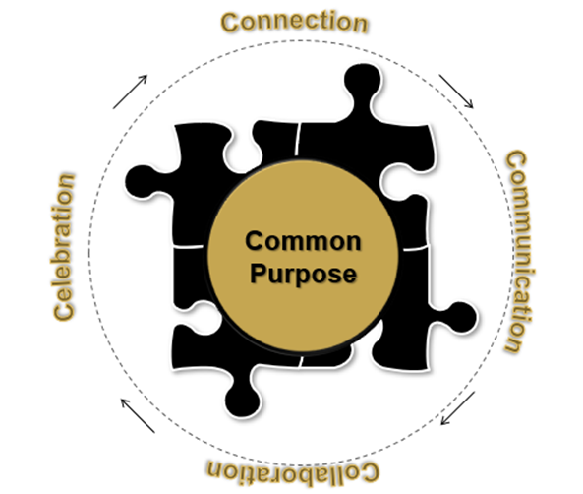

Strengths-based teams share the following “C” based characteristics:

* *Connection*
* *Communication*
* *Collaboration*
* *Celebration*

Your Notes:

## Four Domains of Team Strengths

While each theme has its own power and edge, it can be useful to think about how your talents and strengths help you and the team execute, influence others, build relationships, and absorb and think about information.​

The domains answer the question, “How do I make sense of the world on a greater scale than just my individual themes?”​

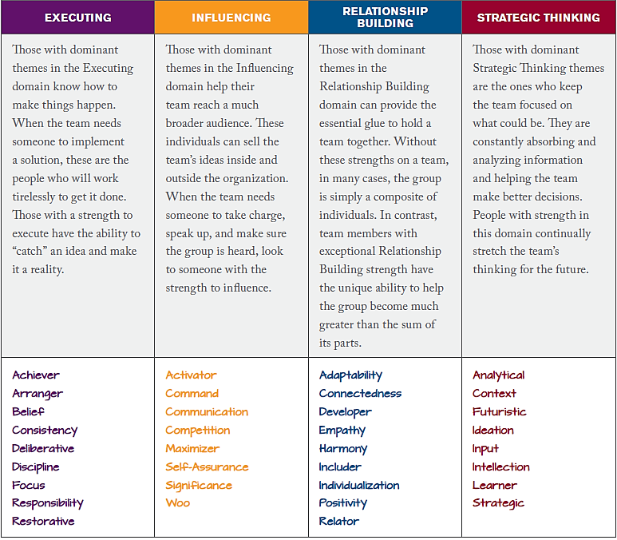

Your Notes: *Four Domains of Team Strengths*

### Breakout Room Exercise: Unique Contributions

In your breakout rooms, discuss the following:​

* What domain is most dominant for you?​
* In which domain are you least dominant?​
* Have you been “blind” to any of your less dominant domains?​
* After each person has discussed their contributions, as a team what insights did you learn about your breakout room team?​
* Pick a spokesperson to provide a debrief of your team’s discussion.​

Your Notes:

## Cohort Team Grid

Please note the team grid/talent matrix below is only a sample. A full customized team grid/matrix will be provided to your team for the session.

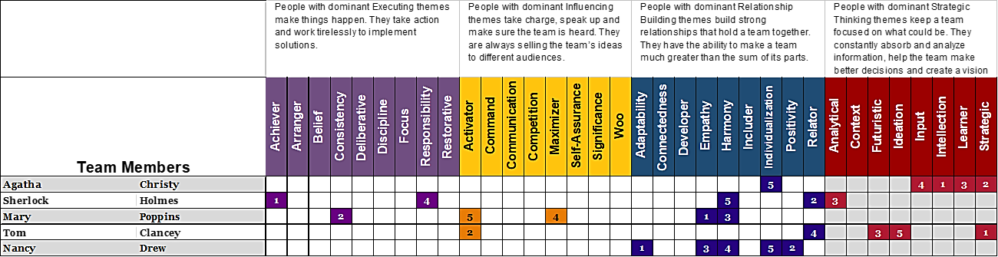

Your Notes:

## Four Basic Needs of Followers

**Stability**

* Security
* Strength
* Support
* Peace
* Consistency Across/Within
* Financial Future Concern

**Hope**

* Direction
* Faith
* Guidance
* Enthusiasm

**Trust**

* Truth
* Honesty
* Integrity
* Respect
* Authenticity
* Consistency Over Time

**Compassion**

* Caring
* Friendship
* Happiness
* Love
* Concern

A leader is someone who can get things done *through* other people.” ~ Warren Buffett

Your Notes:

### Breakout Room Exercise: How to Apply as A Leader

Each theme gives you an edge— how can you use it?

*Lead with Your Strengths*

**Part 1:** Individual Exercise:

* Select one of your themes and review the “How to Apply as a Manager” section.
* Next, review the “Reflect to Plan for Action” section and write a brief description of how you can put them into action with your team.
* You will share this information in the next portion of the exercise.

**Part 2:** Breakout Room Exercise:

In your breakout rooms:

* Each person should discuss what they learned from this exercise and the action plan for their theme.
* Pick 1 item from each person to discuss during the debrief.

Pick a spokesperson for the group to discuss what you learned about your team members’ actions plans.

Your Notes:

## Accomplish Your Goals

# 

# 

Self-Reflection Exercise:​

* Write your most meaningful goal in the center​
* Identify what themes you can use to achieve this goal​
* Answer the following questions:​
  + How will you use your strengths to reach this goal?​
  + How will you know you have been successful​?
* Your facilitator will ask for volunteers to share their insights

*See page 23 of your report for grid and questions.*

Your Notes:

## Closing Discussion

* What is one take away from today’s session?
* What questions do you have?

Your Notes:

## Summary

After today’s session, you are encouraged to read back through your entire participant guide and the “Clifton Strengths for Manager’s Report”. Be sure to also check out the additional resources section of the participant guide for further ways to enhance your learning. Continue to use this material as a tool for professional and personal growth.

Should you have questions, please contact your instructor or [hr.trainingregistration@ucdenver.edu](mailto:hr.trainingregistration@ucdenver.edu).

Check out our Learning and Development [website](https://www1.ucdenver.edu/offices/human-resources/learning-development) for additional course offerings, online training resources, custom workshop opportunities, and so much more!

Thank you for attending today’s session.

## Additional Resources

Clifton Strengths Themes (34)

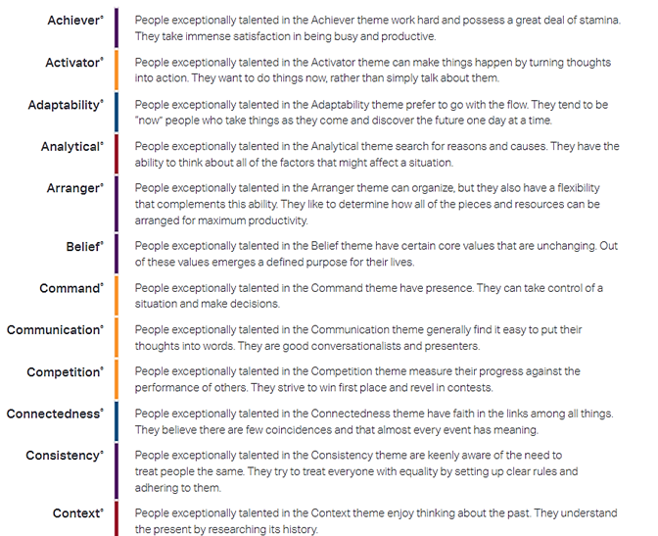

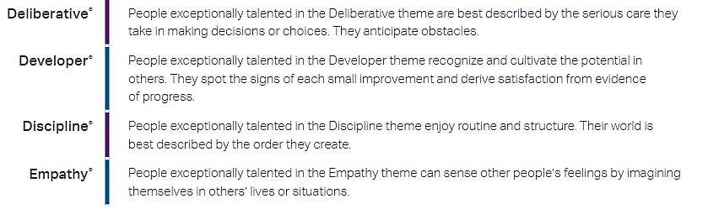



**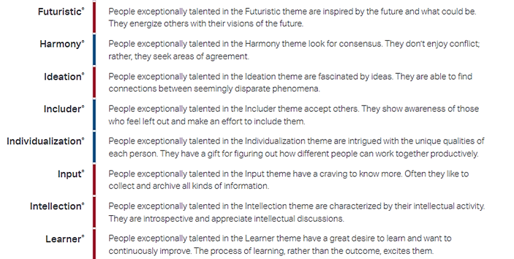**

# 

Articles

* Does a Specific Career Best Match My Clifton Strengths Results? Click this [**link**](https://www.gallup.com/cliftonstrengths/en/249455/specific-career-best-match-top-cliftonstrengths.aspx) to navigate to the article.
* The Strengths of Leadership: You've already got what you need to lead -- but do you know what that is? Click this[**link**](https://news.gallup.com/businessjournal/113956/strengths-leadership.aspx)to navigate to the article.
* Finding Your Leadership Strengths: Why effective leaders must possess a high level of self-awareness? Click this [**link**](https://www.gallup.com/workplace/237038/finding-leadership-strengths.aspx) to navigate to the article.

YouTube Series

* Gallup Theme Thursday’s – Season 1. Take a deeper dive into all 34 strengths. Click this [**link**](https://www.youtube.com/watch?v=k0gjHInPHHc&list=PLxDaK7wIyw9592ZjR_h_rcnbNL8fd_o2m) to navigate to the series.

Resource Guide

* This is a fantastic resource that includes all 34 theme descriptors, action items for all themes, tips on how supervisors can best manage each theme, and sample conversations starters. Access the Resource Guide via this[**link**](https://www1.ucdenver.edu/docs/librariesprovider188/learning-development/clifton-strengthsfinder-resource-guide.pdf).