Using Default Parameters with Form Links In Event Registration and Donation Forms

Copyright © 2011 Harris Connect LLC. all rights reserved. Training documents are proprietary and confidential and should not be shared outside of the client organization or reproduced (including on the Internet unless access is restricted to client’s employees), without our express written consent.

Using this feature allows an admin to display a specific value in a form field when a user clicks on the form link. This feature might be used to set the value of an optional checkbox to “Yes” (for example, “Would you like to receive our monthly e-Newsletter?”) or to pre-fill the dollar amount in a monetary field (for example, display $50 in the Alumni Scholarship Donation amount field.)

In the example below, we are placing a link to a Reunion Event Form on a Reunion Website page, urging class members to donate $50 to the Alumni Scholarship Fund. Default parameters have been added to the Form link to insert a value of $50 in the Alumni Scholarship Donation field when the modified link is clicked and the form displays. The constituent will be able to edit that amount.

Follow these steps:
- Locate the form link url for the event form or donation form in the Preview tab for the specific form.
This is the url for this form: https://www.alumniconnections.com/olc/pub/LV8/event/showEventForm.jsp?form_id=68390

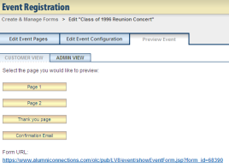

- Locate the identifier for the component to be pre-filled.
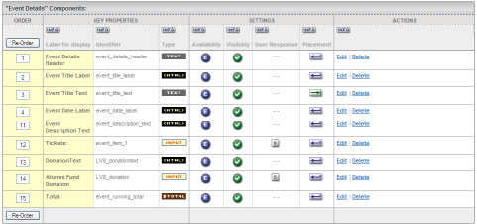

- To the end of the form link URL located in Step 1 above, add this sequence of 6 items:
- & (ampersand)
- referrer_type=UR* or referrer_type=UP*
- & (ampersand)
- identifier for component to be pre-filled
- =
- default value for the component
The above sequence results in this string: &referrer_type=UR&LV8_donation=50

- Include this revised link in an email invitation or on the reunion website to make it available to constituents:
https://www.alumniconnections.com/olc/pub/LV8/event/showEventForm.jsp?form_id=68390&referrer_type=UR&LV8_donation+50

- When the link is clicked, the form will display in this manner; note the pre-filled $50 donation amount:
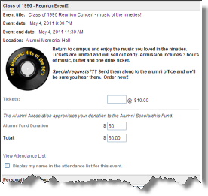

Important Information about Referrer types:
UR: use this code when the values passed via the default parameters will take precedence over existing profile values for authenticated users. So, if a user is authenticated, and the fields that are being set by the default parameters have also been set up to be pre-populated with profile data, the form will display the default parameter values when the user clicks the link.

UP: use this code when existing profile data will take precedence over the values passed via the default parameters for authenticated users. So, if a user is authenticated, and the fields that are being set by the default parameters have ALSO been set up to be pre-populated with profile data, the form will display the profile data when the user clicks the link.

Note that if the user clicking the form link is not authenticated, the default parameter values will always display.

Parameters must follow URL-encoding standards.
For example:
@ = %40 (e.g. mschanba%40harrisconnect.com)
a space = +sing or %20 (e.g. 123+Main+Street or 123%20Main%20Street)
Reference: http://www.w3schools.com/tags/ref_urlencode.asp

