Email Form Respondents
Quick Start Guide

Note: The Email Form Respondents functionality is available within all four Form applications (Event Registration, Donation Forms, Membership Forms, and Survey Forms). It allows an administrator to send an email to all attendees who submitted a particular form.

Sending an email message to form respondents will include some or all of the following steps:
Generate Form Respondent Mailing List: Generate new mailing list containing all individuals who submitted a particular form
Create and Manage Content: Choose to use existing content or create new content
Address & Assemble: Join together the appropriate mailing list and content and assign an Email Name
Send & Schedule: Schedule the Email for broadcast
Reports: Review outcomes of the broadcast

Lists and Content can be joined in the Address & Assemble step at any time for you to Send & Schedule immediately or for a later date.

Begin here: Logon to Admin Tool
- Go to your Administration Center web site.
- You will be prompted to log in using your User ID and Password. For security purposes, three failed attempts to log in will lock your account for up to 2 hours.
- The screen will refresh with the Administration Center landing page.
- Select Forms Management → <form type> → Create / Manage <form type> in the top navigation where form type represents the type of form you’d like to create an email list for (Event Registration, Donation Forms, Membership Forms, and Survey Forms).

Step 1: Generate Attendee Mailing List
- Locate the appropriate form in the list
- Hover over the “Actions” button for that form and click the “Create email list” link (see Figure 1)

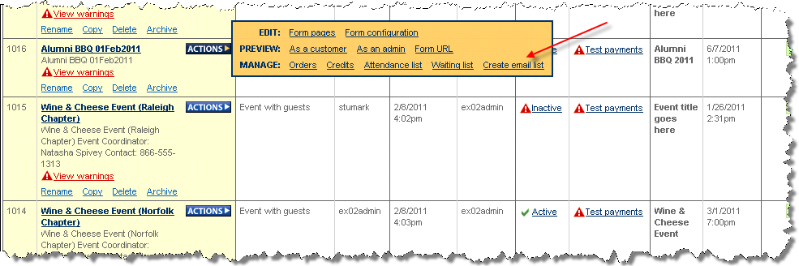
Figure 1

- Click the “Create form respondent list” button in the message box to confirm the creation of the email list – see Figure 2
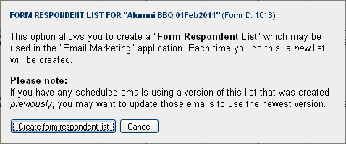
Figure 2

- Click the “Continue to Email Marketing” button in the message box to open the Email Marketing application – see Figure 3. Notice that the name of the newly generated form respondent list is highlighted in red toward the top of the tab – see Figure 4.

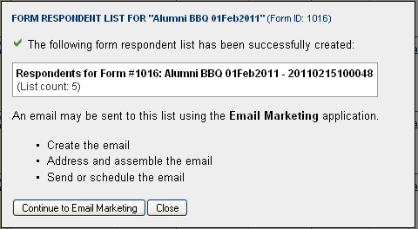
Figure 3
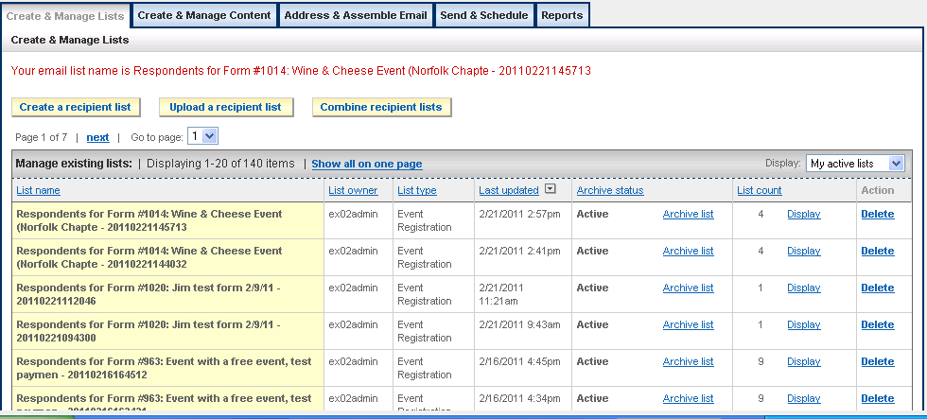
Figure 4

Useful information about Lists:
- Form Respondents Lists are designated with a List Type based on the type of form:
  - For Event Registration forms, List Type = “Event Registration”
  - For Membership forms, List Type = “Membership Forms”
  - For Donation forms, List Type = “Donation Forms”
  - For Survey forms, List Type = “Survey Forms”
- Form Respondent Lists are static, meaning that the list will not be automatically refreshed as new registrations and form submissions occur. In order to refresh a form respondent list, a new list must be generated by repeating the steps outlined above.
- Form Respondent List names include a date and time stamp to designate different versions of the list.
- Form Respondent Lists are not limited to a maximum number of email addresses
- Email Content sent to Form Respondent Lists including cannot contain profile data tags. This is because form respondents may not be in the database and therefore, the associated data tags are not applicable.
- Form Respondent Lists may not be Edited or Duplicated.
- Lists cannot be deleted once they are associated with an email that has been sent. This is to ensure availability of historical data for Reports.

Step 2. Create and Manage Content

IMPORTANT!
Profile data tags cannot be used with Form Respondent Lists – only those tags that are not specific to an individual (like Current Date and form links) may be used

Click on Create and Manage Content tab at top of page.
There are three ways to create content:
- Create HTML content version using WYSIWYG and copy to Text content version.
- Create Text content version only.
- Upload an HTML file, a text file or both

To create new HTML version content
- Click on Create Content button at top of page.
- Name your Content
- Note the two tabs at top of page: HTML version and Text version. The default display is the HTML content version.
- In HTML editor page enter your content between the two solid lines using WYSIWYG editor (similar to the MS Word editor).
- Click on Work with Data Tags button to insert html Data Tags (refer to Email Marketing for Staff and Volunteers manual for full instruction on using data tags).
- Click on Open File Manager button to upload or insert images or document links into the content.
- Click on Preview HTML button often to check your work.

To create new Text version content
- Click on Text version tab at top of page.
- In Text editor page you must also enter content or the email will not launch.
- Click on Work with Data Tags button to insert text Data Tags (please refer to Email Marketing for Staff and Volunteers manual for full instruction on using data tags).
- Click on Open File Manager button to insert links for images or documents into the content.
- Click on Preview Text button often to check your work.

IMPORTANT!
Every email must include a text version but may also include an HTML version. Click the Save Content button at bottom of Text content page to save both HTML and Text content versions

Templates
Templates are designated by checking the box “Mark as a Template” beside the “Name this Content” box at top of page for either HTML or Text content versions. They will display with the “(template)” designation. Templates are created to be used as boilerplates. Changes cannot be made directly to Templates. Templates must be “duplicated” and renamed before any edits can be made. This maintains the integrity of the boilerplate for future uses. To save time, use templates as a basis for content you send frequently or on a regular basis.
- Make a copy of the template you wish to use by clicking on the Duplicate link to the right of the appropriate template.
- Rename the template, but DO NOT mark as Template. Edit then Save.

IMPORTANT NOTES ABOUT CONTENT
1. Do not delete the Removal link (unsubscribe link). This is required for mailing.
2. Remember that content is always required on the Text content page

Useful information about Content:
- It is a good practice to always test your content prior to sending to a mailing list using Send Test Email link in Address & Assemble Email step.
- Content for Text version can be keyed in directly OR it can be copied from the HTML version using the Copy HTML To Text Version button; resulting text may need editing for clarity.
- Content cannot be deleted once it has been associated with an email that has been sent. This is to ensure availability of historical data for Reports.
- Use meaningful naming conventions to identify content for future reference.

Step 3. Address & Assemble Email

Click on Address & Assemble Email tab at top of page.
- Click on Address and Assemble a New Email button.
- Assign a Name to your email.
- Enter all required information on page.
- Click Save This Email button.
- The screen will refresh with your email listed at the top.
- Click on Send Test Email to send yourself or a (test list) a copy of the email.
- Choose Check Spam Rating for a determination on the likelihood of the email being flagged as spam.
- Click on Calculate to see the number of emails that will be sent (this number will remove opt-outs and records with no email address).
- Click on Display to see the recipient’s names.

Note: Email recipients listed in the blind copy (bcc) line will see the content of the email but not any data tag values. These emails will contain ***SAMPLE*** in the subject line to differentiate them from other email.

Step 4. Send & Schedule

Click on Send & Schedule tab at top of page.
- Calendar View will display by default. Click on List View for an alternate chronological listing of emails sent or scheduled.
- To send immediately:
  - Click on Send a Broadcast Email Right Now button.
  - Complete Steps 1-3 that appear in the popup box.
  - Locate the Email on the calendar and click APPROVE.
- To schedule for a later date:
  - Select the date on the calendar.
  - Select the time on the hourly list on the returned page.
  - Complete Steps 1-3 that appear in the popup box.
  - Locate the Email on the calendar and click APPROVE.

Once your email appears on the calendar you must click the Approve link at the bottom of the text. To review information about the email or view the content click on the name of the email.

IMPORTANT!
*****All Emails MUST BE APPROVED before they will launch*****

Step 5. Reports

Once the email has been broadcast to all recipients the email address associated with the logon used to create the email (usually the admin) will receive two items:
- Job Status report: details of the broadcast once it has completed.
- Email with ***SAMPLE*** on subject line; this is a copy of the email content that was sent.
To review outcomes of the broadcast:
  - Click on the Reports tab at top of page.
  - Click on the View Summary link for your Email.
  - The following types of data will be available to you:
    - Start and Stop times
    - Administrative details
    - Links to view the html and text versions of the email
    - Recipient details (total sent, open count)
    - Recipient errors (bounce-backs, other sending problems)
    - Link tracking (count and listing of recipients who clicked on links included in the EMAIL)

For detailed information on Reporting features please refer to the Email Marketing for Staff and Volunteers manual.

Frequently Asked Questions about Email Event Attendees functionality

Q. Will users who registered without an email address be included in the Form Respondent List?
A. No – users who registered without providing an email address will not be included in the List Count reported on the list creation confirmation page nor will they appear in the form respondent email list because the email cannot be received without an email address. In order to ensure that the email is sent to all form respondents, it is suggested that the email address be set up as a required field on the form.

Q. How are duplicate email addresses handled within Form Respondent Lists?
A. If the same email address is used for multiple registration submissions associated with the same form, that email address will be included multiple times in the List Count reported on the list creation confirmation page. In addition, multiple emails will be sent to that address.

Q: Is there a limit to the size of a Form Respondent List?
No – Form Respondent Lists are not subject to any limits so they can include all form respondents regardless of the number.

Q: Why am I getting a mail merge failure when I send an email to a Form Respondent List?
Most likely, this is because you are using profile data tags in the email content you are sending. Because form respondents may or may not have been authenticated (and in some cases, they may not even be in the directory database), profile data tag values cannot be retrieved from the database. As a result, no profile data tags may be used in content that is sent to Form Respondent Lists. To correct the issue, remove the profile data tags from your email content and resend the email.

Q: Can I still use the Email Form Respondents functionality even if I don’t have access to Email Marketing?
No – you must have access to Email Marketing in order to take advantage of the Email Form Respondents functionality. If you do not have access to Email Marketing, please contact your CRM.

Q: I have a question that is not addressed in this document. Who should I contact?
After reviewing the above resources, please contact your CRM with additional questions.

Q: How do I manage numerous unwanted Form Respondent lists?
Unwanted form respondent lists may be archived and reactivated at a later date, or permanently deleted provided they are not referenced in an email on the “Address and Assemble Email” tab. Note that the system will prevent you from deleting recipient lists that are being used in an assembled email - if you attempt to delete one, you will receive a message indicating that the list is in use and cannot be deleted.

