Conflict Styles at Work

Lisa Nelson
CU Denver Ombuds
Participant Guide
May 6, 2026


Welcome to Conflict Styles at Work!

Facilitator:
Lisa Nelson, CU Denver Ombuds Office
lisa.g.nelson@ucdenver.edu
303-315-0046
www.ucdenver.edu/ombuds
Feel free to reach out if you have any questions!

Agenda:
- Understand 5 conflict styles identified through Thomas-Kilmann Conflict Mode research
- Gain insight into our behavior when we encounter conflict
- Expand our flexibility and effectiveness by choosing how we respond to conflict

The Thomas-Kilmann Conflict Mode Instrument (TKI) was developed in early 1970s by Kenneth Thomas and Ralph Kilmann. Since then, it has been validated across thousands of users of different ages, genders and occupational roles.
The purpose of learning about conflict styles or modes is to discover whether you are overusing or underusing one or more of the conflict-handling modes, or styles, so you can be more effective in managing conflict
There is no right or wrong style, we all use all of them, but we typically have one or two that we rely on the most often.

Notes:

Conflict Styles
Understanding how we tend to respond in conflict situations is the first step in becoming more effective in those situations.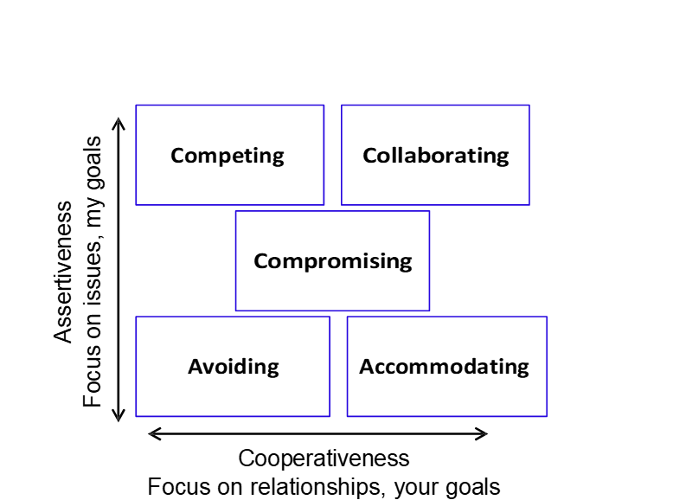

My results:
Avoiding
Accommodating
Compromising
Competing
Collaborating

Conflict Styles in Action

 | Looks like… | Useful when… | Drawbacks
Avoiding | Diplomatically side-step the issue, ignore, hide, procrastinate, deny there is a problem, change subject | It isn’t important to you, not worth it to engage | The conflict continues, no one needs are being met
Accommodating | Give in, obey, apologize, yield to others | Relationship is more important than your goals and interests | Your needs are not being met, your voice not being heard, not contributing to decision/outcome
Compromising | Make concessions, seek to split the difference, find happy medium | You don’t have the time and energy, need for a fast solution | When understanding what everyone needs is more important than a quick solution
Competing | Assertive, interrupting, do not give in, insist on getting own way, need to win | Emergency, when you need to stand up for yourself or something important, implement difficult decisions | Damages relationships, miss out on other perspectives
Collaborating | Listen, identify interests, explore issue in depth, find ways to meet everyone’s interests or common goals | You have the time to commit to the process, buy-in and involvement are important, long-term relationship building | Time factor, every situation does not require this process

Which style(s) do you use the most at work?

Which style could you use more often at work?

What do you notice when thinking about the conflict style(s) you use in your personal life?

What is one thing you are taking away from this webinar?

