Campaign Reports

Table of Contents

Introduction 3
Create A Campaign Report 4
Report on Form Only 8
Report on Email Only 9
Report on All Email and/or All Forms 11

Introduction
Campaigns Reports allow analysis of the effectiveness of campaigns based on responses to the Emails and Forms created for each campaign. Each report will provide both summary and detail information on these responses. Campaigns are defined as a coordinated series of communications with a specific goal. Examples of Campaigns might be Reunion 2009, Annual Fund 2010, Library Building, etc.

Campaign effectiveness might be measured in these ways:
- Event registration numbers for a set of related events
- Donations resulting from link clicks on broadcasts or event registration forms to online donation forms
- Link clicks to links provided in broadcasts to pages on other websites

Emails included in Campaign Reports will include emails created with Email Marketing. Forms included in Campaign Reports will include Event Registration forms, Donation forms, Membership forms, and Survey forms.

Reports can be filtered based on the work of a specific admin, a specific campaign, a specific form type, and/or a specific date range. Reports can include Email only, Forms only, or both Email and Forms. Reports can be printed.

Creating and Assigning Campaigns
- Permission for an admin to access Campaign Reports is granted by the Super Admin in the Administration Center via User Management > Manage Administrative Access > Manage Security Profile.
- New Campaigns can be added in the Administration Center via Community Management > Configuration > Add Campaigns.
- Campaigns are assigned to an email broadcast during the Address & Assemble Email step.
- Campaigns are assigned to a form (event, donation, membership or survey) in Edit Configuration > Categories & Campaigns tab.

Create A Campaign Report
How to create a Campaign Report:
- Log into the Administration Center. Mouse over Reporting > Pre-Defined Reports in the top navigation. Click on Campaign Reports. See figure 1. | 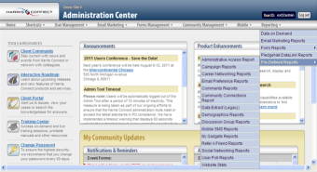  Figure 1
- The Campaign Reports landing page will display. See figure 2. | 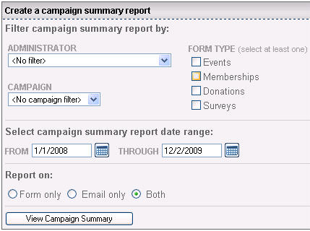  Figure 2
- Choose Filter - Campaign Reports can be filtered and aggregated based on an Admin, a Campaign, or a form type.  - To filter by admin, make the appropriate selection in the drop down box for Admin filter. See figure 3. | 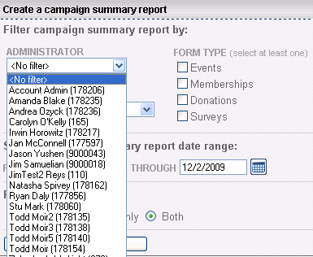  Figure 3

- To filter by campaign, make the appropriate selection in the drop down box for Campaign filter. See figure 4. | 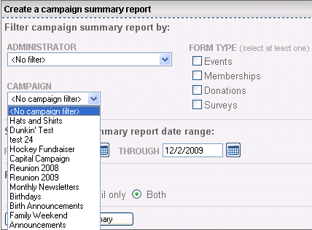  Figure 4
- To filter by form type, make the appropriate checkboxes selection(s) in the Form Type filter area. See figure 5. | 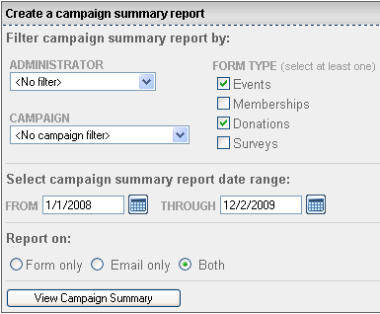  Figure 5
- Choose Date Range for the report - modify the default date if necessary.  - Enter dd/mm/yyyy format into text box. See figure 6.  or  - Choose dates on the calendar that appears by clicking on the calendar icon beside the date field. See figure 7. | Figure 6 | 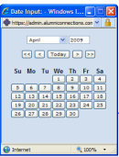  Figure 7

- Choose Report contents  - Form Only will create a report based only on forms created using Event Registration, Survey Forms, Donation Forms or Membership Forms. (See Report on Form Only section below.)  - Email Only will create a report based only on emails created using Email Marketing. (See Report on Email Only section below.)  Both will create a report aggregating Forms and Email data. See figure 8. |  | Figure 8
- Run Report – Click on View Campaign Summary to generate report. See figure 9. |  | Figure 9
- Print Report - Printed report output will appear exactly as displayed online. See figure 10.  Choose:  - Print Summary  - Print Entire Report  - Create another campaign summary report | 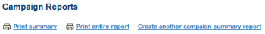  Figure 10

Report on Form Only
How to Report on Form Only
This report will display the aggregate information collected for all Forms associated with the specified Campaign.
1. Choose Report On Form Only. See figure 5.  Campaign Summary section will include:  - Filters for this report  - Form information  See figure 11. | 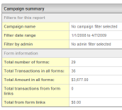  Figure 11
Campaign Details section will include:  - Form ID  - Form Name  - Form Description  - Total Transactions per form (count)  - Total Transactions per form (amount)  See figure 12. | 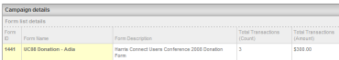  Figure 12

Report on Email Only
How to Report on Email only
This report will display the aggregate information collected for all Email associated with the specified Campaign. In addition to aggregated information, links to each email will be available.

1. Choose Report On Email Only. See figure 5.  Campaign Summary will include:  - Filters for this report  - Email Information  See figure 13. | Figure 13
Campaign Details section will include:  - Email List Details: list of clickable links to mailings in this report. See figure 14. | Figure 14
- Recipient Details by count and percentage. See figure 15. | Figure 15
- Recipient Errors by count and percentage. See figure 16. | Figure 16
- Link Tracking Details by count and percentage for each link. See figure 17. | Figure 17

Links to Forms section will include:  - Links back to each email in the campaign which contains a form  - Total Transactions for form links for each email  - Total Value from form links for each email  See figure 18.  Note: Each email is a hyperlink so you can view entire email in Email Marketing. | 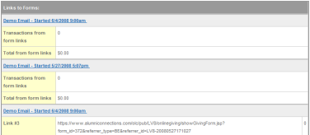  Figure 18
Link click details from non-form links will display all links included in the email that are directed to urls other than Forms, i.e. other websites or server pages. See figure 19. | 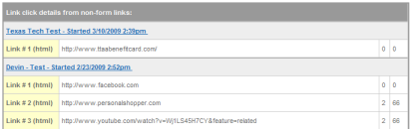  Figure 19

Report on All Email and/or All Forms
This report will display in one report the same information available separately in Form Only and Email Only Reporting (See figures 9-17), but will order them in this format:
- Campaign Summary
    - Filters for this report
    - Email information
    - Form information
- Campaign Details
    - Email list details
    - Form list details
    - Recipient details
    - Recipient errors
    - Link tracking details
- Link Information
    - Links to Forms
    - Link click details from non-form links

Report on All Email or All Forms or All Email and All Forms
To report on ALL Email or ALL Forms or ALL Email AND ALL Forms, do not activate either filter then set date range to maximum. See figure 20. | Figure 20

