Position management

Table of Contents

1. Fit/Gap Overview 2
2. Design and Development Document Objective 2
3. Current CU Position Management Business Processes 2
4. PeopleSoft 8.9 and 9.2 Position Management – Page Comparisons 9

Fit/Gap Overview
The University of Colorado is currently using PeopleSoft HRMS 8.9 with various customizations to meet business requirements and is planning to upgrade to PeopleSoft HCM 9.2.

This Design and Development Requirements document details the outcome of the Fit-Gap analysis of the current University Position Management process in PeopleSoft HRMS 8.9 and the delivered functionality of PeopleSoft 9.2.

Design and Development Document Objective
The purpose of the Position Management Design and Development document is to outline the decisions and solutions required by University of Colorado for Position Management processing.

While the goal is to use delivered PeopleSoft 9.2 Position Management module functionality, the Position Management evaluation may determine that certain current University of Colorado customizations will remain. New and existing functionality will be addressed in this document and customizations (existing and new) will be forwarded to the Leadership team for final approval.

Current CU Position Management Business Processes
  - System
Task | Typical Process used in HRMS 8.9
Position Data -  Creating a Position | HRP creates position in Jobs@CU – this only applies to university staff and classified staff. Once the position is approved in Jobs@CU, the following information feeds to HRMS 8.9: Effective Date, Reason Code (Defaults to “NWJ – New Position from Jobs@CU, Position Number, FTE, Dept, Reports To, Location, Job Code, Standard Hours, FLSA Status. All other job classifications are handled by the HRP through HRMS 8.9.  - Description Tab  - Position Information - Enter Effective Date, Reason  - Job Information - Job Code, Manager level, Reg/Temp, FT/PT, Title, Short Title auto populates. Adjust as necessary and use Title for Working Title.  - Work Location – Dept, Location auto populates. Enter Reports To, Appointing Authority, and Job specific bullets. Proposed Costs NOT used.  - Salary Plan Information – FTE, Percent of Time defaults to 100% and the Std Hrs is 40, Work Period is Weekly and each day populates to 8 hours. Change as needed for the position.  - FLSA status auto populates, adjust based on duties.  - Specific Information –Head Count, WC, Pay Group, and Employee Type auto populate. Change Pay Group and Employee Type to match position needs. Check appropriate BG Check. Education and Government Section are not used. Complete HIPAA and Hazardous Material sections as appropriate for the job.  - Position and Incumbent Data – No Action  - CU Kenexa Job Code Data – Match job to Kenexa Job Code and Profile. System jobs have all been matched to Kenexa codes in 8.9.  - Save  - Optional – “Go To Position Funding” to establish position funding by clicking link. Funding must be entered before Position can be approved  - Funding Distribution – for new position enter Funding Begin Date and establish Speed Type by an Amount or Percentage  - Position and Incumbent Data – auto populates Taken  - Save  - Funding Approval – goes through workflow  - Position Approval – goes through workflow
Position Data -  Updating a Position  used for promotions, transfers, job code change, changes in percent time, location and any other actions available in HRMS 8.9 are used instead of using the Position function in Jobs@CU. | HR Partner (HRP) updates  - Position Information  - Description – must add a row, Enter Effective Date of action; Enter Action/Reason.  - Job Information – change or update per action:  - Work Location – change or update fields per action  - Salary Plan Information – change or update fields per action  - FLSA Status – auto populates, updates as needed  - Specific Information, update as needed for the position  - Specific Information – change or update fields per action  - Position and Incumbent Data – auto populates  - CU Kenexa Job Code Data – change/update per action  - Save  - Change funding distribution if action requires  - Approvals goes through workflow  Updating a position automatically populates Job if Update Incumbent Box is checked
Position Transfer Only | This is a customization.

  - UCCS
Task | Typical Process used in HRMS 8.9
Position Data -  Creating a Position | Position creation and updates for classified positions are managed within HR and students are managed by Student Employment. Once the position is approved in Jobs@CU, the following information feeds to HRMS 8.9: Effective Date, Reason Code (Defaults to “NWJ – New Position from Jobs@CU, Position Number, FTE, Dept, Reports To, Location, Job Code, Standard Hours, FLSA Status. All other job classifications are handled by the HRP through HRMS 8.9.  Add/Update Position Information –  - Description - Enter Effective Date, Reason  - In Job Information - Job Code, Manager level, Reg/Temp, FT/PT, Title, Short Title auto Populate. Adjust as necessary and use Title for Working Title.  - Work Location – Dept, Location auto populates. Enter Reports To, Appointing Authority, and Job specific bullets. Proposed Costs NOT used.  - Salary Plan Information – FTE, Percent of Time defaults to 100% and the Std Hrs is 40, Work Period is Weekly and each day populates to 8 hours. Change as needed for the position. FLSA Status auto populates, adjust based on duties.  - Specific Information –Head Count, WC, Pay Group, and Employee Type auto populate. Change Pay Group and Employee Type to match position needs. Check appropriate BG Check. Ignore Education and Government Section. Complete HIPAA and Hazardous Material sections as appropriate for the job.  - Position and Incumbent Data – No Action  - CU Kenexa Job Code Data – Match job to Kenexa Job Code and Profile. UCCS is matching positions and expect to complete the project by June 2014.  - Save  - Use ‘Go To Position Funding’ to establish position funding as Funding must be established before Position can be approved.  - Funding Approval – No Action  - Funding Distribution – Add a Row, Enter Funding Begin Date and establish Speed Type by an Amount or Percentage.  - Position and Incumbent Data – No Action Taken  - Save  - Funding and Position Approval goes through workflow.
Position Data -  Updating a Position  used for promotions, transfers, job code change, changes in percent time, location and any other actions available in HRMS 8.9 are used instead of using the Position function in Jobs@CU. | HRP handles all steps for existing Lecturers, all others are managed and approved in HR:  - Add/Update a Position – Must add a row  - Description - Enter Effective Date, Reason  - Job Information – Change Job Code, Manager level, Reg/Temp, FT/PT, Title, Short Title auto Populate. Adjust as necessary and use Title for Working Title.  - Work Location – Dept, Location auto populates. Enter Reports To, Appointing Authority, and Job specific bullets. These may stay the same or need to be updated. Proposed Costs NOT used.  - Salary Plan Information – FTE, Percent of Time defaults to 100% and the Std Hrs is 40, Work Period is Weekly and each day populates to 8 hours. Change as needed for the position. FLSA Status, update as needed for the position.  - Specific Information –Head Count, WC, Pay Group, and Employee Type auto populate. Change Pay Group and Employee Type to match position needs. If employee is in position, check the Update Incumbent box so data will feed to Job Data. May need to update BG Check. Ignore Education and Government Section. Complete HIPAA and Hazardous Material sections as appropriate for the job.  - Position and Incumbent Data – No Action, review.  - CU Kenexa Job Code Data – Match job to Kenexa Job Code and Profile.  - Save  - May use ‘Go To Position Funding’ if Speed Type changes  - Approvals go through workflow  Updating the position automatically populates the Job if Update Incumbent Box is checked.
Position Transfer Only | This is a customization

  - UCD
Task | Typical Process used in HRMS 8.9
Position Data -  Creating a Position | HRP creates position in Jobs@CU – this only applies to faculty, university staff and classified staff. Once the position is approved in Jobs@CU, the following information feeds to HRMS 8.9: Effective Date, Reason Code (defaults to “NWJ-New Position from JobsatCU”) Position Number, FTE, Dept, Reports To, Location, Job Code, Standard Hours, FLSA Status. All other job classifications are handled by the HRP through HRMS 8.9:  Organizational Development>Position Management>Maintain Positions/Budgets>Add/Update Position Info:  - Description tab:  - Position Information – Enter Effective Date, Reason.  - Job Information - Job Code, Manager level, Reg/Temp, FT/PT, Title, Short Title auto populates. Adjust as necessary and use Title field for Working Title.  - Work Location – Dept, Location auto populates (change as necessary to reflect the correct location code). Enter Reports To, Appointing Authority, and Job specific bullets. Proposed Costs NOT used.  - Salary Plan Information – FTE, Percent of Time defaults to 100% and the Std Hrs is 40, Work Period is Weekly and each day populates to 8 hours. Change as needed for the position.  - FLSA status auto populates, adjust based on duties.  - Specific Information tab: Head Count, WC, Pay Group, and Employee Type auto populate. Change Pay Group and Employee Type to match position needs. Check appropriate BG Check based on individual position. Education and Government Section are not used. Complete HIPAA and Hazardous Material sections as appropriate for the job.  - Position and Incumbent Data tab: No Action  - CU Kenexa Job Code Data – Match job to Kenexa Job Code and Profile. (in the process of matching positions)  - Save  - Optional – “Go To Position Funding” to establish position funding by clicking link. Funding must be entered before Position can be approved (not 100% true)  - Funding Distribution – for new position enter Funding Begin Date and establish Speed Type by an Amount or Percentage  - Position and Incumbent Data – auto populates Taken  - Save  - Funding Approval – goes through workflow  - Position Approval – goes through workflow
Position Data -  Updating a Position  used for promotions, transfers, job code change, changes in percent time, location and any other actions available in HRMS 8.9 are used instead of using the Position function in Jobs@CU.  Some departments use Jobs@CU to update information such as location code, Reports To and any other actions. | HR Partner (HRP) updates  - Description tab:  - (Position Information) – must add a row, Enter Effective Date of action; Enter Action/Reason.  - Job Information – change or update per action:  - Work Location – change or update fields per action  - Salary Plan Information – change or update fields per action  - FLSA Status – auto populates, adjust based on duties.  - Specific Information tab: change or update fields per action  - Position and Incumbent Data tab: auto populates  - CU Kenexa Job Code Data – change/update per action (in the process of matching positions)  - Save  - Change funding distribution if action requires  - Approvals goes through workflow  Updating a position automatically populates Job if Update Incumbent Box is checked.
Position Transfer Only | This is a customization.

  - UCB
Task | Typical Process used in HRMS 8.9
Position Data -  Creating a Position | HRP creates position in Jobs@CU – this only applies to some regular faculty, research faculty, university staff and classified staff. Once the position is approved in Jobs@CU, the following information feeds to HRMS 8.9: Effective Date, Reason Code (Defaults to “NWJ – New Position from Jobs@CU, Position Number, FTE, Dept, Reports To, Location, Job Code, Standard Hours, FLSA Status. All other job classifications are handled by the HRP through HRMS 8.9.  Organizational Development>Position Management>Maintain Positions/Budgets>Add/Update Position Info:  - Description  - Position Information - Enter Effective Date, Reason  - Job Information - Job Code, Manager level, Reg/Temp, FT/PT, Title, Short Title auto populates. Adjust as necessary and use Title for Working Title.  - Work Location – Dept, Location auto populates. Enter Reports To, Appointing Authority, and Job specific bullets. Proposed Costs information is optional.  - Salary Plan Information – FTE, Percent of Time defaults to 100% and the Std Hrs is 40, Work Period is Weekly and each day populates to 8 hours. Change as needed for the position.  - FLSA status auto populates, adjust based on duties.  - Specific Information –Head Count, WC, Pay Group, and Employee Type auto populate. Change Pay Group and Employee Type to match position needs. Check appropriate BG Check(s). Education and Government Section are not used. Complete HIPAA and Hazardous Material sections as appropriate for the job.  - Position and Incumbent Data – No Action  - CU Kenexa Job Code Data – No Action for HRP. Campus HR Office will match job to Kenexa Job Code and Profile for University Staff positions only.  - Save  - Optional – “Go To Position Funding” to establish position funding by clicking link. Funding must be entered before Position can be approved  - Funding Distribution – for new position enter Funding Begin Date and establish Speed Type by an Amount or Percentage  - Position and Incumbent Data – auto populates  - Save  - Funding Approval – goes through workflow  - Position Approval – goes through workflow
Position Data -  Updating a Position  used for promotions, transfers, job code change, changes in percent time, location and any other actions available in HRMS 8.9 are used instead of using the Position function in Jobs@CU. | HR Partner (HRP) updates  - Description  - Position Information – must add a row, enter Effective Date of action; enter Reason.  - Job Information – change or update per action:  - Work Location – change or update fields per action  - Salary Plan Information – change or update fields per action  - FLSA Status – auto populates, adjust based on duties.  - Specific Information, update as needed for the position  - Specific Information – change or update fields per action  - Position and Incumbent Data – auto populates  - CU Kenexa Job Code Data – No Action for HRP. Campus HR Office will match job to Kenexa Job Code and Profile for University Staff positions only.  - Save  - Change funding distribution if action requires  - Approvals goes through workflow  Updating a position automatically populates Job if Update Incumbent Box is checked.
Position Transfer Only | This is a customization.

PeopleSoft 8.9 and 9.2 Position Management – Page Comparisons
PS 8.9 | PS 9.2
Maintain Positions/Budgets  Add/Update Position Info:  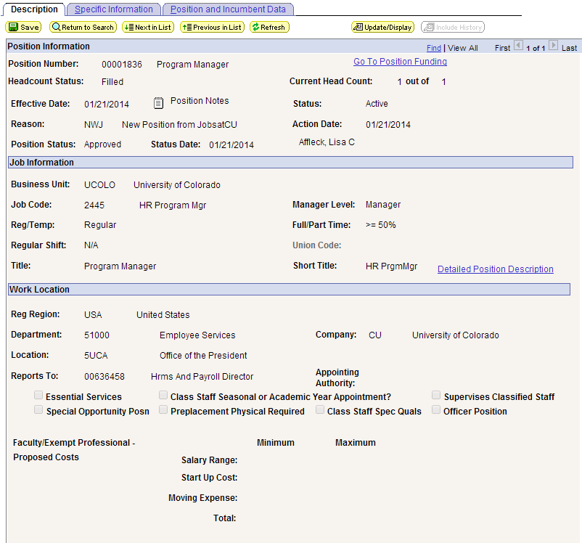  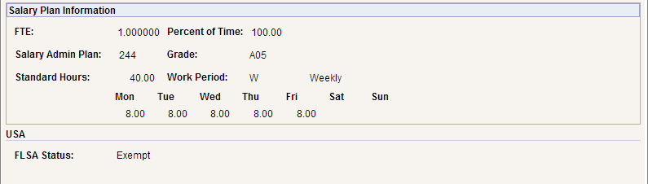  - Eliminate bullets at the top of Position Data.  - Eliminate Position Notes as this will be tracked through approvals.  - Eliminate Go To Position Funding  - Essential Services, Special Quals, Officer, HIPAA, and Hazardous Material Information, etc., check boxes will be built into Position Profiles  - Eliminate Percent of Time in Position as this will be tracked for the Person in Job Data  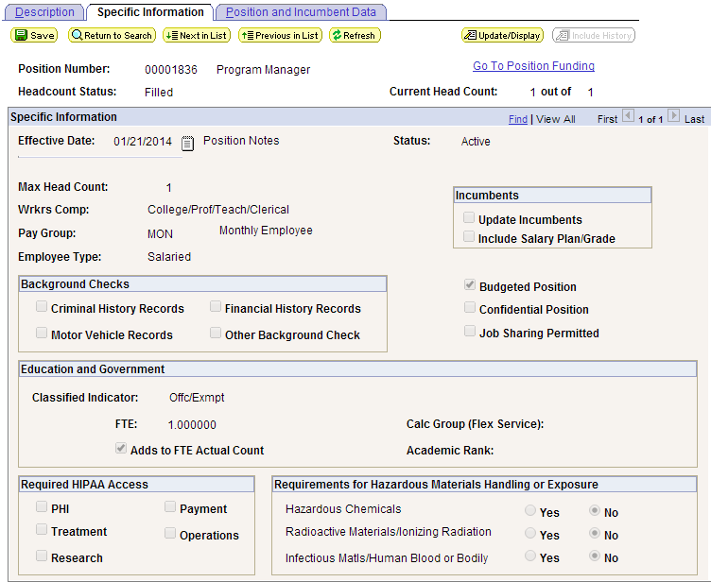  - These fields will be built into Position Profiles  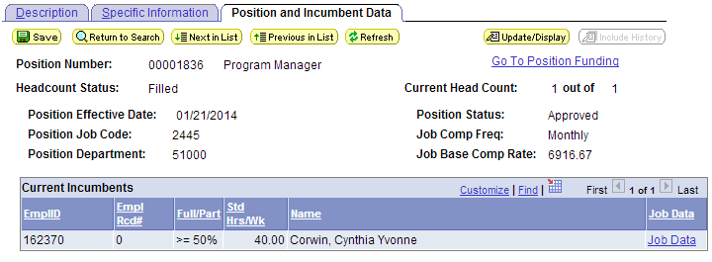  - - Eliminate Job Base Comp Rate  CU Kenexa Job Data  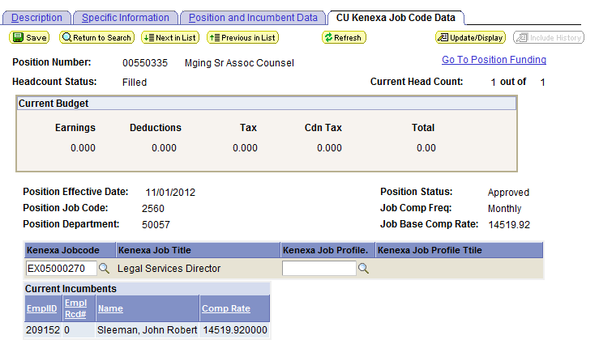  -Kenexa data will move to Job Profiles | Maintain Positions/Budgets  Add/Update Position Info:  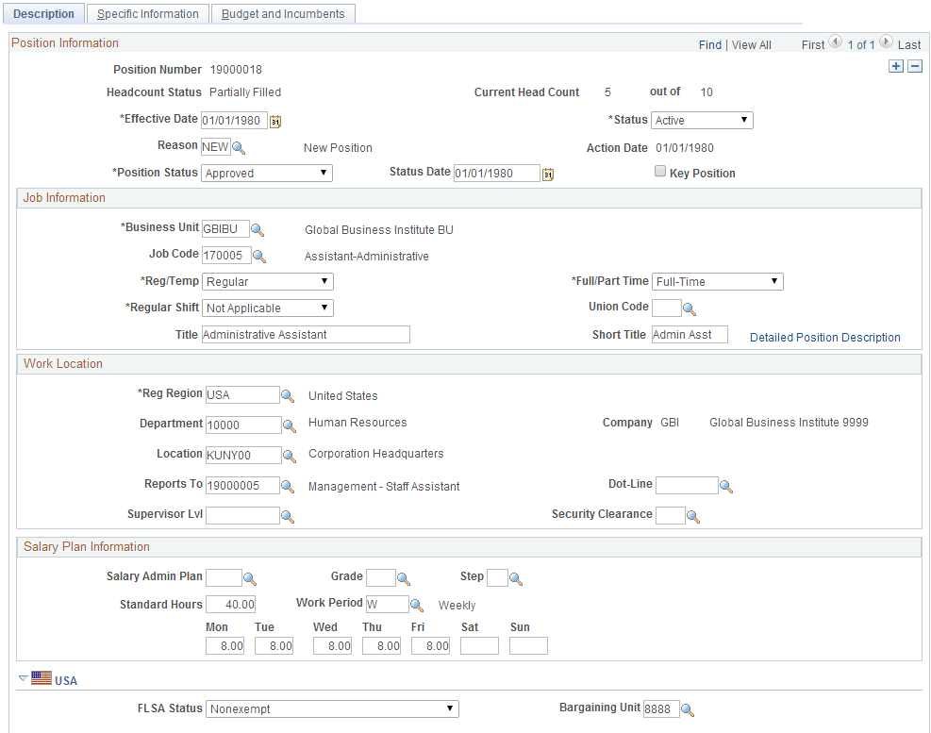  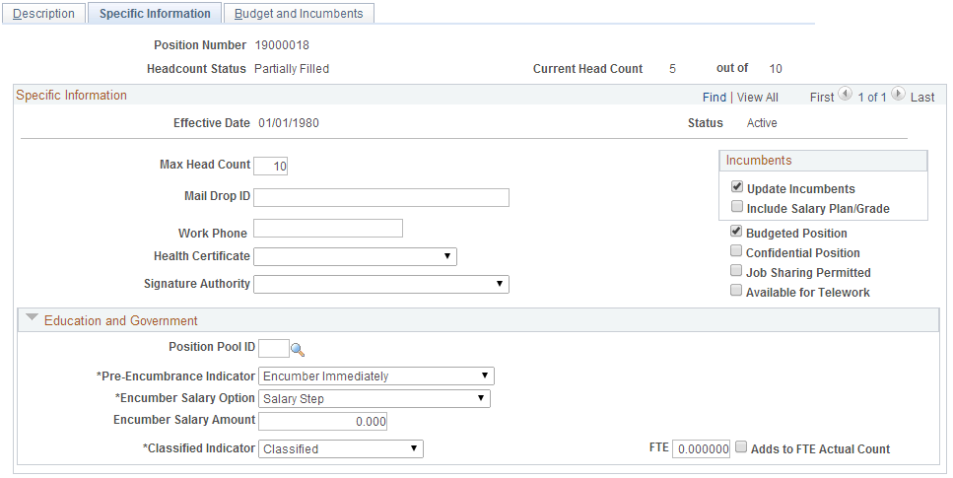  - Mail Drop will be used for Campus Box…tie it to the position.  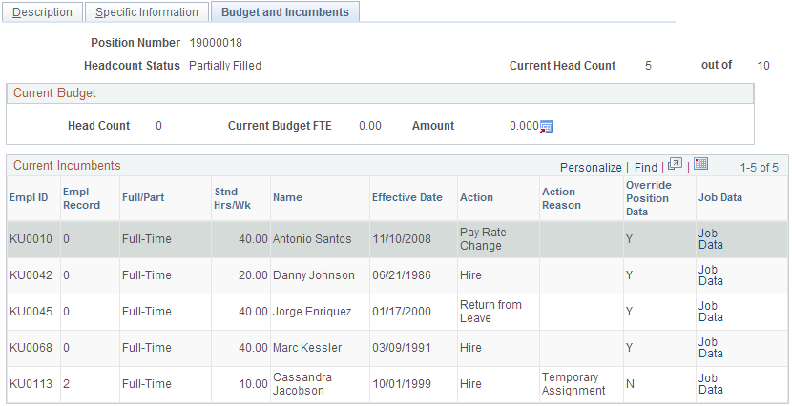
Position Approval:
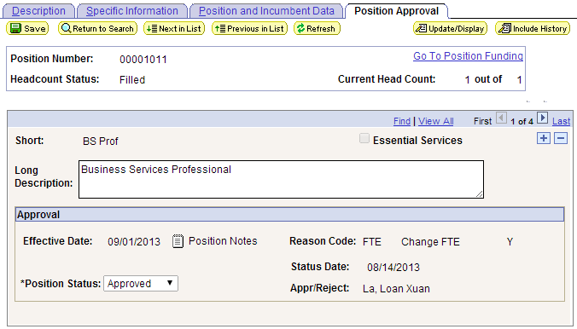
Position Approval will go away by using Forms/Templates and the approval process associated with them in 9.2

