Personal Information

Table of Contents
1. Fit/Gap Overview 2
2. Design and Development Document Objective 2
3. Current CU Personal Information Business Processes 2
3.1 System Office 2
3.2 UCCS 3
3.3 UCD 4
3.4 UCB 7
5. CU PeopleSoft 9.2 Proposed Personal Data Field Changes 10

Fit/Gap Overview
The University of Colorado is currently using PeopleSoft HRMS 8.9 with various customizations to meet business requirements and is planning to upgrade to PeopleSoft HCM 9.2.

This Design and Development Requirements document details the outcome of the Fit-Gap analysis of the current University Personal Information process in PeopleSoft HRMS 8.9 and the delivered functionality of PeopleSoft 9.2.

Design and Development Document Objective
The purpose of the Personal Information Design and Development document is to outline the decisions and solutions required by University of Colorado for Personal Information processing.

While the goal is to use delivered PeopleSoft 9.2 Personal Information module functionality, the Personal Information evaluation may determine that certain current University of Colorado customizations will remain. New and existing functionality will be addressed in this document and customizations (existing and new) will be forwarded to the Leadership team for final approval.

Current CU Personal Information Business Processes
Navigation: Workforce Administration>Personal Information>Add a Person

System Office
Hire a New Employee (Add A Person) | At System New Hires, Promotions, etc., are entered by HR and another HR Specialist approves the action (except POIs as they don’t need approvals).  - Verify all documentation is received and accurate, including offer letter.  - Ensure a position is available, or set up new position (See Position Data)  - Search for a Matching Person  - Add Biographical – Effective Date, Name, DOB, Gender, SSN.  - Contact – Address, Phone and Email.  - Regional – Ethnicity, if not fed from ATS, Military Status.  - Dept Info/Verification – Home Department and Campus Box, I-9 info, and BG Checks. Check Privacy, FERPA, or PERA 140 if necessary.  - Organizational Relationship - Enter appropriate Employment Relationship, hit Add the Relationship, and it leads right to Job Data  - Go to Personal Relationship, Emergency Contact and enter that information  - Go to Citizenship and enter Visa and Citizenship information if necessary.
Personal Data – rehire | Lecturer Rehires are entered by the HRP, others (Classified, University Staff are entered by HR)  The HRP checks HRMS to verify if any changes have been made to the following:  - Biographical Details: highest education level, marital status  - Contact Information: home address, adds mailing address information if different than home, phone information and email address(s)  - Department Verifications: adds new (if applicable) home department, campus box  Remaining information is entered in Job Data.
Personal Relationships | - Add/update Emergency contact Info
Modify a Person - Used for current employees with changes to any personal information | Employee can change the following using the Portal:  Home address  - Phone numbers  - Emergency contact information  - Email addresses  HRP can also change the above information if the employee requests.  Only HR can modify the following in HRMS:  - Biographical Details: data of birth, gender, highest education level, marital status  - Regional: ethnic group and whether the individual was visual identified, military status, and checks whether the person is eligible to work in US  - Department Verifications: changes department if transferred, campus box
Add POI – Add a Person | This is done by either the HRP or the HR Specialist  - Get POI form  - Biographical Details – must enter Effective Date, Name, DOB and SSN  - Contact Information – Enter Address, phone, and private email.  - Regional: Could enter ethnic group if identified, however, not required as this is not an employee/employer relationship  - Employment Relationship – Select POI type, checklist Code, and enter Add the Relationship  - Goes to Add Person of Interest tab.  - Enter POI Description  - Enter Sponsoring Department and current contact  - If Security Type, add a row.  - Enter Planned Exit Date.

UCCS
Hire a New Employee (Add A Person) | At UCCS New Hires, Promotions, etc., are entered by HR and another HR Specialist approves the action. HR Partners (HRP) enters Lecturer Rehires, POIs and PETs. These actions are approved by HR (except POIs as they don’t need approvals).  - Verify all documentation is received and accurate, including offer letter.  - Ensure a position is available, or set up new position (See Position Data)  - Search for a Matching Person  - Add Biographical – Effective Date, Name, DOB, Gender, SSN.  - Contact – Address, Phone and Email.  - Regional – Ethnicity, if not fed from ATS, Military Status.  - Dept Info/Verification – Home Department and Campus Box, I-9 info, and BG Checks. Check Privacy, FERPA, or PERA 140 if necessary.  - Organizational Relationship - Enter appropriate Employment Relationship, hit Add the Relationship, and it leads right to Job Data  - Go to Personal Relationship, Emergency Contact and enter that information  - Go to Citizenship and enter Visa and Citizenship information if necessary.
Personal Data – rehire | Lecturer Rehires are entered by the HRP, others (Classified, University Staff are entered by HR)  The HRP checks HRMS to verify if any changes have been made to the following:  - Biographical Details: highest education level, marital status  - Contact Information: home address, adds mailing address information if different than home, phone information and email address(s)  - Department Verifications: adds new (if applicable) home department, campus box  Remaining information is entered in Job Data.
Personal Relationships | - Add/update Emergency contact Info
Modify a Person - Used for current employees with changes to any personal information | Employee can change the following using the Portal:  Home address  - Phone numbers  - Emergency contact information  - Email addresses  HRP can also change the above information if the employee requests.  Only HR can modify the following in HRMS:  - Biographical Details: data of birth, gender, highest education level, marital status  - Regional: ethnic group and whether the individual was visual identified, military status, and checks whether the person is eligible to work in US  - Department Verifications: changes department if transferred, campus box
Add POI – Add a Person | This is done by either the HRP or the HR Specialist  - Get POI form  - Biographical Details – must enter Effective Date, Name, DOB and SSN  - Contact Information – Enter Address, phone, and private email.  - Regional: Could enter ethnic group if identified, however, not required as this is not an employee/employer relationship  - Employment Relationship – Select POI type, checklist Code, and enter Add the Relationship  - Goes to Add Person of Interest tab.  - Enter POI Description  - Enter Sponsoring Department and current contact  - If Security Type, add a row.  - Enter Planned Exit Date – At UCCS it was a year. A report is generated by HR and sent to Departments to update POI status.

UCD
Task | Typical Process used in HRMS 8.9
Add a Person (personal data and job) – hire | HR partner (HRP) handles all steps for HRMS 8.9 by:  Starts the process by using the campus new hire check list to ensure that hiring paperwork is complete. HRP enters the following into HRMS using the Personal Information Worksheet completed by the employee:  Workforce Administration>Personal Information>Add a person  - Biographical Details: enter name by clicking on “add name”, date of birth, effective date, gender, highest education level, marital status, National ID information (SSN)  - Contact Information: enter home address by clicking on “add address details”, this takes HRP to “Address History”, you then have to click on “Add Address” at which point you can add the address for the individual; add mailing address information if different than home, phone information and email address(s)  - Regional: ethnic group and whether the individual was visual identified, military status (the employee must also complete a self-identification form (http://www.ucdenver.edu/about/departments/HR/FormsTemplatesProcesses/SelfIdentificationForm/Pages/SelfIdentificationForm.aspx) and checks whether the person is eligible to work in US  - Department Verifications: home department, campus box  - Organizational Relationships: must check one of the following boxes: employee or contingent worker or a person of interest (POI)  After these steps an EMPL ID # is created and the HRMS takes the HRP directly to job data pages to enter job information  NOTE: NO APPROVALS REQUIRED
HR office handles the following steps:

- Department Verifications: Privacy Flag, FERPA or PERA 140; Employment Eligibility Proof: I-9 effective date and I-9 expiration date (if exists); checks E-verify pass (if paid by federal contract with FAR e-verify clause); E-verifying completion date; Background Checks: criminal history records completion date. If applicable inputs the following completion dates: financial history records, motor vehicle records, or any other background check
Jobs@ CU – can use “hiring proposal” to upload all personal information. This option is not currently being used by Denver | Anschutz Medical Campus
Add a person – POI (person of interest not an employee) | HR partner (HRP) handles all steps for HRMS 8.9 by:  HRP has POI complete an “Add a Person (POI)” Worksheet. Information is entered by HRP as follows:  Workforce Administration>Personal Information>Add a person  The following pages must be entered:  - Biographical Details: enter name by clicking on “add name”, data of birth, effective date, gender, highest education level, marital status, National ID information (SSN) must be provided and entered by HRP if individual is to have access to various University data and systems  - Contact Information: enter home address by clicking on “add address details”, this takes HRP to “Address History”, you then have to click on “Add Address” at which point you can add the address for the individual; home address, adds mailing address information if different than home, phone information and email address(s)  - Department Verifications: sponsoring department name and number, campus box  - Organizational Type and Relationships: must check the following box for type: a person of interest (POI); this creates a drop down box to choose the relationship of POI;  - Save  - Once saved the system takes you to “Add a person of Interest”. HRP reviews information. Adds or changes date in the “planned exit” field. Click on “ok”  - Click on ok and the system takes  After these steps an ID # is created  HR office – does not handle POI’s  NOTE: NO APPROVALS REQUIRED
Personal Data – rehire | HRP has the rehired employee complete a Personal Information Worksheet.  The HRP checks HRMS to verify if any changes have been made to the following:  Workforce Administration>Personal Information>Modify a Person  - Biographical Details: highest education level, marital status  - Contact Information: home address, adds mailing address information if different than home, phone information and email address(s)  - Department Verifications: adds new (if applicable) home department, campus box  HR office handles the following steps:  - Department Verifications: Privacy Flag, FERPA or PERA 140; Employment Eligibility Proof: I-9 effective date and I-9 expiration date (if exists); checks E-verify pass (if paid by federal contract with FAR e-verify clause); E-verifying completion date; Background Checks: criminal history records completion date. If applicable inputs the following completion dates: financial history records, motor vehicle records, or any other background check  NOTE: NO APPROVALS REQUIRED
Personal Data – Modify a Person  Used for current employees with changes to any personal information including department transfers | Employee can change the following using the Portal:  - Home address  - Phone numbers  - Emergency contact information  - Email addresses  HRP can also change the above information if the employee requests.  Only HRP (or HR) can modify the following in HRMS:  - Biographical Details: data of birth, gender, highest education level, marital status  - Regional: ethnic group and whether the individual was visual identified, military status, and checks whether the person is eligible to work in US  - Department Verifications: changes department if transferred, campus box  NOTE: NO APPROVALS REQURIED

UCB
Task | Typical Process used in HRMS 8.9
Add a Person (personal data and job) – hire | HR partner (HRP) handles all steps for HRMS 8.9 by:  Starts the process by using the campus new hire check list to ensure that hiring paperwork is completed. HRP enters the following into HRMS using the Personal Information Worksheet completed by the employee:  Workforce Administration>Personal Information>Add a person  - Biographical Details: enter name by clicking on “add name”, date of birth, effective date, gender, highest education level, marital status, National ID information (SSN)  - Contact Information: enter home address by clicking on “add address details”, this takes HRP to “Address History”, you then have to click on “Add Address” at which point you can add the address for the individual; add mailing address information if different than home, phone information and email address(s)  - Regional: ethnic group and whether the individual was visual identified, military status and checks whether the person is eligible to work in US  - Department Verifications: home department, campus box  - Organizational Relationships: must check one of the following boxes: employee or contingent worker or a person of interest (POI)  After these steps an EMPL ID # is created and the HRMS takes the HRP directly to job data pages to enter job information  NOTE: NO APPROVALS REQUIRED
HR office handles the following steps:

- Department Verifications: Privacy Flag or PERA 140; Employment Eligibility Proof: I-9 effective date and I-9 expiration date (if exists); checks E-verify pass (if paid by federal contract with FAR e-verify clause); E-verifying completion date; Background Checks: criminal history records completion date. If applicable inputs the following completion dates: financial history records, motor vehicle records, or any other background check
Jobs@ CU – can use “hiring proposal” to upload all personal information. This option is not currently being used by Boulder Campus
Add a person – POI (person of interest not an employee) | HR partner (HRP) handles all steps for HRMS 8.9 by:  HRP has POI complete an “Add a Person (POI)” Worksheet. Information is entered by HRP as follows:  Workforce Administration>Personal Information>Add a person  The following pages must be entered:  - Biographical Details: enter name by clicking on “add name”, data of birth, effective date, gender, highest education level, marital status, National ID information (SSN) must be provided and entered by HRP if individual is to have access to various University data and systems  - Contact Information: enter home address by clicking on “add address details”, this takes HRP to “Address History”, you then have to click on “Add Address” at which point you can add the address for the individual; home address, adds mailing address information if different than home, phone information and email address(s)  - Department Verifications: sponsoring department name and number, campus box  - Organizational Type and Relationships: must check the following box for type: a person of interest (POI); this creates a drop down box to choose the relationship of POI;  - Save  - Once saved the system takes you to “Add a person of Interest”. HRP reviews information. Adds or changes date in the “planned exit” field. Click on “ok”  - Click on ok and the system takes  After these steps an ID # is created  HR office – does not handle POI’s  NOTE: NO APPROVALS REQUIRED
Personal Data – rehire | HRP has the rehired employee complete a Personal Information Worksheet.  The HRP checks HRMS to verify if any changes have been made to the following:  Workforce Administration>Personal Information>Modify a Person  - Biographical Details: highest education level, marital status  - Contact Information: home address, adds mailing address information if different than home, phone information and email address(s)  - Department Verifications: adds new (if applicable) home department, campus box  HR office handles the following steps:  - Department Verifications: Privacy Flag or PERA 140; Employment Eligibility Proof: I-9 effective date and I-9 expiration date (if exists); checks E-verify pass (if paid by federal contract with FAR e-verify clause); E-verifying completion date; Background Checks: criminal history records completion date. If applicable inputs the following completion dates: financial history records, motor vehicle records, or any other background check  NOTE: NO APPROVALS REQUIRED
Personal Data – Modify a Person  Used for current employees with changes to any personal information including department transfers | Employee can change the following using the Portal:  - Home address  - Phone numbers  - Emergency contact information  - Email addresses  HRP can also change the above information if the employee requests.  Only HRP (or HR) can modify the following in HRMS:  - Biographical Details: data of birth, gender, highest education level, marital status  - Regional: ethnic group and whether the individual was visual identified, military status, and checks whether the person is eligible to work in US  - Department Verifications: changes department if transferred, campus box  NOTE: NO APPROVALS REQURIED

CU PeopleSoft 9.2 Proposed Personal Data Field Changes
There are fields in Personal Data that must be maintained. Below are sample shots of the new screens in 9.2 and decisions regarding customizations are listed in Red. If the customizations are to be maintained, they may not always be in found in the same record structure.
PS 9.2
- Modify a Person

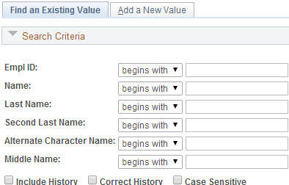

- Custom naming configuration (Last Name, ‘space’ First Name) will not carry forward into 9.2. Searching under Name is broader in 9.2. Can search by first name under Name field.

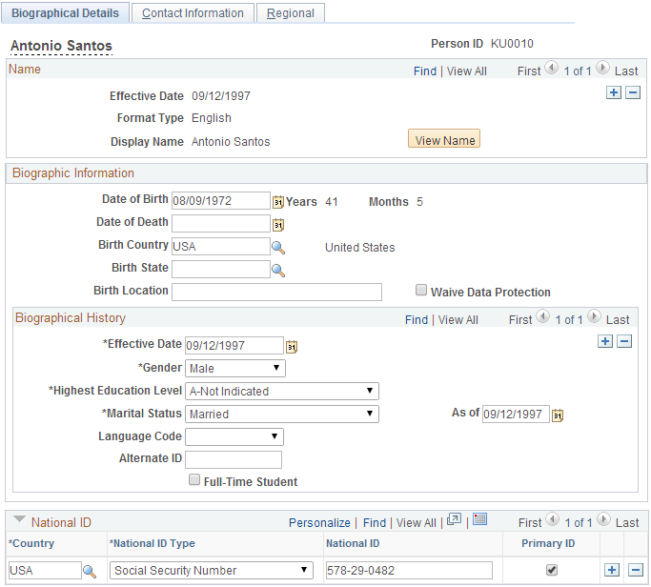

- Will not hide birth state
- Highest Education Level needs feeds to CIW. This can be recorded in Employee and Position Profile and obtained at hire – needs further discussion w/IR
- Keep SSN Encryption – Customization to be determined
- Can Waive Data Protection replace the Privacy checkbox on the Department/Verification Tab? Change the meaning of the Waive Data Protection. Only HR users can update this field. Customization to be determined.

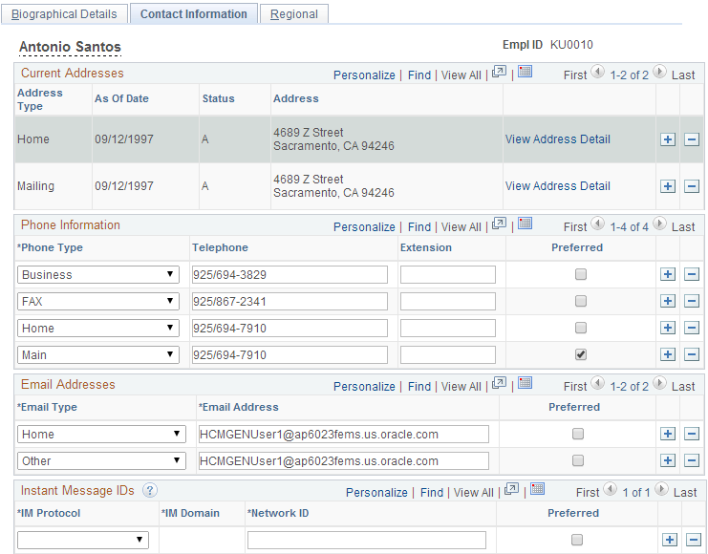

- Must enter at least Home and Mailing address

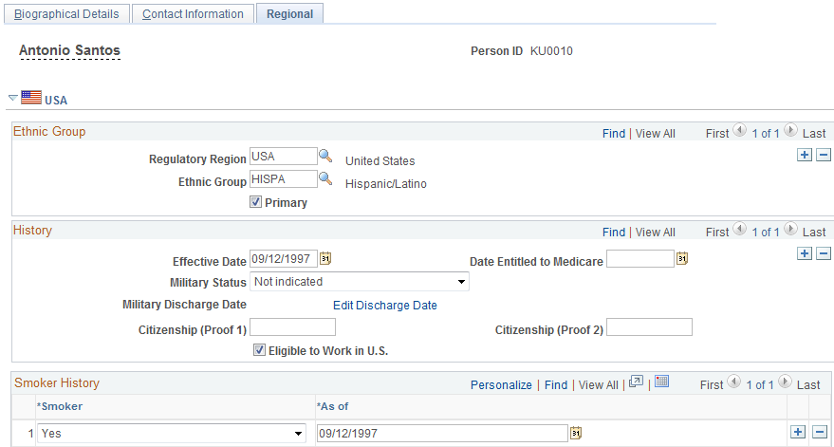

- Visually Identified will be maintained.
- Two part Race/Ethnicity question is part of self service and will be required as part of the on-boarding process. This data will feed to the Ethnicity Group field and feed to the CIW.
- Ethnicity/Race and Military codes will be configured correctly at time of implementation.

THIS IS A CUSTOM CU PAGE:

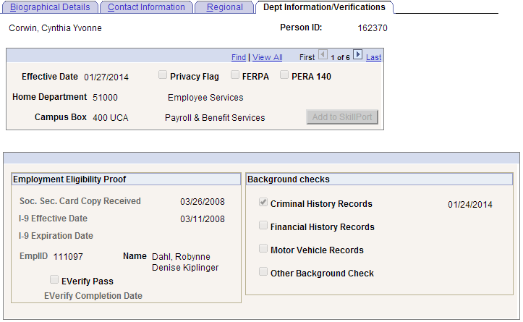

- Campus Box will be removed from Personal Data and maintained on Position under the Mail Drop ID. Home Department will be tied to Primary Job in 9.2.
- Privacy Flag, FERPA, and PERA 140 customizations will migrated and be associated with Personal Data, and maintained under a unique CU Tab.
- I-9 information and Colorado Affirmation will be moved to the on-line I-9 form in 9.2.
- Background Checks will be built into Position Profile or may be able to be incorporated into Taleo. Records of a completed Background check will be fed back to HCM and maintained in the unique CU Table as this is required for reporting purposes and tracking POI background checks.
- Need a Sponsor and Sponsoring Department for POIs. Still investigating how this will be implemented.

I-9 Data is found in a separate tab under Personal Information – Complete/Reverify EE I-9 Form.
Data entry begins with Self Service with the employee. Once employee information has been entered, the employee clicks Accept which makes the document available for the employer or authorized representative to review and enter verification information. After the employer completes sections 2 and 3 they must also click Accept to submit the I-9. After these steps are complete, the I-9 is available to print in PDF format.

I-9 receipt and Expiration Report – this is can be generated to notify administrators of I-9’s that require re-verification
