Job Information

Table of Contents

1. Fit/Gap Overview 2
2. Design and Development Document Objective 2
3. Current CU Job Information Business Processes 2
3.1 System 2
3.2 UCCS 3
3.3 UCD 4
3.4 Boulder 4
4. PeopleSoft 8.9 and 9.2 Job Information – Page Comparisons 6

Fit/Gap Overview
The University of Colorado is currently using PeopleSoft HRMS 8.9 with various customizations to meet business requirements and is planning to upgrade to PeopleSoft HCM 9.2.

This Design and Development Requirements document details the outcome of the Fit-Gap analysis of the current University Job Information process in PeopleSoft HRMS 8.9 and the delivered functionality of PeopleSoft 9.2.

Design and Development Document Objective
The purpose of the Job Information Design and Development document is to outline the decisions and solutions required by University of Colorado for Job Information processing.

**While the goal is to use delivered PeopleSoft 9.2 Job Information module functionality, the Job Information evaluation has determined that a portion of the current University of Colorado customizations will remain. New and existing functionality will be addressed in this document.

Current CU Job Information Business Processes
Navigation: Workforce Administration>Job Information>Job Data

System
Task | Typical Process used in HRMS 8.9
Job Data – Hire  All other actions basically follow the same process with minor variations, except as documented below. | Job Data is entered and approved by HR for Classified and University Staff employment groups.  - Work Location - Enter Action/Reason, Position Number and department info. After Entering Position Number if the job title doesn’t populate then HR may have to close out and ensure Position info is approved before entering Job Data.  - Job Information – Verify Job Code and Title, Reports To, Percent of Time, and Standard Hrs and modify if necessary  - No changes to Payroll or Salary Plan.  - Compensation – Change Frequency if necessary (e.g, Pay Differentials).Select appropriate Pay Component/Rate Code and hit Calculate Compensation.  - Benefit Program Participation (HR and HRPs do not see this Tab)  - Employment Information – Can use Override box to update various Employment Dates, Classified Cert Date (if appropriate). Entry of Appt End Date for Faculty and 12 Mo Faculty box if appropriate, but nothing else for faculty fields.  - May use Work Location Tab to go to Position Data and Funding Distribution to update those records

UCCS
Task | Typical Process used in HRMS 8.9
Job Data – Hire  All other actions basically follow the same process with minor variations, except as documented below. | Job Data is entered and approved by HR staff for all employment groups except Students. These are entered and approved by Student Employment.  - Work Location - Enter Action/Reason, Position Number and department info. After Entering Position Number if the job title doesn’t populate then HR may have to close out and ensure Position info is approved before entering Job Data  - Job Information – Verify Job Code and Title, Reports To, Percent of Time, and Standard Hrs and modify if necessary  - No changes to Payroll or Salary Plan.  - Compensation – Change Frequency if necessary (e.g, Pay Differentials).Select appropriate Pay Component/Rate Code and hit Calculate Compensation.  For Contract Pay:  - Change Pay Frequency to ‘C’, select Contract Pay. Enter Effective Date, Contract Pay Type, Payment Term, Contract Begin/End Date and Actual Start/End Date  - Under Pay Component select appropriate Rate Code, enter Comp Rate (Contract amount) and hit Calculate Compensation.  - Benefit Program Participation (HR and HRPs do not see this Tab)  - Employment Information – Can use Override box to update various Employment Dates, Classified Cert Date (if appropriate). Entry of Appt End Date for Faculty and 12 Mo Faculty box if appropriate, but nothing else for faculty fields.  - May use Work Location Tab to go to Position Data and Funding Distribution to update those records
Re-Hire (Lecturers) | HR Partner (HRP) handles all steps for Lecturer appointments in HRMS 8.9 by:  - Review offer letter and verifies position data.  - Work Location - Enter Action/Reason. Either enter or verify Position Number and department info. After Entering Position Number if the job title doesn’t populate then the HRP may have to close out and ensure Position info is entered and approved before entering Job Data  - Job Information – Verify Job Code and Title, Reports To, Percent of Time, and Standard Hrs and modify if necessary  - No changes to Payroll or Salary Plan.  - Compensation –For Contract Pay:  - Change Pay Frequency to ‘C’, select Contract Pay. Enter Effective Date, Contract Pay Type, Payment Term, Contract Begin/End Date and Actual Start/End Date  - Under Pay Component select appropriate Rate Code, enter Comp Rate (Contract amount) and hit Calculate Compensation.  - Benefit Program Participation (HR and HRPs do not see this Tab)  - Employment Information –Enter Appt End Date but nothing else for faculty fields.  - May use Work Location Tab to go to Position Data and Funding Distribution to update those records  HR office handles the following steps:  - Reviews tab entries and approves Re-hires.

UCD
Task | Typical Process used in HRMS 8.9
Job Data – Hire  All other actions follow same steps as a HIRE with minor variations | After entering applicable personal information HRMS takes HRP to the Job Data panels. The HRP enters the following:  - Work Location: enters effective date of hire (day employee will start working); action should automatically be populated to “HIRE”; enter the reason using the lookup function; enter position number  - Job Information: automatically populated – verify information and change if necessary  - Payroll: choose the appropriate local tax if applicable  - Salary Plan: automatically populated – no entry required  - Compensation: change pay frequency if applicable; enter rate code and comp rate; click on calculate compensation; if paid by contract:  - Change pay frequency to “C”  - Click on contract pay  - Change effective date if different  - Enter contract pay type, payment term, contract begin and end date, actual start date and actual contract end date  - Click ok  - on compensation page enter rate code as Base C; comp rate will be the contract amount  - Employment Information: the only fields that are not automatically populated are: 12 month faculty box check if applicable; appointment end date – used for lecturers, temporary employees, student employees or any employment classification that has an end date  - SAVE  - Once saved the action flows to worklist for approval  - Approvals are based on workflow (HR approves: classified; Denver faculty(includes PRA’s and lecturers) and exempt; Anschutz faculty and exempt are approved by the college/school Dean’s Office; Student Employees are approved at the department level; Medical Residents are approved by GME; Post Doc’s are approved by the Post Doc office)

Boulder
Task | Typical Process used in HRMS 8.9
Job Data – Hire  All other actions follow same steps as a HIRE with minor variations | After entering applicable personal information HRMS takes HRP to the Job Data panels. The HRP enters the following:  - Work Location: enters effective date of hire (day employee will start working); action should automatically be populated to “HIRE” (or “REHIRE”); enter the reason using the lookup function; enter position number  - Job Information: automatically populated – verify information and change if necessary  - Payroll: choose the appropriate local tax if applicable  - Salary Plan: automatically populated – no entry required  - Compensation: change pay frequency if applicable; enter rate code and comp rate; click on calculate compensation; if paid by contract:  - Change pay frequency to “C”  - Click on contract pay  - Change effective date if different  - Enter contract pay type, payment term, contract begin and end date, actual start date and actual contract end date  - Click ok  - on compensation page enter rate code as Base C; comp rate will be the contract amount  - Employment Information: the only fields that are not automatically populated are: 12 month faculty box check if applicable; appointment end date – used for lecturers, temporary employees, student employees or any employment classification that has an end date  - SAVE  - Once saved the action flows to worklist for approval  Approvals are based on workflow. For Boulder Campus, HR approves classified and university staff; VC for Research Office approves research faculty; all others approved at department level or college/school dean’s office.

PeopleSoft 8.9 and 9.2 Job Information – Page Comparisons
PS 8.9 | PS 9.2
Job Data:  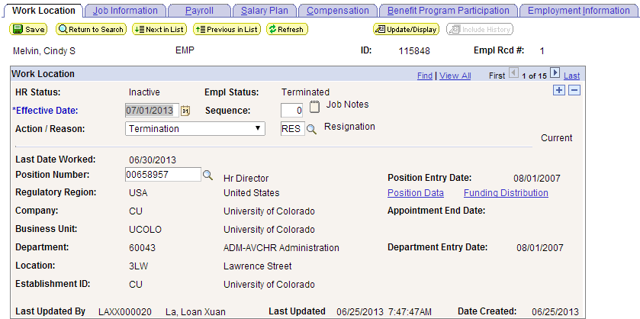  -While Notes is available in 9.2, comments can be included in the Approval process.  -Eliminate link to Position Data and Funding Distribution  -Eliminate Last Updated By, Last Updated and Date Created – could run queries | Job Data:  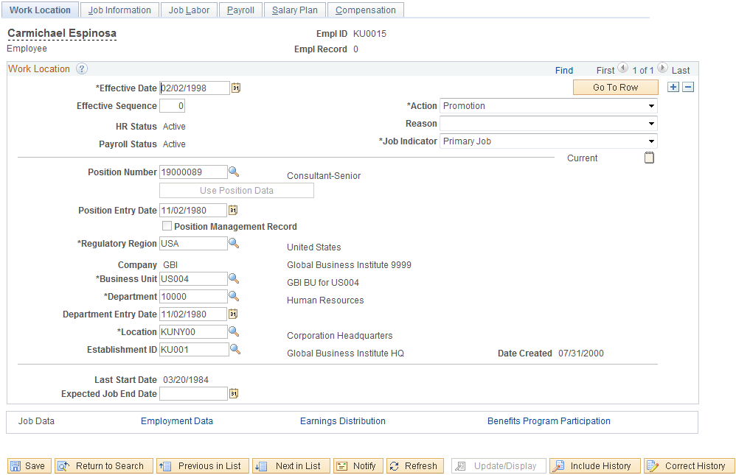
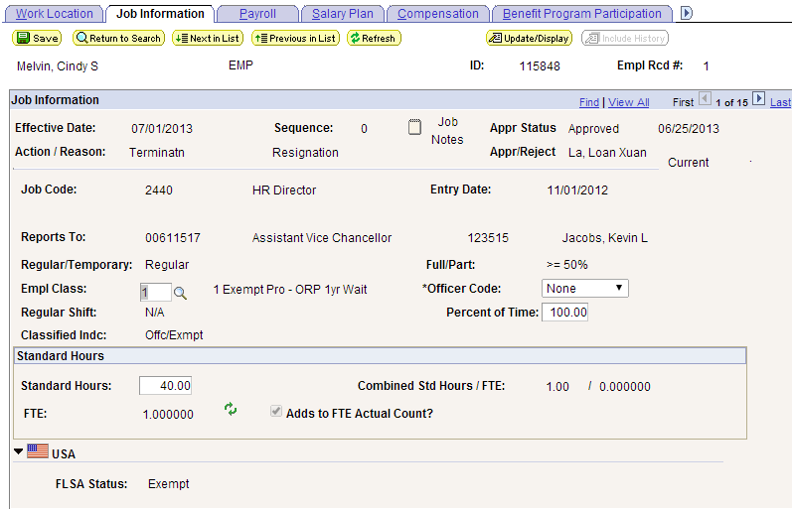  - Will keep Percent of Time in a unique CU Tab so Research Faculty can be track their percent of time for research and grant requirements. | 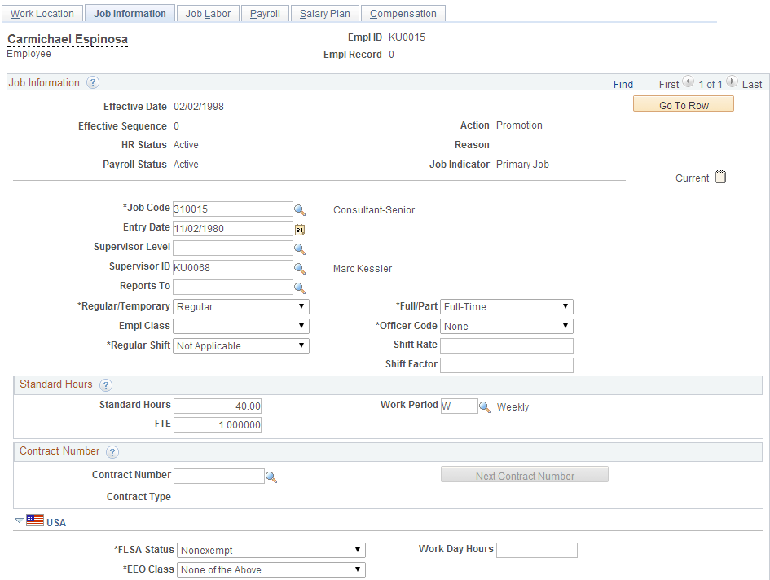
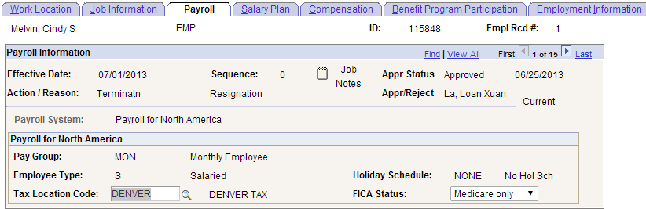 | 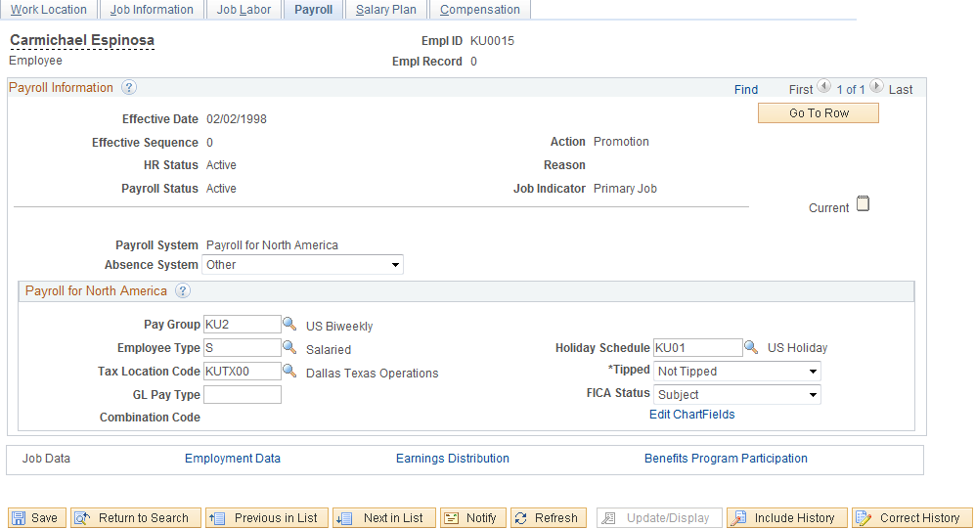
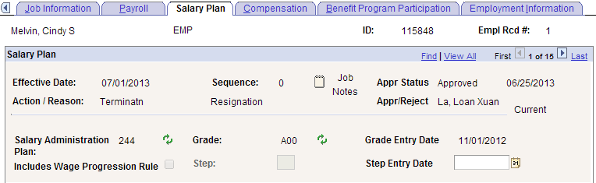 | 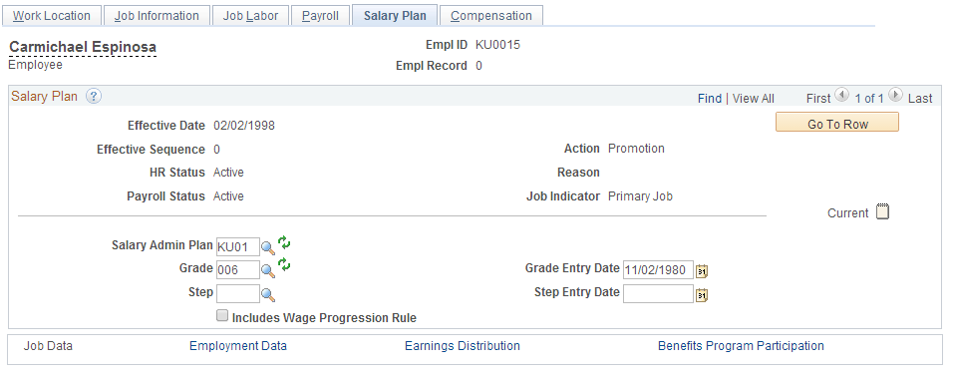
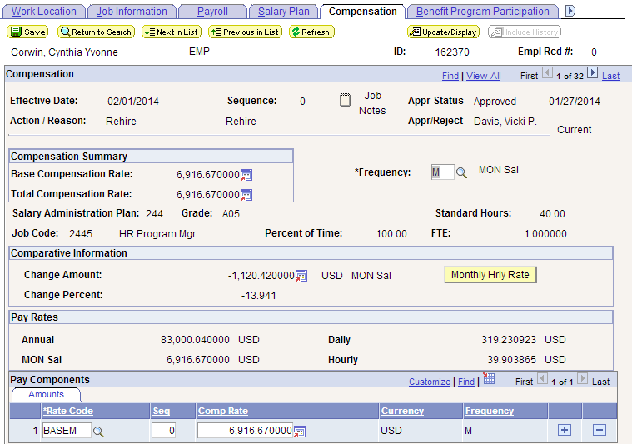  -Eliminate Salary Administration Plan from Compensation Tab | 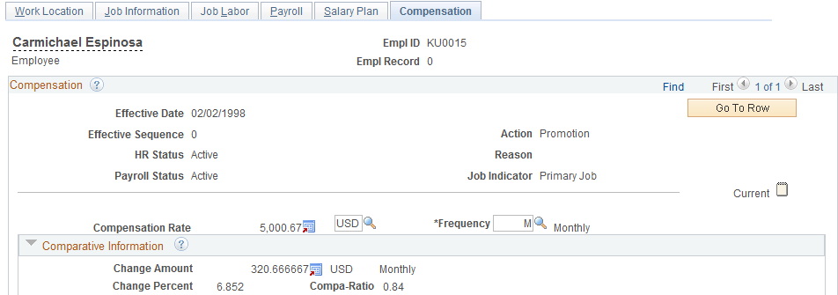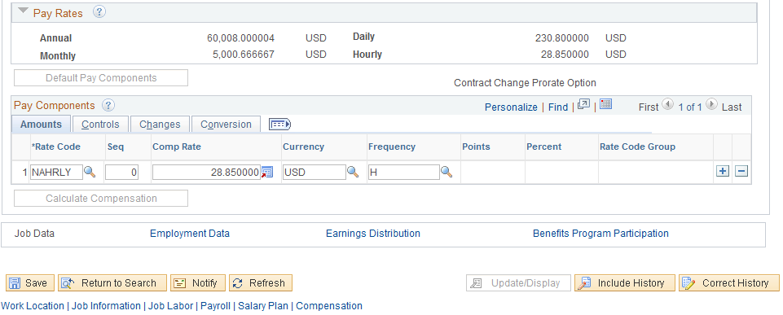
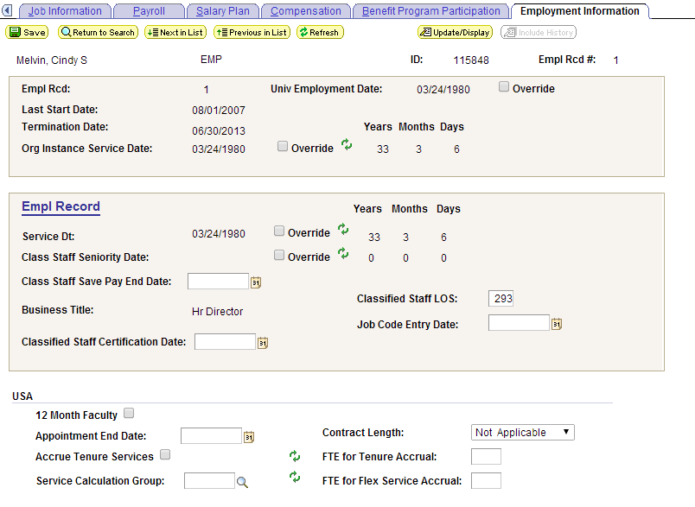  -Eliminate 12 month faculty check box – discuss with campuses and HR staff  -Discuss Service Dates customizations. This will be done in June or July meeting | 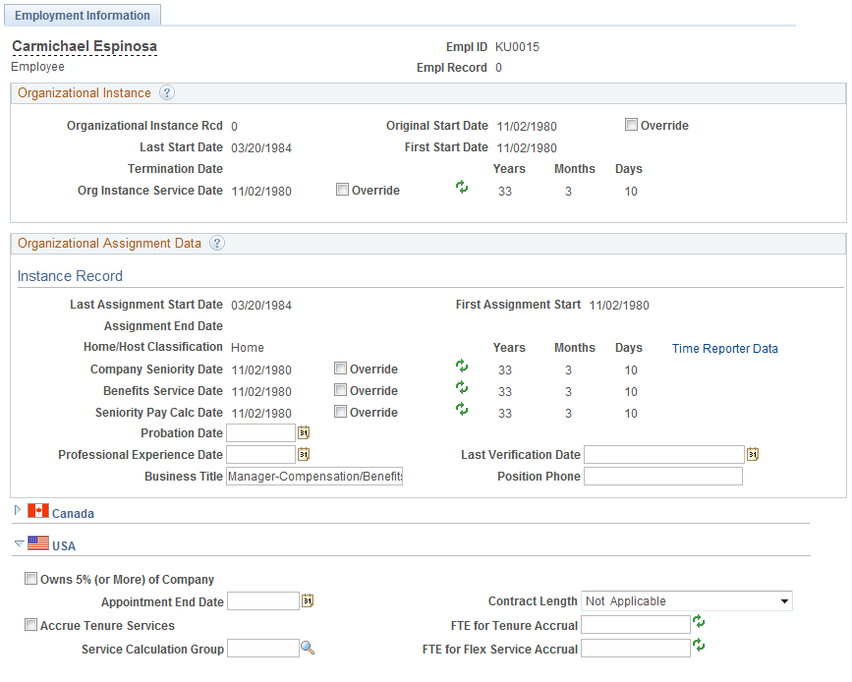
Job Data Transfer/Rehire only
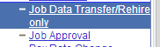
-Eliminate Customization
Job Approval CU
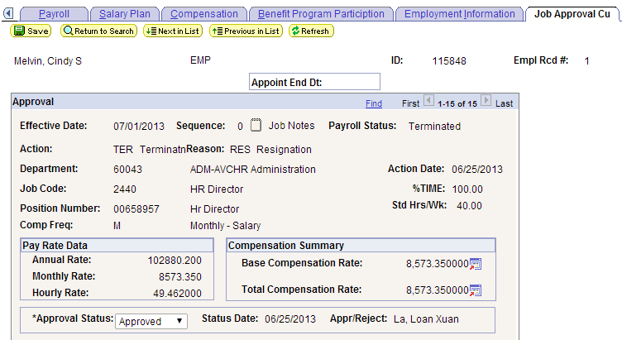
-Eliminate Customization – HR forms will track approvals

