How to

Connect to CUSYS-Guest Wireless Network
When laptop is out of the docking station click on the Wireless Network Connection icon in the lower-right corner of your screen
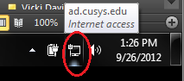
Select “Connect automatically” and Click “Connect”
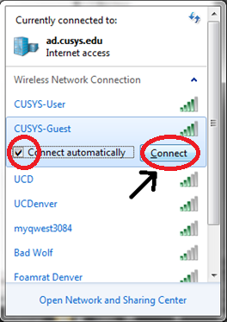

Type in the Security key. This will be located in the room you are in or you can contact the UIS Service Desk by e-mail or by phone below:
help@cu.edu
303-860-4357

Click “Ok”
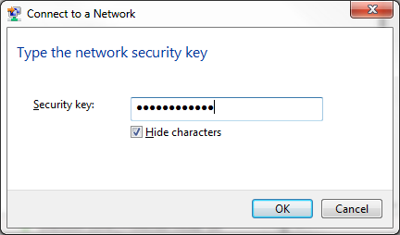
The screen will appear briefly and then disappear
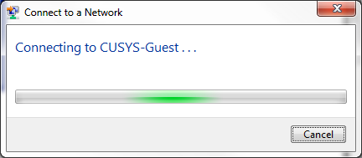
To verify you are connected to the CUSYS-Guest in the lower-right corner of your screen click on the wireless connection icon

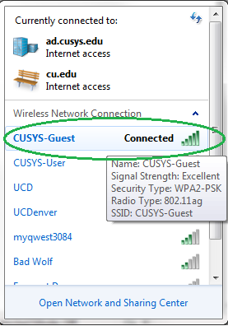
You are now connected to the CUSYS-Guest wireless connection. The laptop will now automatically connect to the CUSYS-Guest wireless connection.

