Using Personalized Form Links In Email Marketing

This feature allows an admin to insert a specialized link to an Event Registration or Donation form within the content of an email message. When the member opens the email and clicks on the form link, the form will display pre-populated with the member’s profile data (name, address, class year, etc.).

Follow these steps:
- Create the Event or Donation form in the usual manner. Make note of the Form ID number.

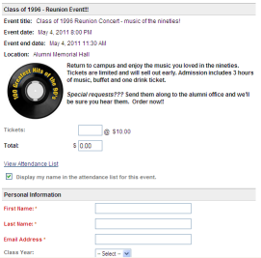 | 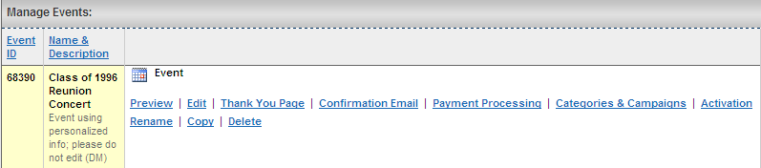

- Request that your CRM to make the personalized version of the Form ID available to you as a data tag.

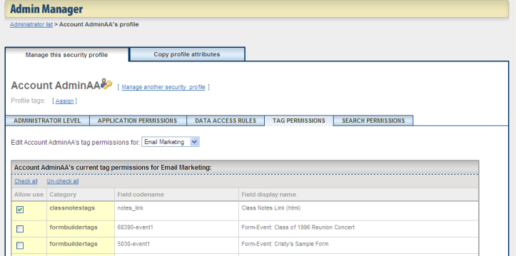

- Create the content for the Email in the usual manner.

- Click on “Work with Data Tags” button.

- Insert the data tag that is prefaced with “Form Event _Personalized” (name of your event) into the content area.

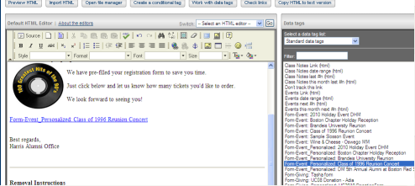

- Click Preview HTML button to verify formatting.

- Test thoroughly.
  - Send Test Email using option on Address & Assemble Email page. This will send a form to the admin pre-filled with the admin’s profile information.
  - Send& Schedule to a small test group of members with different email providers. This will verify the content and identify any provider-specific issues.

- Schedule and Approve the email when accuracy is confirmed.

- Recipients who click on the link to the form inside the email will see the form pre-filled similarly to this:

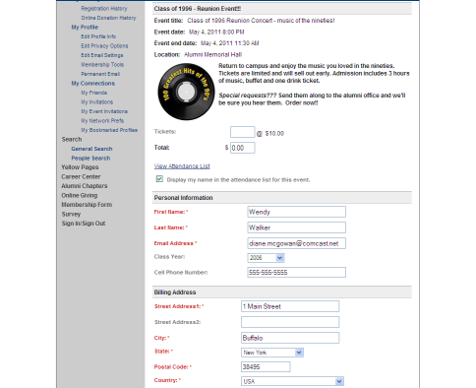

- Check Email Reports to view the total number of transactions and total dollars received from members who registered or donated directly from the link in the email. This will measure your results for this method of delivering event information.

