Form Categories Quick Start Guide
How to assign a category to a form:
- Log into the Admin Center.  - Go to the appropriate form application (i.e. Event Registration, Donation, Membership, or Survey Forms).  - Click the Edit link next to the appropriate form.  - Click the Edit Event/Form Configuration tab.  - Click the Categories & Campaigns tab.  - Select the appropriate category from the Available Categories list. | 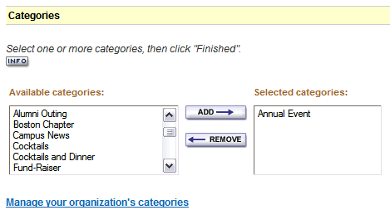  Figure 1
- Click the Add button. The selected category will appear in the Selected Categories list.
- Scroll down to the bottom of the page, and click Finished. The page will refresh with the Categories and campaign mapping successful onscreen confirmation at the top of the page.

How to un-assign a category from a form:
- Log into the Admin Center.
- Go to the appropriate form application (i.e. Event Registration, Donation, Membership, or Survey Forms).
- Click the Edit link next to the appropriate form.
- Click the Edit Event/Form Configuration tab.
- Click the Categories & Campaigns tab.
- Select the appropriate category from the Selected Categories list.
- Click the Remove button. The selected category will be removed from the Selected Categories list, and re-appear in the Available Categories list.
- Scroll down to the bottom of the page, and click Finished. The page will refresh with the Categories and campaign mapping successful onscreen confirmation at the top of the page.

How to add a new category:
- Log into the Admin Center.  - Select Community Management > Configuration > Manage/Add Form Categories.  - Click the Add a category link in the border.  - Enter the Category Name, and select which form application(s) this category should apply to.  - Click the Save button. The page will refresh with the newly added category in the list below in alphabetical order. | 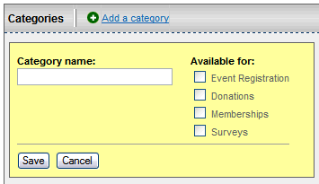  Figure 2

How to archive a category:
- Log into the Admin Center.
- Select Community Management > Configuration > Manage/Add Form Categories.
- Click the Archive link next to the appropriate category name. The page will refresh with the category flagged as archived.

How to restore a category:
- Log into the Admin Center.
- Select Community Management > Configuration > Manage/Add Form Categories.
- Click the Restore link next to the appropriate category name. The page will refresh with the category flagged as available.

How to rename a category:
- Log into the Admin Center.  - Select Community Management > Configuration > Manage/Add Form Categories.  - Click the Edit link next to the appropriate category name.  - Enter the new name for the category, and click Save. | 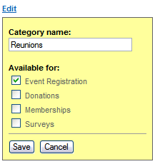  Figure 3
How to change form application assignments for a category:
- Log into the Admin Center.
- Select Community Management > Configuration > Manage/Add Form Categories.
- Click the Edit link next to the appropriate category name.
- Enter select or deselect the appropriate form applications for the category, and click Save.

