Data On Demand

Table of Contents

Introduction 3
Define Report Queries 4
Create a report list 4
Date Search Options 5
Search Extensions 6
Upload a report list 11
Combine report lists 12
Edit, duplicate, and delete report lists 14
Display 15
List Management 15
View and manage report queries, field lists, reports 15
Define Report Content 18
Create Content 18
Re-order Fields 18
Drag and Drop 19
Edit, duplicate, and delete report content 20
Assemble Reports 21
Define A Report 21
Edit, duplicate, and delete reports 22
Run Reports 23
Download a Report 23
Email a Report 25
Display a Report 26
Appendix A: Importing a Report into a Spreadsheet 27

Introduction

The Data On Demand tool provides authenticated administrators the ability to access and manage their data on their own schedule. This reporting tool will enable users to define their own queries based on their data set. For example, administrators may be most interested in obtaining email addresses that were updated within the last week, and running that query on a weekly basis; or mailing addresses or phone numbers that changed within the last 20 days, etc. Data on Demand gives administrators maximum control over what data elements will be accessed at what time interval, in addition to what format and method of delivery is preferred.

All permissions for administrators using Data on Demand are set by the Super Administrator using the Admin Manager application (separate manual available). For access, login to the Administration Center, mouse over User Management in the top navigation. The User Management sub-menu will display. Select Manage Administrative Access.

Define Report Queries
Define Report Queries allows administrators with proper access level to create, upload, or combine report lists. Queries

Create a report list
Create a report list allows administrators to create a list using Standard or Advanced Query Builder. Standard Query Builder allows the administrator to build a basic query using a hierarchy tree structure. Advanced Query Builder allows the administrator to create complex queries. Lists created in Data on Demand will also appear as a list in Email Marketing.

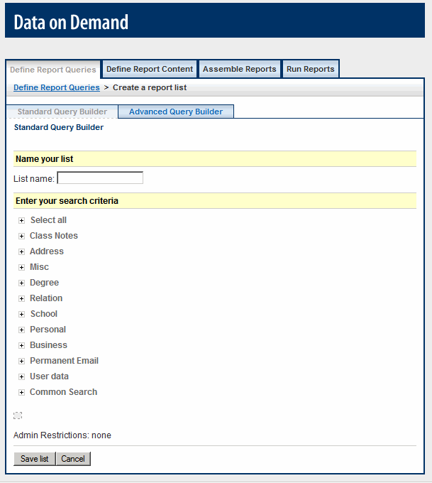  Standard Query Builder | 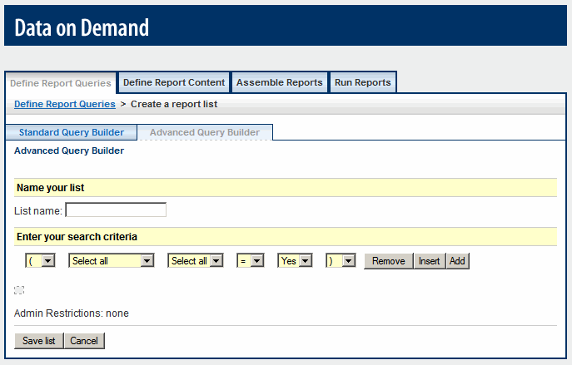  Advanced Query Builder
event:
How to create a report list using Standard Query Builder:
- Login to the Administration Center.  - Mouse over Reporting in the top navigation. The Reporting sub-menu will display.  - Select Data on Demand. The Define Report Queries tab will display.  - Click the Create a report list button ().  - Select the Standard Query Builder tab, if not already selected.  - Operators  - = - Equal To  - != - Not Equal To | - Enter the list name. See figure 1.  - Click the expand icon (), to view the available fields in the appropriate table. Use the collapse icon () to hide the fields.  - Enter the appropriate value(s) for each field. Query OK message displays when the query is valid.  - Click Save list, or Cancel to abort.  - The Create & Manage Lists page will display with the newly created list at the top of the list.  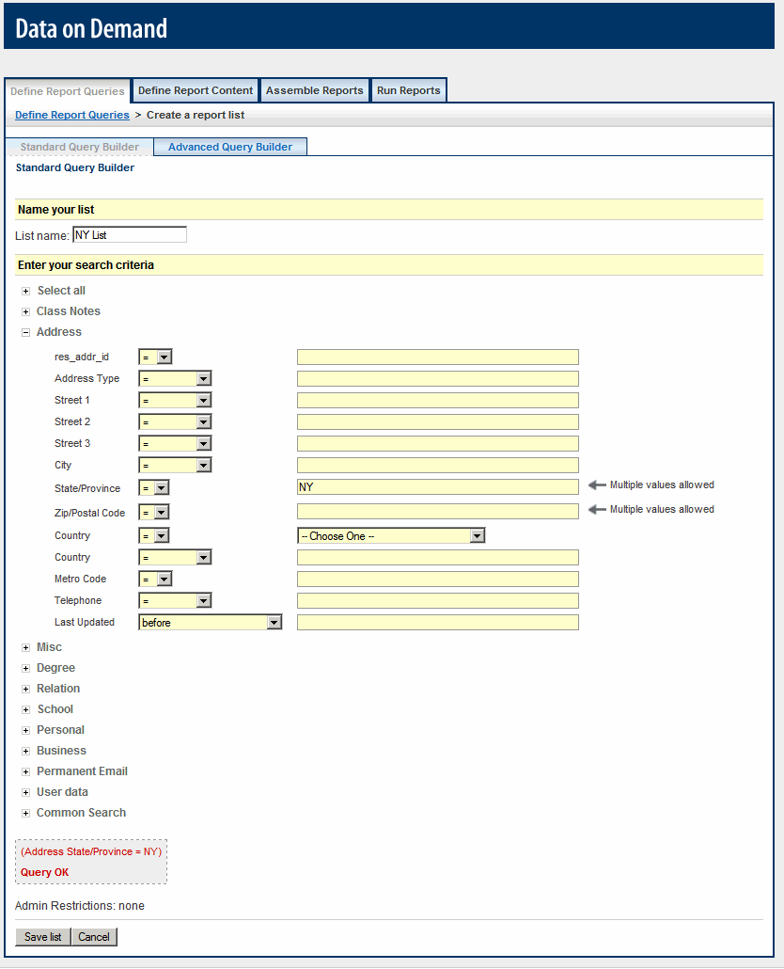  Figure 1

Date Search Options
Date Search Options allow administrators to extend their ability to target by date.

New Search Options | Description | Example
Previous n days | Captures records where the date is previous to number (n) days the list is run | Capture all records where registration date is within the last 4 days; Enter the number 4
Previous n weeks | Captures records where the date is previous to number (n) weeks the list is run | Capture all records where registration date is within the last 3 weeks; Enter the number 3
Previous n months | Captures records where the date is previous to number (n) months the list is run | Capture all records where registration date is within the last 2 months; Enter the number 2
Previous n years | Captures records where the date is previous to number (n) years the list is run | Capture all records where registration date is within the last year; Enter the number 1
Next n days | Captures records where the date is in the next number (n) days the list is run | Capture all records where membership expiration date is within the next 4 days; Enter the number 4
Next n weeks | Captures records where the date is in the next number (n) days the list is run | Capture all records where membership expiration date is within the next 3 weeks; Enter the number 3
Next n months | Captures records where the date is in the next number (n) days the list is run | Capture all records where membership expiration date is within the next 2 months; Enter the number 2
Next n years | Captures records where the date is in the next number (n) days the list is run | Capture all records where membership expiration date is within the next year; Enter the number 1
Day-of-year previous n days | Captures records where the day of the year is number (n) days previous to the time the list is run. | Capture all members, who's renewal date was yesterday; Enter the number 1
Day-of-year next n days | Captures records where the day of the year is number (n) days away from the time the list is run. | Capture all members, whose birthday is today; Enter the number 0.

Search Extensions
Search Extensions enables administrators to search across data fields and modules such as ClassNotes, Permanent Email, Career Advisory Network, etc.

For example: An administrator can obtain a list of all Florida alumni/members from the class of 1999, who posted a Career News - Professional Accomplishment ClassNote within the last 3 months.

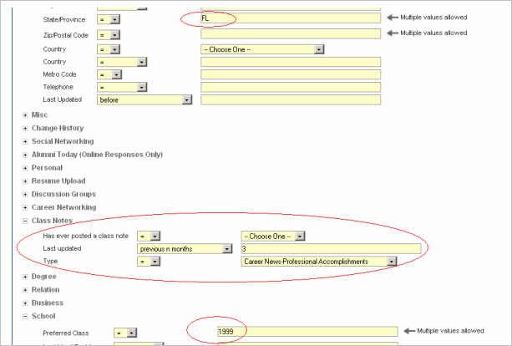
Administrators may activate the new Search Extensions via User Management -> Manage Administrative Access -> Search Definitions tab for the appropriate admin.

Class Notes
Administrators are able to capture all alumni/members who have ever submitted a ClassNote (Yes/No) within the Online Community, who have submitted a ClassNote for a specific Type, and the date range of when the ClassNote was last updated.

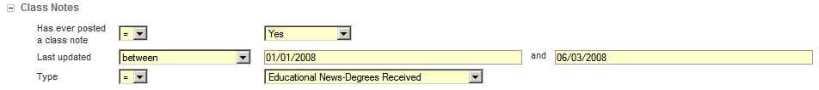

Profile Photo
Administrators are able to capture all alumni/members who have uploaded a profile photo (Yes/No) and the date range of when the profile photo was uploaded.

Resume Upload
Administrators are able to capture all alumni/members who have uploaded a resume (Yes/No) and the date range of when the resume was uploaded.

Career Advisory Network (CAN)
Administrators are able to capture all alumni/members who have registered for the CAN and the date range of when the alumni/member registered for the CAN.

Permanent Email
Administrators are able to capture all alumni/members who have a permanent email address (Yes/No), an active permanent email addresses (Yes/No), a permanent email address with a specific Mail or Domain name, their permanent email forwarding to a specific email address, enabled Greylisting (Yes/No), and who have created a permanent email address within a certain date range.

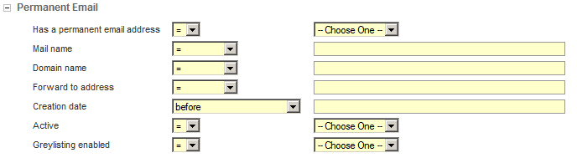
Change History
Administrators are able to capture the Change History for all alumni/members.

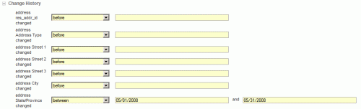

Email Marketing
Administrators are able to capture all alumni/members who opened an email or clicked on a specific link.

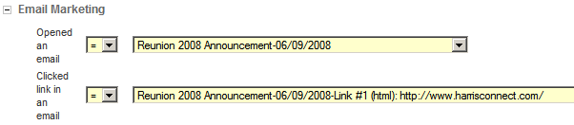

Discussion Groups
Administrators are able to capture all alumni/members who are members of any discussion group (Yes/No) or who are members of a specific group. The Discussion Groups search extension applies to both versions (Legacy Discussion Groups and Groups 2.0).

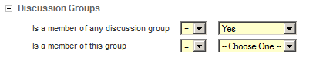

Social Networking
Administrators are able to capture all alumni/members who have at least one friend (Yes/No).

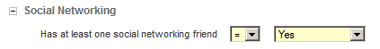

Online Giving*
Administrators are able to capture all alumni/members who have made a donation (Yes/No), who submitted their donation within a certain date range, who gave a particular dollar amount, and who gave a particular total giving amount.

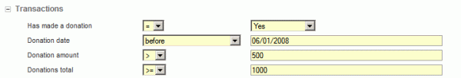

Memberships*
Administrators are able to capture all alumni/members who have completed a membership form (Yes/No), who have submitted their membership within a certain date range, and who have joined at a specific membership amount.

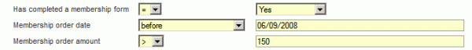

*Indicates applications listed under the Transactions section. The new Event Registration and Surveys applications will also fall under the Transactions section.

How to create a report list using Advance Query Builder:
- Login to the Administration Center.  - Mouse over Reporting in the top navigation. The Reporting sub-menu will display.  - Select Data on Demand  - The Define Report Queries tab will display.  - Click the Create a report list button ().  - Select the Advanced Query Builder tab.  - Enter the list name. See figure 2.  - Select the appropriate table, field, and logical operator (equal to/not equal to).  - Enter the appropriate value(s).  - Select the appropriate Boolean operator (and/or). Query OK message displays when the query is valid.  - Click Save list, or Cancel to abort. The Create & Manage Lists page will display with the newly created list at the top of the list. |  | 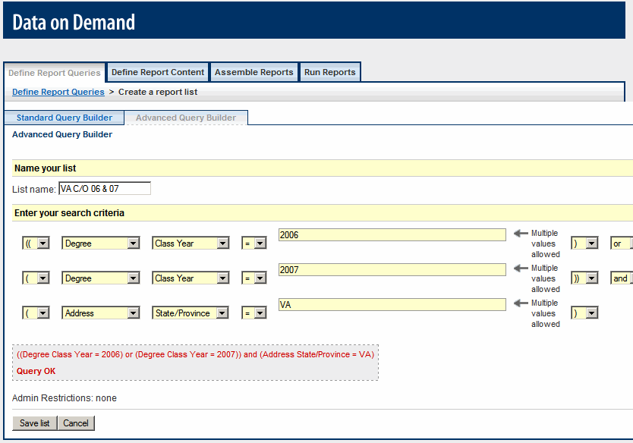  Figure 2
Boolean Operators (and/or): Use Boolean operators to join simple queries to create complex queries.

OR is used to join synonymous or related statements, and instructs the reporting tool to retrieve any record that contains either (or both) of the terms, thus broadening your search results.

AND is used to join when both (or all) the conditions must appear in the items you retrieve.

Parenthesis: Use parenthesis to group statements together to clarify the order of operations. For example: I could create a list of Virginia Young Alumni, which would be all members with class year equal to 2006 or 2007 and State equal to VA. See figure 3. The operations within the innermost pair is performed first, followed by the next pair out, etc., until all operations within parentheses have been completed. Then any operations outside the parentheses are performed.
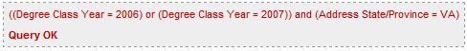
Notice the double parenthesis class year equal to 2006 or 2007.

Figure 3

How to capture all records:
- Login to the Administration Center.  - Mouse over Reporting in the top navigation. The Reporting sub-menu will display.  - Select Data on Demand. The Define Report Queries tab will display.  - Click the Create a report list button.  - Expand the Select All section.  - Set Send to all equal to Yes.  IMPORTANT!  Be sure Search All is checked in Administration Center>User Management>Manage Administrative Access>Search Definitions for all appropriate administrators. | 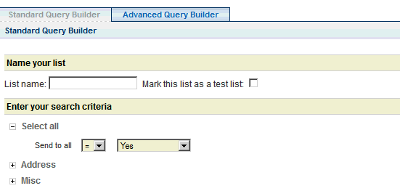

Upload a report list
Upload a report list allows administrators with the proper access level to upload a list of unique IDs or upload a tab-delimited text file containing email address, first name, and last name.

IMPORTANT!
The file to be uploaded for use with Data On Demand is expected to be a plain text file containing unique ID's (client ID) only, one entry per line. Each ID record line should be terminated by a carriage return/line feed (CR/LF or 13/10 ASCII).
How to upload a list of IDs:
- Login to the Administration Center.
- Mouse over Reporting in the top navigation. The Reporting sub-menu will display.
- Select Data on Demand. The Define Report Queries tab will display.
- Click the Upload a report list button (). The Upload a list of IDs page displays. See figure 4.
- Enter the list name.
- Click the Browse button to search for the text file of Unique IDs to upload.
- Click Begin upload, or Cancel to abort. The Create & Manage List page will display with the newly uploaded list at the top of the list.

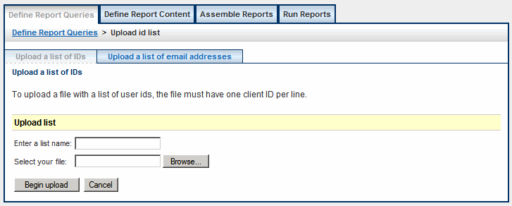
Figure 4
H

How to upload a list of email addresses:
s:

- Login to the Administration Center.  - Mouse over Reporting in the top navigation. The Reporting sub-menu will display.  - Select Data on Demand. The Define Report Queries tab will display.  - Click the Upload a report list button (). The Upload a list of IDs page will display.  - Click the Upload a list of email addresses tab. The Upload a list of email addresses page will display. See figure 5.  - Enter the list name.  - Click the Browse button to search for the text file of Unique IDs to upload.  - Click Begin upload, or Cancel to abort. The Create & Manage List page will display with the newly uploaded list at the top of the list. | 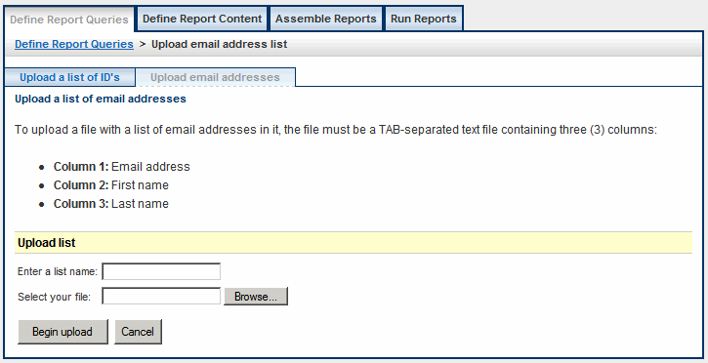  Figure 5

IMPORTANT!
The ability to upload email addresses is an additional feature. Please contact your Client Relations Manager for more information on this feature.

Combine report lists
Combine report lists feature allows administrators with the appropriate access level to create a composite list using existing lists. How to upload a list of email addresses:

How to combine lists of reports
- Login to the Administration Center.  - Mouse over Reporting in the top navigation. The Reporting sub-menu will display.  - Select Data on Demand. The Define Report Queries tab will display.  - Click the Combine report lists button (). The Create composite list page will display. See figure 6.  - Enter the list name.  - Select the combination method (add, take the intersection with, or subtract).  - Select an available list. The list type will display next to the list.  - Click the Add button () to add the list, click Remove button () to remove the list, and click the Insert button () to insert a new list and combination method.  - Click Check List to verify the new list is valid.  - Click Save list, or Cancel to abort. The Create & Manage List page will display with the newly saved list at the top of the list. | 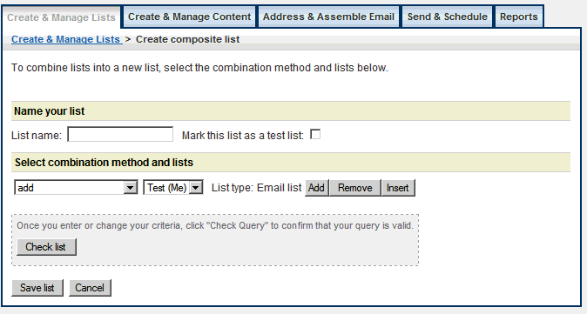  Figure 6  Add  The Add method will combine the elements in all selected lists.  Intersection  The Intersection method will combine only the set of elements that are in the selected lists.  Subtract  The Subtract method will subtract the elements found in all selected lists.

Edit, duplicate, and delete report lists
Standard and Advanced Query Builder lists can be edited, duplicated, and deleted. Uploaded ID and Email Lists can only be deleted. An administrator must have appropriate access controls setup in the Admin Manager tool in order to successfully manage report lists.
How to edit a report list:
 | - Login to the Administration Center.  - Mouse over Reporting in the top navigation. The Reporting sub-menu will display.  - Select Data on Demand. The Define Report Queries tab will display.  - Click the Edit link next to the appropriate report list. See figure 7. The Create report list page will display with the list name displayed.  - Click the expand icon () and collapse icon (), to view and hide the available fields.  - Make all necessary modifications. Query OK message displays when the query is valid.  - Click Save list, or Cancel to abort.  The Create & Manage Lists page will display. | 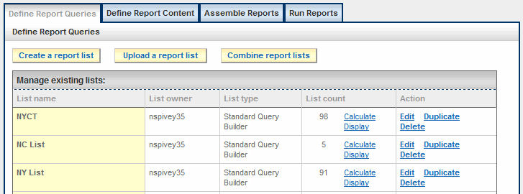  Figure 7
 | How to duplicate a report list: | How to delete a report list:
 | - Login to the Administration Center.  - Mouse over Reporting in the top navigation. The Reporting sub-menu will display.  - Select Data on Demand. The Define Report Queries tab will display.  - Click the Duplicate link next to the appropriate report list. See figure 7. The Create report list page will display with the list name displayed as Copy of <Original List Name Here>.  - Modify the list name.  - Click the expand icon () and collapse icon (), to view and hide the available fields. Query OK message displays when the query is valid.  - Click Save list, or Cancel to abort.  The Create & Manage Lists page will display with the newly saved report list. | - Login to the Administration Center.  - Mouse over Reporting in the top navigation. The Reporting sub-menu will display.  - Select Data on Demand. The Define Report Queries tab will display  - Click the Delete link next to the appropriate report list. See figure 7. An “Are you sure…” popup window will display. See figure 8.  - Click OK, or Cancel to abort  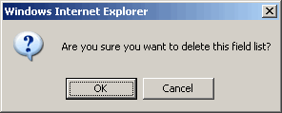  Figure 8
Calculate
Calculate allows administrators to calculate the number of records in the list. Unknown displays until the administrator clicks the Calculate link. The number of records must be re-calculated after the list has been edited.

Display
Display allows administrators to view the newly saved list on screen.

List Management
List Management allows administrators to easily view and manage lists within the Data on Demand tool. Administrators can sort, filter and archive lists. The term lists refers to report queries, field lists, and reports.

View and manage report queries, field lists, reports

How to sort lists:
- Login to the Administration Center.
- Mouse over Reporting in the top navigation. The Reporting sub-menu will display.
- Select Data on Demand. The Define Report Queries tab will display.
- The Create and Manage Lists page will display. See figure 9.
- Click the column header link to sort the lists by that header. Ascending is the default order.
- Click the order icon () to change the display order from ascending to descending.

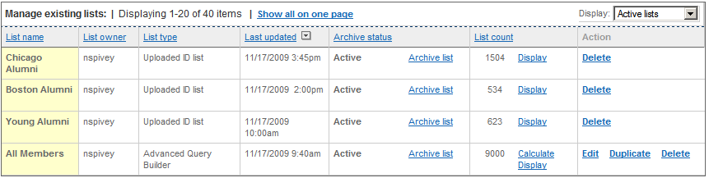
Figure 9

Suggestion: Click the Show all on one page link to display all available lists on one page.

How to filter lists:
Login to the Administration Center.
Mouse over Reporting in the top navigation. The Reporting sub-menu will display. Select Data on Demand. The Define Report Queries tab will display. See figure 10.

Select the appropriate tab, if applicable.

Once on the appropriate tab, click to expand the filter Display dropdown menu.
Select the desired filter from the list. The page will automatically refresh with the lists that match the filter display option selected.

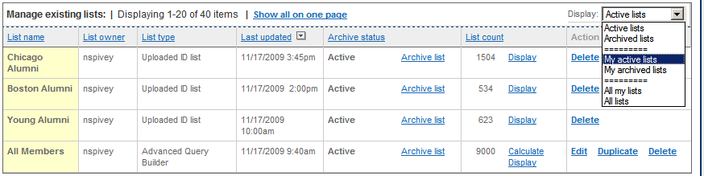
Figure 10
Note: Super Admin and some Admins will have additional display filter options, where they can choose to view only their active lists (My active lists), archived lists (My archived lists), or all their lists (All my lists).

How to archive a list:
Login to the Administration Center. Mouse over Reporting in the top navigation. The Reporting sub-menu will display. Select Data on Demand. The Define Report Queries tab will display. See figure 11.

Select the appropriate tab, if applicable.

Once on the appropriate tab, click the Archive list link next to the list in the Archive status column. The page will automatically refresh, and the Archive status will be updated.

Figure 11
Note: If viewing lists using the Activate list filter display, the newly archived list will disappear from the current view.

How to view archived list:
Login to the Administration Center.
Mouse over Reporting in the top navigation. The Reporting sub-menu will display. Select Data on Demand. The Define Report Queries tab will display. Select the appropriate tab, if applicable.

Once on the appropriate tab, select the Archived lists or All lists to view archived lists. The page will automatically refresh.

Suggestion: Use the sort feature or Show all on one page link if you are unable to locate your archived list.

How to re-activate list:
Login to the Administration Center.
Mouse over Reporting in the top navigation. The Reporting sub-menu will display. Select Data on Demand. The Define Report Queries tab will display. Select the appropriate tab, if applicable.

Once on the appropriate tab, click the Activate list link next to the list in the Archive status column. The page will automatically refresh, and the Archive status will be updated.

Note: If viewing lists using the Archived list filter display, the newly activated list will disappear from the current view.

Define Report Content
Define report content allows administrators with proper access level to create and modify field lists as report content.

Create Content
How to create content:
- Login to the Administration Center. Mouse over Reporting in the top navigation. The Reporting sub-menu will display. Select Data on Demand.  - Select the Define Report Content tab. The Define Report Content page will display.  - Click the Create a field list button (). The Field list details page will display. See figure 12.  - Enter the Field list name.  - Select report fields from the available list on the left.  Selecting Multiple Fields  PC Users – Hold Ctrl + click the mouse  Mac Users – Hold Apple key + click the mouse  - Click the Add to field list button. The selected fields will appear in the Selected fields list on the right. | 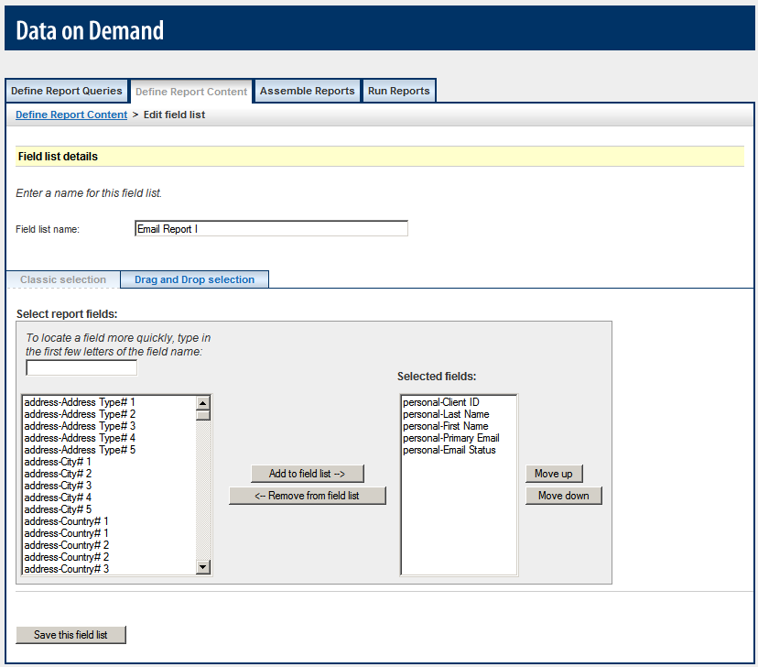  Figure 12  - To remove selected fields: Select fields in the Selected Fields list and click the Remove from field list button.  - Click Save this field list. The Define Report Content page will display with the newly saved field list at the top of the list.

Re-order Fields
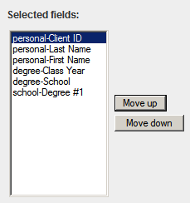  Figure 13 | Use the Move Up and Move Down buttons to change the order in which fields are displayed in the report. See figure 13.

Drag and Drop
The Drag and Drop Selection tab enables administrators to easily create and reorder selected data fields.

How to use drag and drop:
- Login to the Administration Center. Mouse over Reporting in the top navigation. The Reporting sub-menu will display. Select Data on Demand.  - Select the Define Report Content tab. The Define Report Content page will display.  - Click the Create a field list button (). The Field list details page will display.  - Click the Drag and Drop Selection tab.  - Select the appropriate table tab at the top of the tab. The available data fields will load in the list to the left.  - Select a field by clicking and holding the cursor, and drag the field to the Selected Fields list on the right. See figure 14.  - Release the field. The field will display at the bottom of the Selected Field list. See figure 15.  - Continue steps 6 – 8 until as needed.  Re-order Fields  Drag and drop fields in the order you wish them to display top-to-bottom will display left-to-right. | 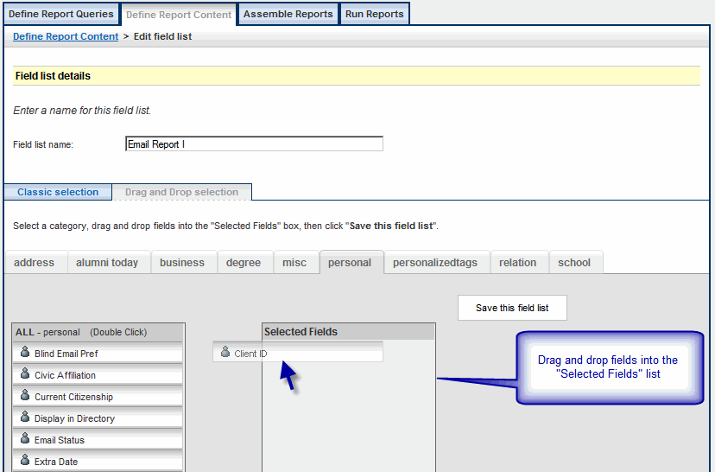  Figure 14  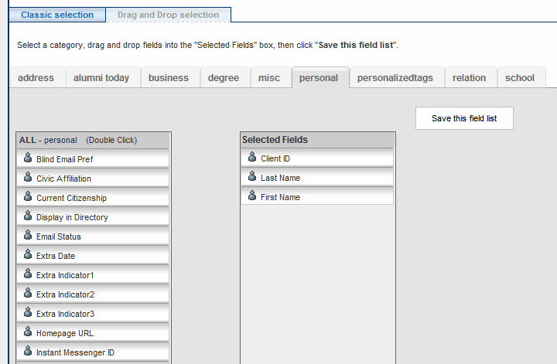  Figure 15
Field Filter
Administrators can quickly find fields by typing in a keyword into the field filter. The available field list will update with only the matching fields. See figure 16.

To return to the full list of available data tags:  - Highlight the Keyword.  - Click the [Delete] button on the keyboard.  The original list of available fields will display. | 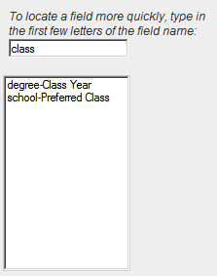  Figure 16

Edit, duplicate, and delete report content
Administrators with proper access level can edit, duplicate, and delete report content (field list details).

How to edit a report content:
- Login to the Administration Center. Mouse over Reporting in the top navigation. The Reporting sub-menu will display. Select Data on Demand.  - Select the Define Report Content tab. The Define Report Content page will display.  - Click the Edit link next to the appropriate field list name. See figure 17. The Field list details page will display with the field list name displayed.  - Make all necessary modifications to the field list.  - Click Save this field list. The Define Report Content page will display | 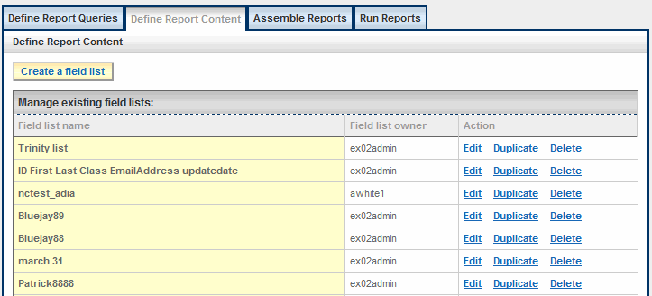  Figure 17
How to duplicate a report list: | How to delete a report list:
- Login to the Administration Center. Mouse over Reporting in the top navigation. The Reporting sub-menu will display. Select Data on Demand.  - Select the Define Report Content tab. The Define Report Content page will display.  - Click the Duplicate link next to the appropriate field list name. See figure 17. The Field list details page will display with the field list name displayed as Copy of <Original Field List Name Here>.  - Modify the Field list name.  - Make all necessary modifications to the content.  - Click Save this field list. The Define Report Content page will display with the newly saved field list at the top of the list. | - Login to the Administration Center. Mouse over Reporting in the top navigation. The Reporting sub-menu will display. Select Data on Demand.  - Select the Define Report Content tab. The Define Report Content page will display.  - Click the Delete link next to the appropriate field list. See figure 14. An “Are you sure…” popup window will display. See figure 18.  Figure 18  - Click OK, or Cancel to abort.

Assemble Reports
Assemble reports allows administrators with proper access level to assemble the report by combining the report list and the report content (field list).

Define A Report
 | How create new report:
- Login to the Administration Center. Mouse over Reporting in the top navigation. The Reporting sub-menu will display. Select Data on Demand.  - Click the Assemble Reports tab. The Assemble Reports page will display.  - Click the Define a report button (). The Report definitions details page displays. See figure 19.  - Enter the Report definition name.  - Select the Output format.  Note: Comma-delimited (.csv) files will automatically open in Microsoft Excel.  - Select a report list.  - Select a field list.  - Click Save this report definition. The Assemble Reports page will display with the newly created report at the top of the list. |  | Figure 19

Edit, duplicate, and delete reports
Administrators with proper access level can edit, duplicate, and delete reports.
How to edit a report list:
- Login to the Administration Center. Mouse over Reporting in the top navigation. The Reporting sub-menu will display. Select Data on Demand.  - Click the Assemble Reports tab. The Assemble Reports page will display.  - Click the Edit link next to the appropriate report. See figure 20. The Report definitions details page will display  - Make all necessary modifications to the report details.  - Click Save this report definition. The Assemble Reports page will display. | 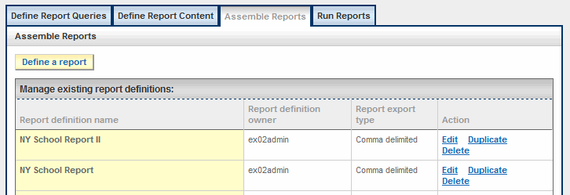  Figure 20
How to duplicate a report list: | How to delete a report list:
- Login to the Administration Center. Mouse over Reporting in the top navigation. The Reporting sub-menu will display. Select Data on Demand.  - Click the Assemble Reports tab. The Assemble Reports page will display.  - Click the Duplicate link next to the appropriate report. See figure 20. The Report definitions details page will display with the report definition name displayed as Copy of <Original Report Definition Name Here>.  - Modify the Report definition name.  - Make all necessary modifications to the email details.  - Click Save this report definition. The Assemble Reports page will display with the newly created report at the top of the list. | - Login to the Administration Center. Mouse over Reporting in the top navigation. The Reporting sub-menu will display. Select Data on Demand.  - Click the Assemble Reports tab. The Assemble Reports page will display.  - Click the Delete link next to the appropriate report. See figure 17. An “Are you sure…” popup window will display. See figure 21.  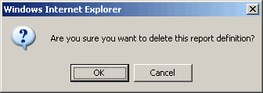  Figure 21  - Click OK, or Cancel to abort.

Run Reports

Download a Report
Run reports tab allows administrators with the proper access level to download, email, or display a saved report.
How to download a report:
- Login to the Administration Center.  - Mouse over Reporting in the top navigation. The Reporting sub-menu will display. Select Data on Demand.  - Click the Run Reports tab. The Run Reports page will display.  - Select the appropriate report to generate from the dropdown menu.  - Click Download report. A File Download window will appear. See figure 22.  - Click the Save button on the File Download window. See figure 23.  Note: Click Open to open the report, or click Cancel to abort.  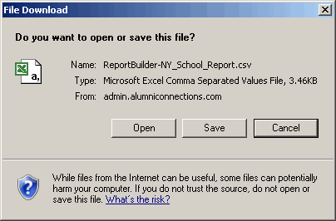  Figure 23  Notice the default name will be ReportBuilder-Report_Name. The file extension (.csv/.txt) depends on the Output Format selected when the report was assembled.  - Click the Save button. A Download complete window will display. See figure 25.  - Click Open to open the report.  - Note: Comma-delimited (.csv) files will automatically open in Microsoft Excel. See figure 26. For more information about importing reports see Appendix A: Importing a Report into a Spreadsheet. | 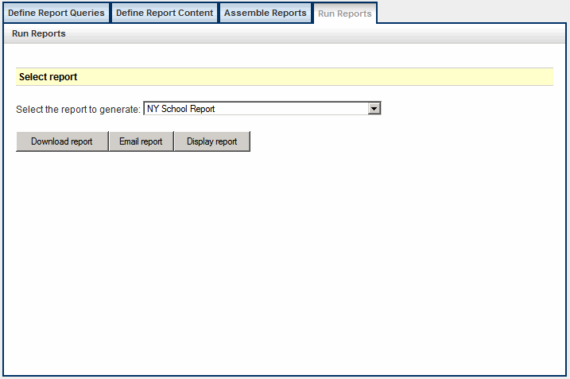  Figure 22  - A Save As window will display. See figure 21. Be sure to save the report file where you can find it later.  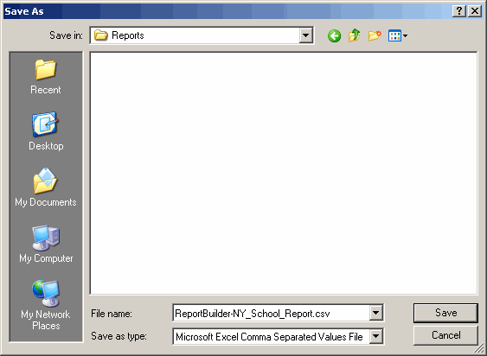  Figure 24  Figure 25

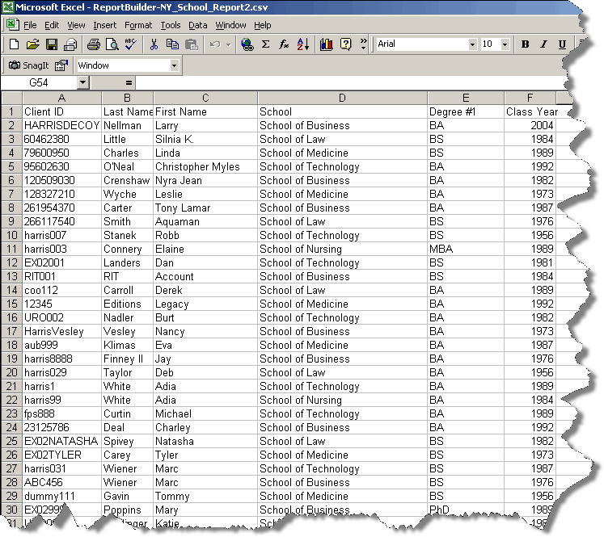

Figure 26

Email a Report
How to email a report:
- Login to the Administration Center. Mouse over Reporting in the top navigation. The Reporting sub-menu will display. Select Data on Demand.  - Click the Run Reports tab. The Run Reports page will display.  - Select the appropriate report to generate from the dropdown menu.  - Click Email report. An onscreen confirmation will display stating the Report has been emailed successfully to the administrator’s preferred email address. See figure 27. | 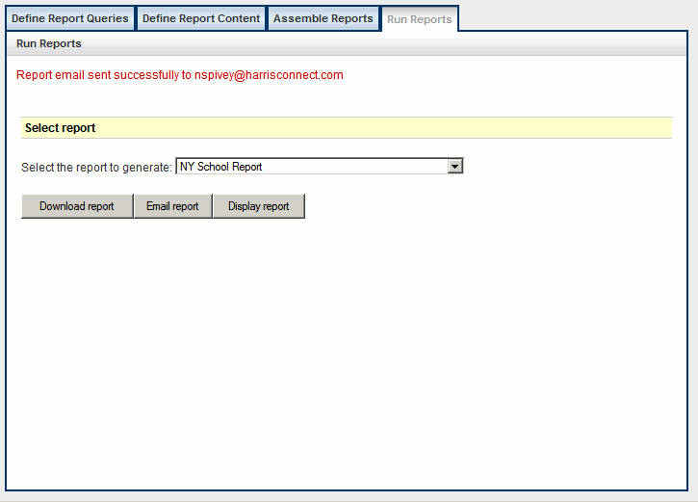  Figure 27

Display a Report
How to display a report:
- Login to the Administration Center. Mouse over Reporting in the top navigation. The Reporting sub-menu will display. Select Data on Demand.  - Click the Run Reports tab. The Run Reports page will display.  - Select the appropriate report to generate from the dropdown menu.  - Click Display report. The report will display. See figure 28. | 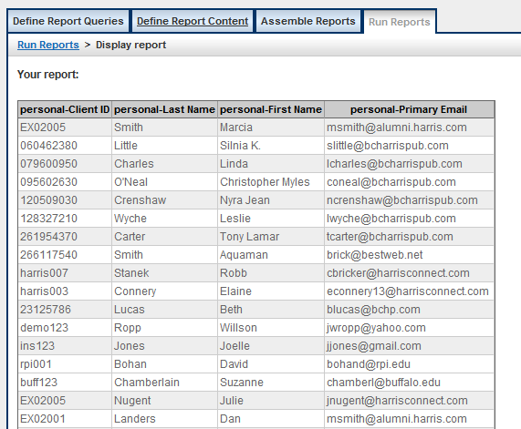  Figure 28

Appendix A: Importing a Report into a Spreadsheet

To import a report into Microsoft Excel for Windows, follow these steps.
- Open Microsoft Excel.  - Click File > Open. The Open dialog box appears. See figure A.  - In the Files of type list, select All Files (*.*).  - Select the report file to import.  - Click Open.  The Text Import Wizard dialog box appears. See figure B.  - Select Delimited if not already selected.  - Click Next. Excel displays step 2 of the Text Import Wizard. See figure C. In the Data preview section, Excel shows how it will import your data.  - Click Next. Excel displays step 3 of the Text Import Wizard. See figure D.  - Click Finish. The report will display. See figure E. | 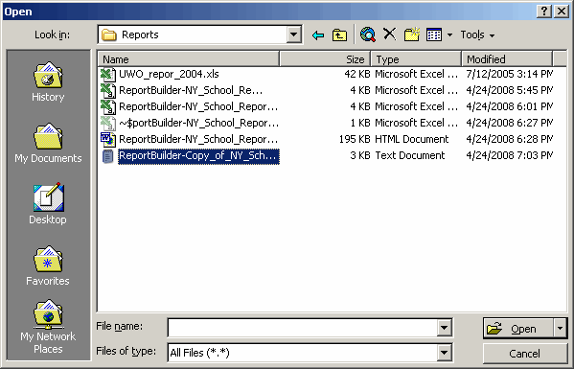  Figure A
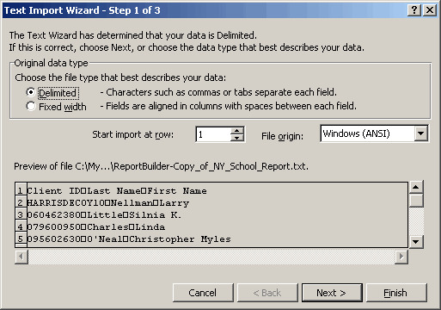  Figure B | 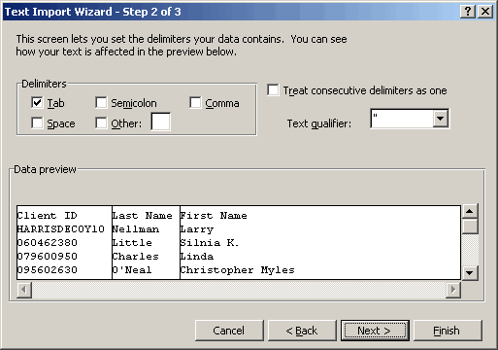  Figure C
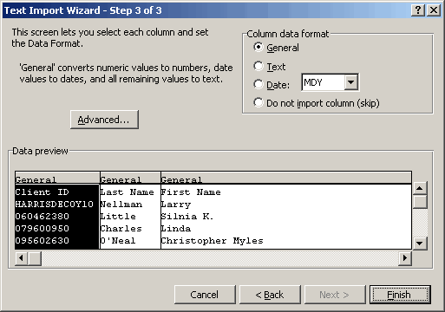

Figure D

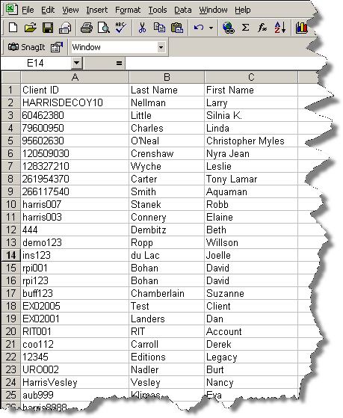

Figure E

