How to Use Data Tags to Personalize Email Marketing

Copyright © 2011 Harris Connect LLC. all rights reserved.
Training documents are proprietary and confidential and should not be shared outside of the client organization or reproduced (including on the Internet unless access is restricted to client’s employees), without our express written consent

Administrators have the ability to create personalized email content by using data tags to display a particular constituent’s information as it appears in their database record. Data Tags can be used in both HTML and Text versions of content.

For example, you can include the constituent’s first and last name in the salutation: Dear Natasha Spivey. In addition, you can use these tags to include deep links directly into the registration process (Registration Link) to encourage registration, the online directory update process (Update Link) to encourage data updates, or the web-based opt-out process (Unsubscribe Link). This feature can also be used to display Class Notes in email content to add interest.

There are many Data Tags available for your use, but they must be enabled for each admin. This is accomplished by the organization’s SuperAdmin using the Admin Manager Tag Permissions functionality. Below is a list of some commonly used Data Tags.

These instructions have been excerpted from the Email Marketing manual available in the Client Online Community Training Center. Please consult the manual for additional information.

Follow these steps to use Data Tags:
- Log into your Administration Center.  - Mouse over Email Marketing in the top navigation.  - Click on Create & Manage Email Content.  - Click on button. The Data Tags will appear on the right side of the page. See Figure 1. | - Anchor your cursor in your content window exactly where you wish to place the data tag.  - Highlight the desired data tag from the Data tags list on the right of the screen.  - Click the button for HTLM Version page  or the  for Text Version page.  - The data tag will appear in the content area.
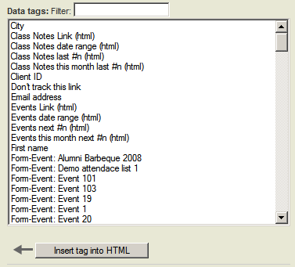
Figure 1

Explanations of Some Commonly Used Data Tags:

- Class Note Link – Inserts a link to the Class Notes page of the Online Community.  - Class Notes date range – Inserts most recent 5 Class Notes submitted between Jan. 1, 1990 to Jan. 1, 2020. Administrators may edit the number of Class Notes and the date range.  - Client ID – Inserts the member’s Client ID from the database.  - Email Address – Inserts the member’s Email Address from the database.  - Events Link – Inserts a link to the Event Calendar on the Online Community.  - Events date range – Inserts next 2 upcoming events between Jan. 1, 1990 to Jan. 1, 2020. Administrators may edit the number of events displayed and the date range.  - First Name – Inserts the data contained in the First Name field of the database.  - Last name – Inserts the data contained in the Last Name field of the database  - Open Count – Tracks when a member initially opens the HTML version of the email message.  - Preferred class year – Inserts class year contained in the Preferred Class field of the online database. | - Form: <Form Name> - Inserts a link to the Donation/Membership form listed. Email Marketing Reports will track every time a member clicks on the Form link, and whether the member made a donation or joined.  IMPORTANT!  The form must reside in the Harris Donation or Membership Builder tool.  - Security Info – Inserts the security info contained in the online database. The Security Info (Access Code) is required to validate a member’s record during the registration process.  - Unsubscribe link – Inserts an unsubscribe/opt-out link. Email Marketing Reports will track when a member clicks on this link and if he/she actually unsubscribed.  - User ID – Inserts the data contained in the User ID field of the database.  - User update link – Inserts a link to the MyPage. Member will be prompted to login. Email Marketing Reports will track when a member clicks on this link and if he/she actually updates his/her profile information.  - Registration link – Inserts a link to the Registration page of the Online Community. Email Marketing Reports will track every time a member clicks on the Registration link, as well as if he/she actually registered at that time.
IMPORTANT!
When merging content with an Email Address list, certain data tags such as Registration Link are considered invalid. Email Address lists should be targeted to non-members of the Harris database; therefore, the Registration Link, which links members to the 3rd step of the registration process, is not needed.

Only the following data tags are valid for an email list: First Name, Last Name, Email Address, Open Count, Mailing Address tags, and Unsubscribe Link.

