Donation Forms ~ Frequently Asked Questions

DFFAQ-1-8-1-10

Q. How can I create a list of possible funds to which the donor can direct the gift?
A. First create a custom component and place it appropriately on your form. You can create either a Custom Dropdown list or a Radio Button list for your donors to use. Then edit the component with your fund options. You will be able to collect the donor’s choices in detailed Donation Reports.

Q. I don’t want to use the default components that reference Appeals or Joint Gifts or Matching Programs. What should I do?
A. On the page listing the component, under the Visibility Column, click on the green checkmark so that it toggles to a grayed-out X. This will prevent the components from displaying in your form but will be available if you later need to add them.

Q. I’m creating reports to send to other departments, and the field heading labels for each column are difficult to understand. How can I resolve that?
A. You can create custom headings for any reports. Click on Reporting>Donation Reports. Click on the blue tab “Customize Report Labels” near the top of the page. This is will display the database field name for each of the fields in your form; enter your preferred label in the white input box, then click Update Field Labels.

Q. I’m creating multiple pages on my form to collect survey information. I would like them only to appear for alumni from certain class years. Can I do that?
A. You can accomplish that goal by using a Conditional Trigger. (Be sure you have designated class year in the Personal Section on a previous page as a required field.) Click on the Create a New Page link at the top of the Edit Form Page list. Next, click on the blue tab for your new page and click on Edit page properties. Scroll to the Conditional Trigger section and choose the class year(s) for which you want to display your new page.

Q. We get many donations through checks in the mail or phone calls into our office. Can I include these so I can report on them with the donations entered online?
A. You can use the User Order Entry tool to easily do that: Forms>Donations>Submit a Donation Form For User. You will be brought to a landing page displaying all your donation forms. Choose the appropriate form. If you want to associate the donation with a client ID click on Submit Form for Community User; otherwise choose Anonymous Registrant. You will complete the form just as the donor would do it online. One caveat: when you create the form be sure to include the ability for admins to enter checks (and other forms of payment if applicable); do that by clicking on Edit Form Configuration>Payment Processing>Additional Payment Options. Select the options you want to use, then click on Finished button.

Q. I don’t understand why or when I would activate a form based on certain dates?
A. This feature is useful if you have a fundraising drive with a deadline in place, as one example. This feature will automatically close (deactivate) the form for you on the exact day and time you specify.

Q. Can I customize the Thank You Page and Confirmation Email using the custom data tags I created just for this form?
A. Yes, you can insert standard or custom tags in these two pages. When you click on the link View a full list of data tags (on the Thank You Page tab or the Confirmation Email tab) you will see a list of pre-defined standard data tags followed by a list of the custom tags created from your custom components for this form.

Q. Can you share some Best Practices for online giving forms?
A. Yes, here are a few suggestions to consider:
- When designing your forms include input from the folks on staff who understand your department and business transaction requirements to be sure you collect all the required data.
- The form should be clear, concise and easy to complete with all required fields clearly marked.
- Marketing is critical; be sure to include the link to your form frequently throughout your website and in both electronic and print communications.
- Be sure to include a link to your security and privacy policies to ensure donors of the safety of their transmission, along with a phone number or email address for donor questions.
- Consider adding a disclaimer explaining that the Confirmation Email will serve as the donors receipt for tax purposes, if applicable.

You can view good examples of online Giving forms created by other clients. Go to the Harris Connect Online Community then click on Achievement Awards (public) and/or Client Showcase (password protected).

Q. How can I set up Recurring Billing for some of my Online Giving forms?
A. Recurring Billing will allow your members to pay their gift in multiple payments over a selected period of time. You will be able to offer recurring billing provided the following two requirements have been met:
- You are using Cybersource as your Gateway processor.
- Cybersource has enabled the Merchant ID you will be using for this form to accept recurring billing (if unsure, check with your CRM prior to creating the form).

Then, follow these steps:
- Click on the Edit Form Configuration tab for the form you will be editing. Scroll down to the Recurring Payments section and select the Recurring payments accepted option. (If Recurring Payments WILL NOT be accepted, select the Recurring payments not accepted option and ignore the rest of the Recurring Billing section.)
- Using the Edit Form Pages tab, create the four (or five if using start date) form components necessary for processing recurring payment requests as displayed in Figure 1.
- Map your new form components for CyberSource. In order for Recurring Payment Billing to be correctly processed by CyberSource, you must indicate which form components contain the data that CyberSource needs for this type of processing. This is called "mapping" and is displayed in Figure 2.

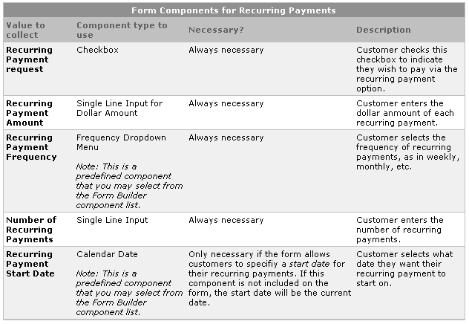
Figure 1
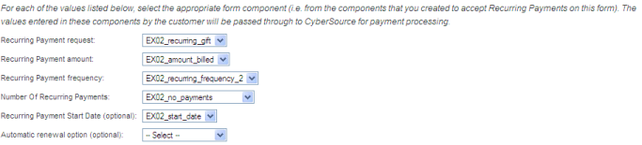
Figure 2

Q. What's the best way to test recurring billing and auto-renew in donations?
A. We suggest that you test with a live card for $1 daily or some other manageable frequency, and credit via CyberSource Business Center.

Q. Are there any plans to allow admins to credit donations back (like we can in events)?
A. Yes, this is on the list of future enhancements. We have no timeframe available at this time.

